Old Dominion University
CYSE 270 Linux System for Cybersecurity
Assignment #6 File Permissions

Alysia Beckles
01127384

Below is the snippet of a sample lab report.
Task A
- . Create three groups, employee, payroll, and admin?
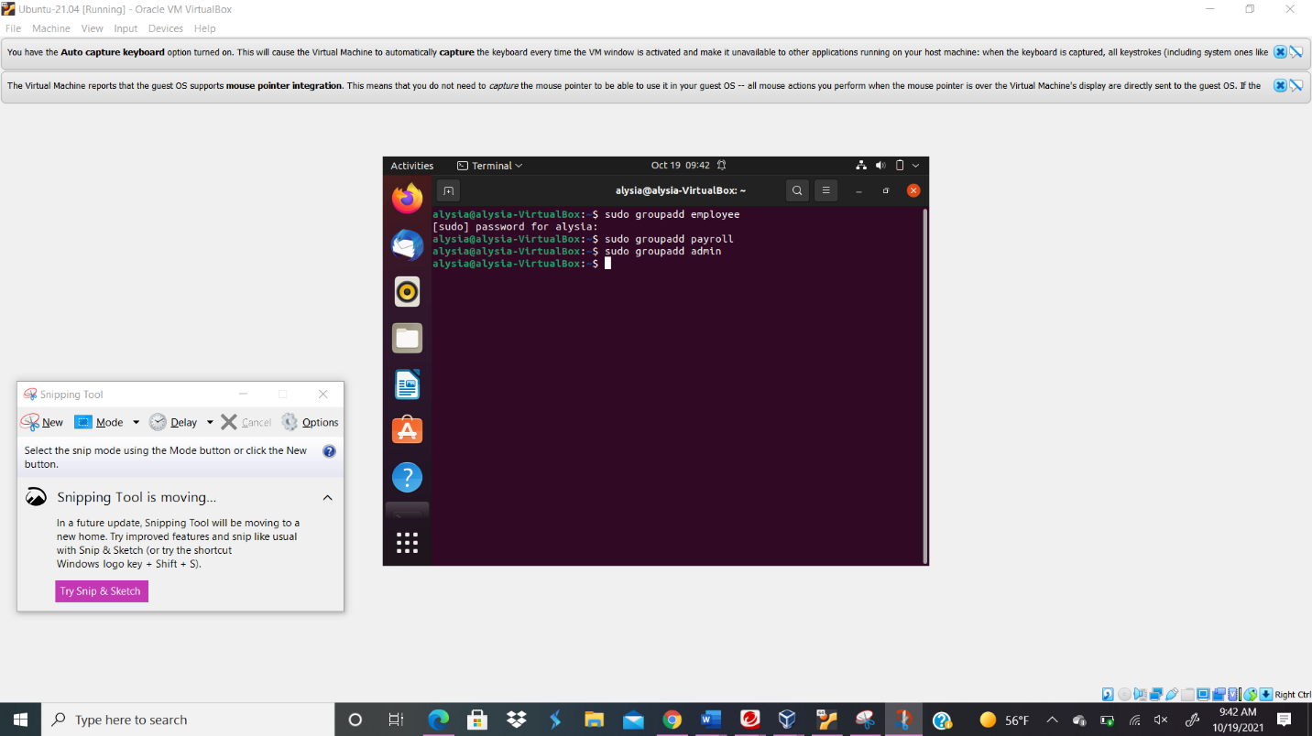

Your explanation goes here. For example:
In order to create three groups with the names employee, payroll, and admin, I typed the command sudo groupadd (groupname). To create the employee group I typed sudo groupadd employee in the terminal. The sudo command gives me permission to run commands as a superuser while the groupadd enables me to create a group. In order to create the payroll group I typed the command sudo groupadd payroll and in order to create the admin group, I typed the command sudo groupadd admin.
- . Create three user accounts with a specified home directory for Sophia, Olivia, and Emma. Set the primary group for Sophia, Olivia, and Emma to "employee", "payroll", and "admin", respectively. And change their login shell to /bin/bash.
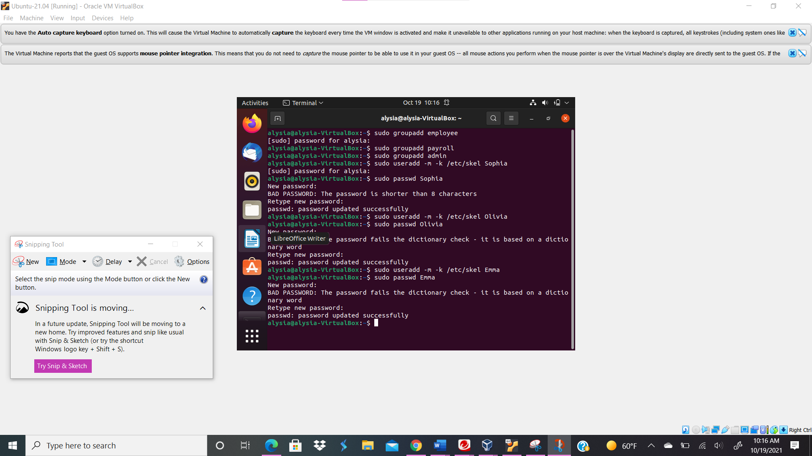
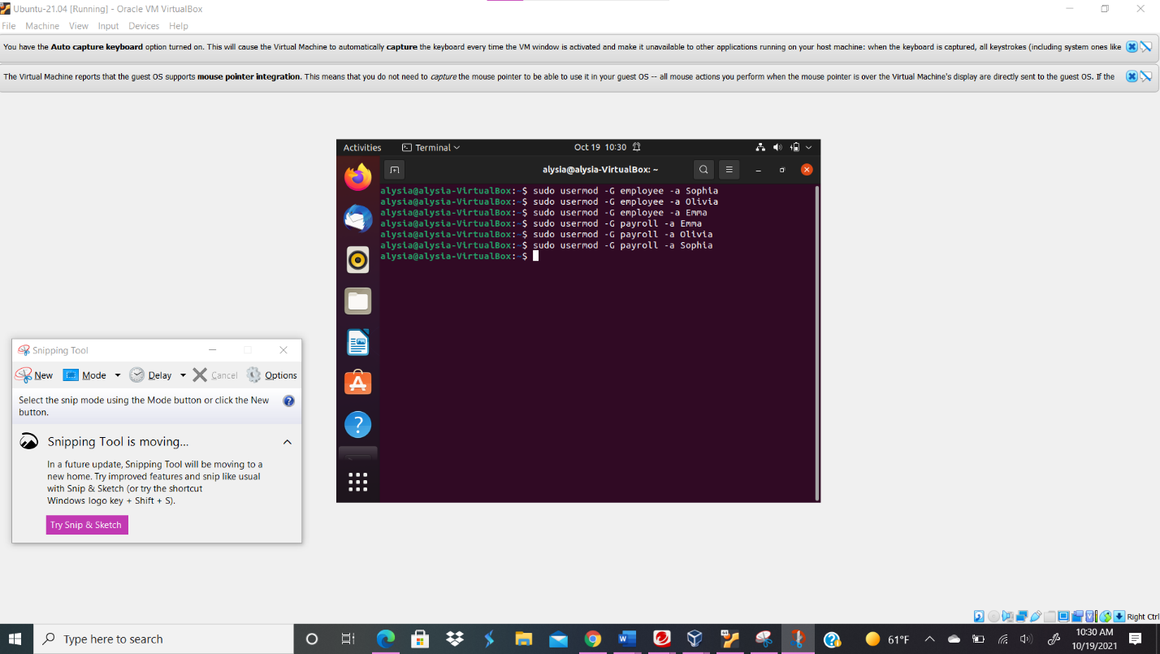
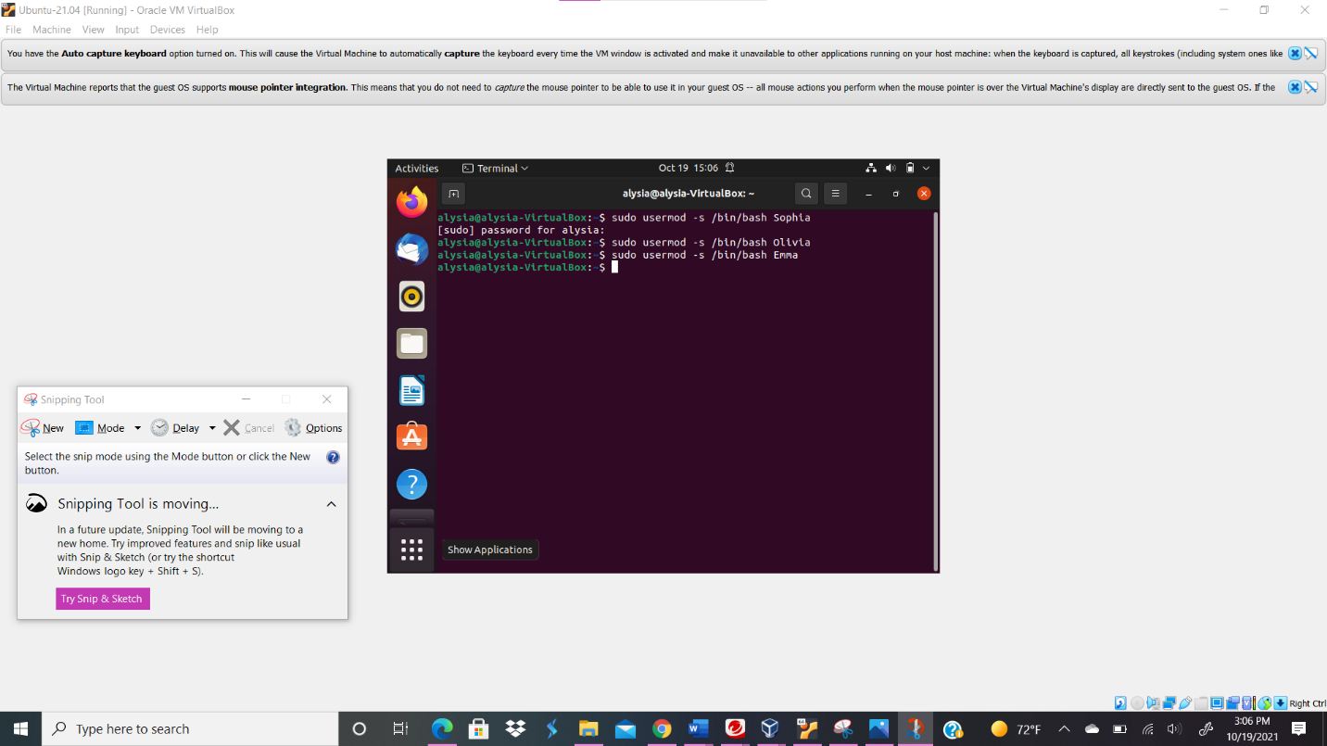
Your explanation goes here. For example:
In order to create Sophia user account with a specified home directory, I typed the command sudo useradd -m -k /etc/skel Sophia. The -m command enables me to create a user’s home directory and /etc/skel allows me to create a default home directory, while useradd enables me to create user accounts. I typed the same command to create a user account with a specified home directory for Emma and Olivia too. Then, created passwords. In order to set Sophia, Emma, and Olivia to the primary group employee,payroll, and admin, I typed the command sudo usermod -G (groupname) -a (user account). The -G appends the user to a specific group while -a appends. For instance sudo usermod -G employee -a Sophia puts the user account Sophia in the employee group. Then I typed the command sudo usermod -s /bin/bash Sophia in order to change the user Sophia’s login shell. I typed the same command for Olivia and Emma by changing the user account Sophia to their respective user account names.
- Create a shared group called "your_midas" (replace it with your MIDAS ID) and set this shared group as the above accounts' secondary group.
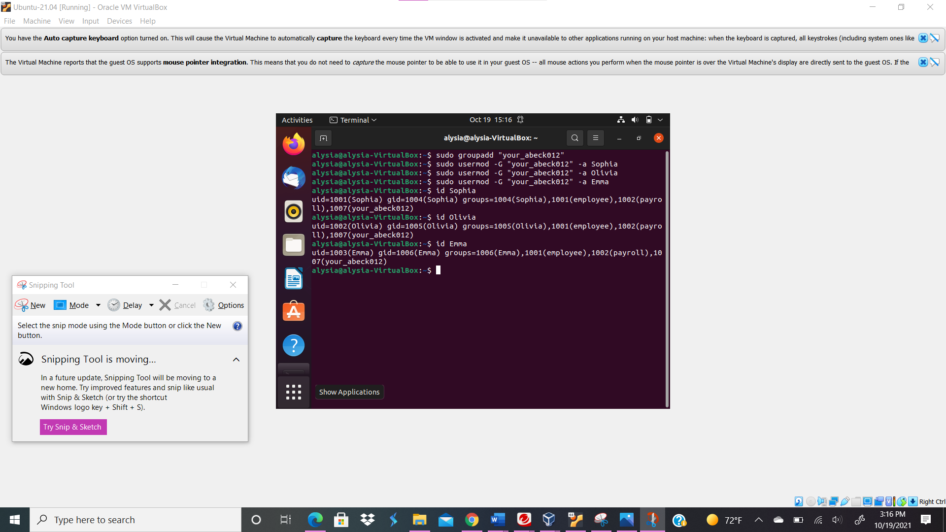
Your explanation goes here. For example:
I created a shared group called “your_abeck012” by typing the command sudo groupadd “your_abeck012”. Then, I typed the command sudo usermod -G “your_abeck012” -a Sophia to make the “your_abeck012” shared group Sophia’s secondary group. I typed the same command for Emma and Olivia too; sudo usermod -G “your_abeck012” -a Emma and sudo usermod -G “your_abeck012” -a Olivia. In order to check user’s group profile, I typed the command id Sophia and saw that she was in all the groups I put her in; same for Olivia and Emma.
- Create a directory named /home/cyse_project, which to be owned by the group, your_midas.
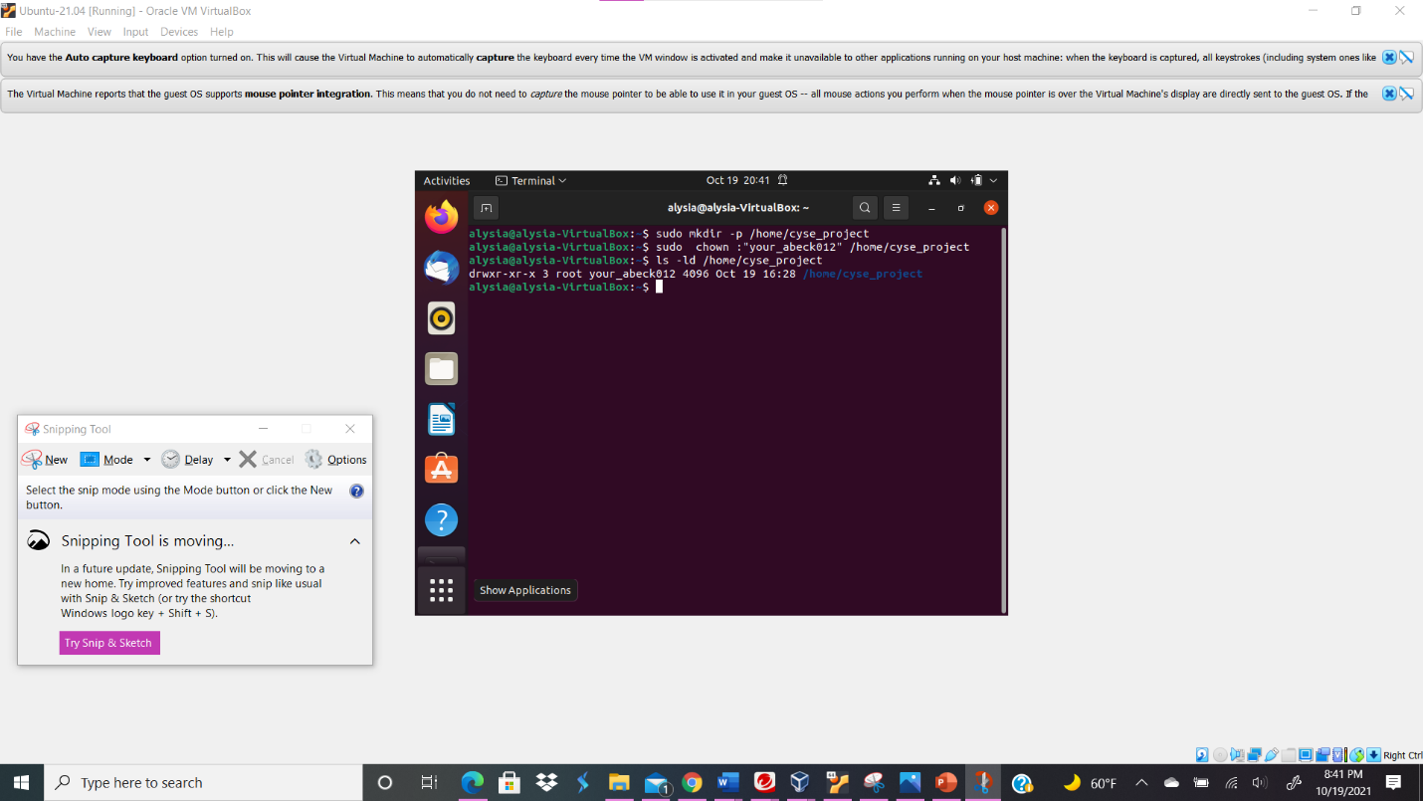
Your explanation goes here. For example:
I typed the command sudo mkdir -p /home/cyse_project in order to create a directory. The mkdir -p command can create subdirectories. The sudo chown : “your_abeck012” /home/cyse_project command enables the “your_abeck012” group to own the directory /home/cyse_project. In order to check the permission of the directory I typed the command ls -ld /home/cyse_project.
- Change the permissions of the /home/cyse_project directory to "drwxrwx---" so that only the project group members have access to this directory.
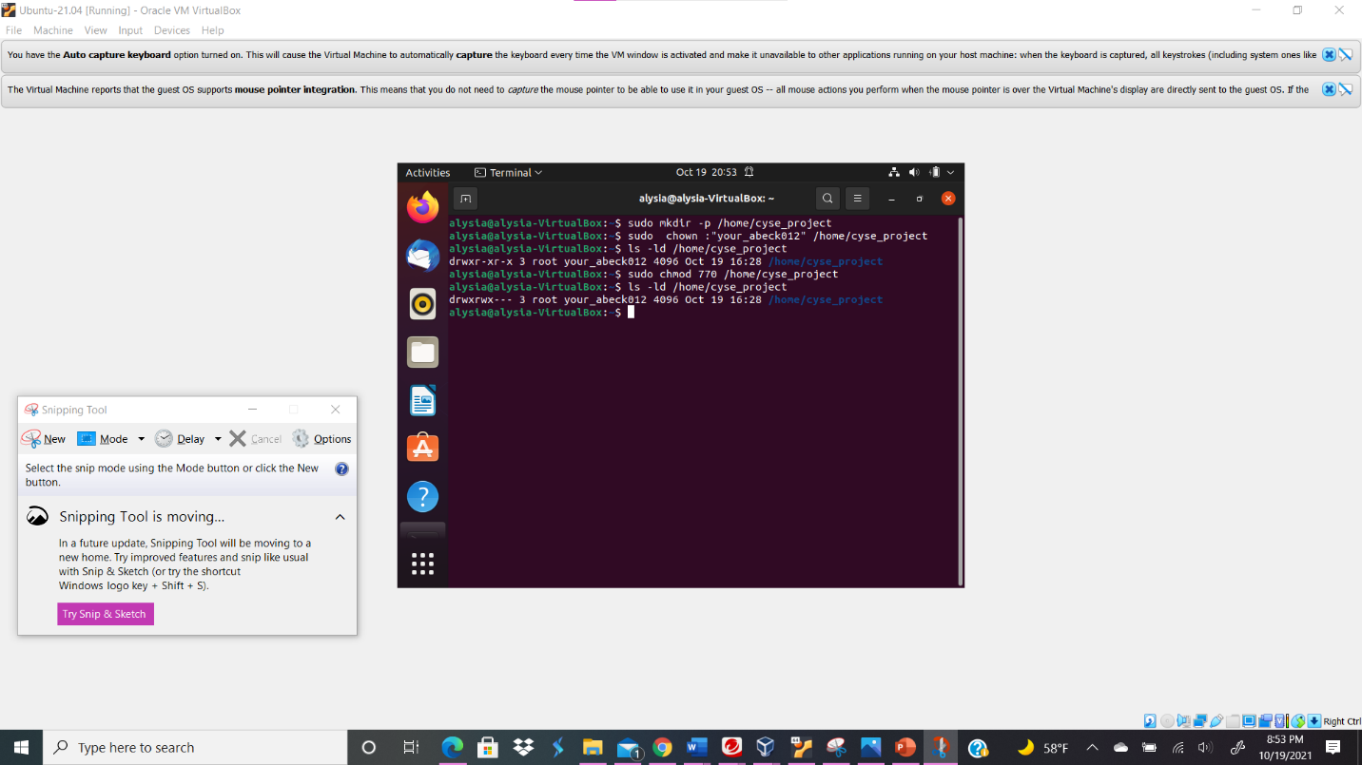
Your explanation goes here. For example:
I typed the command sudo chmod 770 /home/cyse_project to drwxrwx, so that only project group members have access to the directory; this gives owner and group full permission.
- Switch to Sophia's account. Change the default permissions to "-rw-r-----" for Sophia when she creates a file or directory. Check the value of umask, and permission of a new file after this step.
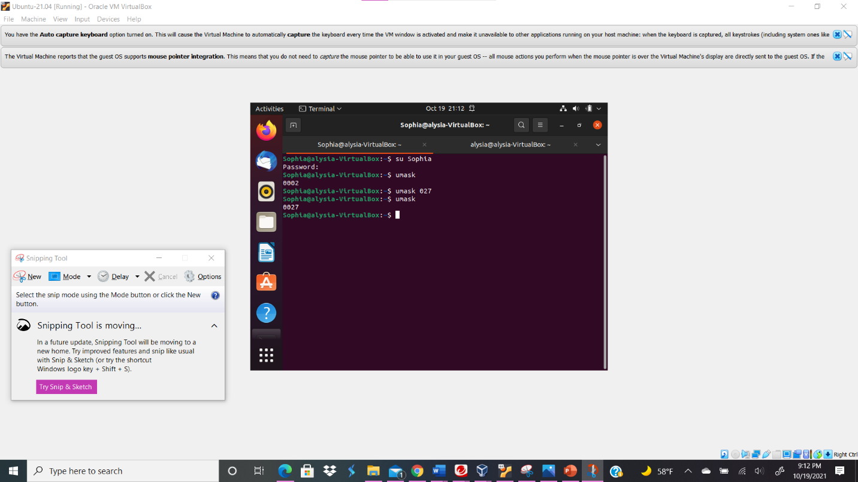

Your explanation goes here. For example:
First, I switch the user account by typing su Sophia. Then, I change the default permissions to "-rw-r-----" for Sophia when she creates a file or directory by typing thr command umask 027. Group has write permission removed while all other users have all permissions removed.Then, I check the value of umask by typing umask in the terminal.
- Create a new file called "Sophia_homework" in the home directory and put your name in the file. After this step, remember to check the content and the permission of the new file.
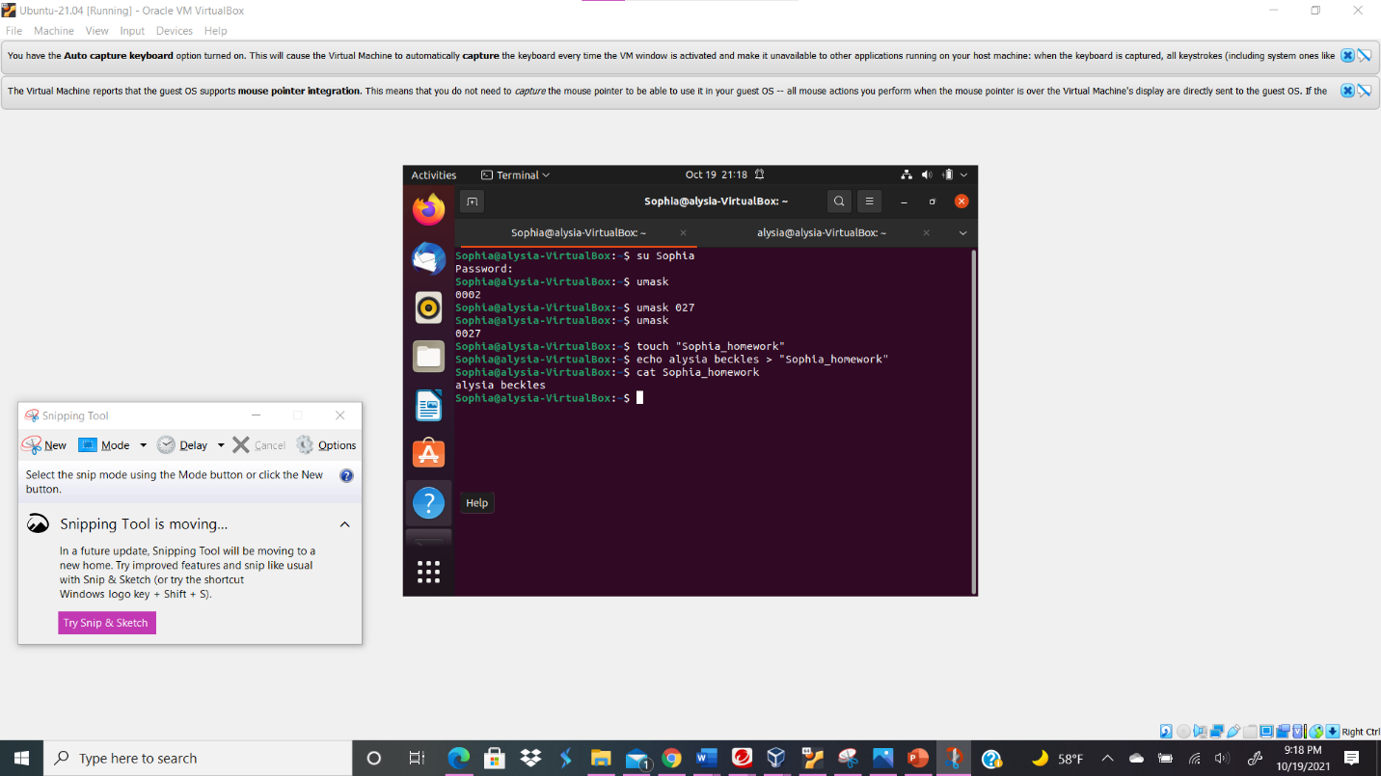
Your explanation goes here. For example:
In order to create a new file in the home directory, I typed the command touch “Sophia_homework”. Then, I typed echo alysia beckles > “Sophia_homework” to put my name in the file. I type the command cat Sophia_homework to see that the content in the file is alysia beckles.
- Copy "Sophia_homework" to the /home/cyse_project directory. After this step, remember to check the permission of the file in the shared directory.
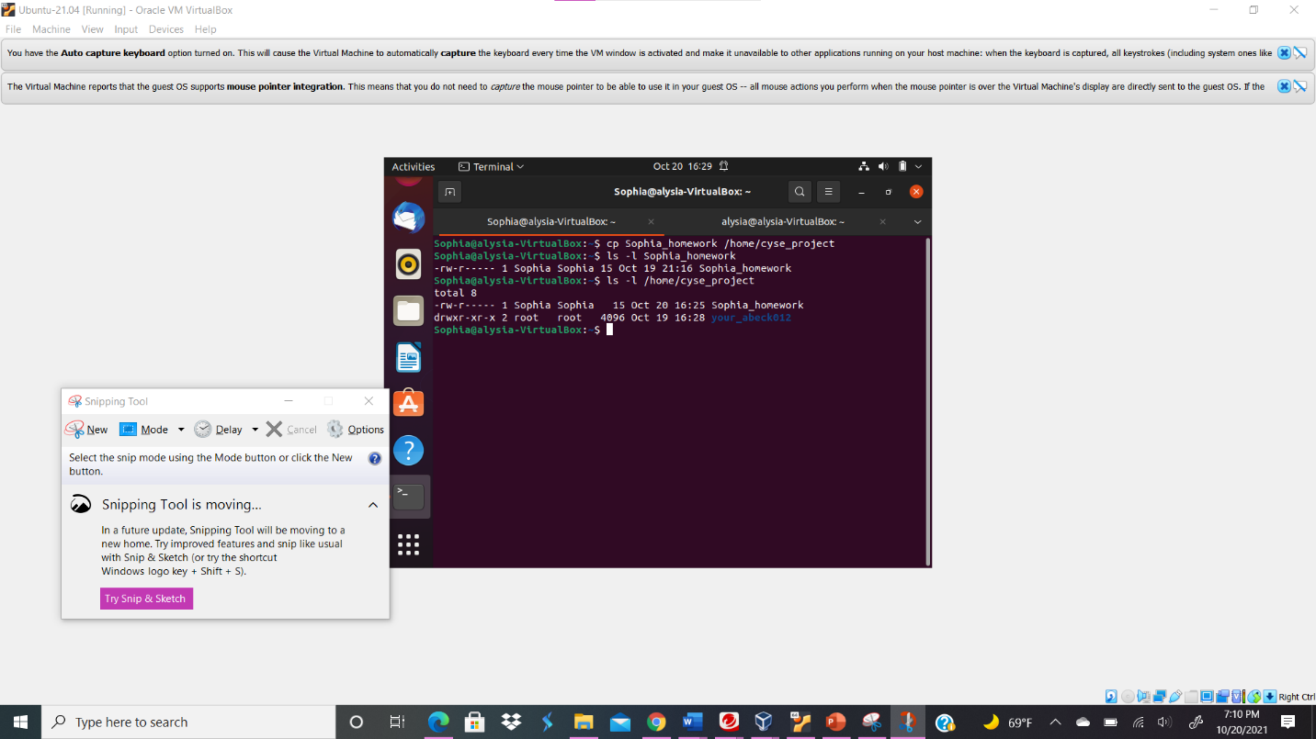
Your explanation goes here. For example:
I typed the command cp Sophia_homework /home/cyse_project to copy the file in the directory. Then I typed the command ls -l /home/cyse_project to see the permissions of the Sophia_homework file in the directory.
- Switch to Emma's account. Try to read "Sophia_homework" in the /home/cyse_project directory.
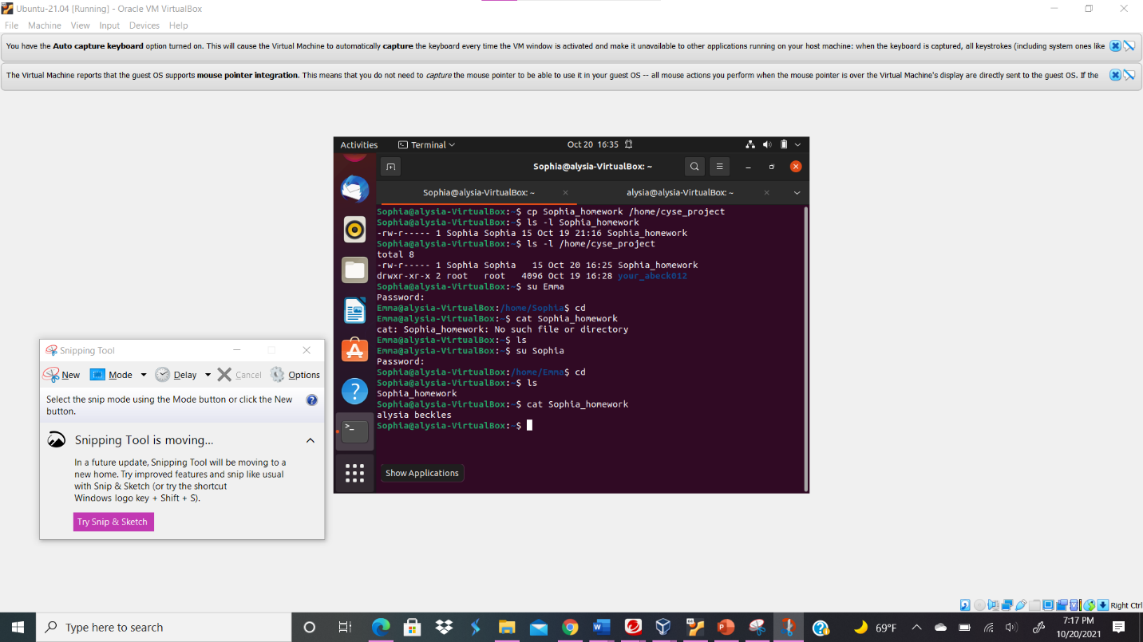
Your explanation goes here. For example:
I typed the command su Emma to switch to Emma’s user account. Then, I typed the command cat Sophia_homework and saw that I could not read the file from the user account Emma.
Task B
- Switch to root account. To allow group members to access this file, you need to fix the sharing issue by setting the correct SGID group values to give the group user read permission.
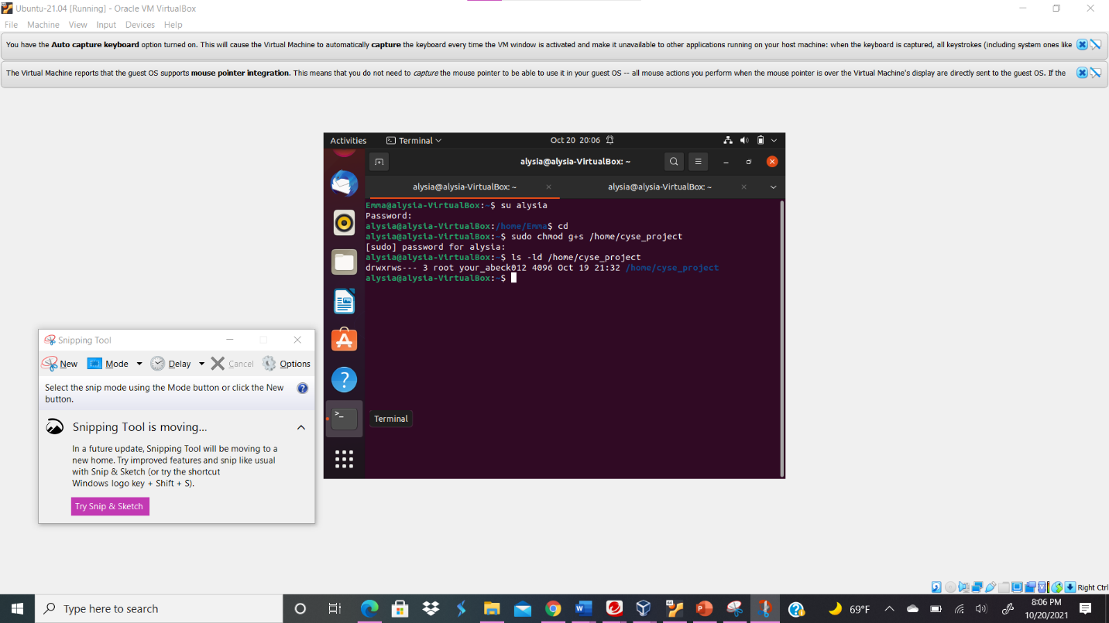
Your explanation goes here. For example:
I typed su alysia in order to allow group members to access files. Then, I typed the command sudo chmod g+s /home/cyse_project to give SGID group values that gives group users read permission (chmod g+s).
- Switch to Sophia's account. Copy "Sophia_homework" to the /home/cyse_project directory as "Sophia_homework2".
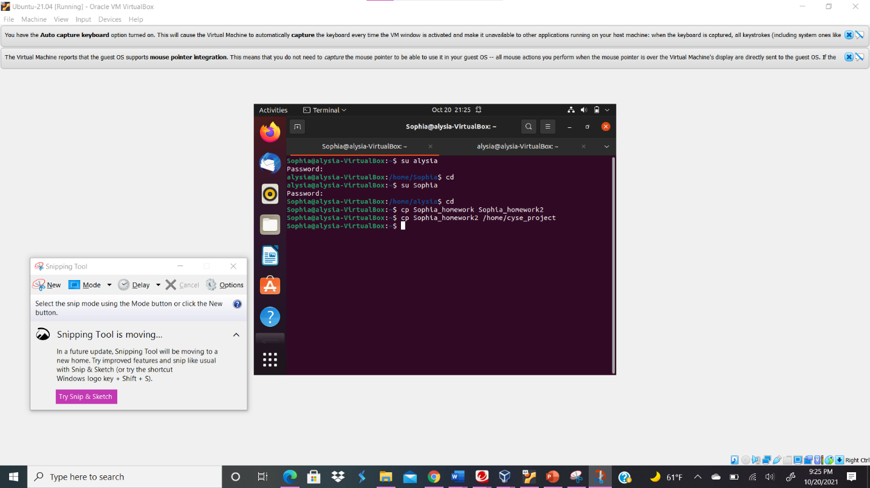
Your explanation goes here. For example:
I switched to Sophia’s account by typing su Sophia. Then, I typed cp Sophia_homework Sophia_homework2 to copy the content from Sophia_homework to Sophia_homework2. Finally, I typed the command cp Sophia_homework2 /home/cyse_project in order to copy the file to /home/cyse_project directory.
- Switch to Emma's account. Try to read "Sophia_ homework2" in the /home/cyse_project directory.
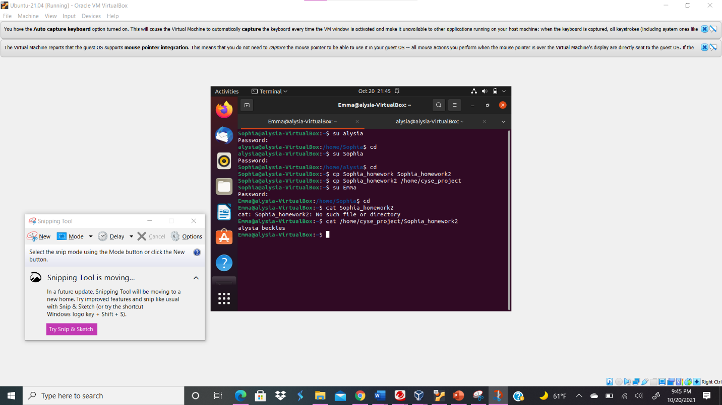
Your explanation goes here. For example:
I typed the command su Emma to switch to Emma’s account. Then I typed the command cat /home/cyse_project/Sophia_homework2 to read the file from the /home/cyse_project in Emma’s account; I could read the contents in the file too.
Task C
- Switch to root account. To disallow group members to access the files in this folder, you need to fix the sharing issue by setting the correct SGID group values to remove the group user read permission.
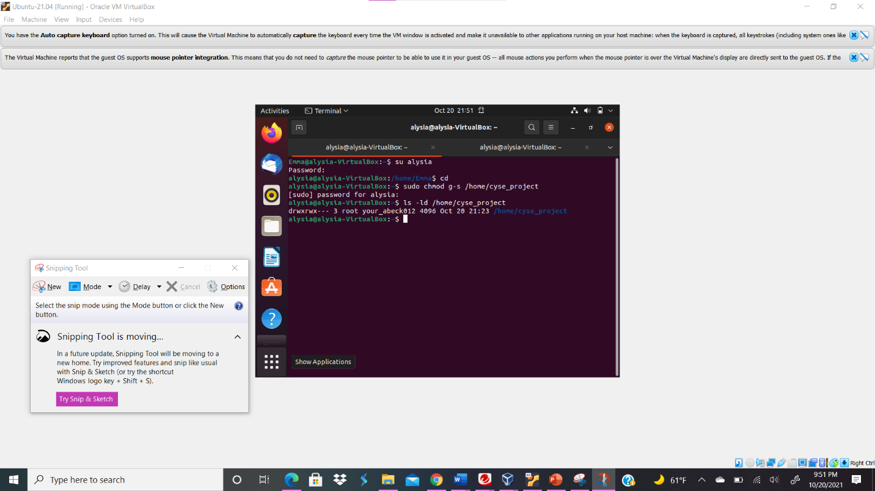
Your explanation goes here. For example:
I typed su alysia in order to disallow group members to access files. Then, I typed the command sudo chmod g-s /home/cyse_project to give SGID group values that remove the group users read permission (chmod g-s).

- Switch to Sophia's account. Copy "Sophia_homework" to the /home/cyse_project directory as "Sophia_homework3".
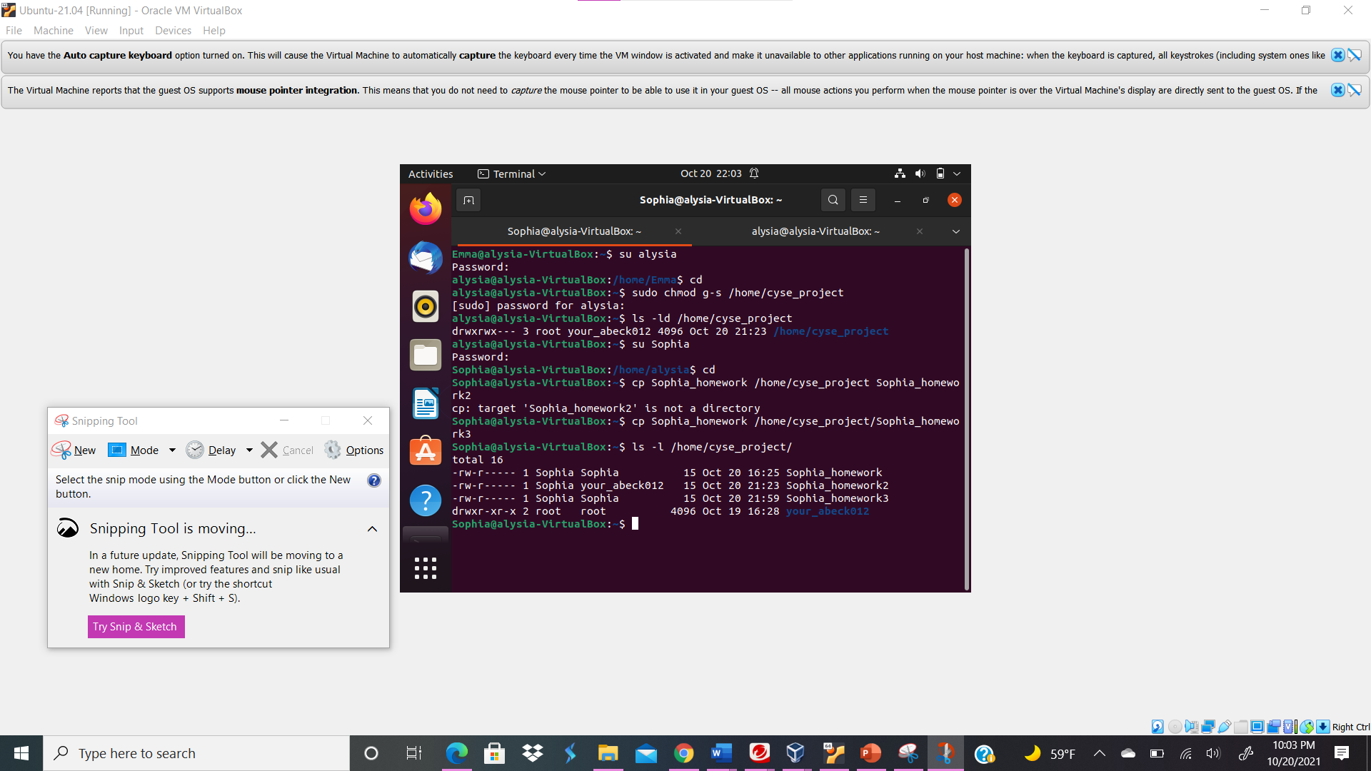
Your explanation goes here. For example:
I switched to Sophia’s account by typing su Sophia. Then, I typed cp Sophia_homework /home/cyse_project/Sophia_homework3 to copy the content from Sophia_homework to Sophia_homework3 and to copy the file to /home/cyse_project directory. Then ls -l command /home/cyse_project/ shows the list of files under the /home/cyse_project directory.
- Switch to Olivia's account. Try to read "Sophia_home3" in the /home/cyse_project directory.
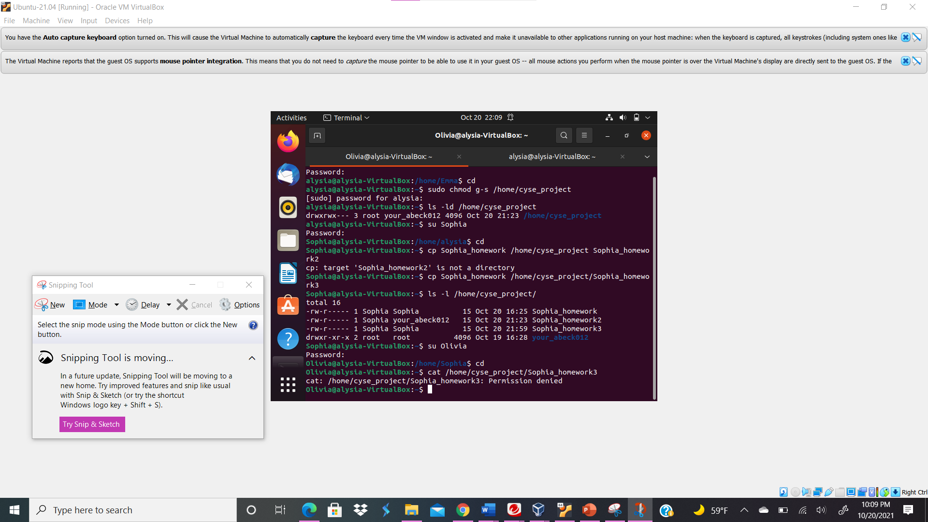
Your explanation goes here. For example:
I switched the user account to Olivia by typing su Olivia. Then, I typed the command cat /home/cyse_project/Sophia_homework3 to see if I can read the file in the user account, Emma; I could not read the contents in the file.

