Old Dominion University
CYSE 270 Linux System for Cybersecurity
Assignment #7 Manage local storage

Alysia Beckles
01127384

Below is the snippet of a sample lab report.
Part I
- Execute the ls /dev/sd* command to see the current hard disk devices.
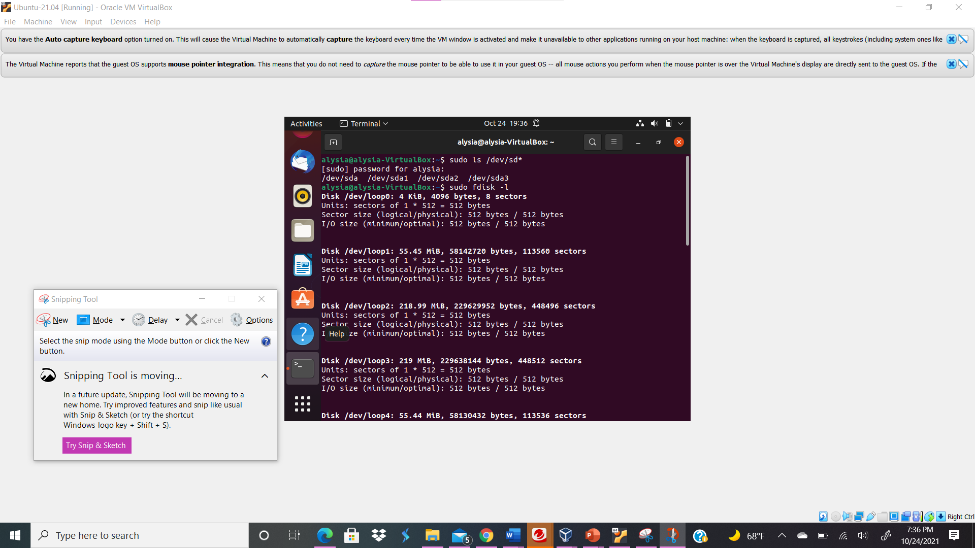

Your explanation goes here. For example:
I utilized the sudo ls /dev/sd* command in order to see the current hard disk devices; there was only four hard disk drives present.
- Execute the fdisk -l command to list the current hard disk partitions.
Your explanation goes here. For example:
I typed the command sudo fdisk -l in order to see the current hard disk partitions; I did not see a partition that I created.
- Execute the parted -l command to list the current hard disk partition table.
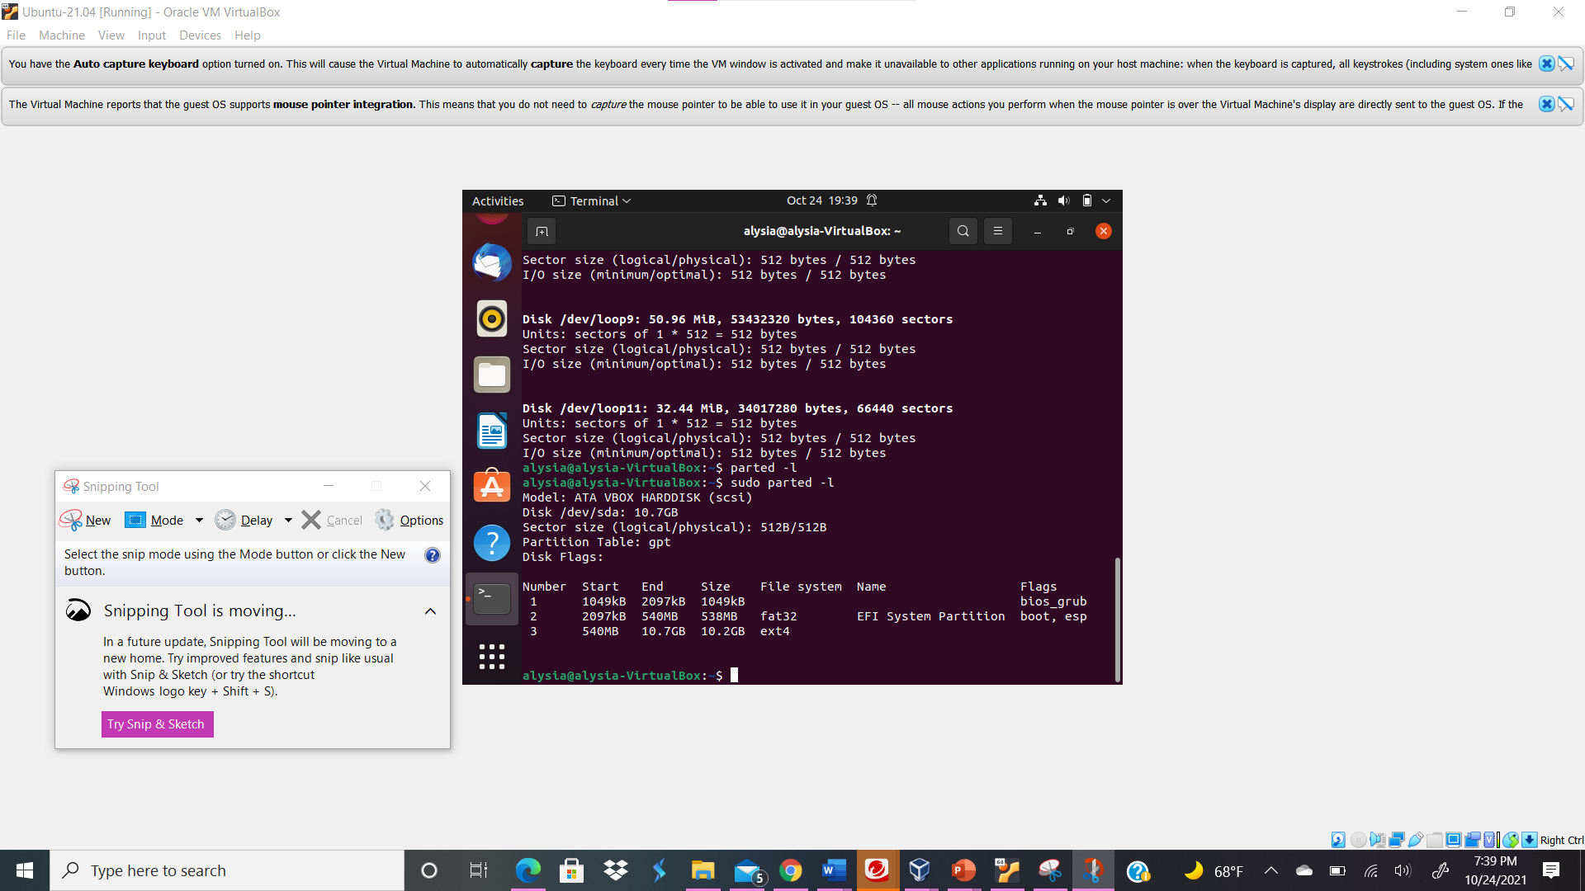
Your explanation goes here. For example:
I typed the command sudo parted -l in order to see the current hard disk partition table; The only hard disk shown was /dev/sda and three partitions from that specific hard disk with filesystems.
Part II

- In the Oracle VM VirtualBox setting, attaching a new virtual hard disk with the size of 200 MB to your current Linux VM. Name it as “your_midas.vdi”
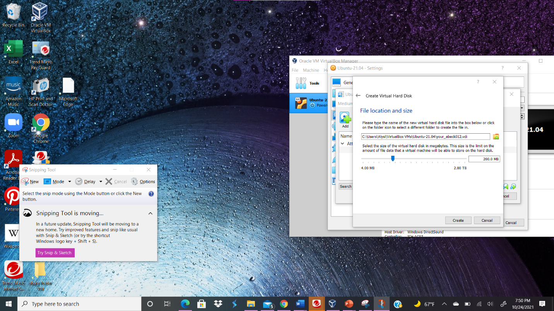
Your explanation goes here. For example:
I created a new virtual hard disk with the size of 200 MB to my current Linux Oracle in VM VirtualBox by configuring the settings with the name your_abeck012.vdi.
- Load this virtual hard disk to your virtual machine.
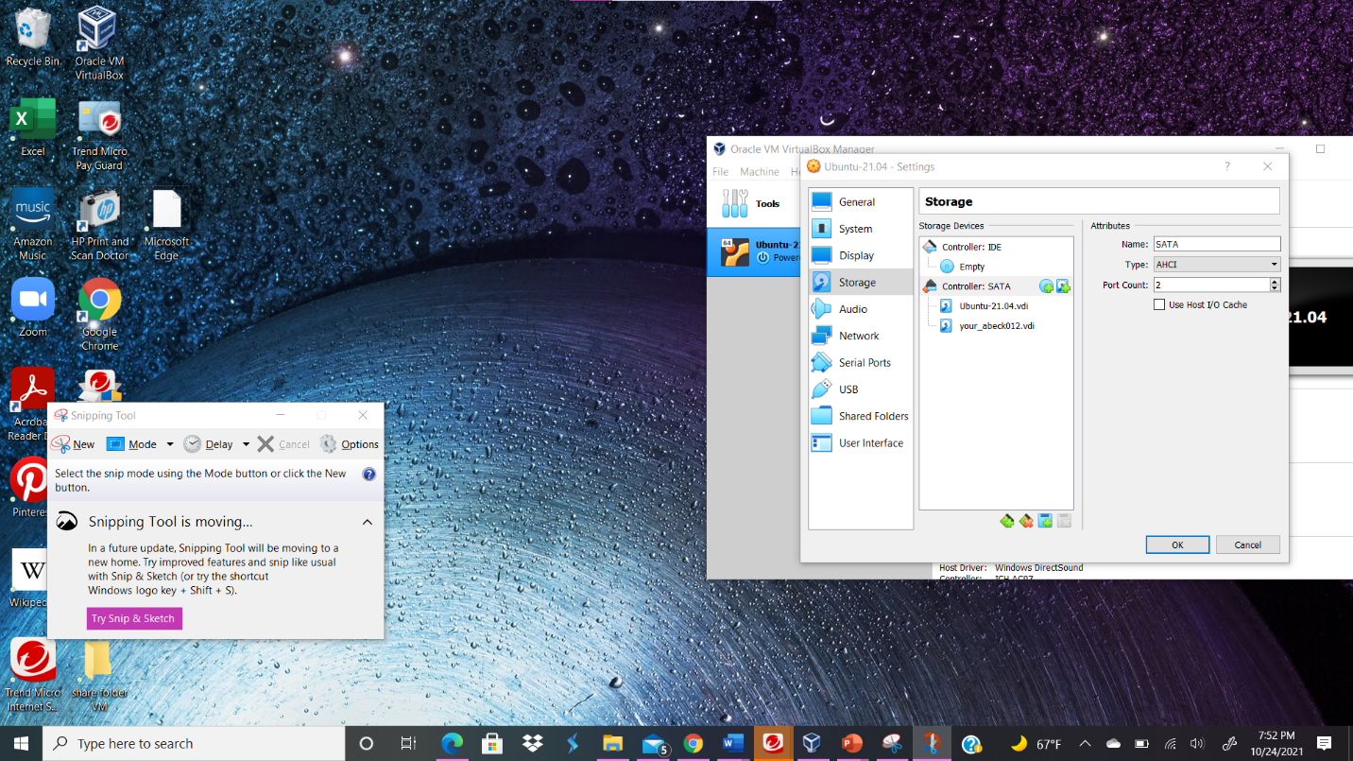
Your explanation goes here. For example:
I loaded the virtual hard disk to my virtual machine by clicking create and clicking the specific virtual hard disk, then click ok to save the virtual hard disk.
- Repeat the steps in Part I, and highlight the differences with the new virtual hard disk.
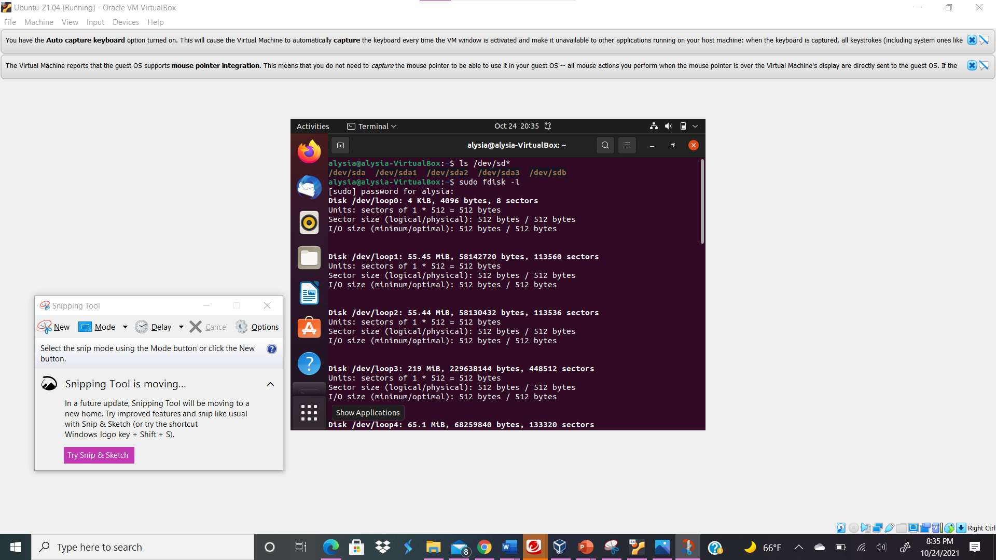
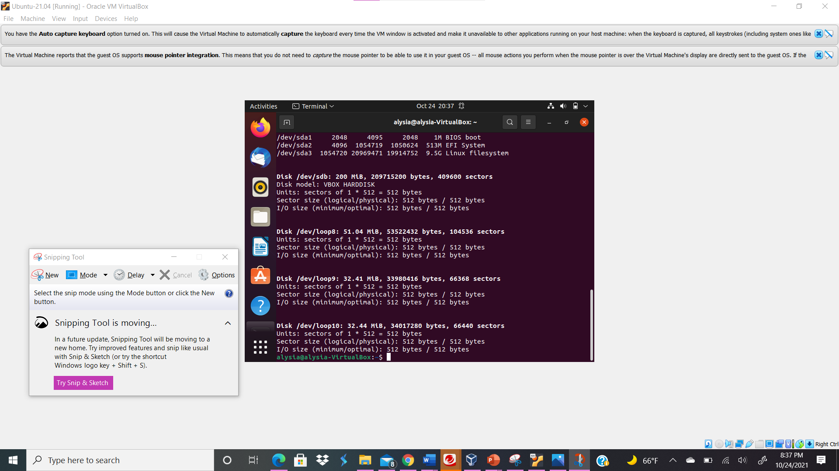
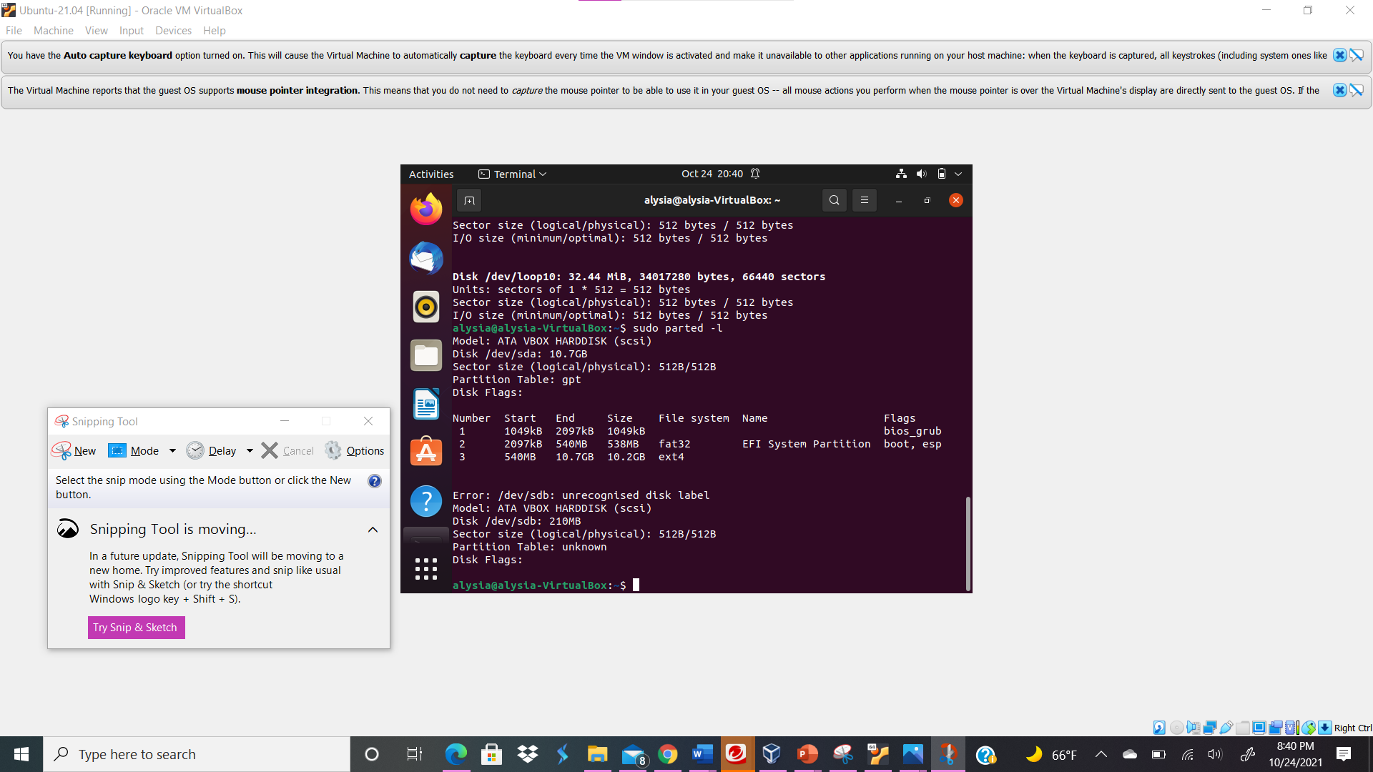
Your explanation goes here. For example:
I utilized the sudo ls /dev/sd* command in order to see the current hard disk devices; now I can see the new virtual hard disk that I created along with the four hard disk drives present and highlighted; /dev/sdb. Next, I typed the command sudo fdisk -l in order to see the current hard disk partitions; I did see the the virtual hard disk that I created /dev/sdb but I did not see any partitions. Next, I executed the parted -l command to list the current hard disk partition table; I seen the new virtual hard disk I created, /dev/sdb but did not see a filesystem nor a partition.
Part III

- Use the fdisk command to create a new primary partition on the new virtual hard disk attached in Part II.
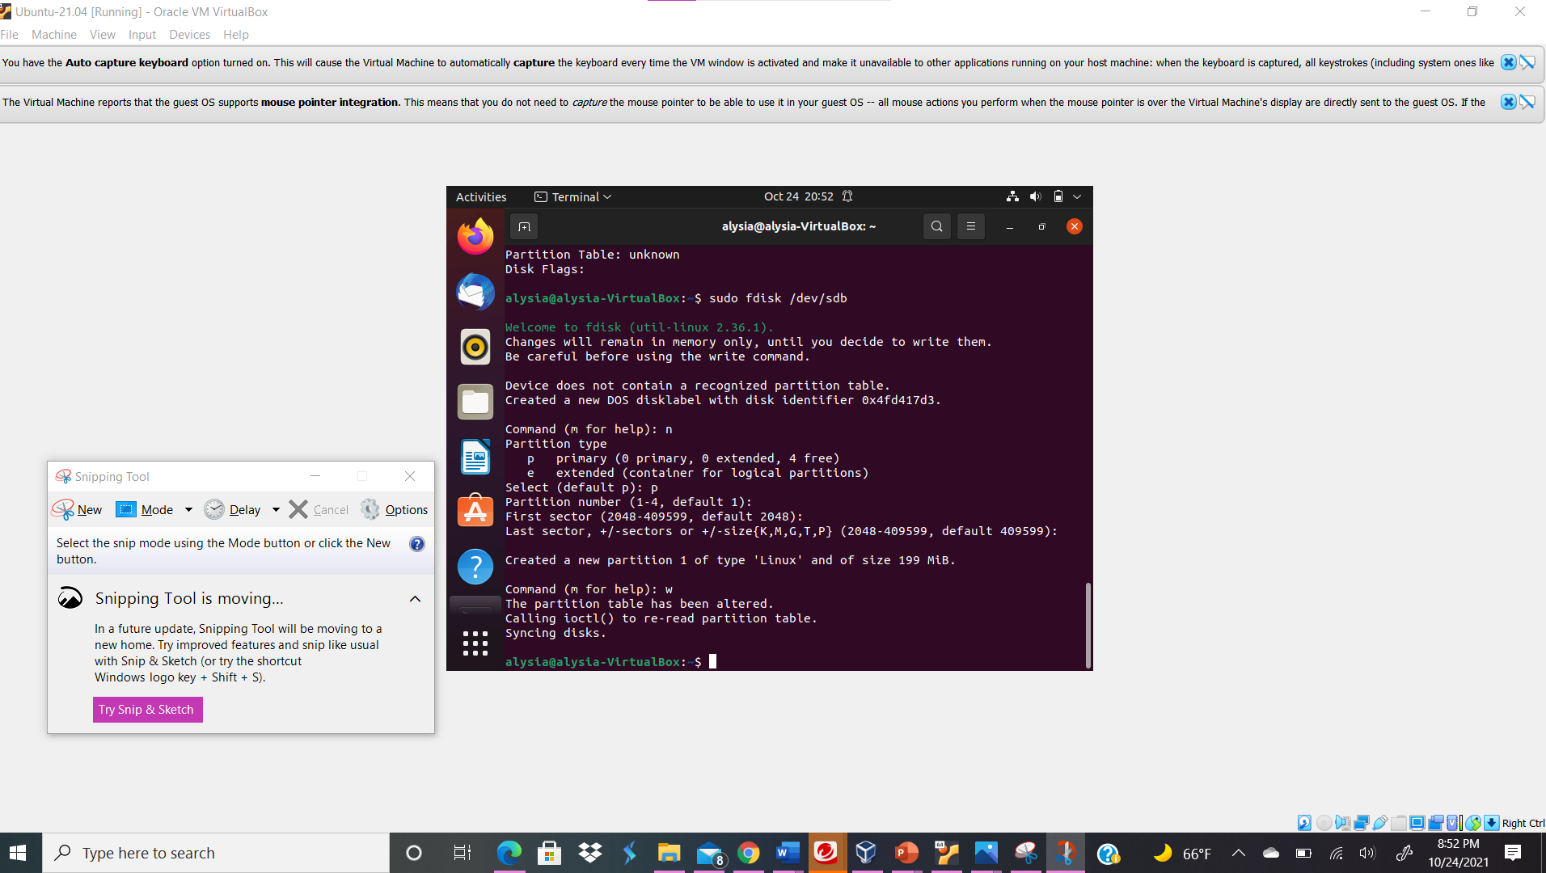
Your explanation goes here. For example:
I typed the command sudo fdisk /dev/sdb in order to create a new primary partition on the new virtual hard disk /dev/sdb. I typed “n” to create a partition in the terminal. Then I typed “p” to create a new primary partition. Then I pressed enter to create the partition on default 1.
- Use the correct command to create an ext4 filesystem on the new partition.
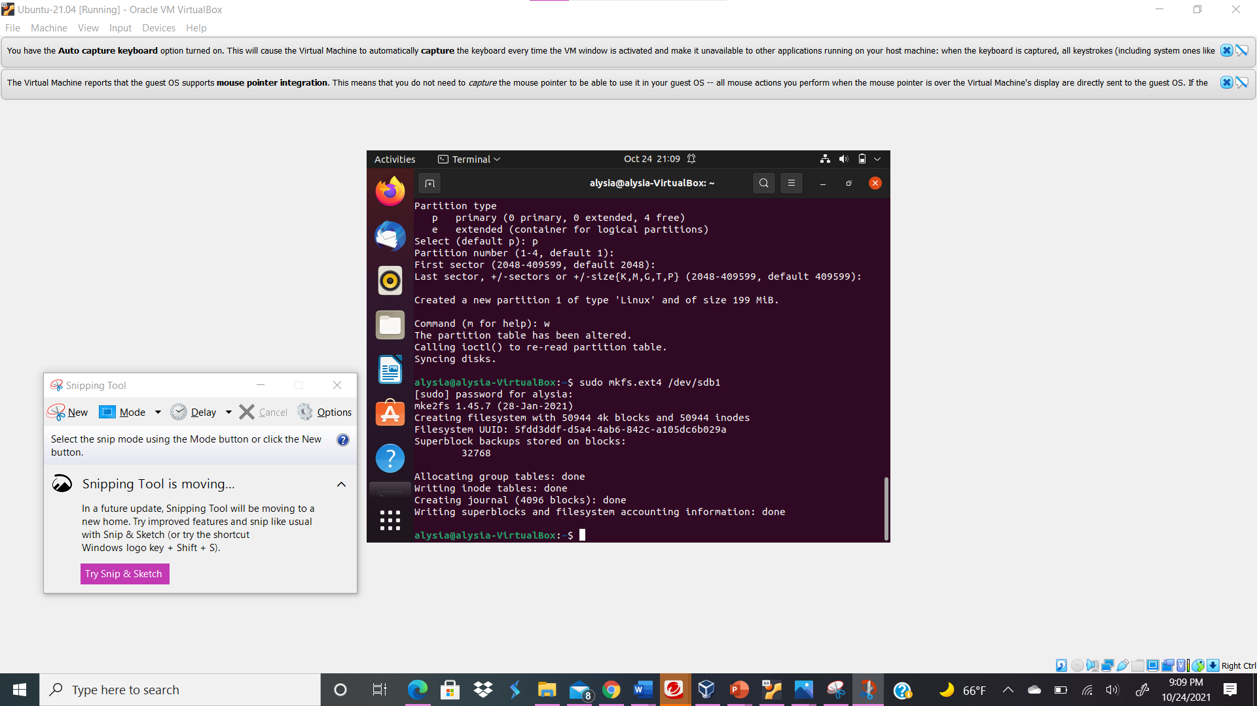
Your explanation goes here. For example:
I typed the command sudo mkfs.ext4 /dev/sdb1 in order to create a ext4 filesystem on the new partition that I created in the previous question.
- Repeat the steps in Part I, and highlight the differences.
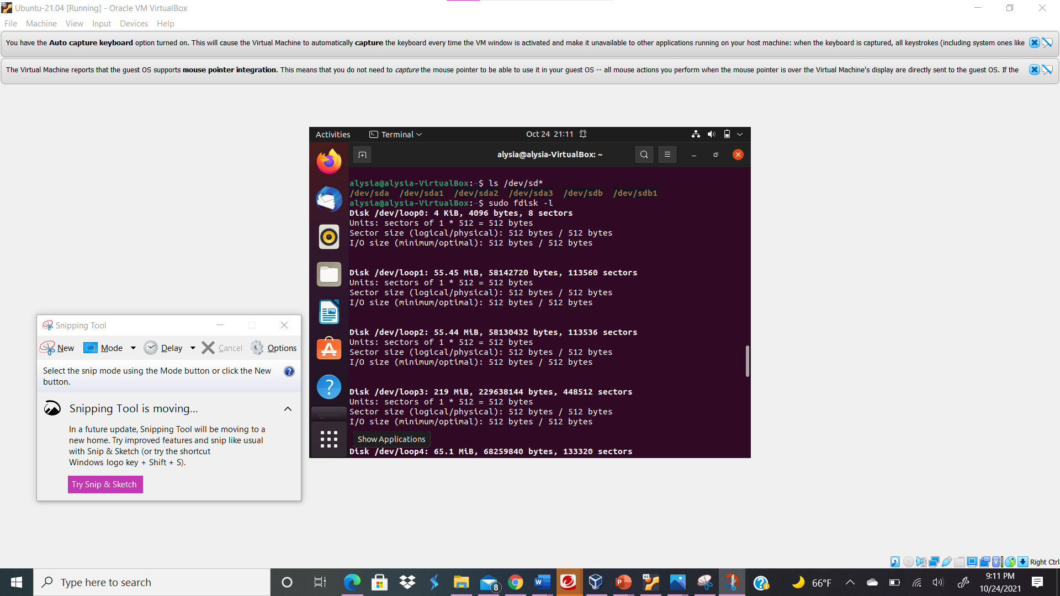
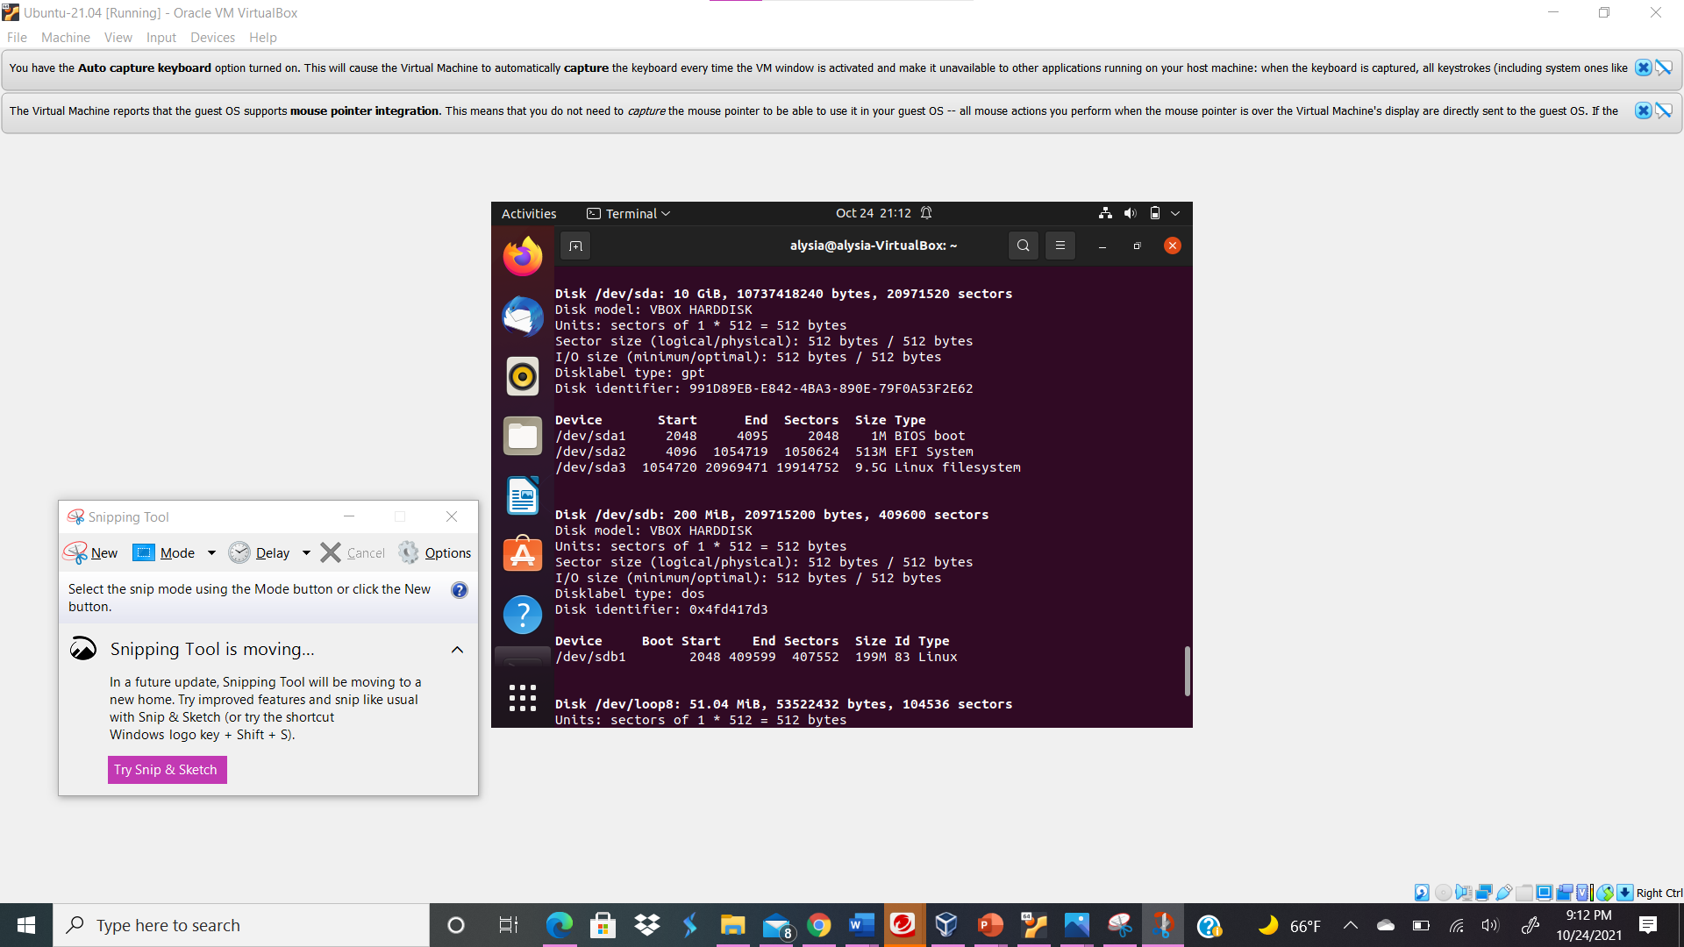
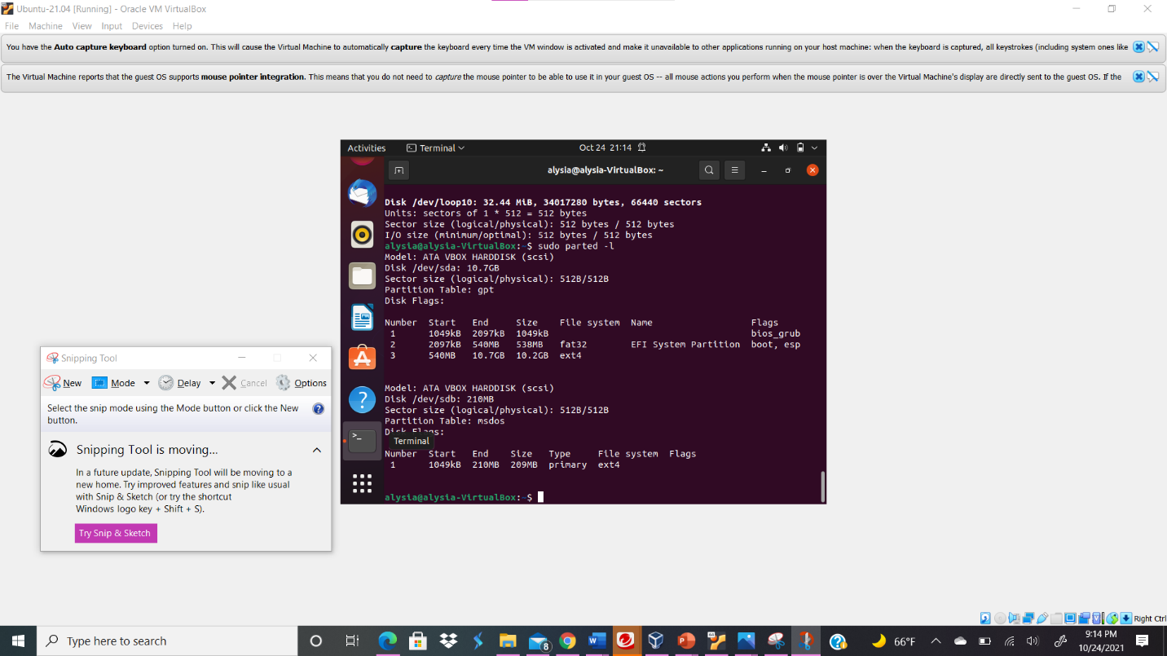
Your explanation goes here. For example:
Above I utilized the sudo ls /dev/sd* command in order to see the current hard disk devices; now I can see the new virtual hard disk that I created along with the four hard disk drives present and highlighted; /dev/sdb and the device /dev/sdb1. Next, I typed the command sudo fdisk -l in order to see the current hard disk partitions; I did see the the virtual hard disk that I created /dev/sdb and saw the new partition That I created /dev/sdb1 device under the /dev/sdb virtual hard disk. Next, I executed the parted -l command to list the current hard disk partition table; I seen the new virtual hard disk I created, /dev/sdb and the filesystem ext 4, and the number of partitions on the virtual hard disk I created, 1, and type of partition, primary.
- Make a new directory named /cyse. And mount the new partition under this directory.
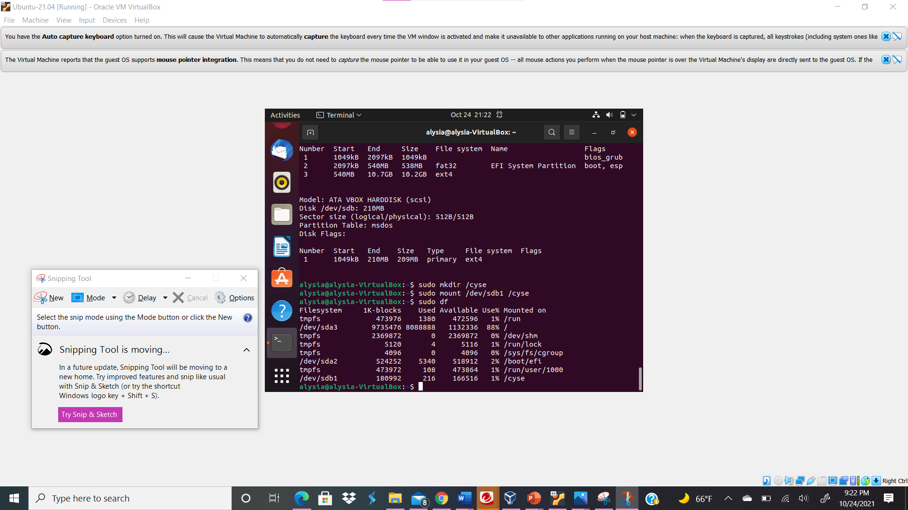
Your explanation goes here. For example:
I created a new directory named /cyse by typing the command sudo mkdir /cyse. Then I typed the command sudo mount /dev/sdb1 /cyse in order to mount the new partition under this directory.
- Use the df command to check the mounting point of the new partition.
Your explanation goes here. For example:
Above I used sudo df command to check the mounting point of the new partition
- Create a new file named forYourMIDAS.txt (replace YourMIDAS with your MIDAS ID) in the directory /cyse and put your name in that file.
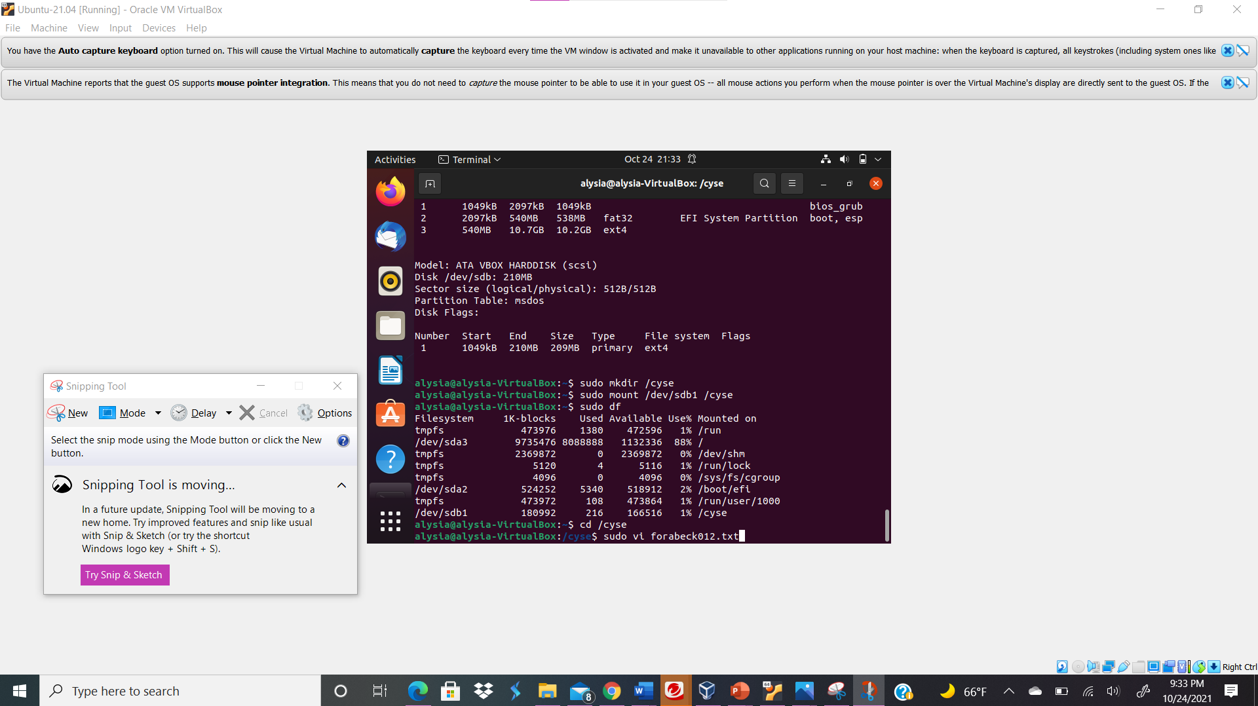
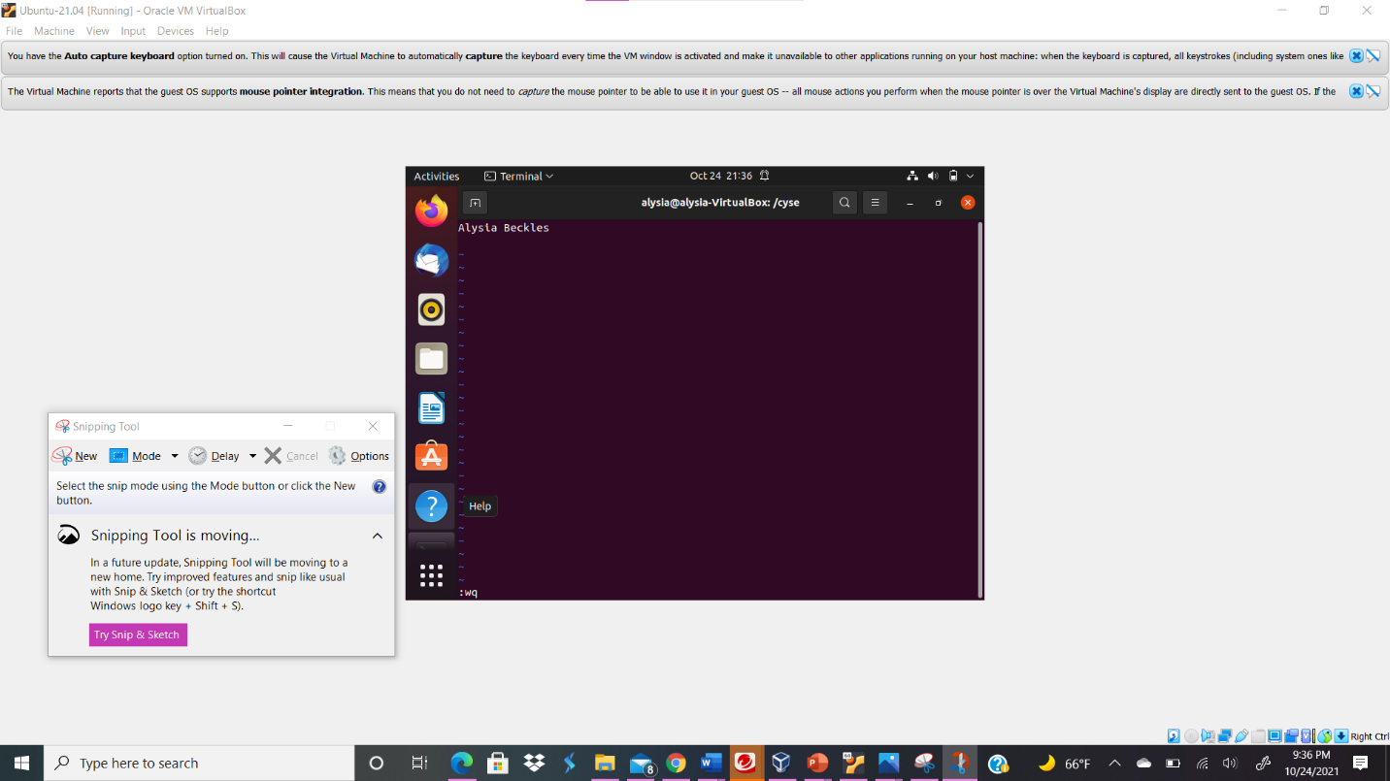
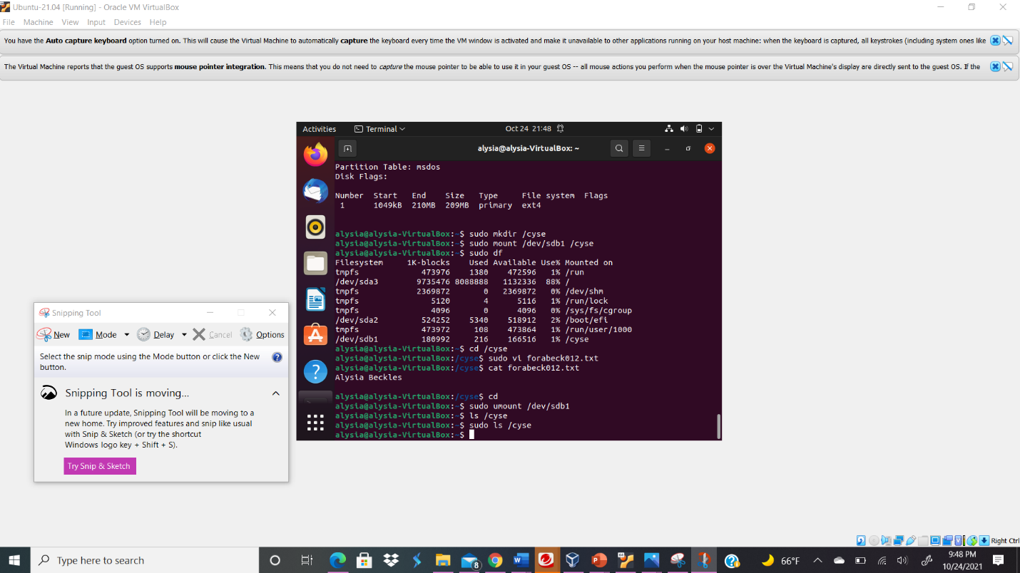
Your explanation goes here. For example:
First I typed the cd /cyse command in order to change the directory to cyse and create a file under the directory. Then, I typed the command sudo vi forabeck012.txt in order to create the file and write inside the file.
- Unmount /cyse directory.
Your explanation goes here. For example:
Above I typed the command cd to go to the root directory. Then I typed the command sudo unmount /dev/sdb1 in order to unmount the /cyse directory.
- Check the contents in /cyse directory. What do you find?
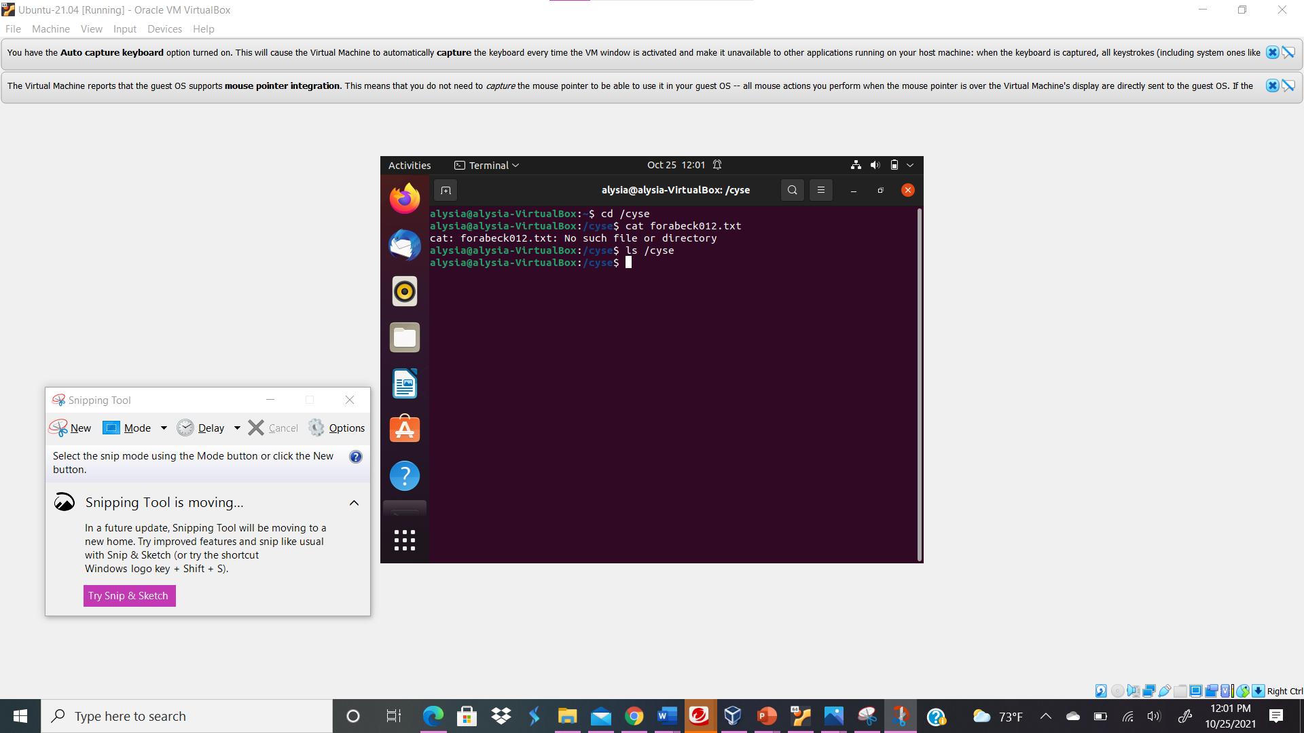
Your explanation goes here. For example:
The file does not exist.

