Old Dominion University
CYSE 301 Cybersecurity Techniques and Operations
Assignment #M4.1 Linux Password Cracking

Alysia Beckles
01127384

Below is the snippet of a sample lab report.
Task A
- Create two groups, one is cyse301f21, and the other is your ODU Midas ID (for example, pjiang). Then display the corresponding group IDs.
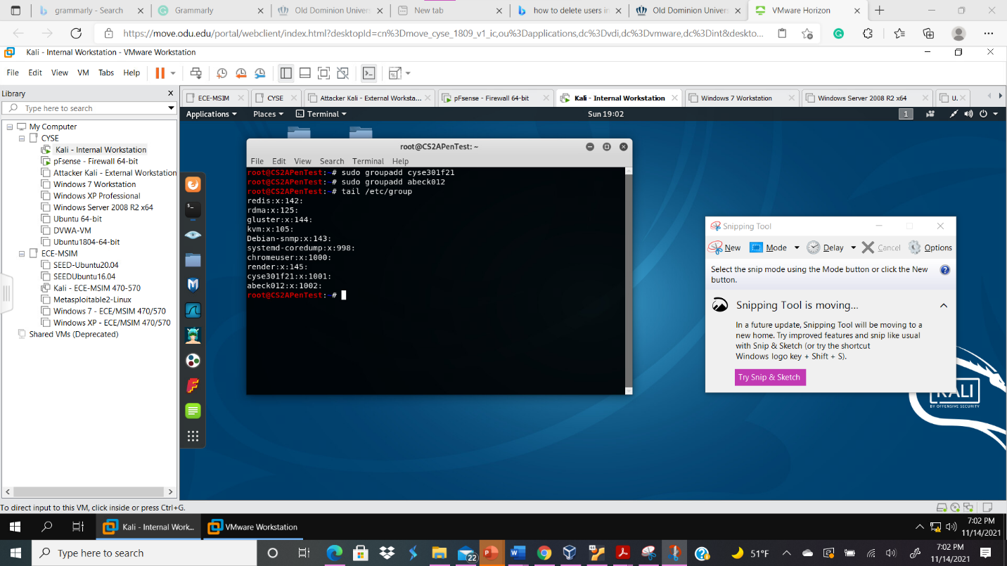

Your explanation goes here. For example:
Above I type the command sudo groupadd cyse301f21 in order to create a new group with the name cyse301f2. Then, I created another group with the command sudo groupadd abeck012 to create a group named after my MIDAS. Next, I type the command tail /etc/group to see the last few lines of the group file.
- Create and assign three users to each group. Display related UID and GID information of each user.
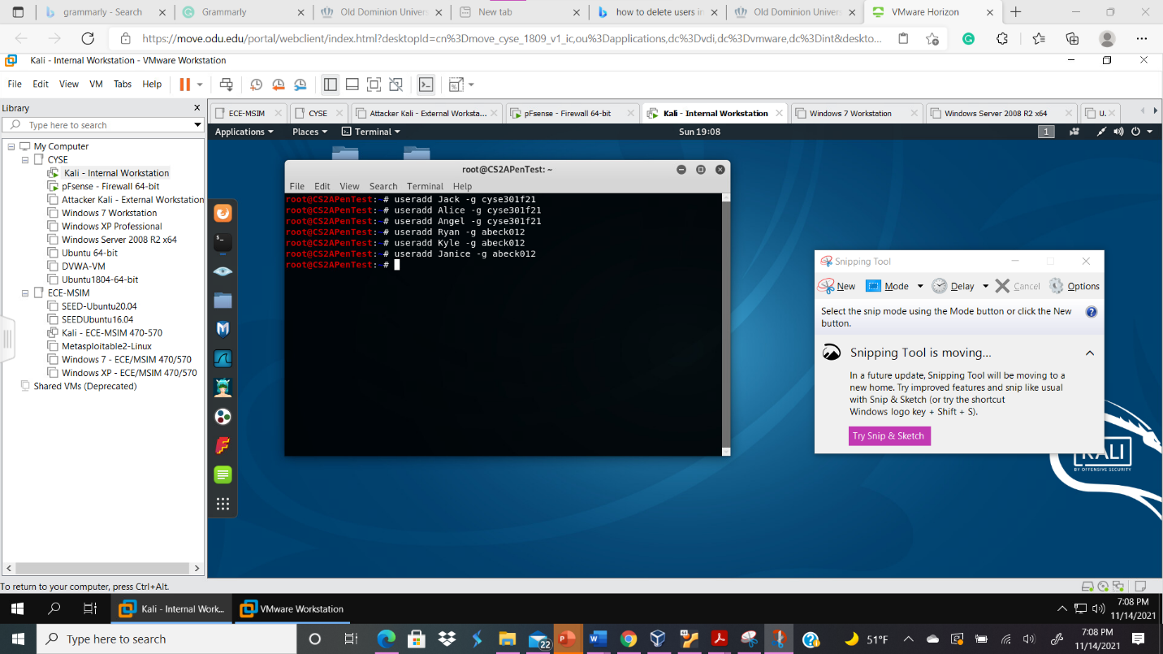
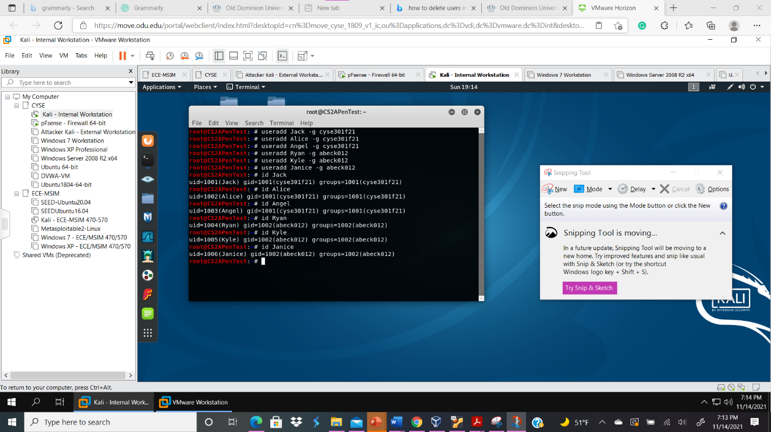
Your explanation goes here. For example:
Above I typed the command useradd username -g cyse301f21 three times in order to add a username to the group cyse301f21. Next, I typed the command useradd username -g abeck012 three times in order to assign three different usernames to the new group that I created abeck012. Next, I type the if username command such id Jack to see the user id (UID) and group id (GID); the UID is Jack while the GID is cyse301f21.
- Choose six passwords, from easy to hard, and assign them to the users you created. You need to show me the password you selected in your report, and DO NOT use your real-world passwords.
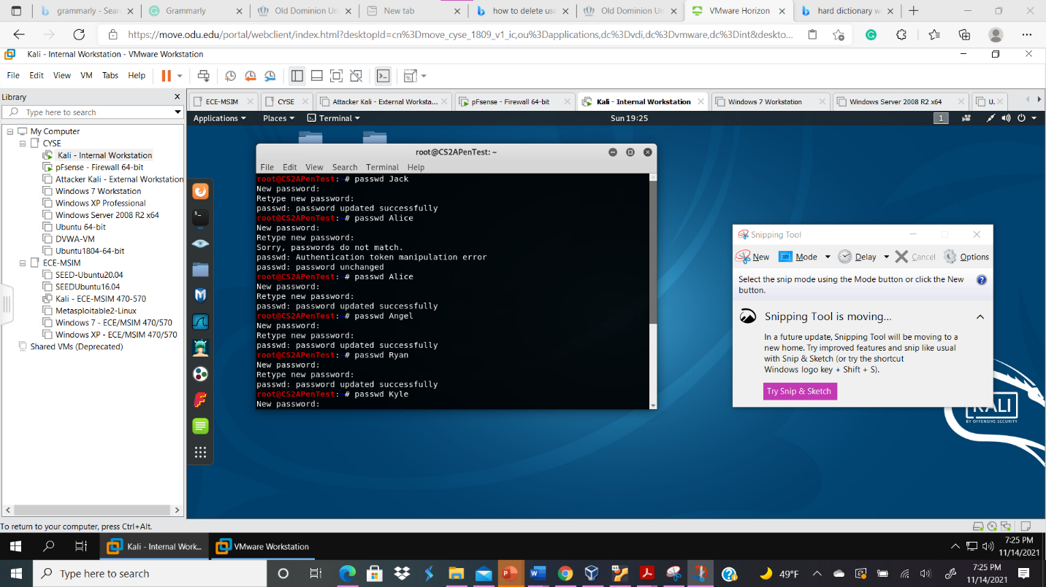
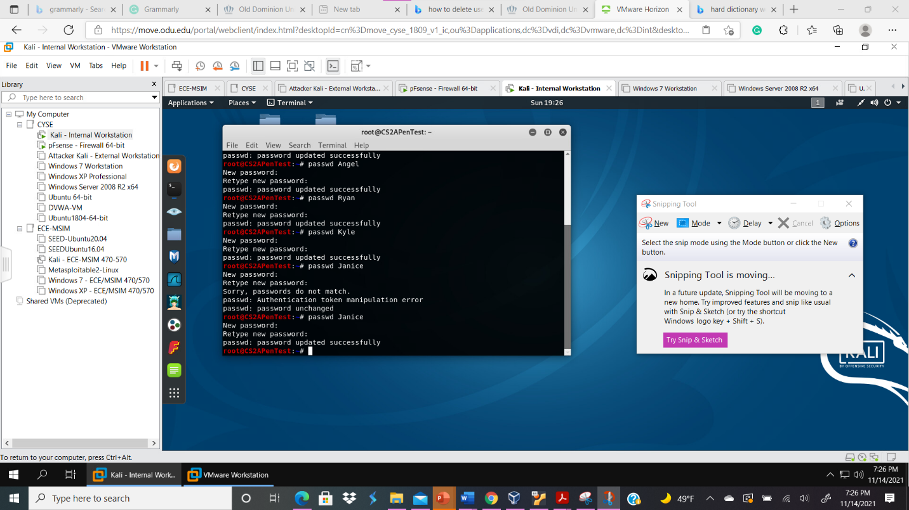
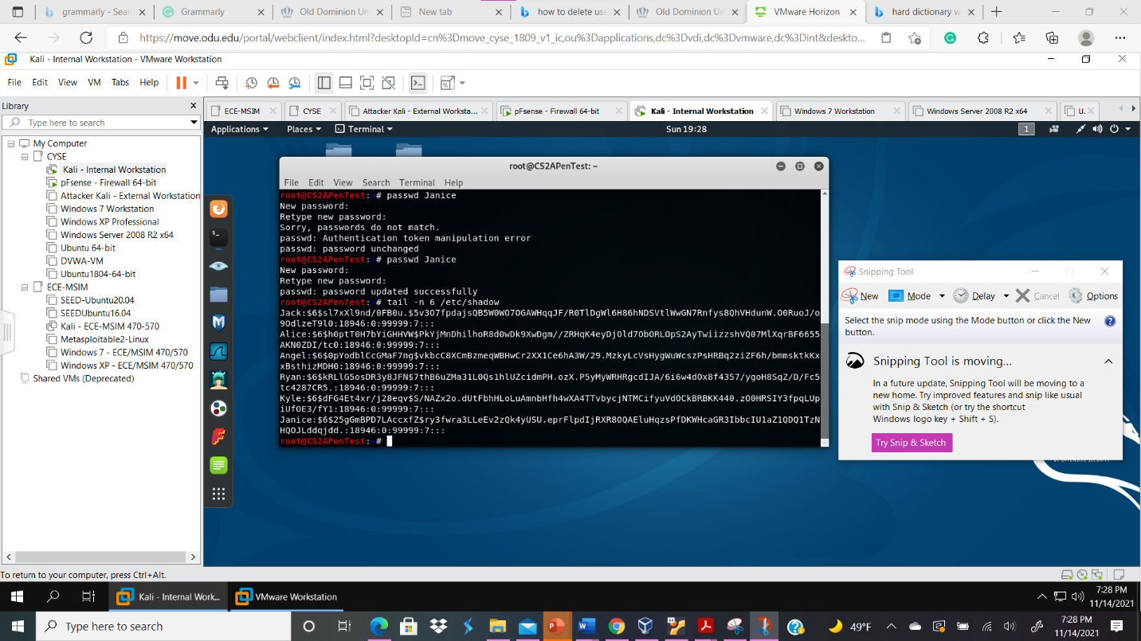
Your explanation goes here. For example:
In order to create a password for each of the users I created, I typed the command passwd username six times. For passwd Jack, I typed wonder as the password. For passwd Alice, I typed wonderful1 as the password. For passwd Angel, I typed cat2234 as the password. For passwd Ryan, I typed Ryan12897652 as the password. For passwd Kyle, I typed Ha33yn322 as the password. For passwd Janice, I typed d8t8rm1nate897654 as the password. Then, I typed the command tail n -6 /etc/shadow to see the encrypted version of my passwords/ display the shadow of each user’s password along with the last six lines of the /etc/pasword file
- Export all six users’ password hashes into a file named “YourMIDAS-HASH” (for example, pjiang-HASH). Then launch a dictionary attack to crack the passwords. You MUST crack at least one password in order to complete this assignment.
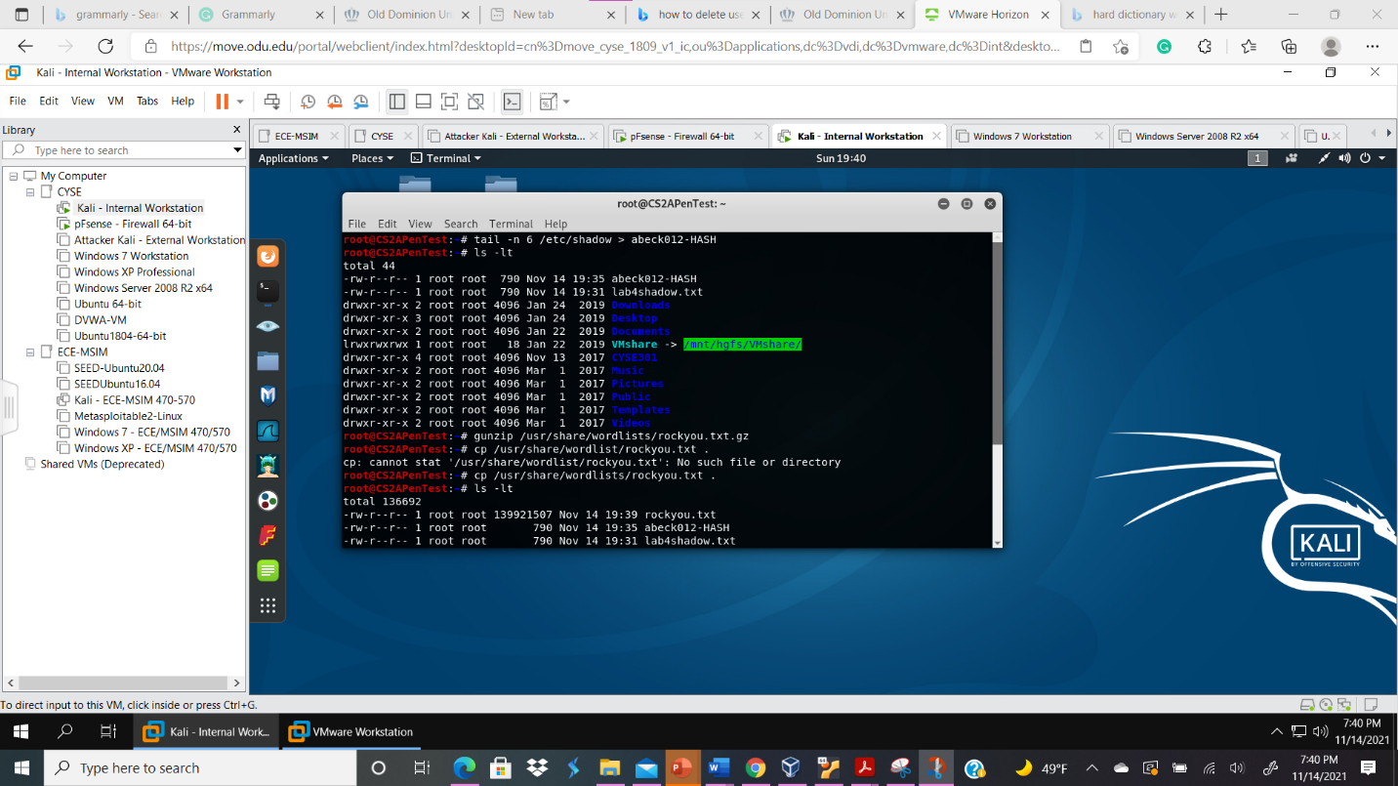
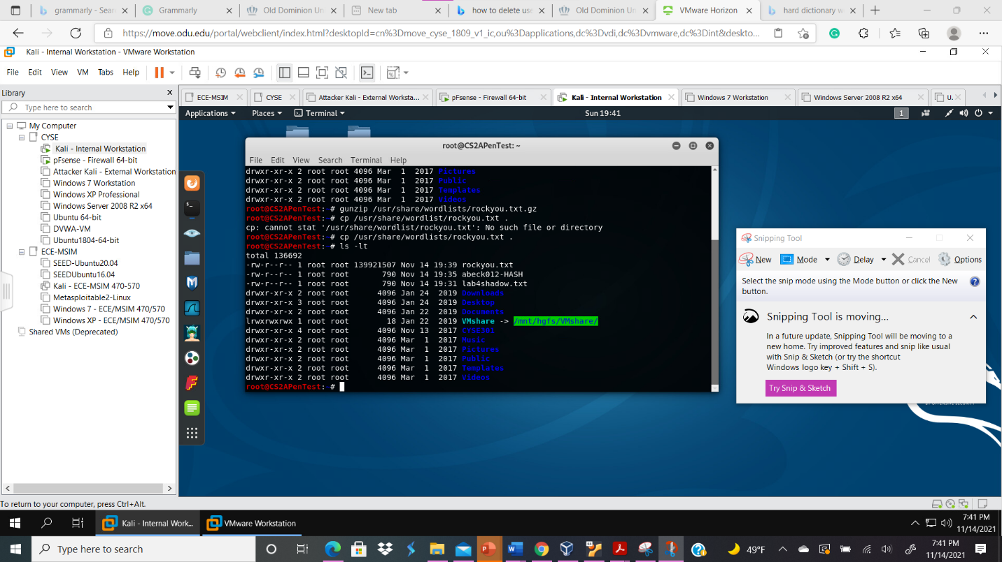
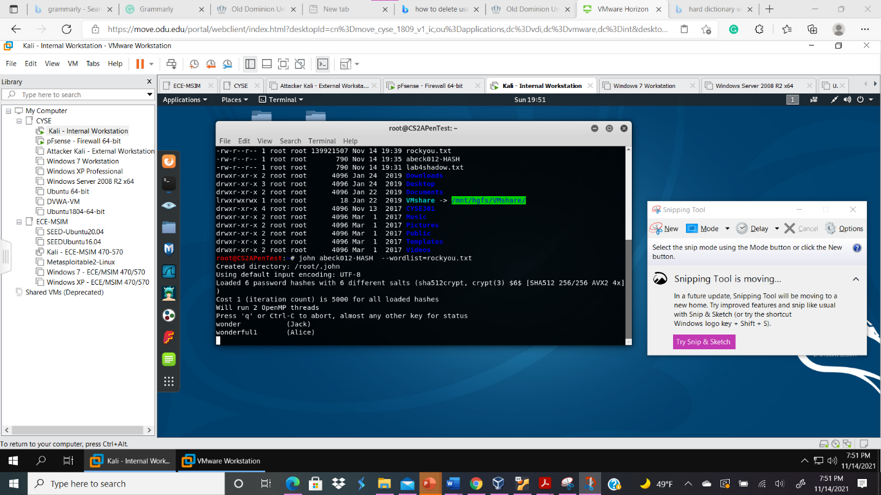
Your explanation goes here. For example:
Above I typed the command tail –n 6 /etc/shadow > abeck012-HASH in order to save the last lines of the /etc/shadow file such as the password hashes from the users I created into the abeck012-HASH. Next, I type the command ls -lt which enables me to see a long list of files in the order that I last modified it. Next, I typed the command gunzip /usr/share/wordlists/rockyou.txt.gz in the terminal to unzip the rockyou.txt default wordlist. Next I typed the command cp /usr/share/wordlist/rockyou.txt . to copy the default wordlist to the current working directory. Finally, I type the command john abeck012-HASH --wordlist=rockyou.txt to run a dictionary attack. After a few minutes I was only able to crack two passwords from the users that I created, Jack’s password was wonder and Alice’s password was wonderful1.

