Old Dominion University

CYSE 301 Cybersecurity Techniques and Operations

Assignment #1.2 Basic Wireshark Practice

Alysia Beckles

01127384

**Below is the snippet of a sample lab report.**

Task A

1. Use Wireshark to capture and save ALL related packets when you ping the URL "www.odu.edu". a. Locate the DNS queries and responses in the traffic. b. What is the IP address of the DNS server? c. What information is answered from the DNS server? d. Apply the proper display filter in Wireshark to show ICMP requests. e. Apply the proper display filter in Wireshark to show ICMP responses. f. Show the Protocol Hierarchy Statistics of the traffic.

Figure 1 Example Screenshot for task A.1 (you don't have to make notations on your screenshot)

**Your explanation goes here. For example:**  
Above is the network configuration in my Kali Linux. I use the command "ifconfig," and the IP address returned is "192.168.10.13".

1. K

**Your explanation goes here. For example:**  
Above is the network configuration in my Kali Linux. I use the command "ifconfig," and the IP address returned is "192.168.10.13".

**Your explanation goes here. For example:**  
Above is the network configuration in my Kali Linux. I use the command "ifconfig," and the IP address returned is "192.168.10.13".

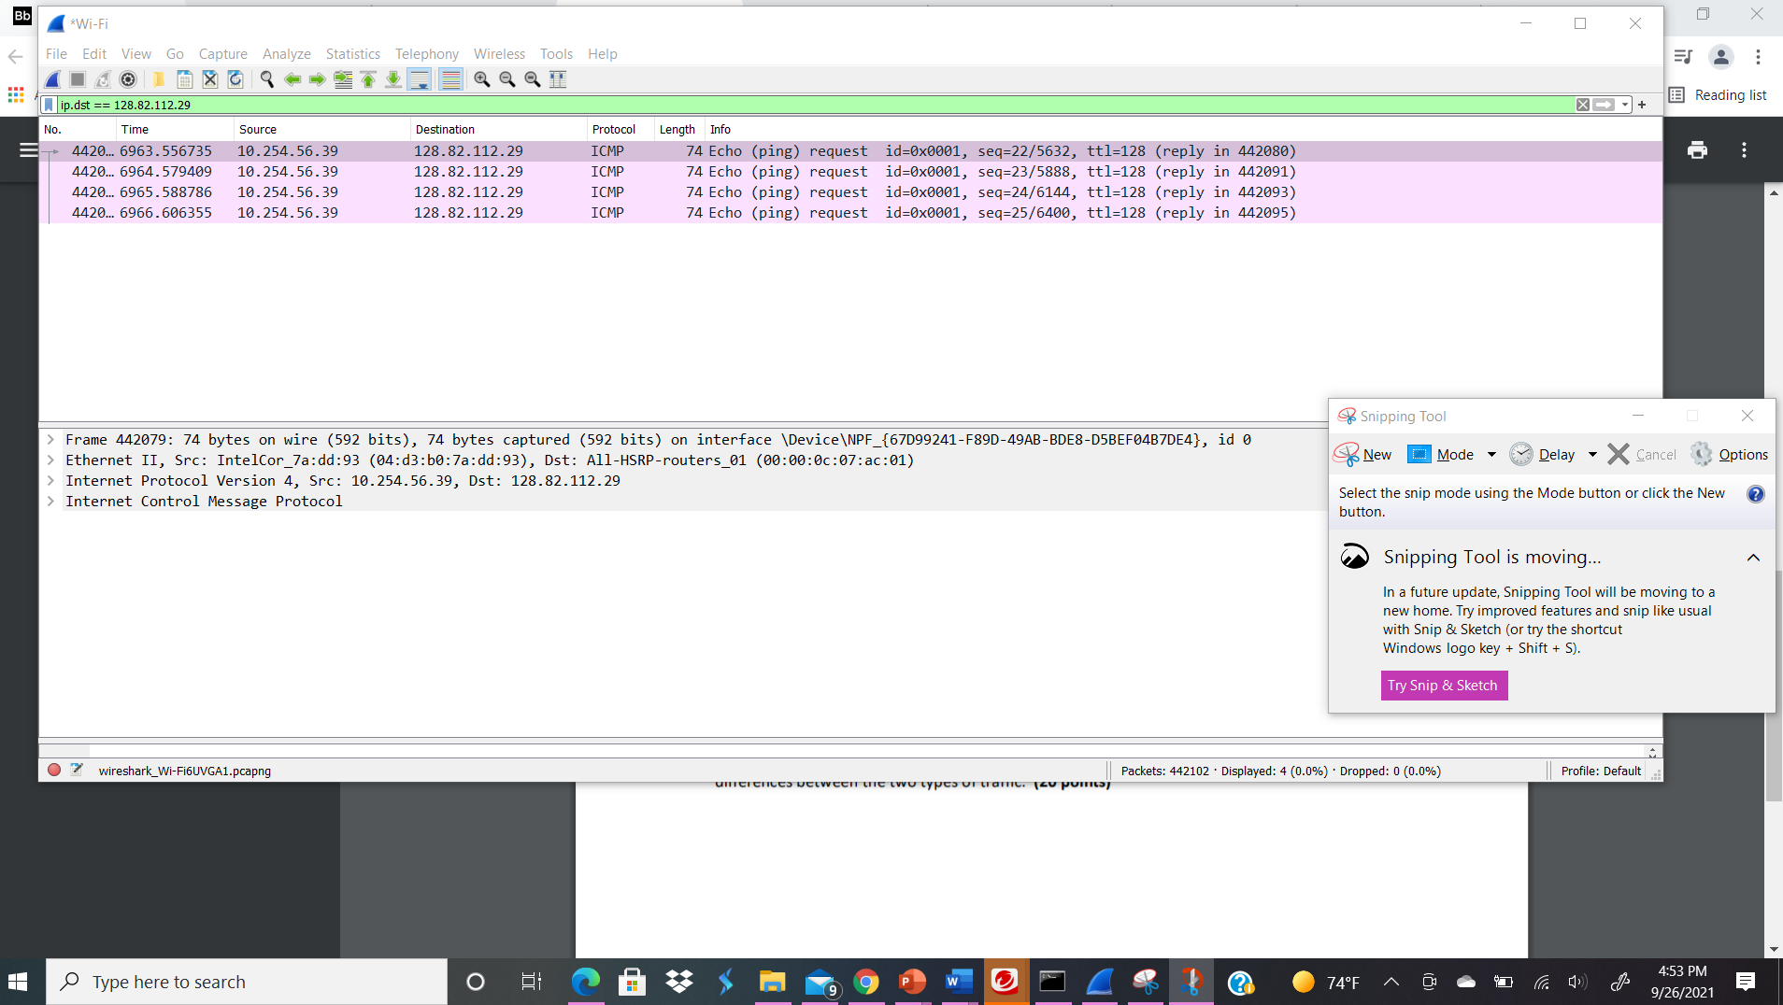

**Your explanation goes here. For example:**  
Above is the network configuration in my Kali Linux. I use the command "ifconfig," and the IP address returned is "192.168.10.13".

**Your explanation goes here. For example:**  
Above is the network configuration in my Kali Linux. I use the command "ifconfig," and the IP address returned is "192.168.10.13".

**Your explanation goes here. For example:**  
Above is the network configuration in my Kali Linux. I use the command "ifconfig," and the IP address returned is "192.168.10.13".

1. Use Wireshark to capture and save ALL related packets when you visit the URL www.odu.edu in a new Incognito window. Stop capturing after the ODU website is fully loaded. a. Locate all DNS queries and responses after you open the website and highlight the DNS query for the ODU website. b. How many other DNS queries have been captured after the ODU website is loaded? Can you explain why this happens? c. Combine what you have observed in the previous questions. Can you identify the widgets (external links) loaded on the ODU website? d. Show the Protocol Hierarchy Statistics of the traffic.
2. K

1. L

balabala…

**VM info**