Laboratory Exercise D3 – Evading Detection Systems

1. Overview

For this lesson, students will use the Cyber Range: Kali Linux with Metasploitable (2020.09) environment to evade detection systems using Nmap and Metasploit.

2. Resources required

This exercise requires a Kali Linux VM running in the Cyber Range.

3. Initial Setup

For this exercise, you will log in to your Cyber Range account and select the Kali Linux with Metasploitable (2020.09) environment, then click “start” to start your environment and “join” to get to your Linux desktop login. Log in using these credentials:

Username: student
Password: student

4. Tasks

Task 1: Fragmenting packets

By splitting up the TCP header into smaller packets, we can confuse a detection system. Since the entire packet is not there, it will be not be detected as malicious. We have already discovered the target in previous lessons (in this instance 10.1.32.187). For this lesson, we will continue attacks against the discovered Metasploitable target.

A fragmented scan requires root privileges, so we will use sudo here. Open a terminal and complete the following:

- sudo nmap -f <Target IP>

As you can see in the screenshot below, this attempt returned open and closed ports. In some cases, you will get “all 1000 scanned ports are filtered.” This is common and the technique does not always work. In other words, it did not make it through the firewall. It is important to know several methods to bypass detection systems. If you have time, try to run the command again. You may get different results. You can also try switching to root instead of using sudo.

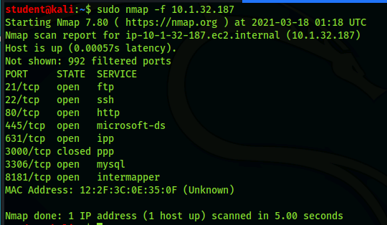

Task 2: Changing the mtu size

Changing the Maximum transmission unit (mtu) will decrease the maximum size of a packet to the specified size. By completing a quick sudo ifconfig in the terminal, we can view a generalized mtu. As shown in the screenshot, the mtu size is usually a larger number.

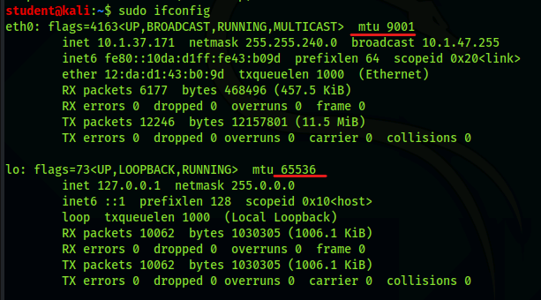
This technique can sometimes find hidden ports/services when you use a mtu that is too large or extremely small. In this case, we will try a small mtu.

- sudo nmap -f --mtu <packet size> <Target IP>
- In my case : sudo nmap -f --mtu 128 10.1.32.187

No difference in this instance; however, this technique can be used to bypass a firewall. You would know that you were successful if there were more ports/services revealed.

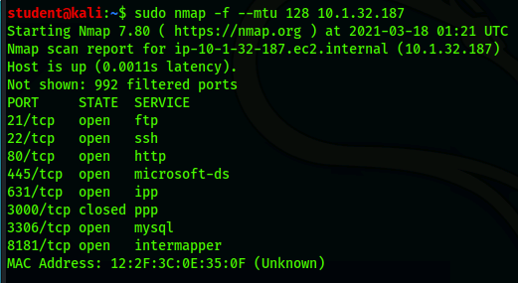

Now that we know this technique is effective on this machine, let’s get Metasploit up and running so we can check all the ports and save it to our database.

Task 3: Setting the Metasploit SQL database to run on startup

So far, we have started the SQL database each time we logged in. We can update the startup scripts by using the update-rc.d command. Complete the following steps, so that next time we need to start the msfconsole, we will not need to type the command sudo service postgresql start.

- sudo update-rc.d postgresql enable
- sudo service postgresql start
- sudo msfconsole

Task 4: Bypassing detection systems using the msfconsole

- Be sure to switch to the metasploitable workspace by typing workspace metasploitable.
- Type hosts in the msfconsole.
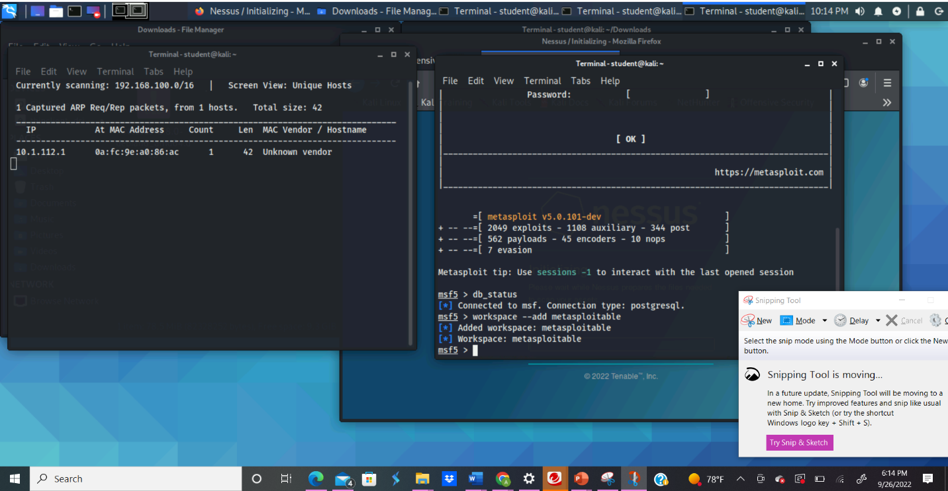
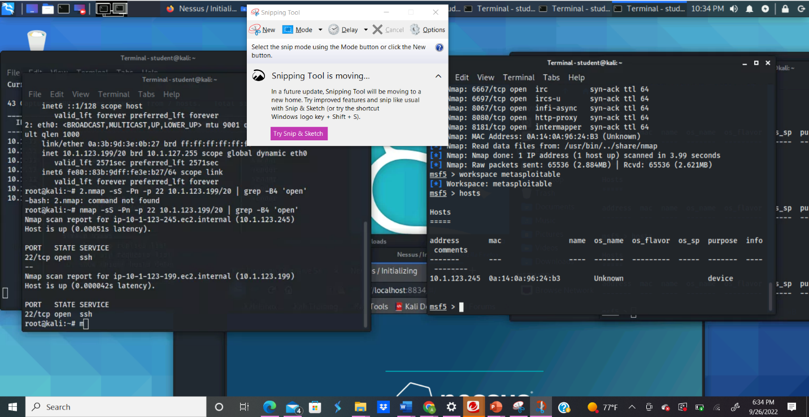

If you have hosts other than the Metasploitable target, you need to delete them as they are out of scope. Remember this is done with the hosts -d <IP1, IP2, IP3, >. Do not forget to add a space after the comma. There should be a host in the database from Module 3. If you have no hosts, then it is possible that your environment has been reset. Refer back to module 3 lesson exercise 1 on how to set up Metasploit.

In the Metasploit console, type the following command:

- db_nmap -T5 -p- -Pn -f --mtu 128 <target IP>
- In my case: db_nmap -T5 -p- -Pn -f --mtu 128 10.1.32.187
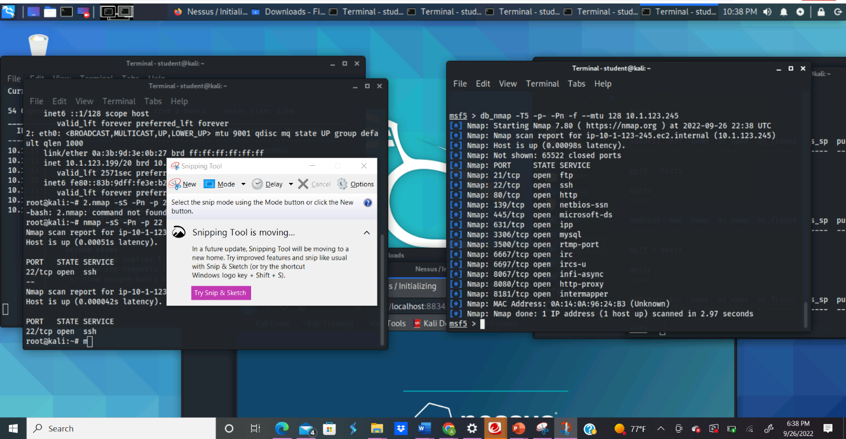

Remember that the -p- will scan all ports from 1 through 65535. You can press the spacebar to view the progress. The screenshot below shows my results (yours may vary).

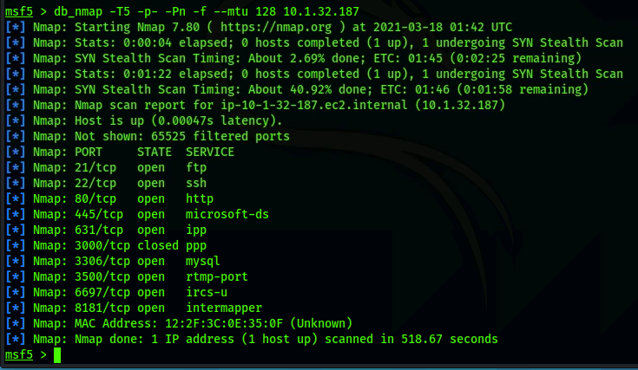

Now let’s see if we can use this technique to enumerate the target. For this, we will add the -A option and specify all the ports that were discovered.

[NOTE: You may find more or less ports. Use the ports you discovered in the command below.]

- db_nmap -p 21,22,80,445,631,3000,3306,3500,6607,8181 -A -f --mtu 128 <target IP>
- In my case: db_nmap -p 21,22,80,445,631,3000,3306,3500,6607,8181 -A -f --mtu 128 10.1.32.187
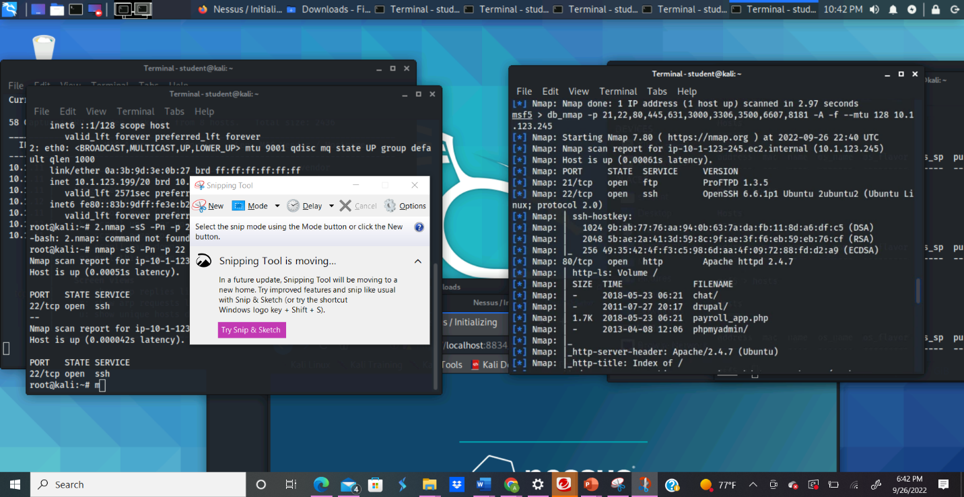
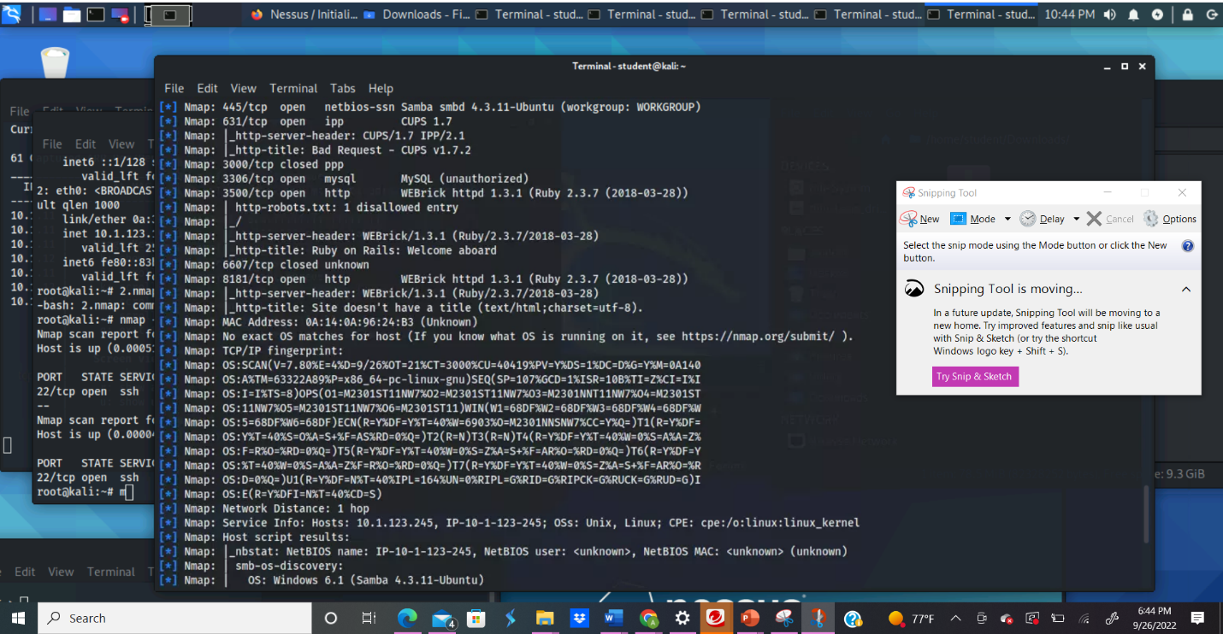

As you can see in the screenshot below, we have a lot of information returned. The scan was a success.

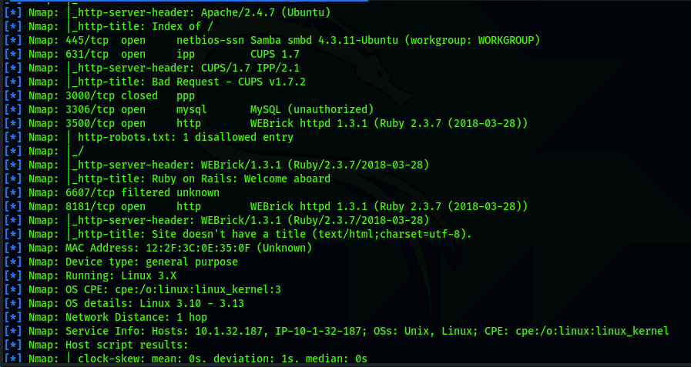

NOTE: If your scan gets hung up, use CTRL + C to stop the scan and try again. It should only take about 2 minutes to scan. If the scan still does not work, logout of the VM then log back in and repeat the steps. If that still does not work, ask your instructor to reset your VM. In this case, you will need to refer back to module 3 lesson exercise 1 on how to set up Metasploit, and then it is highly recommended you repeat Task 3 of this lab.

To view all the details about what has been discovered type services and press enter. Here we can see there are several vulnerable services. This is rare in a real system; however, exploitable services on port 80, 8181, and any other http are usually the first services an attacker will attempt to exploit.
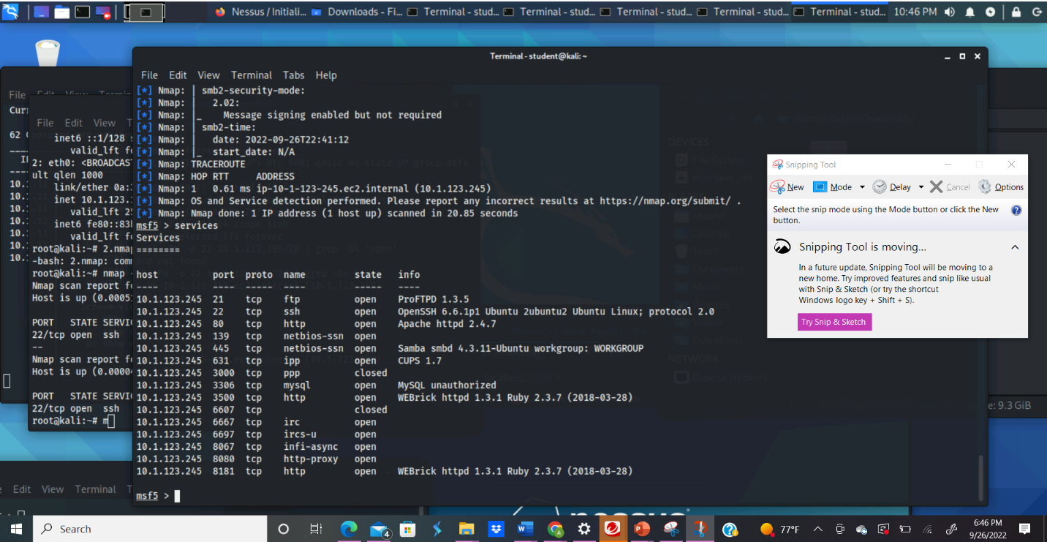

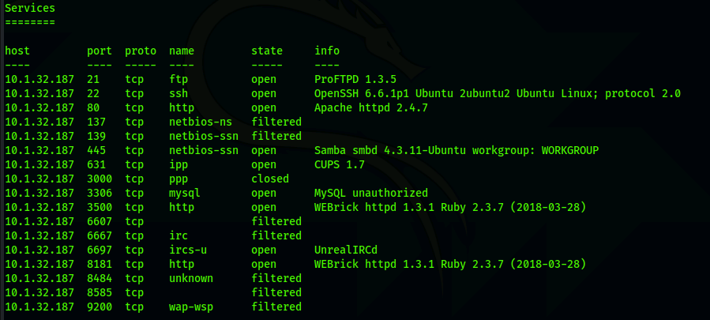

You can check what the http services are by opening a browser and typing <ip>:<service port>
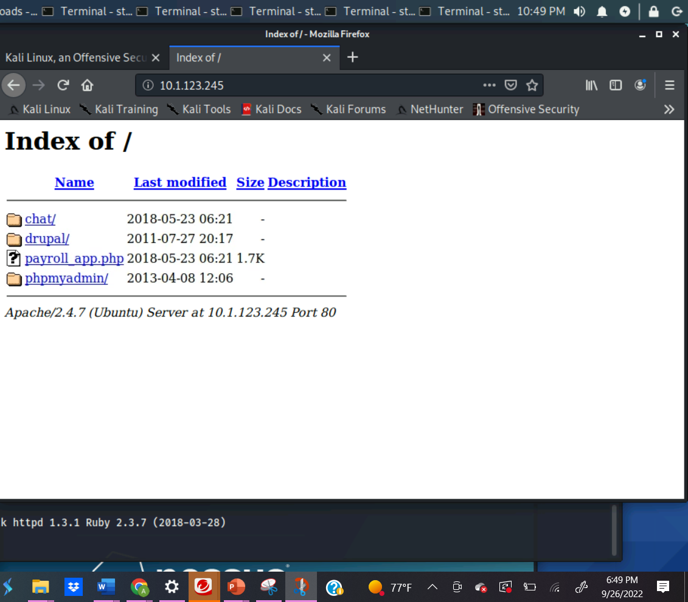

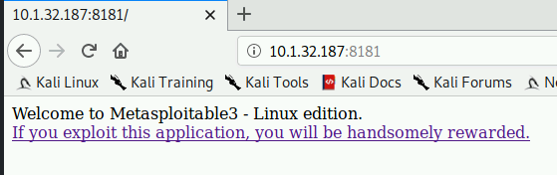
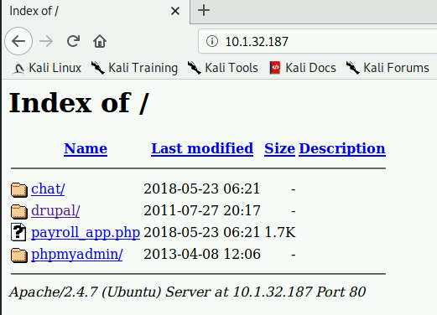

Task 5: Bypassing Firewalls with Nmap Scripts

Nmap has scripts that can bypass firewalls as well. The details of how this works is explained in the PowerPoint.

The default location of Nmap scripts is in /usr/share/nmap/scripts folder. If we navigate to this folder, we can search the available scripts. First navigate to the scripts folder in a new terminal tab.

This following command will list results in the current directory for “firewall.”

- ls -a *firewall*

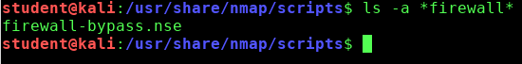

Now that we have found a suitable script, we can copy and paste it into the terminal at the right location. In the msfconsole, complete the following command:

- db_nmap -p- -A -T5 --script firewall-bypass <target IP>

Note, this took about 16 minute to complete.

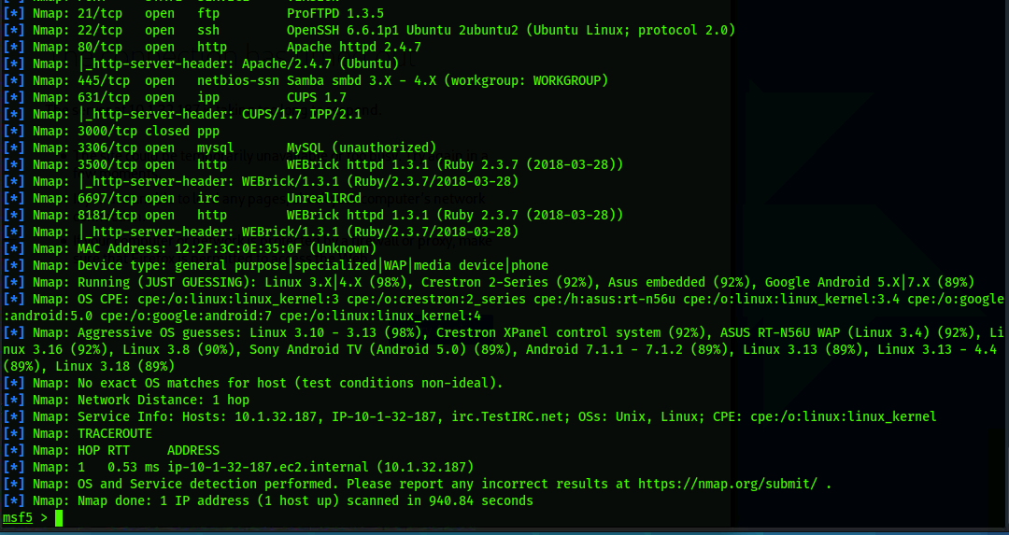

Task 6: Service Version UDP Scanning

Completing a UDP scan will return results that may or may not be accurate. In other words, it is not always reliable. I have gone down many rabbit holes only to find that the port was really closed and not filtered. However, if firewall/IDS/IPS rules are set to block TCP scanning techniques, UDP may be useful to gather information. Let’s complete a UDP scan in the msfconsole. Be sure you are root.

- db_nmap -sU -T5 <target IP>

Ports that are listed as closed but are showing a service may be inaccurate or they may be services that once were used but no longer are installed on the target. Ports that are open are usually accurate. We are not showing any filtered ports, so there are no issues there. In previous scans, port 137 was showing as closed or unknown.

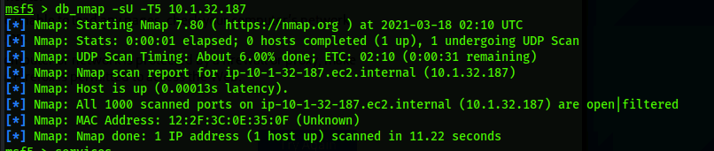

We cannot be 100% sure that the UDP scan results showing “open” are correct. UDP scanning is a difficult task as UDP does not require confirmation that packets have reached their destination; however, if paired up with a service version scan, the results can be useful when scanning against a firewall. The scan is very slow so you will have to be patient. For our example, we will speed up the process by only scanning the most likely used ports. We do this by adding a --version-intensity 0. We can also add a -T5 for speed. However, time is limited so we will focus only on a simple service version scan with the ports that we found. Return to the msfconsole and complete the following command:

- db_nmap -sV -T5 -p 21,22,80,445,631,3000,3306,3500,6607,8181,8585,8484,6697,6667,9200 <target IP>

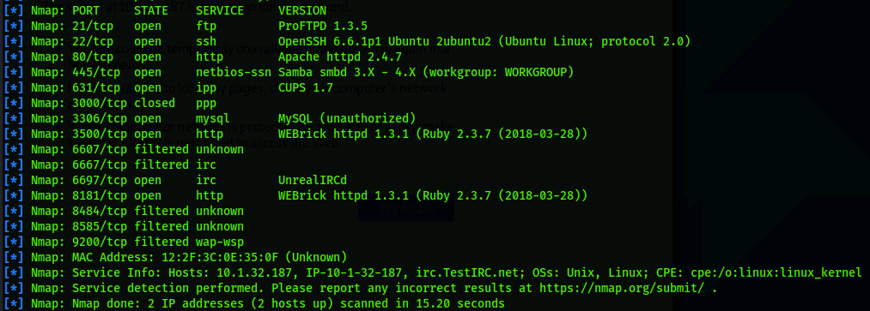

Oftentimes when scanning and sniffing you will get few results due to firewalls, IDS/IPS rules, and blocked protocols. The above techniques will bypass many attempts to stop information gathering. Recon, scanning/enumeration, and sniffing are all information gathering techniques. Sniffing, and firewall/IDS/IPS evasion are still under phase 2 of hacking (scanning/enumeration). When pentesting, remember there are three phases: preattack, attack, and post attack. Phase one and two of a hack is actually phase 1 of a pentest.

