# **Media and Violence**

# **Abstract**

The impact of media violence on young aggression has long been studied in the research, and a better understanding of the psychosocial factors that influence media violence's impact on young aggression is evaluated for to study the negative consequences of violent media and deviant behaviour in children and adolescents. Youngster’s violent emotions were studied over time after being exposed to differing degrees of media violence in various circumstances, according to this study. Individuals exposed to a high level of media violence (H-MVE) demonstrated higher levels of proactive aggression in both irritation and low-irritation settings, as well as higher levels of violent conduct in low-irritation scenarios, when compared to those exposed to a low level of media violence (L-MVE) (L-MVE). After being encouraged, all participants' levels of anger and proactive aggressiveness increased substantially, and the levels of anger and proactive aggression in the H-MVE group were significantly higher than those in the L-MVE sample. Rumination and wrath, on the other hand, acted as a moderator in the relationship between exposure to media violence and violent behaviour. Overall, this study adds to the conceptual foundations of the long-term impact of media violence on individual violent behaviour. Second, this study adds to our understanding of the relatively new but vitally important phenomenon of the media violence-individual aggressiveness mechanism, which is a highly novel and critical occurrence.

# **Literature Review**

Issues concerning the influence of media violence on aggressiveness are not limited to any one kind of media, but commonly include television, cinema, video, music, and video games. Media exposure has been characterized as "visual depictions of physical hostility committed by one human or humanoid figure against another." (Anderson and Bushman, 2018). Others, however, think that indeed violent lyrics may also result in hostility. Psychologists often describe aggression as behavior or attitude designed to cause damage to another person. Aggressive behavior may manifest itself in a variety of ways. (Arntson, 2020). Physical aggressiveness encompasses a range of behaviors, from ramming and pushing to more significant physical attacks, such as violent actions that may result in serious harm while Verbal aggressiveness (e.g., speaking unpleasant things to people) and interpersonal violence are less significant kinds of hostility. (Aroustamian, 2019)

Multiple variables are considered to contribute to violent and aggressive behavior throughout time. It has been proposed that factors that encourage aggressive tendencies in youngsters, such as violent media, may effectively lead to years later increased violence and aggression. (Brüning, 2021)

# **Effects of media on society**

Randomized trials convincingly reveal that short-term exposure of violent media increases the chance of violent behaviour in both children and adults. Priming is probably the most significant underlying mechanism for this impact, while imitation and heightened alertness also play an important role. Prospective longitudinal studies also demonstrate that adult's exposure to violent electronic and print media increase their likelihood of aggressive behaviour over time (Chen and Yorgason, 2018). These long-term impacts are a result of the robust observational learning and desensitization processes that psychologists and neuroscientists now recognize occur routinely in the human infant. (Cuc, 2017). People develop ascriptive display for the behaviour they encounter in everyday life or in the mainstream media, as well as emotional responses and social cognitive distortions that support such behaviour. Additionally, stereotyping processes cause youngsters to seek out individuals who act aggressively in the media or in actuality, resulting in a negative spiral process that enhances the likelihood of violent conduct. (Cui and Worrell, 2019)

# **Long term and short-term Impacts of violent media**

The way that mass media and computer games impact emotions most likely magnifies the effects of mass media. Regular exposure to emotionally evocative media or video games may cause some natural emotional responses to become habitual. (El-Ibiary, 2017). "Desensitization" is the term for this process. After repeated exposures, viewers' negative emotions to a single violent or horrifying sight become less intense. Increased heart rates, perspiration, and self-reports of pain are common after exposure to blood and gore, for example. The youngster, on the other hand, develops "desensitized" to this unpleasant emotional reaction after repeated encounters. The teenager may then plan and execute proactive aggressive behaviour without fear of punishment. (Furlow, 2017)

Anger is often seen as an emotional precursor to violent behaviour. When a person becomes enraged, a network of hostile ideas, violent impulses, and aggressive screenplays and patterns are triggered. The emphasis is on anger facts . This process alters a person's perception of a circumstance, making them more likely to make aggressive judgments and engage in violent behaviour. (Grossman and Paulsen, 2018).

When a person is exposed to violent media for a long time, he or she becomes more prone to anger or has a greater degree of arousal when angered. Participants in violent media, particularly violent online games, are often reprimanded by their peers when they are provoked by or perform poorly against their opponents. (Igwebuike, 2021). When challenged by an opponent or scolded by a colleague, those who have been exposed to a high level of media violence (H-MVE) are more likely to activate emotional arousal and cognitive activity linked with hostility. As a result, we expect that when confronted with a provocative situation, those with an H-MVE will be more enraged, resulting in more violent behaviour, than those who have just small levels of media violence exposure (L-MVE). (Houston-Kolnik, Soibatian and Shattell, 2017)

# **Significance of the Problem**

The research was carried out by using longitudinal study of diverse population. Electronic questionnaire was distributed among the population of 550 randomly selected university students. The questionnaire was completed by 495 students. The age of the participants ranges from 18 to 22 years. According to the score of the electronic media questioner, it was divided into two major groups; 28% in H-MVE from the top and 28% of L-MVE from the bottom. Among these the male and female participants of ration was 60% and 40% respectively. All the participants have the normal visual activity and consent was taken from them.

|  |  |
| --- | --- |
| Total participants | 550 |
| Selected participants | 495 |
| Age range | 18-22 years |
| HMV-E | 28% |
| LMV-E | 28% |
| Male to female ratio | 60-40 |

*Table: Research Details*

***Graph: Relationship between the Media exposure and violence. Blue line indicate the short time exposure of violence where orange line to the long term exposure where silver line remain constant***

The graph indicates that the violence and aggression increase when one is exposed to the violent media. The exposure to violent media for a long time increases the probability of the aggression while the exposure to the short time has the effects but at the limited level.

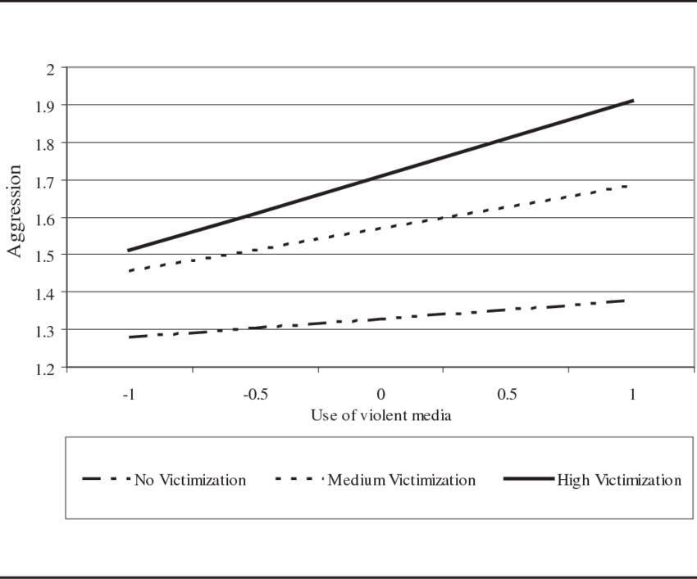

Graph 02: Aggression and different type of violent media

# **Factors and Variables**

Basically, two most important factors are under consideration in the research; Media and aggression. Media has the evident impact on the aggression and anger. Here aggression is considered as the type of violence which is often seen in diverse age groups especially in the adults and teens. Exposure of media has been seen as the driving force while its impact is studied in from of emergent aggression. (Kokkinos, Voulgaridou and Despoti, 2021)

Acts of violence that are observed or "virtually performed"  by youngsters make up a major part of an individual's media exposure. By the age of 18, the typical adolescent would have seen over 200000 incidents of violence on tv alone. Similarly, adolescent music, particularly rap music, has gotten increasingly vicious. 3,17,26 Adolescents are increasingly exposed to violence on the Internet, as well; a poll of more than 1600 10- to 16-year-olds found that 36% had been experienced to violent scenes on the Web. 29 There is also a lot of violence in video games. (Prouse, 2017). More than half of all video games are classed as including violence, according to a recent examination of the ESRB ratings, with more than 89% of games certified as acceptable for children 11 years and older. (Ratta, 2017). Long-term exposure to these types of media depictions leads to a greater acceptability of violence as a legitimate manner of resolving conflicts and attaining one's objectives. Children and teenagers can and do readily access violent material that is judged improper for them by different rating methods and parents, according to studies. (Redefining Communication. Social Media and the Age of Innovation, an Introduction, 2019)

# **Conclusion**

The GAM about the long-term impact of media violence on aggressiveness is confirmed in this research, which also investigates the link and process between exposure to media violence and aggression from the standpoint of anger. Individual hostility may grow as a consequence of long-term exposure to violent media, according to the findings. Second, those who have had a long-term MVE are much more likely to have more anger, which leads to increased violence in provocation situations. Furthermore, individual ’s mental processing and cognitive patterns are directly connected to the development of rage. Those with a long-term MVE are more likely to analyze and pay more attention to provocative stimuli repeatedly, demonstrating a rumination propensity; as a result, they are more likely to feel angry. (Waddell et al., 2019). Anger also increases aggression-related decision-making by speeding up the engagement of aggressive testing based.

This research has possible ramifications for the prevention and management of aggressive behaviour in H-MVE patients, despite certain limitations. On the one hand, H-MVE persons need cognitive training to improve their pondering propensity; on the other hand, H-MVE individuals' emotional regulation abilities, particularly in provoking circumstances, should be developed to lessen their angry experiences. There are substantial clinical implications to be derived from these observations. Children are more likely than adults to have long-term effects from seeing violence, even though both adults and children may become angry when they see it. The strictest rules are needed to stop children from acting aggressively again and again, so this is why they need the most protection. In spite of the fact that the effects of a single exposure aren't likely to last for very long, parents should be encouraged to protect their kids from the kind of prolonged exposure that frequent use of video games or watching violent TV shows is likely to cause.

# **References**

1. Anderson, C.A. and Bushman, B.J. (2018). Media Violence and the General Aggression Model. *Journal of Social Issues*, [online] 74(2), pp.386–413. Available at: http://www2.psych.utoronto.ca/users/tafarodi/psy427/articles/Anderson%20&%20Bushman%20(2018).pdf.
2. Arntson, C. (2020). Designed to Fail: Media Representations of Racialized Classrooms and Schools. *Canadian Journal of Family and Youth / Le Journal Canadien de Famille et de la Jeunesse*, 12(2), pp.1–14.
3. Aroustamian, C. (2019). Time’s up: Recognising sexual violence as a public policy issue: A qualitative content analysis of sexual violence cases and the media. *Aggression and Violent Behavior*, 50, p.101341.
4. Brüning, K. (2021). ‘I’m Neither a Slut, Nor Am I Gonna Be Shamed’: Sexual Violence, Feminist Anger, and Teen TV’s New Heroine. *Television & New Media*, p.152747642110153.
5. Chen, C.H. and Yorgason, E. (2018). Redefining Asian Masculinity in the Age of Global Media. *Asian Communication Research*, 15(2), pp.123–153.
6. Cuc, M.C. (2017). The Influence of the Media in Publicizing Violence. *New Trends and Issues Proceedings on Humanities and Social Sciences*, 3(3), pp.34–40.
7. Cui, D. and Worrell, F.C. (2019). Media, Symbolic Violence and Racialized Habitus: Voices from Chinese Canadian Youth. *Canadian Journal of Sociology*, 44(3), pp.233–256.
8. El-Ibiary, R. (2017). Media Portrayal of Street Violence Against Egyptian Women: Women, Socio-Political Violence, Ineffective Laws and Limited Role of NGOs. *IAFOR Journal of Media, Communication & Film*, 4(1).
9. Furlow, B. (2017). Media violence and youth aggression. *The Lancet Child & Adolescent Health*, 1(2), pp.91–92.
10. Grossman, D. and Paulsen, K. (2018). On media violence and aggression. *Journal of the American Academy of Physician Assistants*, [online] 31(8), pp.11–12. Available at: https://journals.lww.com/jaapa/Fulltext/2018/08000/On_media_violence_and_aggression.1.aspx.
11. Houston-Kolnik, J.D., Soibatian, C. and Shattell, M.M. (2017). Advocates’ Experiences With Media and the Impact of Media on Human Trafficking Advocacy. *Journal of Interpersonal Violence*, 35(5-6), p.088626051769233.
12. Igwebuike, E.E. (2021). Verbal horror and slaughterhouse imagery in media representation of herdsmen violence. *Journal of Language Aggression and Conflict*.
13. Kokkinos, C.M., Voulgaridou, I. and Despoti, G. (2021). The Indirect Effects of Anger on Relational Aggression through Anger Rumination. *Journal of School Violence*, pp.1–12.
14. Prouse, C. (2017). Autoconstruction 2.0: Social Media Contestations of Racialized Violence in Complexo do Alemão. *Antipode*, 50(3), pp.621–640.
15. Ratta, D.D. (2017). Expanded places: Redefining media and violence in the networked age. *International Journal of Cultural Studies*, 21(1), pp.90–104.
16. Redefining Communication. Social Media and the Age of Innovation, an Introduction. (2019). *Special Issue 1-Dec2019*, 1(Special Issue).
17. Seitz, D.K. (2020). ‘Missing’ Racialized Violence, Disturbing Continuities: Countertopographies of Violence in the Bruce McArthur Murders. *Journal of Canadian Studies*, 54(2-3), pp.459–482.
18. Shelomovska, O.M. (2019). THE DYNAMICS OF THE CONSUMPTION OF TRADITIONAL AUDIOVISUAL MAS-MEDIA AMONG THE STUDENT’ S YOUTH OF THE CENTRAL REGION OF UKRAINE. *Habitus*, (9), pp.103–111.
19. Singh, S. (2018). Violence against Women in the Age of Social Media. *Contemporary Social Sciences*, 27(2), pp.38–44.
20. Supplemental Material for Who Finds Media Violence Funny? Testing the Effects of Media Violence Exposure and Dark Personality Traits. (2021). *Psychology of Popular Media*.
21. Waddell, T.F., Bailey, E., Weber, M., Ivory, J.D. and Downs, E. (2019). When Media Violence Awakens our Better Nature: The Effect of Unpleasant Violence on Reactivity toward and Enjoyment of Media Violence. *Journal of Broadcasting & Electronic Media*, pp.1–18.