- (Used nanoDir for file name instead of steg by accident) Steps 1-3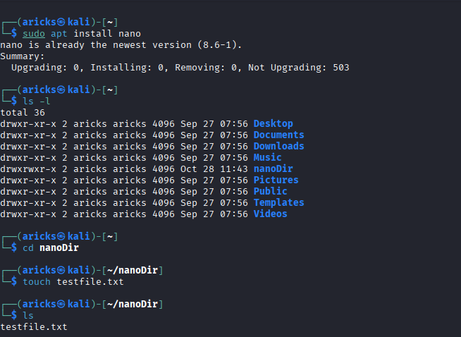

- Step 4 
- Step 7 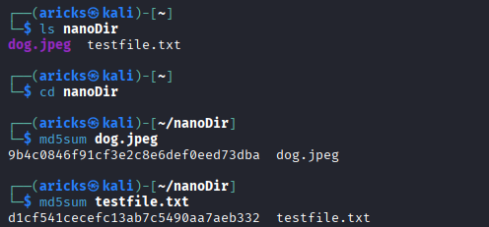

- Step 8 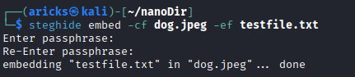

- Step 9 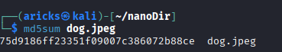

- Step 10
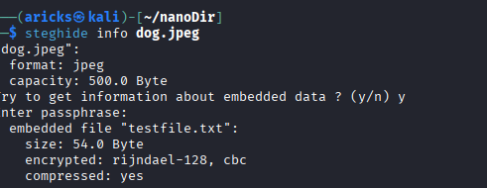

- Step 11 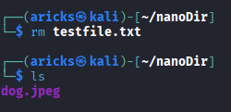

- Step 12 and 13 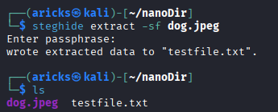

- Step 14 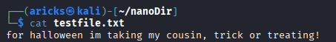

- Step 15 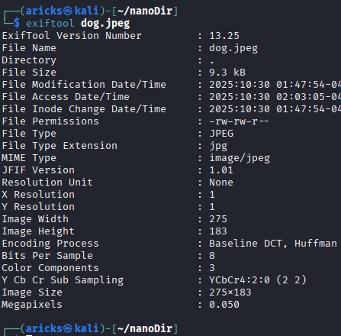
- Step 16 and 17 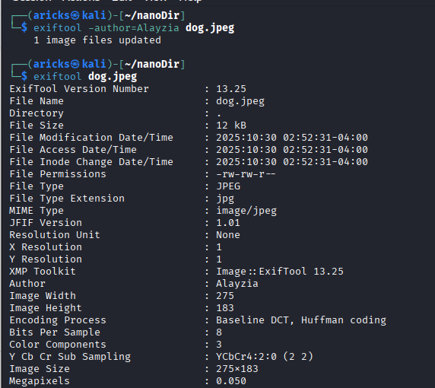

- Step 18 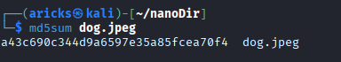
Visually different hash output

