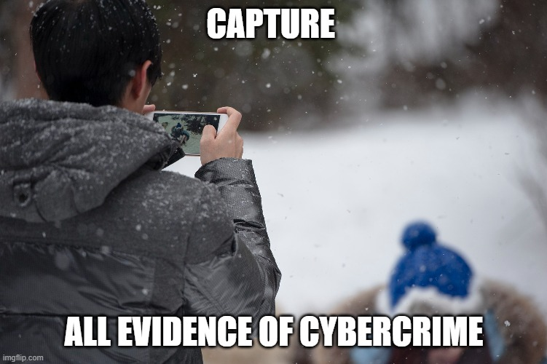Week 7 Journal Entry

-Any signs of cybercrime activity must be recorded to be able to track culprits.

-The core of employee learning is through being educated by fellow employees.

-This meme explains how an individual in a cybersecurity sector’s main objective is to protect consumer assets.

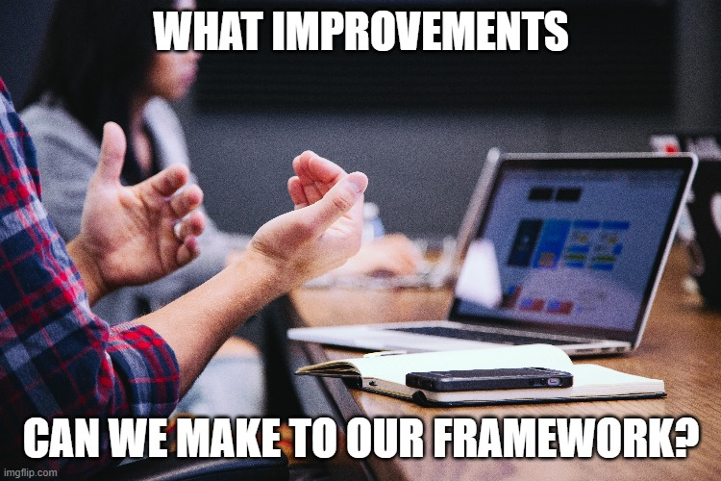

-Employees must have discussions on how they can improve their framework, which optimizes efficiency in their objective.

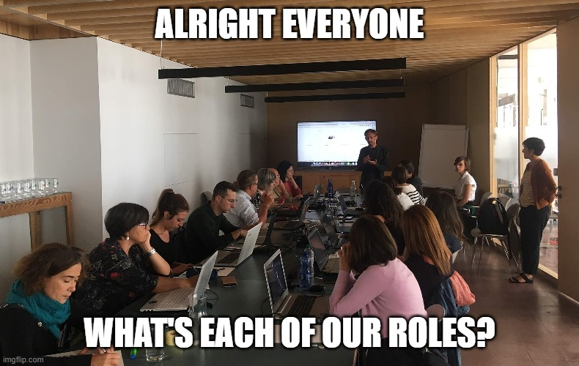

-Everyone has a role in the company protecting consumers.

-How employees should act in their framework can change, but it is done to improve efficiency.

-Not only is protecting the consumers a vital objective, but finding these culprits is important too.

-Everyone must work together as a part of human systems integration.

-Employees need to be able to know what their doing to defend against these threats.

-Every employee has their role in defending against cyberattacks.