Task 4: Mind Map

Catherine L Hurt
Old Dominion University
HMSV 440W: Program Development, Implementation, & Funding
February 18, 2024

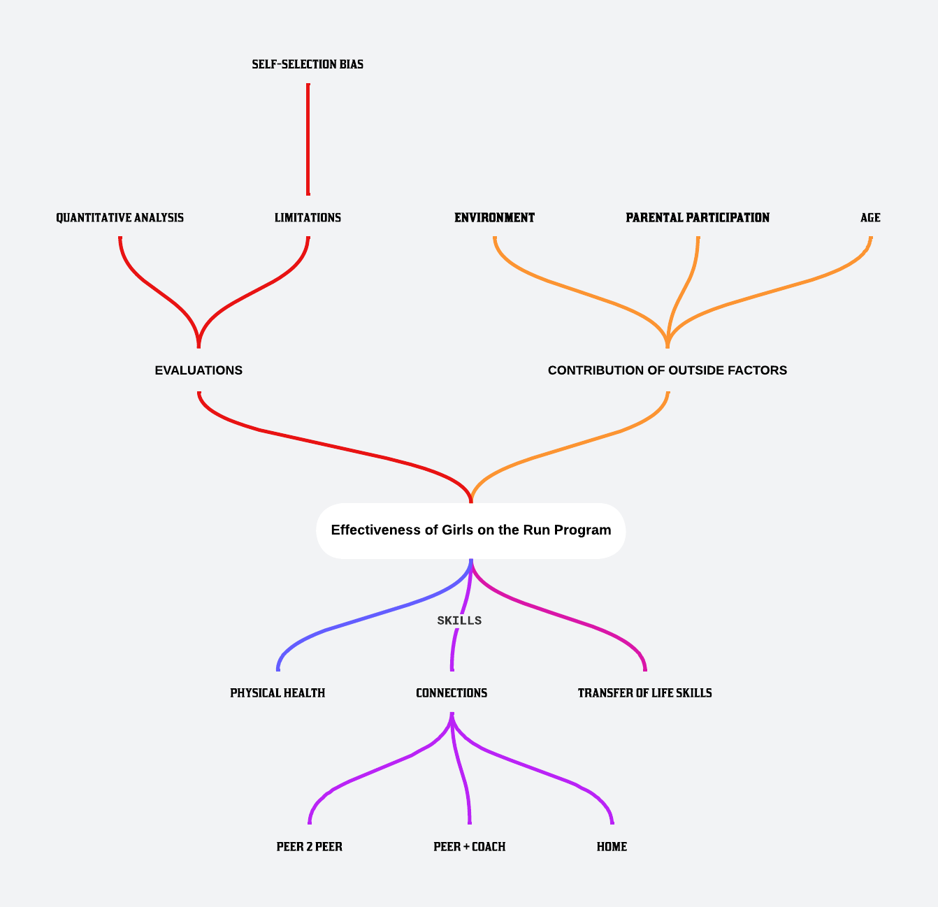

References
Gabriel, K. K., DeBate, R. D., High, R. R., & Racine, E. F. (2011). Girls on the Run: A Quasi-Experimental Evaluation of a Developmentally Focused Youth Support Program. Journal of Physical Activity & Health, 8, S285-S294. https://doi.org/10.1123/jpah.8.s2.s285
Weiss, M. R., Kipp, L. E., & Riley, A. (2023). Inspiring IDEA: Girls on the Run’s developmental approach to and assessment of inclusion, diversity, equity, and access programming. Frontiers in Psychology, 14, 1128680-1128680. https://doi.org/10.3389/fpsyg.202
Weiss, M. R., Kipp L. E., Reichter, A., & Bolter, N. D. (2020). Evaluating Girls on the Run in Promoting Positive Youth Development: Group Comparison on Life Skills Transfer and Social Processes. Pediatric Exercise Science. 32(3), 172-182.
Weiss, M. R., Kipp, L. E., Reichter, A., Espinoza, S. M., & Bolter, N. D. (2019) Girls on the Run: Impact of a Physical Activity Youth Development Program on Psychosocial and Behavioral Outcomes. Pediatric Exercise Science, 31(3), 330-340.

