Case Analysis On Information Warfare

PHIL 355E

Professor Nicol

William Patchel (01181567)

12/04/2022

Information warfare has never been more prevalent than it is today. In America there is widespread concern over the way large social media corporations use our data. Most recently in the 2016 election between Donald Trump and Hillary Clinton, Facebook has been the topic of discussion. In the months leading up to the election, Facebook had been accused of using personal information collected from their platform to target, disrupt, alter, and distribute information in order to sway people's votes in the election. Information warfare continues to evolve today as the spread of fake news, targeted ads, and propaganda continue to remain. In this Case Analysis I will argue that Utilitarianism shows us that Facebook did engage in information warfare because the outcome of Facebook's actions weren't for the benefit of the majority but rather for their own interests, and further that they were partly responsible for the election outcome because of the tactics and strategies they used to target voters.

In the article written by Prier some of the central concepts discussed were how social media is a tool for information warfare, how cyber attacks can influence society's trust for their government, and what's to come for the future of information warfare. Social media is not just a tool for information warfare in the 2016 election it was the battleground. The use of social networking, propaganda, and targeted news articles were a large component of Facebook's toolkit. Prier also discusses how cyber attacks influence a society's trust in their government. Prier talks about how today's current cyber operations employed by countries like Russia or the Islamic state (IS) target people within the society, influencing their beliefs and behaviors, thus diminishing trust in their government. “According to the U.S. Senate report, Russia [used](https://www.bbc.com/news/technology-49987657) social media during the 2016 electoral campaign to influence voters and conduct an information warfare campaign designed to spread disinformation and societal division in the United States. The document reads that Russia mostly targeted the issues such as race, immigration, and Second Amendment to the U.S. Constitution (the right of the people to keep and bear Arms). According to the report, over 66 percent of Facebook advertisement content contained a term related to race and was [targeting](https://www.intelligence.senate.gov/sites/default/files/documents/Report_Volume2.pdf) African Americans. Russia was doing its best to trigger racial confrontation and incite a conflict among American voters.” (usmcu.edu). Another example of this would be the soviet union challenging Americans' belief in the capitalist system trying to get American citizens to adopt or sympathize with a fascist or even communist regime. Figure 1 shows propaganda from the Soviet Union towards America to incite division among the citizens.*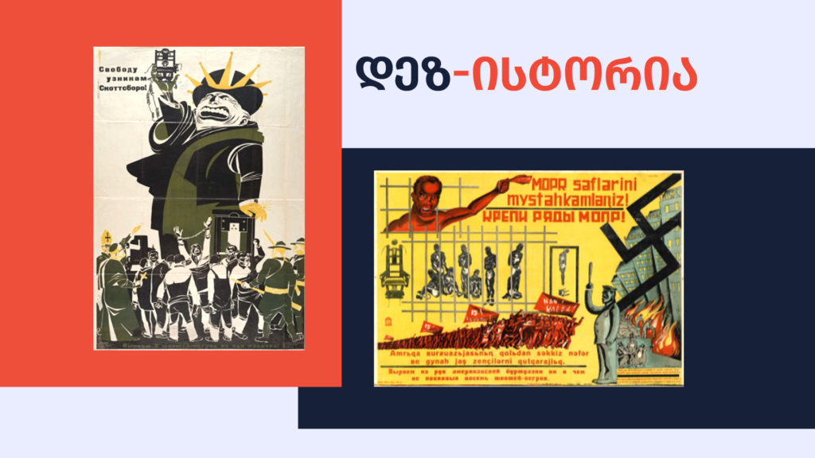Figure 1*

Utilitarianism is the doctrine that actions are right if they are useful or for the benefit of a majority. Facebook and their actions were not created under the intentions for the benefit of the majority; they were simply looking for their own personal gain. Although in this scenario it is arguable depending on which side of the political spectrum you preside on that this was for the benefit of the majority, in this paper I am trying to be as unbiased as possible in order to maintain integrity for the case analysis. “This year Clinton won 228 electoral votes while Donald Trump won 290, according to the most recent [figures](http://www.nytimes.com/elections/results/president). But in terms of the popular vote, she won 60 million votes compared to Trump’s 59.8 million.” (news.medill.northwestern.edu). These were the electoral stats for the 2016 election, if Facebook was looking out for the interests of the majority they would have been helping the Democratic party, but they were driven by internal goals. The tactics that Facebook employed such as targeting individuals and essentially force feeding news and propaganda to them was clearly not inspired by utilitarianism, they were very driven by internal motives.

In the article written by Scott one of the central concepts discussed were ways to regulate the internet more and would it be beneficial, regulation and licensing of the internet. What Scott is saying is that if the internet is dangerous and can be used for cybercrime, cyber warfare, and many other dangerous things shouldn't it be a licensed tool? That then begs the question is internet access a right or a privilege and who gets to decide that. If it is a right it could very well still be licensed. Take guns for example, under the 2nd amendment of the Constitution all citizens have the right to bear arms. Yet gun licenses are very prevalent throughout the nation with the majority of states requiring a license to carry. And if the internet is a privilege much like driving cars, we would still need a license due to the dangerous nature of driving. So it's more because of the dangerous nature of the internet that Scott proposes regulating its access. This poses many more questions as well how would we go about giving people licensees and how would we then change the whole cyber infrastructure of America so that it adheres to this new licensing clause.

In terms of utilitarianism the center of Scott fits in very well with the good for the majority. Having formal training and licensing from the government to grant access to the internet is looking out for the good of the majority. It is proposed to make the internet a safer place to navigate and ensure that the people accessing it are aware of the dangers and not as susceptible to the propaganda and fake news that they would be exposed to. This may fix a lot of abusive algorithms targeting users as well. But this is all a hypothetical, there are so many other factors and regulations that would need to be in place as well. Like who would be the one regulating the users of the internet and how would they stop people who aren't supposed to be using the internet from committing fraud. But there are also flaws in this outlook, looking at all the countries that have highly regulated internet and licenses for their users are often if not always tyrannical governments. Because they are able to control so much of the information coming in and out they control what their citizens see. In this quote from (freedomhouse.org) it states the complete opposite and that the internet should remain less regulated and free to the people. “Strictly regulate the use of surveillance tools and personal-data collection by government and law enforcement agencies. Government surveillance programs should adhere to the [International Principles on the Application of Human Rights to Communications Surveillance](https://necessaryandproportionate.org/principles/), a framework agreed upon by a broad consortium of civil society groups, industry leaders, and scholars for protecting users’ rights. The principles, which state that all communications surveillance must be legal, necessary, and proportionate, should also be applied to biometric surveillance technologies and open-source intelligence methods such as social media monitoring.” rules like that would still give power to large corporations like Facebook and their influence in information warfare would still be great.

In conclusion it has been shown using utilitarianism that Facebook was wrongly using information warfare against political parties in order to push their own political interests. Some alternate views are that they were not using information warfare and that they were rightfully delivering catered advertisements to their users based on their preferences. Afterall there were willingly using the platform and Facebook does have the right to deliver whatever ads they want to their users. This could very well be true but pushing an agenda and selling information to third party companies is wrong and strongly suggests that they were pushing an agenda with information warfare.

References:

Iagorashvili, Irakli. “How Soviet Propaganda Used Racism against the United States.” *Myth Detector.ge*, 13 Sept. 2021, https://mythdetector.ge/en/how-soviet-propaganda-used-racism-against-the-united-states/.

dukeomara2017. “Explainer: How Hillary Won the Popular Vote but Lost the Election.” *Medill Reports Chicago*, 14 Nov. 2016, https://news.medill.northwestern.edu/chicago/how-hillary-won-the-vote-but-lost-the-election/.

“Policy Recommendations: Internet Freedom.” *Freedom House*, https://freedomhouse.org/policy-recommendations/internet-freedom.