In the first 50 hours of my internship for this semester my responsibilities ranged drastically as I wore many hats during the first start of the semester. I was responsible for helping the new students that we’ve recruited get up to speed with the new dashboard system we implemented in our ticketing system servicenow.

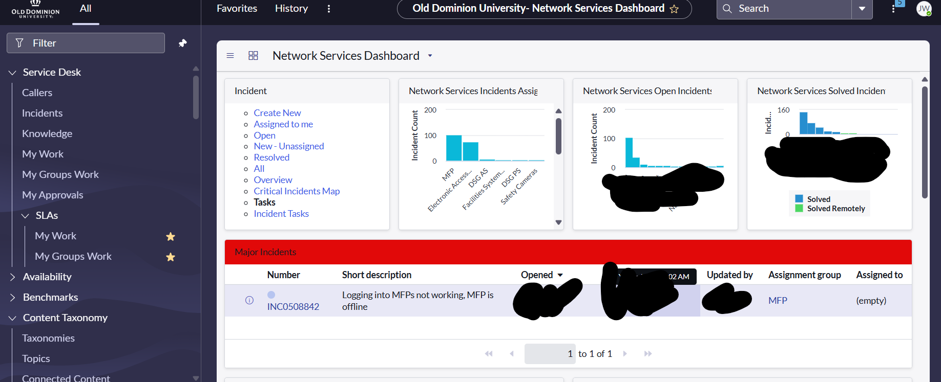

This new dashboard separates our tickets by their specific services we provide. I also helped develop this dashboard this summer before the school year started to promote accountability and assurance of task completion in a timely manner to meet our SLA(Service level agreement) for each of the tasks. With the dashboard we can see the separation of services that my team handles as this was imperative for us to add instead of manually filtering the tickets ourselves. Having them in the GUI proved to increase our teams workflow and productivity.

In our team we are responsible for providing software support for MFP(Multi Function Printers), EAC (Electronic access control systems),Camera systems. In the MFP realm during this time I was supporting the new students by giving them a list of the paper deliveries that needed to be completed by the end of the week by using our in house tool called “Pinnacle”. Pinnacle allows us to get billing information for all departments and charge them for billable work we do around campus.

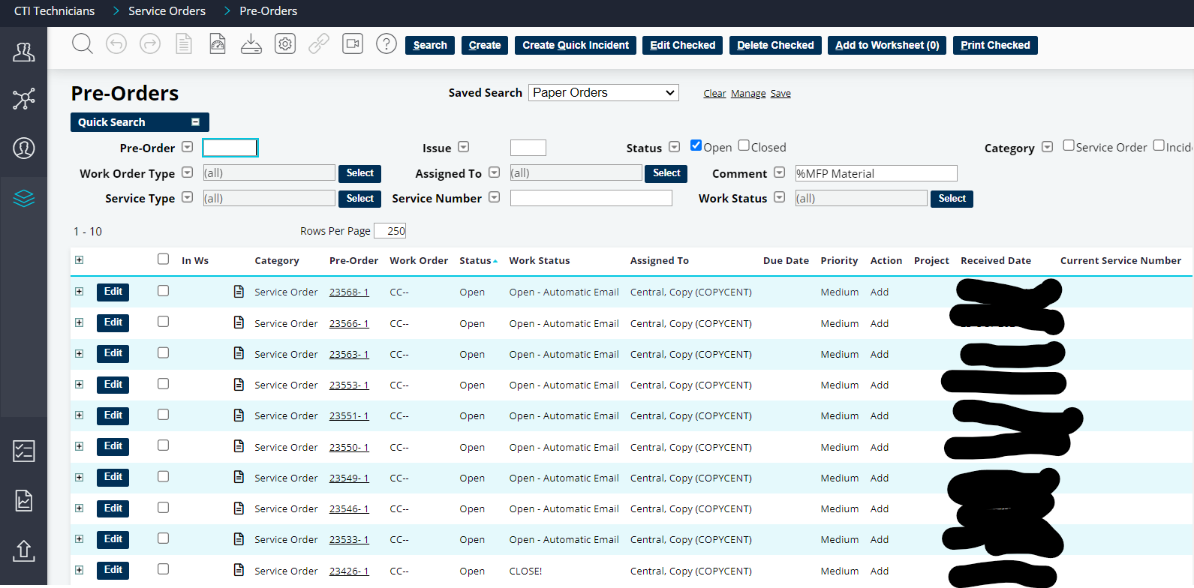

This system allows us to assign work orders to specific departments and allow us to log our time for each service we provide during work hours. Our other services we provide are also billed under pinnacle (EAC and Camera’s). The main 50 hours just included mostly supervision of the new student works and assigning talent to the correct services that were needed for that specific day.