Journal Entry 7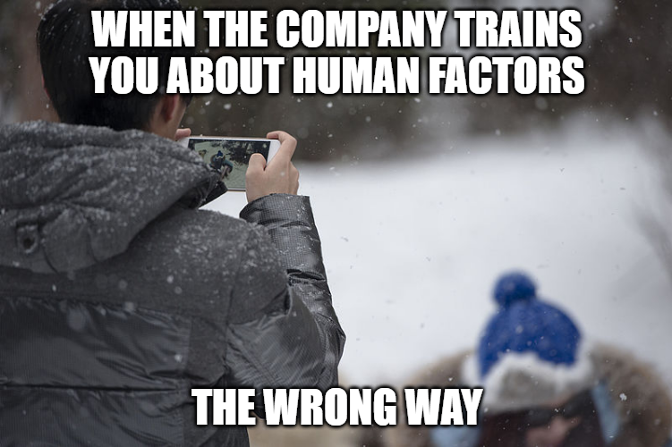

All of the images together tell a story about how human factors are necessary when talking about human-centered cybersecurity. The first photo is someone outside being entertained by their phone instead of enjoying the snow. This represents human error. When talking about human-centered cybersecurity, human error must be reduced to improve business operations. Many cybersecurity professionals aren’t trained in the human factors approach of cybersecurity, so organizations may consider hiring a human factors expert to help educate professionals in the business about human factors in cybersecurity. The second picture represents this with an expert talking to a group of professionals about human factors. The third picture represents a professional that fully understands how human factors work and its importance in cybersecurity. This can be maintained with a human factors program so that human-centric issues can continue to be addressed within the organization and employees continue with ongoing training.

