Damian Richardson

Professor. Mehr

CYSE 270

October 20th, 2024

Lab #7 Manage Local Storage

CYSE 270: Linux System for Cybersecurity

Part I– Check your file system (30 points).  
Submit the screenshot for All the three steps.  
Step 1. Execute the ls /dev/sd* command to see the current hard disk devices. [use sudo ]]

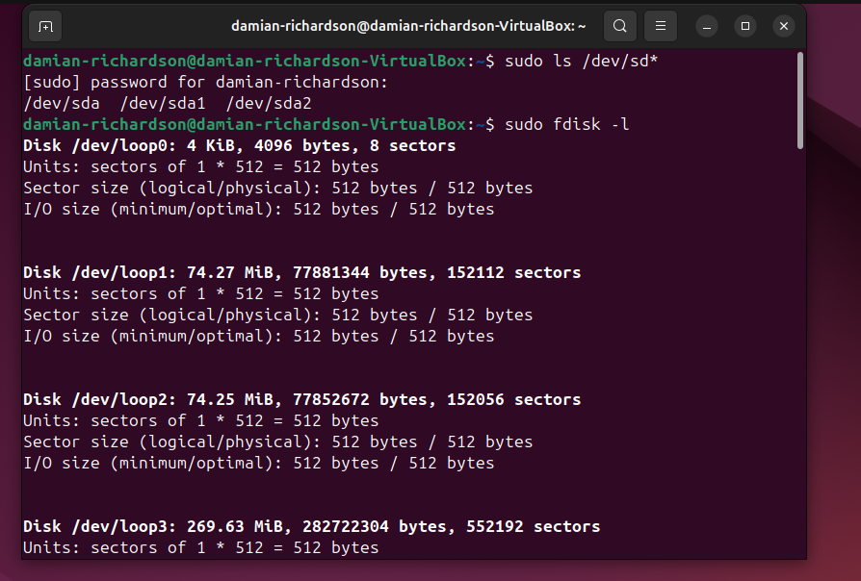  
Step 2. Execute the fdisk -l command to list the current hard disk partitions. [use sudo ]

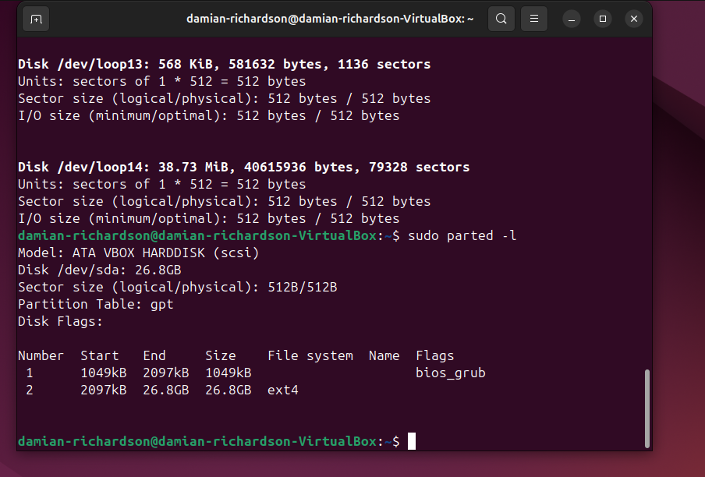  
Step 3. Execute the parted -l command to list the current hard disk partition table. [use sudo ]

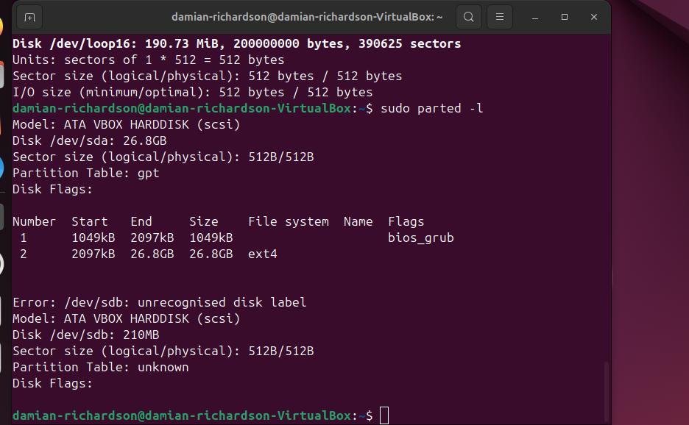  
Part II– Create a new virtual disk (30 points)  
Submit the screenshot for All the three steps.  
Step 1. In the VM setting, attach a new virtual hard disk with the size of 200 MB to our current LinuxVM. Name it as “your_midas.vdi” [ HINT: Please refer to the slides and discussion during the class for week 7]

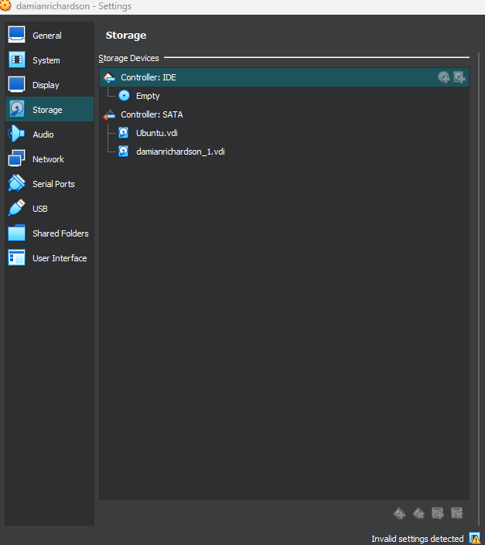  
Step 2. Load this virtual hard disk to your virtual machine.  
Step 3. Repeat the steps in Part I and highlight the differences after adding the new virtual hard disk.



THE NEW HARDDRIVE HAS BEEN ADDED, BUT IT IS UNRECOGNISED BECAUSE IT IS NOT MOUNTED OR PARTIONED.

Part III– Creating Partitions and Filesystems (60 points)  
Submit the screenshot for All the three eight steps.  
Step 1. Use the fdisk command to create a new primary partition on the new virtual hard disk attached in Part II.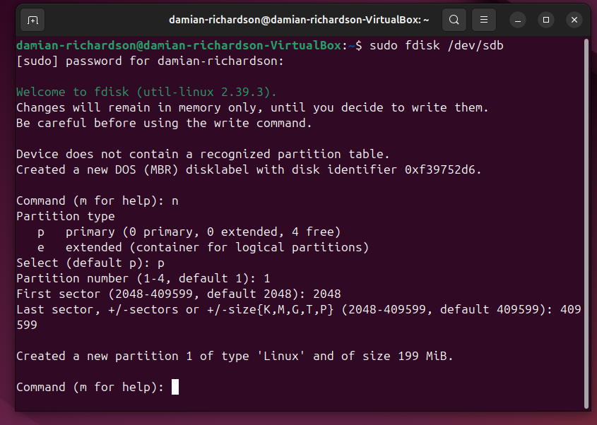  
Step 2. Use the correct command to create an ext4 filesystem on the new partition.

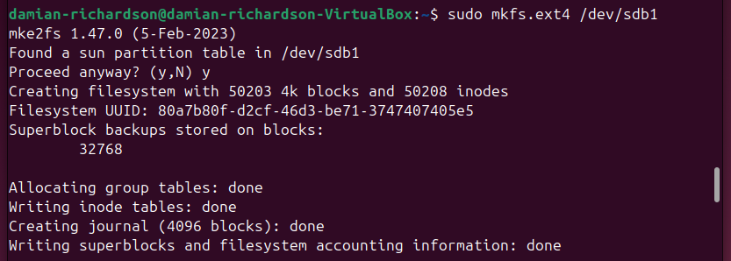  
Step 3. Repeat the steps in Part I and highlight the differences.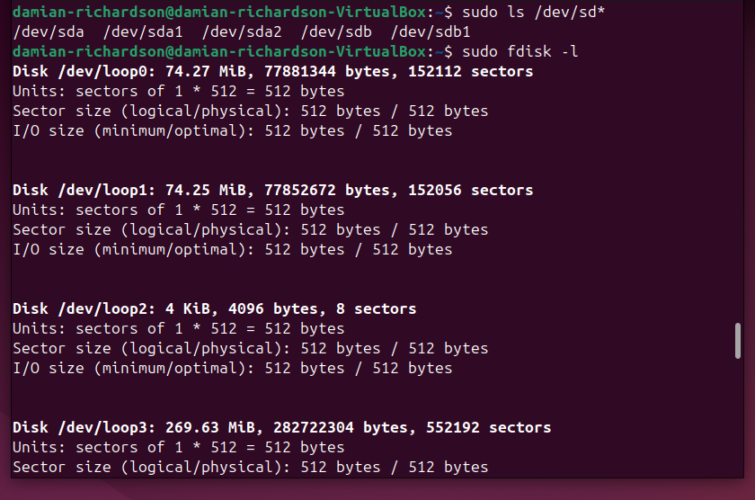

THERE IS NOW A PARTITION TABLE AND THE HARDDRIVE IS RECONGISED. THERE IS ALSO AN EXT4 FILE.

Step 4. Make a new directory named /cyse. And mount the new partition under this directory.

  
Step 5. Use the df command to check the mounting point of the new partition.

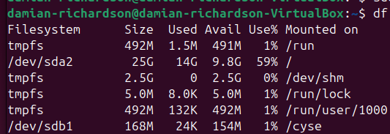  
Step 6. Create a new file named for YourMIDAS.txt (replace YourMIDAS with your MIDAS ID) in the directory /cyse and put your name in that file.  
   
Step 7. Unmount /cyse directory. 

Step 8. Check the contents in /cyse directory. What do you find? 

THERE IS NOTHING IN THIS DIRECTORY BECAUSE THE HARDDRIVE IS NOT MOUNTED.