Damian Richardson
Professor. Mehr
CYSE 270
November 10th, 2024
Lab #9

CYSE 270: Linux System for Cybersecurity
Assignment-9

Task A - Backup your system (Using crontab) [100 points]
Scenario: Performing system backup can be time-consuming, and the process is often overlooked. For this scenario,
- (10 Points) Create a new user Alice (with home directory) and
- (50 Points) Write a shell script that backups Alice’s home directory by creating a tar file (tape archive), using the following steps:
a.
    - Take 2 inputs with their values- your MIDAS name and current date (for example, midas=svatsa).
    - Create a variable named as filename that should be assigned the value as MIDAS-date (example output after executing the script would be like, svatsa2021.3.17-01.16.430).
    - Using tar command, create a tape archive for Alice’s home directory (/home/Alice) and the filename created above (in step-2-ii). (Please learn about tar command in Linux for its usage)
  - Move the tape archive file/tar file (created in step 2-iii) to /var/backups/ directory using correct command in linux.
  - To optimize the disk usage, pick a compression algorithm (bz2, gzip, or xv) to compress the tar file you created in /var/backups/ in the previous step-2b.
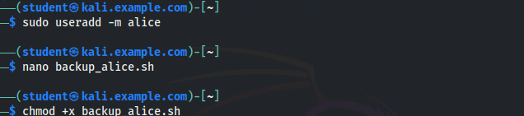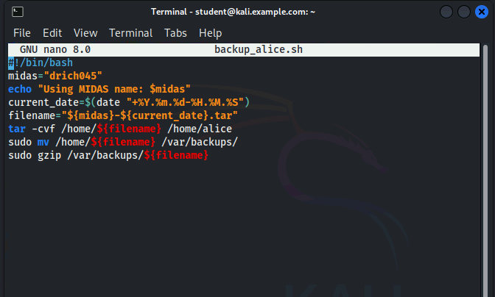
- (30 Points) Create a crontab file to keep the scheduled task running for 3 minutes, then check the contents in the /var/backups directory. Your output should be look similar to the following:
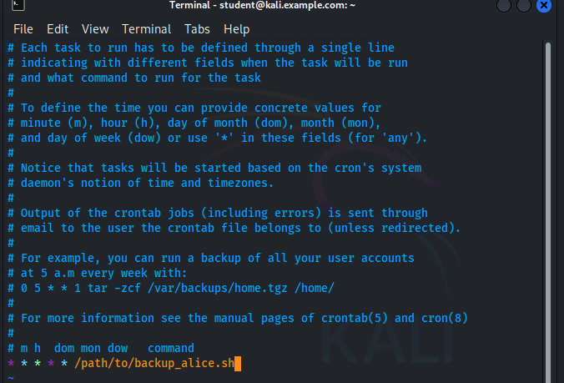
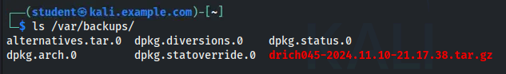
- (10 Points) Cancel the crontab jobs.
