Damian Richardson
Professor Mehr
September 14, 2024
CYSE 270
Assignment #2 “Working With Command Lines”
Task: vi Practice on Ubuntu / Kali Linux (20 * 5 = 100 points)
Open the terminal in your VM, then complete the following tasks. Please take the screenshots
of all the necessary commands that you execute for each step and submit the screenshots with
their step number in a word or pdf file.
NOTE: You may write the correct vi editor commands, if screenshot is not applicable. Please see
the note added to some steps below.
1. Copy the file /usr/share/doc/zstd/copyright to your home directory. [NOTE:
alternatively, you can use any text file that is large if you cannot find this file on yours.
For example: If you are not able to locate copyright file in your VM, you may copy
/etc/passwd file to your home directory to work for lab-3.]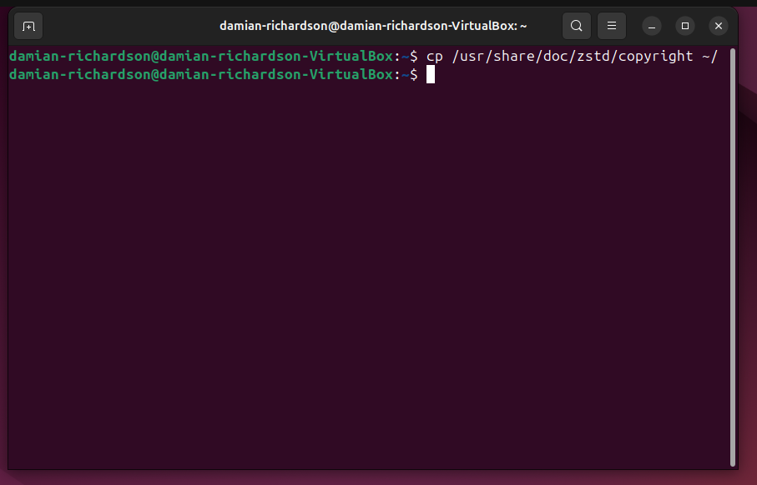
2. Perform a long list in your current directory using the correct command.
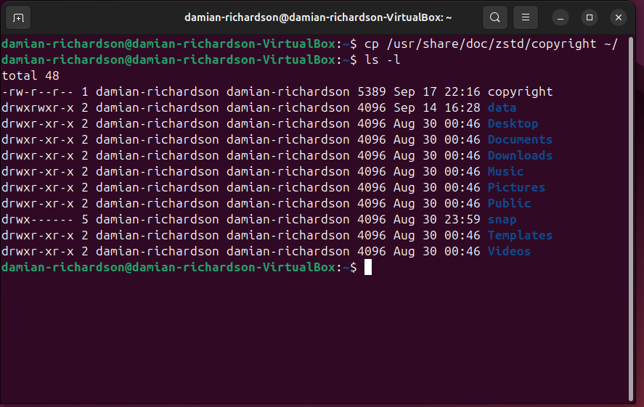

3. Open the file copyright (or any file that is large enough with multiple lines of text) in a
vi-editor using vi command.
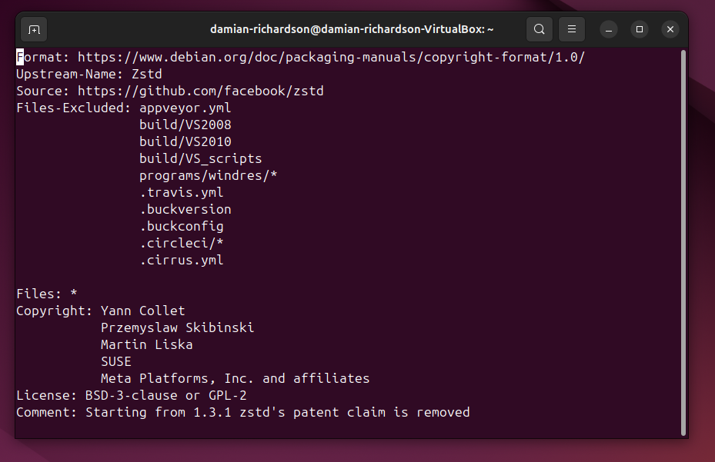

4. Move to line 15, then insert your MIDAS ID in the same line with the following format:
****XXXX****(replace XXXX with your own MIDAS name).
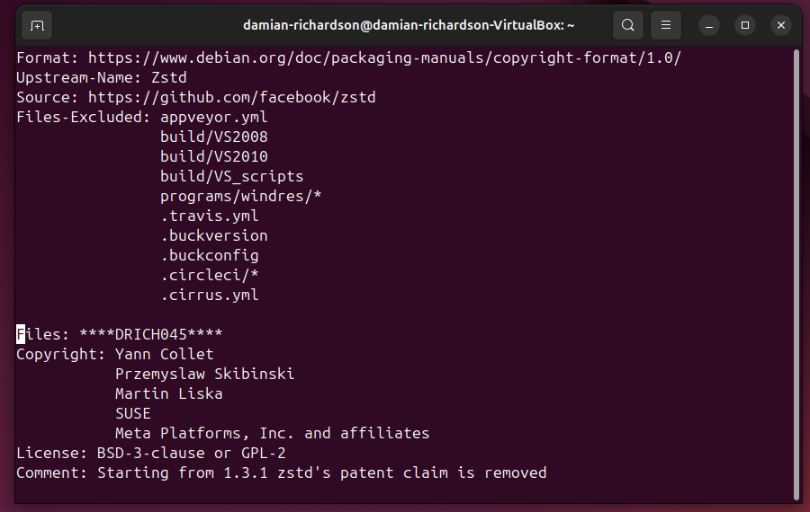

5. Return to the command mode (using ESC key).
6. Open a new line below the current line using correct command (please refer to slides
with the list of commands used in vi editor)
7. Return to the command mode.
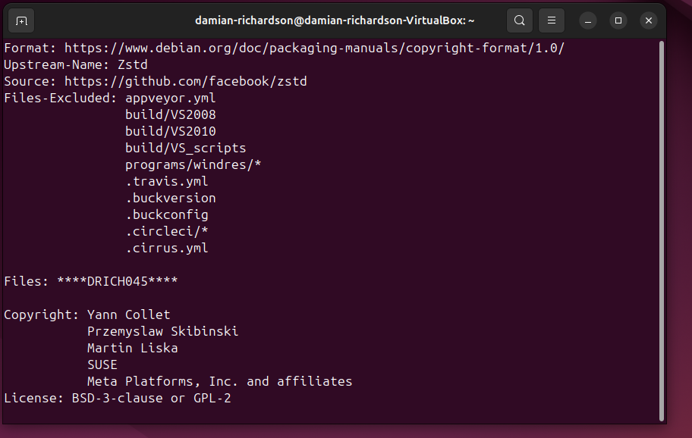

8. Use command to Insert “****XXXX ****” five times.
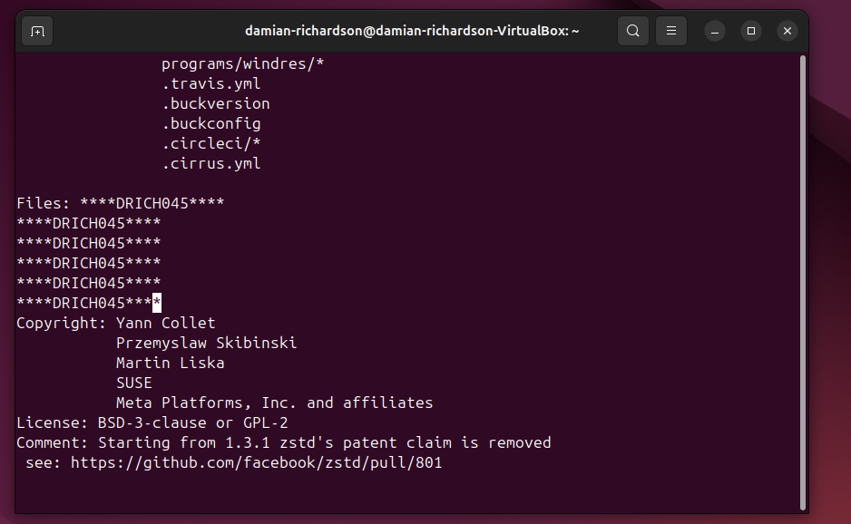

9. Use command to return the top of the file. [Please write the correct command for this
step]
THE COMMAND FOR THIS STEP IS 1G
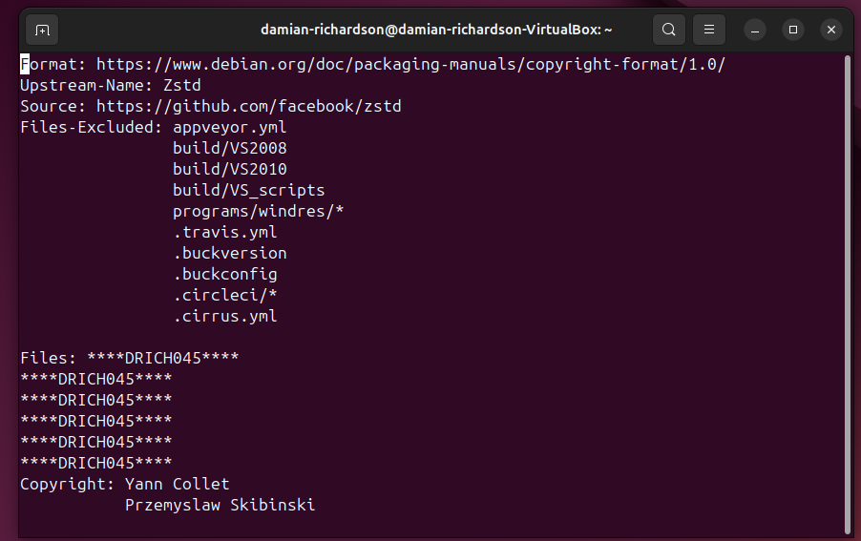

10. Move forward three sentences. [Please write the correct command for this step with
step number] THE COMMAND FOR THIS STEP IS 3)
11. Move forward four words. [Pease write the correct command for this step] THE COMMAND FOR THIS STEP IS 4w
12. Search for the word example or any word existing in the document that you are using
for lab-3. [Please take the screenshot for this step to submit]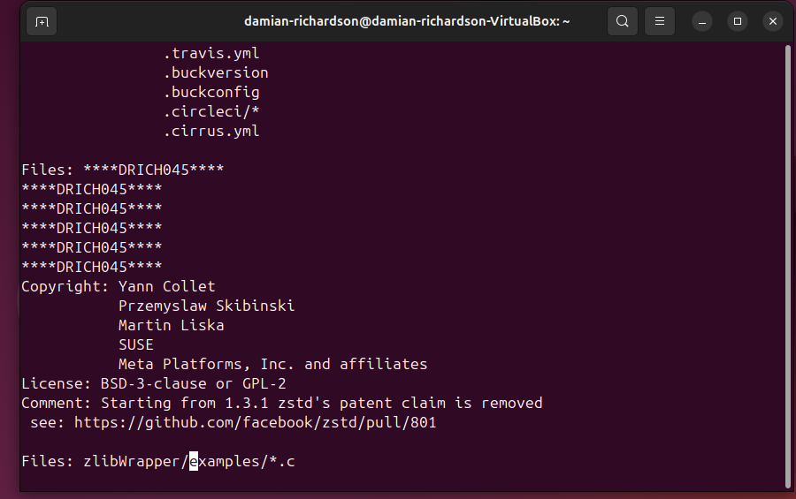

13. Continue to the next occurrence of the search term example. [Please take the
screenshot for this step to submit]
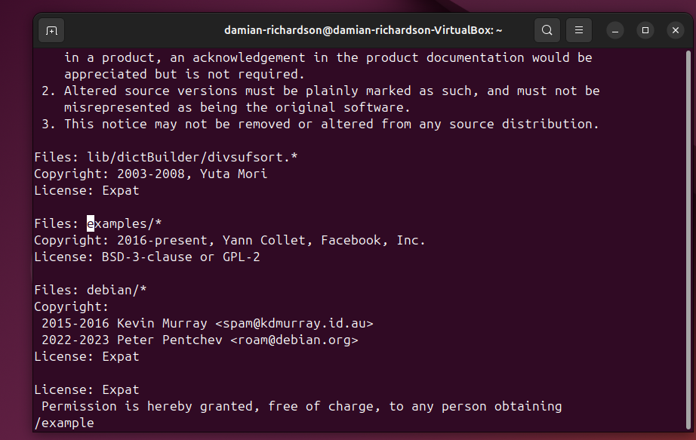

14. Delete the current word, example. [Please take the screenshot for this step to submit]
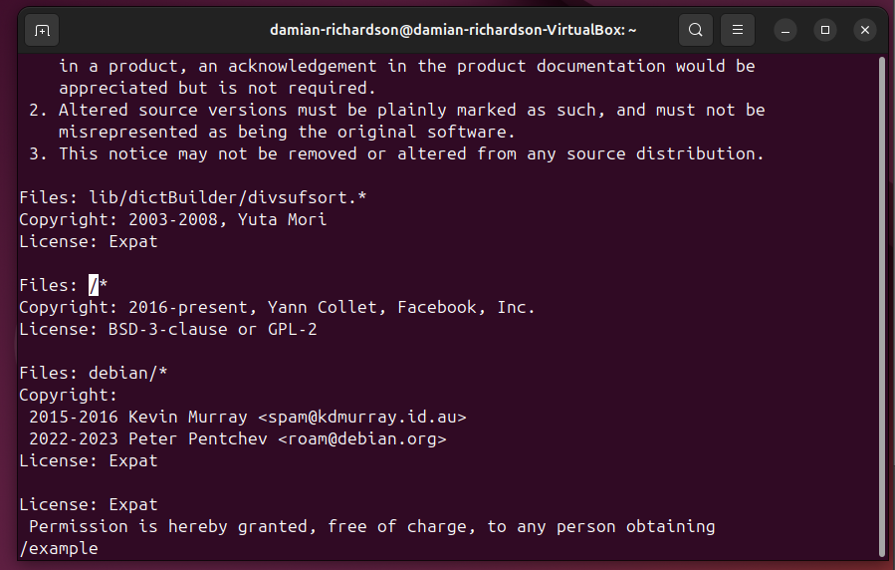

15. Delete the current line. [Pease write the correct command for this step] THE COMMAND FOR THIS STEP IS dd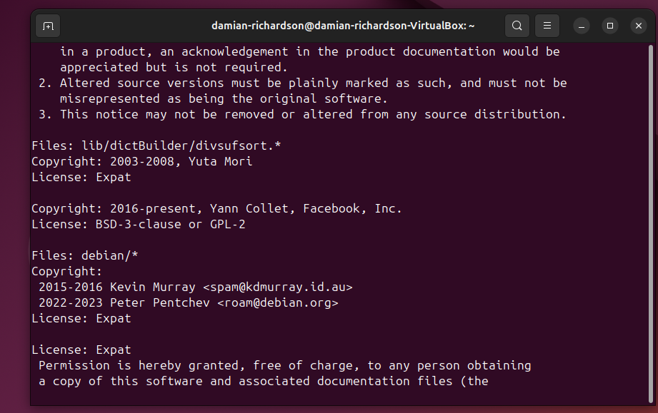

16. Use command to jump to the end of the file.
17. Copy line 16 and paste the text at the end of the document. [Pease write the correct
command for this step] THE COMMANDS FOR STEP 17 IS yy followed by G and p.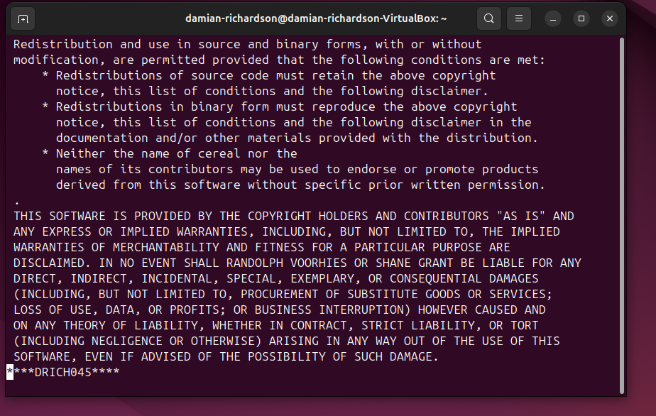

18. Replace all occurrences of http with HTTP throughout the document. [Please take the
screenshot for this step to submit]
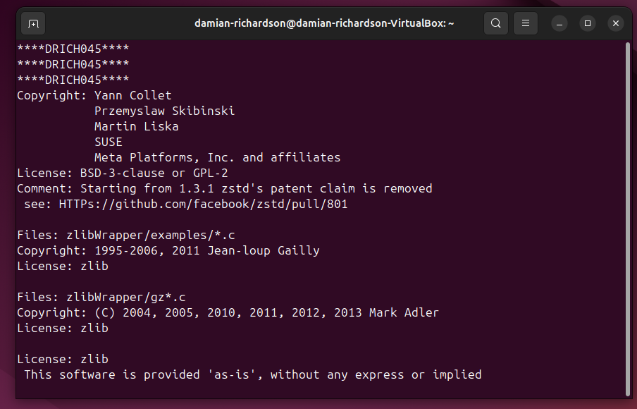

19. Save and quit the document. [Please take the screenshot for this step as well and
submit]
20. Rename the file copyright to copyright_cyse270 [Please take the screenshot for this
step as well and submit]
