REMIX 3

The contiguity principle is about keeping text and imagery closely together to make it easier for the viewer to improve the viewers comprehension of the text and imagery related. This principle is used to prevent readers from being introduced to an image with little to no context then having to scroll to the bottom of the page/image to a caption box that will connect the image to text. The contiguity principle allows for a smoother flow of information gathering and connecting.
For my use of the Contiguity principle, I have a diagram of a cable wiring needed to run through a building and the location of the telecom closet and equipment rooms located in a high school building. I created this diagram along with a budget of the equipment needed in my IT 315 course from a previous semester. The top image is the newly created diagram map using the contiguity principle, the bottom image is the original diagram created at the time during the IT 315 course.

TOP IMAGE
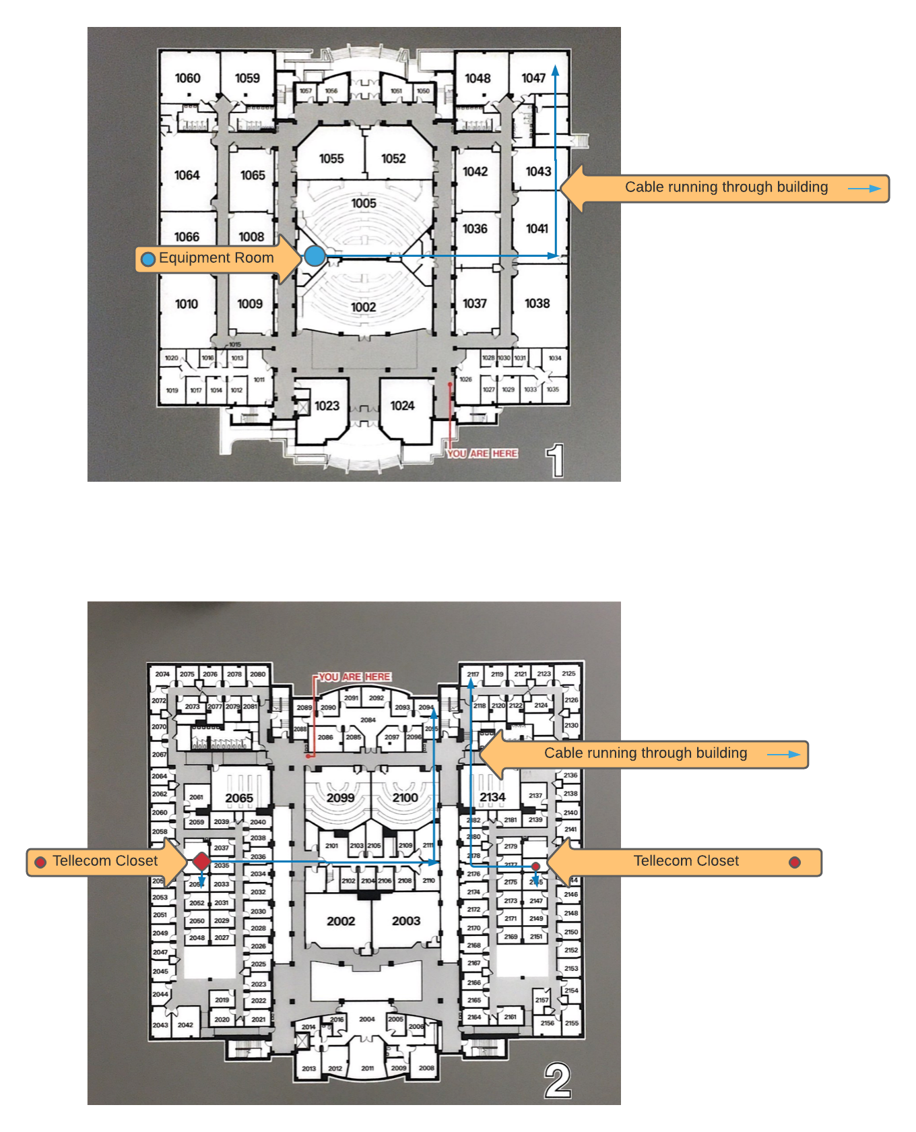
BOTTOM IMAGE
