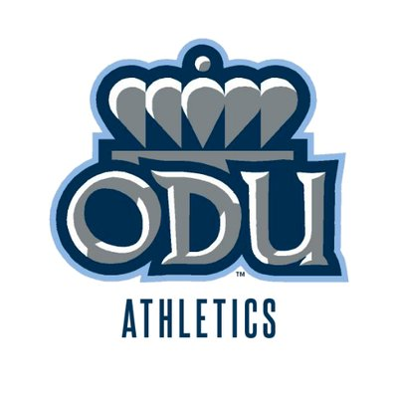

|  |  |  |  |  |
| --- | --- | --- | --- | --- |
| YEAR LONG ODU SPORTS BINGO BOARD | | | | |
| B | I | N | G | O |
| Like your favorite ODU athlete’s Post | Eat a hotdog @ concessions | Sing The ODU Fight Song | Tailgate with a classmate | Take a picture at the Monarch Fountain |
| Buy a jersey | Be on the jumbotron. | Participate in a halftime event. | Wait in line. | Post a picture in ODU gear |
| Record a TOUCHDOWN | Wear your Hudson Blue gear | **BE A ODU FAN**  **(FREE)** | Take a selfie with your favorite ODU athlete (with a mask) | Buy a ticket to an ODU sports event. |
| Follow an ODU athlete | Like a post from all sports twitter account | Buy ODU Gear in Online Store | Watch an ODU game on TV | Sing the Victory Chant. |
| Make it on a ODU sports team’s social media story | Attend an ODU sports event | Play with Taylor Heinicke in Madden | Sing the National Anthem. | Get an ODU Athlete to follow you back on any media outlet |