Devin Matkozich
8/21/2026
CRJS310

Online Sexual Exploitation of Teens: Grooming, Sextortion, and CSAM

Executive Summary

- Online groomers build trust with minors and then manipulate them to exploit their victim’s vulnerabilities.

- Social media has created more opportunities for offenders to communicate with minors, expanding education and safety features are important for protecting teens and children online.

- Sextortion allows offenders to use intimate images and the threat of exposing them to pressure victims into giving them more images, money, or other demands.

- Sextortion can have serious and lasting effects on teenagers like fear, embarrassment, and even self-harm.

- Artificial intelligence (AI) has created new tactics for offenders to exploit children. Using AI, they can create or manipulate sexual images using regular photographs, even if a victim never provided sexual content.

- Protecting children from online sexual exploitation starts with stronger laws and improving education about grooming and sextortion.
Introduction
Starting with the internet and now social media, teenagers have been able to meet new people and make friends easier than ever before. However, these same advancements in technology have also created more opportunities for offenders to find and take advantage of minors. Online sexual exploitation happens when an offender, using the internet, manipulates a minor for sexual purposes. What happens is victims are then being pressured into sending sexual images or videos that might be saved and shared or used against them in a form of blackmail. Three major issues involving online sexual exploitation of teenagers are grooming, sextortion, and the growing use of artificial intelligence (AI).
Online grooming is when an offender starts a relationship with a minor having the intent to first get their trust before they attempt to exploit them. Offenders will often try to pretend to be someone else online. They will use methods like lying about their age to match the victims, because victims might feel more comfortable talking to something they think is their own age. Over time, as the relationship grows, the conversations will progressively become more personal or sexual. This can then lead to the perpetrator asking for sexual images or videos and once sent that is when sextortion usually begins.
Sextortion occurs when someone threatens to expose and distribute a victim’s sexual content unless the victim provides either more sexual content, money, or any other idea the offender has. They will often use a victims fear of having their private photos shared with their friends or family to try to take control over their victims.
With the innovation of Artificial Intelligence (AI), new concerns have been voiced because of how it is being used in the sexual exploitation of minors. AI tools can now generate realistic images and manipulate already existing images, which allows offenders to create sexualized content of a minor without them ever sending sexual images. For example, any photo that has been posted online could be manipulated into a sexual deepfake. The AI generated CSAM creates new challenges for not only victims but also for law enforcement. As technology continues to develop, the importance of understanding how traditional forms of online exploitation like grooming and sextortion occur, as well as keeping up with the newer threats involving AI, is vital in better protecting teenagers online.
Online Grooming
Online grooming is one of the newer ways offenders have been using to take advantage of minors. It happens when an adult uses online communication to get sexual content from a minor. Offenders will often use different manipulation techniques like deception, sexualization, and constant/intense contact to take advantage of children’s vulnerabilities. (Whittle, 2014) While some perpetrators might spend months developing a relationship to gain the victim’s trust, others might introduce sexual content the same day of connecting to them. Since grooming can come in many different forms, it can be difficult for minors and guardians to recognize when it is happening.
One study has shown that while teenagers are vulnerable to online grooming, certain characteristics like social isolation, lack of support, and low self-esteem can increase their risk of becoming a victim. (Reneses et al., 2023) Another study done in 2020, surveyed 1,133 students from the United States and found that 23% reported having long and intimate online conversations with adult strangers while they were minors. Another 17% reported being sexually solicited online by adult strangers. (Greene-Colozzi et al., 2020) Finding out the true prevalence of online grooming can be challenging because incidents often go unreported and minors might not recognize the interactions they’ve experienced were abusive.
Social media platforms provide opportunities for offenders to meet and communicate with minors. As pointed out in Figure 1, Instagram was reported as the most common platform that was used as the method of communication for online grooming. To combat this issue, Instagram took a step to protect children and made Instagram Teen Accounts. For users that are 13-17, they have specific built-in safety settings like private profiles and blocking messages from strangers. Facebook and snapchat have also followed this model to help protect the teens that use them.

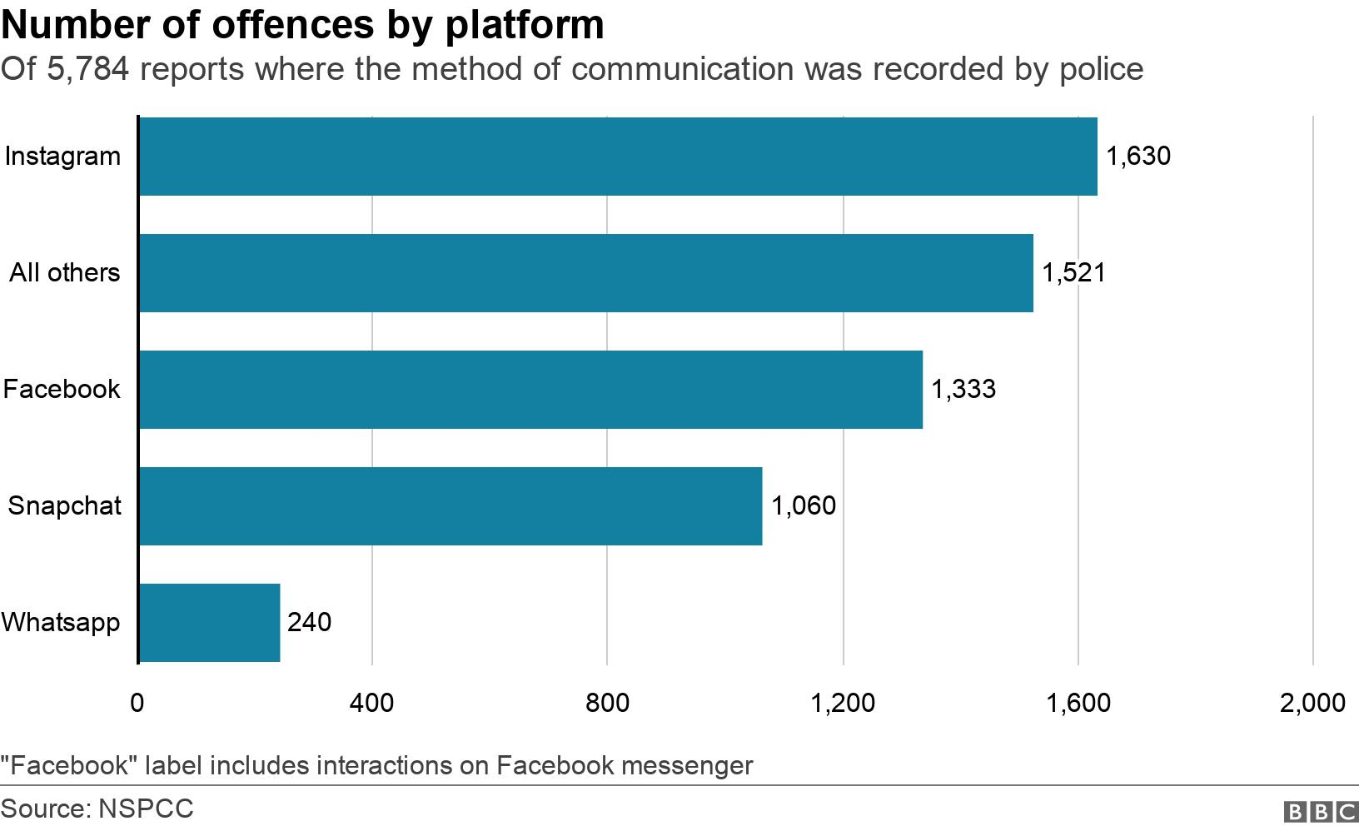
Figure 1. Number of offences by platform
Source: NSPCC, reported by BBC

Sextortion
Once grooming has begun, it can often lead to online sexual exploitation which is also called sextortion. Sextortion is when an offender will threaten to expose a victim’s sexual content to try and force the victim to give them more images, money, or other demands. (Wolak et al., 2017) A lot of criminals create fake online profiles to get close to their victims. In one study they found that 60% of minors actually knew their offenders in real life. (Wolak et al., 2017) Many of the offenders were either past or current romantic partners of the victims. This helps emphasize that sextortion does not always come from complete strangers online but also from individuals that the victim might have already had a relationship with and trusted.
Once an offender has a sexual image, they use the fear of that image being shared with family or friends to pressure the teen into doing things they might not have done before. With the threat of exposing intimate images online looming over them, victims can often feel that they have no other choice but to comply with the demands. While complying might pause the pressure that they’re receiving, it does not guarantee that the offender will delete the pictures or stop making even more demands. This often creates an ongoing cycle of abuse where the offender will continue to gain more control over the victim’s lives. The fear can also make victims afraid to even ask for help. According to Figure 2, a study saw that about 15% of the victims reported physically harming themselves. That is why sextortion can be so damaging for the victims and can have lasting effects on the teenagers even after the offender ceases communication.
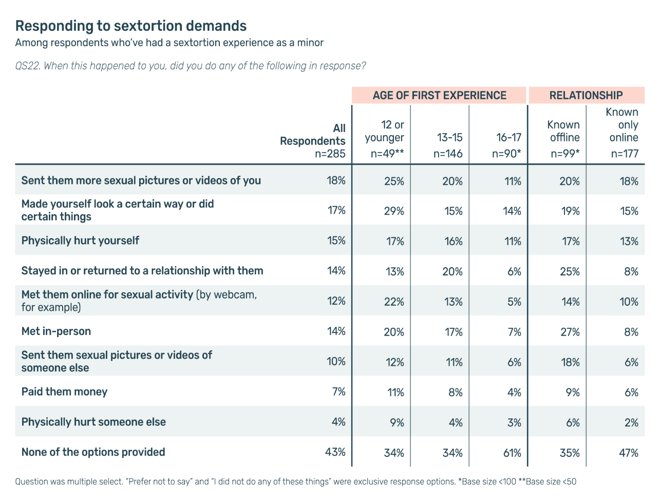
Figure 2. Responding to sextortion demands (Thorn, 2025)

AI and Child Exploitation

With technology continuing to develop, AI has created new ways for teenagers to be sexually exploited online. In the past, offenders would generally need an actual intimate image of a victim to cause that fear that is used in sextortion. Generative AI has changed the dynamic because realistic sexual images can now be created or manipulated using regular photos of an individual. These actions can be characterized into two categories. The first manipulates an already existing image of a teenager to make it sexually explicit, while the other involves creating a completely new image that does not depict an actual child. (Dushi et al., 2025) This new technology has created more concerns for teenagers because even normal pictures from family trips or Instagram can be manipulated without their consent. Figure 3 shows how one study found that 42% of individuals that consumed AI-CSAM had attempted to contact children directly through online platforms. The other 58% were afraid that using AI-CSAM would lead to sexual conduct in person with children or adults.
AI generated content can also be tied directly to other forms of exploitation like sextortion. Since manipulated images of real children can be used to harass the victims, sextortion can take place when no sexual images are even sent. The synthetic CSAM has also created new challenges for law enforcement when trying to track down the offenders. AI has made it so AI generated CSAM can be created in a few seconds and manipulated into another victim just as fast. This makes it more complicated when law enforcement goes to identify these culprits and remove the child abuse from further spreading.

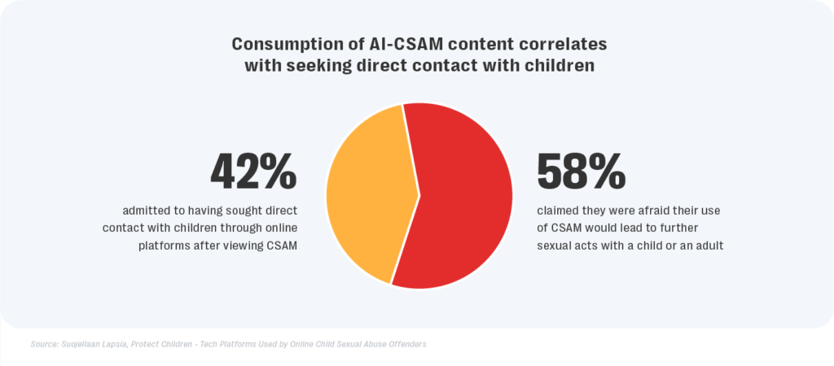
Figure 3. Consumption of AI-CSAM content correlates with seeking direct contact with children
Source: Suojellaan Lapsia / Protect Children, Reported by Kaul, 2024
Moving Forward
As recently as March 25, 2026, the Senate unanimously voted to “remove the requirement that minors be identifiable for the purposes of criminal liability related to sexually explicit depictions of minors.” (Senate Democrats, 2025) While this is a good start to better punish offenders, the EU has been more progressive with their efforts of protecting children. The European Parliament has introduced new laws to combat child sexual abuse crimes more effectively, starting with updating new offenses. Members of the European Parliament (MEP) have made it so offenders that use artificial intelligence systems to produce child sexual abuse material is now illegal. (European Parliament, 2026) Another new law the EU has pushed for was to address and punish online grooming. Now anyone that even proposes to meet a child under the age of consent for sexual purposes can be sent to jail. That includes attempting online solicitation of a child for CSAM and sextortion can be punished with jail time. (European Parliament, 2026)
With the innovations of AI-generated CSAM images becoming more realistic, it is important that society creates more child protection laws. The government and technology companies will need to enforce new practices and continue to adapt to how offenders misuse the tools that AI provides. One way that communities can make it safer for their children is by how we educate them on the issue. Schools should teach children how to spot grooming, fake profiles, and how to shut down the grooming conversations. The National Center for Missing & Exploited Children (NCMEC) has created a list of red flags to stop grooming and could be distributed to schools, then taught to the children. (NCMEC, 2026) The education should extend to helping victims where grooming has already started, so that they have someone to get help from instead of complying to the offender’s demands. Platforms also have a duty to make it so when reporting suspicious accounts that actions are swift and those reviewing the reports are also well trained to spot the issues.
Glossary
Deepfakes: a digital image, video, voice, etc. that has been convincingly generated or altered to misrepresent someone as doing or saying something that was not actually done or said (Merriam-Webster, n.d -a)
Grooming: to build a trusting relationship with (a minor) in order to exploit them especially for nonconsensual sexual activity (Merriam-Webster, n.d -b)
Sextortion: extortion in which a perpetrator threatens to expose sexually compromising information (such as sexually explicit private images or videos of the victim) unless the victim meets certain demands (Merriam-Webster, n.d -c)

References
Reneses, M., Riberas-Gutiérrez, M., & Bueno-Guerra, N. (2023, August 16). Cyberpsychology. https://cyberpsychology.eu/article/view/36761
Greene-Colozzi, E. A., Winters, G. M., Blasko, B., & Jeglic, E. L. (2020). Experiences and Perceptions of Online Sexual Solicitation and Grooming of Minors: A Retrospective Report. Journal of child sexual abuse, 29(7), 836–854. https://doi.org/10.1080/10538712.2020.1801938
Whittle, H. C., (2014, April). An exploration of young people’s vulnerabilities to online. University of Birmingham eTheses Repository. https://etheses.bham.ac.uk/id/eprint/5469/1/Whittle14ForenPsyD_Redacted.pdf
Wolak, J., Finkelhor, D., Walsh, W., & Treitman, L. (2017, May). Sextortion-of-minors-characteristics-and-dynamics.pdf. Journal of Adolescent Health. https://www.unh.edu/ccrc/sites/default/files/media/2022-02/sextortion-of-minors-characteristics-and-dynamics.pdf
Dushi, D., Berdufi, N., & Karagianni, A. (2025, September). The legal framework and legal gaps for AI-generated child sexual abuse material - sciencedirect. ScienceDirect. https://www.sciencedirect.com/science/article/abs/pii/S2212473X2500077X
Senate passes bill banning AI-generated child sexual abuse material. Senate Democrats. (2025, February 6). https://senatedemocrats.wa.gov/orwall/2025/02/05/senate-passes-bill-banning-ai-generated-child-sexual-abuse-material/
BBC. (2020, May 29). Facebook dominates cases of recorded social media grooming. BBC News. https://www.bbc.com/news/technology-52841358 (Figure 1)
Sexual extortion & young people: Navigating threats in Digital Environments. Thorn. (2025, July 28). https://www.thorn.org/research/library/sexual-extortion-young-people/ (Figure 2)
Kaul, A. (2024, April 22). Generative AI is supercharging the creation of child exploitation content | resolver. Resolver . https://www.resolver.com/blog/generative-ai-supercharging-csam-creation/ (Figure 3)
European Parliament. (2026, June 22). Combating child sexual abuse: Agreement on updated rules. News European Parliament . https://www.europarl.europa.eu/news/en/press-room/20260622IPR45906/combating-child-sexual-abuse-agreement-on-updated-rules (European Parliament)
National Center for Missing & Exploited Children. (2026). Online enticement. Online Enticement. https://www.ncmec.org/theissues/onlineenticement? (NCMEC)
Merriam-webster. (n.d.-a). Deepfake definition & meaning - merriam-webster. https://www.merriam-webster.com/dictionary/deepfake
Merriam-webster. (n.d. -b). Grooming definition & meaning - merriam-webster. https://www.merriam-webster.com/dictionary/grooming
Merriam-webster. (n.d.-c). Sextortion definition & meaning - merriam-webster. https://www.merriam-webster.com/dictionary/sextortion

