Questioning Ethics in Cybersecurity
Devin Matkozich
CYSE 280 – Windows System Management & Security
Professor Malik A. Gladden
April 21st, 2026
Introduction
Ethics means doing what is right even when no one is watching, but what happens when everyone is behind a screen? Cybersecurity has been integrated into our daily lives by protecting individuals’ sensitive information from malicious threats. While no protection is perfect, institutions and governments have a role to act ethically when managing and accessing privileged information. Cybersecurity is not only about stopping attacks but also collecting data and so when doing that it is important to keep those powers in check. As technology continues to grow intertwined with our lives, organizations attain more power and profit from users’ data, which raises concern about privacy and control. Government agencies like the National Security Agency (NSA) and the Federal Bureau of Investigation (FBI) are some of the leading organizations responsible for protecting national security, however; some of their methods have raised major questions about ethics. This paper will dive into describing what ethics is related to cybersecurity, how the development of AI has introduced ethical concerns, the role of the government within cybersecurity ethics, and how cybersecurity scandals have highlighted the contrast between security and ethical responsibility.
Ethics within Cybersecurity
Defining ethics in cybersecurity is more than simply following laws and regulations, because of the exponential growth. It involves making decisions that protect users even when there is no legal demand to do so. In an article by Augusta University, they break down how cybersecurity professionals often have privileged access to data so they can attempt to penetrate the same system they are protecting. (Augusta University, 2023) This practice is called white hat hacking or is also known as ethical hacking. Ethical hacking is an essential part of cybersecurity since they have the job of finding weaknesses before the threat actors can exploit them. While it is necessary for them to have private access to company’s networks, it also raises alarms about trust and responsibility from those directly involved. Considering that the information the professionals are protecting happens to be the exact same data that the hackers are working to steal, is why it is important for cybersecurity professionals to follow strict ethical standards. In Figure 1, it shows that cyber incidents have increased significantly over time, which agrees with the proposal that as the internet evolves, cybercrime does too.
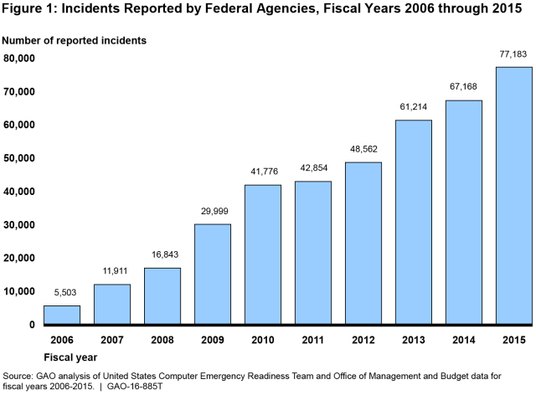
Ethical AI in Cybersecurity
With the rapid development of Artificial Intelligence (AI), the increase in the number of new ethical concerns is rising within cybersecurity. AI is used for detecting threats and responding to them faster than humans could, it can also absorb and analyze massive amounts of data quicker as well. While AI can be a great tool for cybersecurity communities, it also makes some groups question how much control these systems should have and how the data they rely on is collected and used. One of these groups is Harvard professor Michael Impink, the instructor of AI ethics in business, who believes that biases are one of the biggest ethical issues that AI faces. Impink suggests that the three main causes of biases in AI: the programmers, the algorithm, or the data used to train the system. (Short, 2026) Seeing that AI is trained on large amounts of human material, there is a possibility to reflect human biases or even reveal sensitive personal information. The increased risk of biased outcomes and privacy concerns, forces organizations like National Institute of Standards and Technology to make guidelines with the goal of encouraging more responsible AI use. This helps underline the efforts being made in cybersecurity to carefully balance efficiency with the ethical responsibilities of user’s privacy.
Figure 2
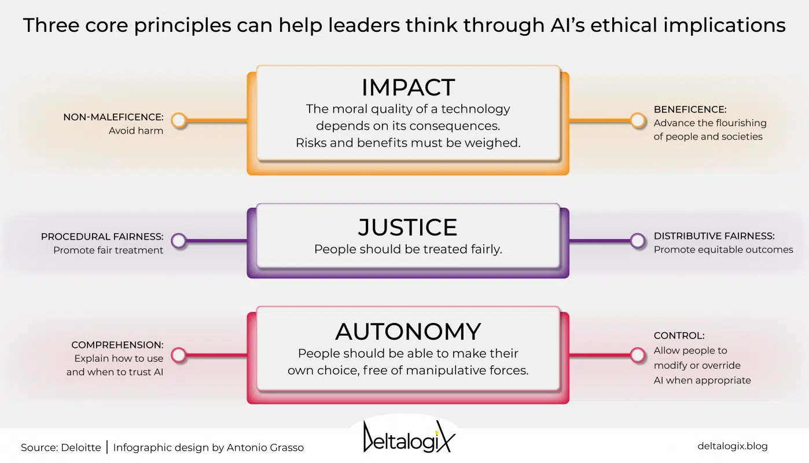

Government Scandals in Cybersecurity
For all the good that the government does in enforcing cybersecurity policies, there have been a few scandals that raises some serious ethical questions about their own practices. One of the most well known and controversial examples is the Edward Snowden leaks. Snowden exposed that the NSA had been carrying out large scale surveillance on U.S. citizens. The programs that they were operating collected massive amounts of data. It included phone calls/texts and internet searches, without public knowledge or consent. (Younger, 2020) While government officials have said their actions were necessary for national security, many critics like Snowden argued that spying on U.S. citizens goes against their right of privacy. The main issue is deciding whether protecting national security is warranted, even if it violates citizens’ freedoms. Snowden did break the Espionage Act of 1917, because he revealed that the government was surveying its own citizens. However, that does not necessarily make his actions wrong. This situation underlined that there are complex dilemmas within cybersecurity ethics, where some efforts to increase safety have come at the cost of citizens privacy.
Figure 3

Governments’ current cybersecurity ethical guidelines
The government has the important job of establishing guidelines for the cybersecurity industry, which is then used to promote ethical behavior for organizations while also protecting citizens’ sensitive information. After the Snowden situation, the government’s cybersecurity guidelines got a lot stricter and are now more focused on transparency and protecting data, not stealing it. Two organizations who are leaders in providing ethical frameworks are the National Institute of Standards and Technology (NIST) and the Cybersecurity & Infrastructure Security Agency (CISA). The most prevalent system is NIST’s Cybersecurity Framework 2.0, it focuses on 5 key goals: Identify, Protect, Detect, Respond, and Recover. (NIST, 2024) Together, these functions help organizations manage cybersecurity risks while still encouraging responsible techniques for handling data.
Figure 4
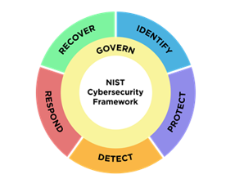
While NIST focuses more on technical aspects, CISA’s AES Code of Ethics and Compliance reinforces the ethical expectations that people learning about cybersecurity should follow through their codes of conduct. CISA’s goal is to “ensure all students are given every opportunity to learn in a safe, ethical, and protected environment.” (CISA, 2023) Their guidelines promote students looking to learn about cybersecurity to act with integrity, protect sensitive data, and lastly to ensure no one exploits or mishandles privileged information. Both of these guidelines are used together with the goal to encourage not only strong cybersecurity practices but to also have a strong ethical compass while doing so.
Conclusion
Ultimately, ethics within cybersecurity is extremely complex and continuously evolving, especially when new issues develop that go beyond just simply protecting systems from hackers. As the rapid growth of technology continues, both governments and organizations are faced with increasing responsibility to act ethically when protecting users’ sensitive information. This report broke down what ethics is related to the cybersecurity community. Emphasized the significance of protecting user data, while still maintaining principles such as transparency, accountability, and trust. Along with covering, how even though the government has started to get more involved in regulating companies, it has also faced criticism for its contradictions. One example to illustrate is Edward Snowden’s case, where the government labeled a criminal for whistleblowing. While many U.S. citizens argued his whistle blowing was not only ethical but even heroic for exposing the NSA for violating citizens privacy. This emphasizes the difficulties of balancing protection and security versus individuals’ privacy. Additionally, artificial intelligence has introduced a growing number of ethical concerns. Specifically with the lack of transparency from either the programmer or the data which can often lead to biases and misuse of that same information. Lastly, while current guidelines do provide a strong foundation, they do not always guarantee ethical behavior in practice. The cybersecurity ecosystem is always advancing, and so should the ethical standards and regulations that organizations should use. It is important that the community continues to push for responsible, transparent, and ethical use of technology in cybersecurity.

References
Augusta University. (2023, August 21). Cybersecurity ethics grows in urgency as the digital landscape continues to Transform Society. Cybersecurity Ethics: What Cyber Professionals Need to Know. https://www.augusta.edu/online/blog/cybersecurity-ethics
Short, L. (2026, March 6). Ethics in AI: Why it matters - professional & executive development: Harvard DCE. Professional & Executive Development | Harvard DCE. https://professional.dce.harvard.edu/blog/ethics-in-ai-why-it-matters/#The-Future-of-AI-Ethics
Nardo, C. D. (2025, November 27). Ethics and artificial intelligence: What is the real dilemma?. DeltalogiX. https://deltalogix.blog/en/2022/04/05/ethics-and-artificial-intelligence-what-is-the-real-dilemma/
Office, U. S. G. A. (2026, April 23). Federal Cybersecurity challenges. U.S. Government Accountability Office (U.S. GAO). https://www.gao.gov/blog/2016/10/06/federal-cybersecurity-challenges
University of Texas. (2023, February 15). Edward Snowden: Traitor or hero?. Ethics Unwrapped. https://ethicsunwrapped.utexas.edu/case-study/edward-snowden-traitor-hero
The NIST Cybersecurity Framework (CSF) 2.0. National Institute of Standards and Technology. (2024, February 24). https://nvlpubs.nist.gov/nistpubs/CSWP/NIST.CSWP.29.pdf
Cybersecurity & Infrastructure Security Agency. (n.d.). AES code of Ethics and compliance | cisa. America Cyber Defense Agency. https://www.cisa.gov/resources-tools/resources/aes-code-ethics-and-compliance
Younger, N. (2021, February 23). The case of Edward Snowden. National Whistleblower Center. https://www.whistleblowers.org/news/the-case-of-edward-snowden/

