TalkAbroad - Student Workbook

SPAN 102 – Beginner Spanish II

## Conversation 2 – La buena salud y la comida (U7-U8)

### Prepare (45 min)

* Schedule your conversation
  + Remember to schedule at least 36 hours in advance.
* Review
  + Review relevant vocabulary.
  + Learn at least 10 new words about this topic.

|  |  |
| --- | --- |
|  |  |

* Plan
  + Write a list of 4-5 questions you can ask your conversation partner about how they incorporate healthy routines into their daily lives and habits and activities they consider promote good health.
* Write a list of 4-5 questions you can ask your conversation partner about their favorite and non-favorite foods and places they like to eat; a regional or unique dish of their country
* Avoid questions that elicit a simple one-word (yes/no) answer.
* Think about how you would respond to each of the questions if they were asked to you (prepare for any vocabulary that you might not know).
* Read through the Interact and Reflect portion of the sequence to help anticipate any other questions you might need to ask of your partner.

_________________________________________________________________________

_________________________________________________________________________

_________________________________________________________________________

_________________________________________________________________________

_________________________________________________________________________

_________________________________________________________________________

_________________________________________________________________________

_________________________________________________________________________

_________________________________________________________________________

_________________________________________________________________________

_________________________________________________________________________

________________________________________________________________________________

_________________________________________________________________________

_________________________________________________________________________

_________________________________________________________________________

_________________________________________________________________________

* Practice
  + Practice asking your questions out loud. Can you answer your own questions?
  + If available, find a partner from class and practice asking and answering questions together.
* Consider
  + What are some places that you notice you are having trouble communicating? Are there any new words or structures that you can learn before your conversation?

_________________________________________________________________________

_________________________________________________________________________

_________________________________________________________________________

_________________________________________________________________________

* + What are some techniques to help navigate a conversation? What sort of phrases would be helpful?

_________________________________________________________________________

_________________________________________________________________________

_________________________________________________________________________

_________________________________________________________________________

### Interact (15 min)

Remember, you do not have to talk for the entire 15 minutes. It is a conversation! Aim to participate in at least 60% of the conversation.

* (1-2 Minutes) Introduce yourself to your conversation partner and get to know some basic information about each other.
* (7-8 min) Ask your partner how they incorporate healthy routines into their daily lives. What are habits and activities they consider promote good health. Discuss any other areas of wellbeing you would like to discuss.
* (7-8 minutes) Talk about your favorite foods and places to eat. Ask your conversation partner about their preferences. What are some foods that you do not like to eat? Places you do not prefer to eat? Ask and share about some of the regional dishes in your country. What are some foods that are unique to your respective countries? Which foods do you have in common? What influences from other countries do you notice?

* Tips
  + Try to *think* in the language of your conversation. Your ability to think in English is much more complex right now and often, problems arise when you think of something to say in English that you are not able to say in the target language.
  + If there are words or major ideas that you don’t understand, please ask your partner to help explain/elaborate.
  + Remember, the conversation will be recorded so you don’t have to understand 100% of what your partner says during the conversation. You will have time later to look up specific words.
  + If your conversation goes a bit off topic, *that is ok*! The important takeaway from this is that you are building the ability and confidence to interact in the language.
  + When your partner answers a question, try to ask a related follow-up question instead of moving directly to another prepared question that might not be related.

### Reflect

* Review
  + Download and listen to the audio recording of your conversation.
* Write **in English**
  + Overall, how did your conversation go? Explain

_________________________________________________________________________

_________________________________________________________________________

_________________________________________________________________________

_________________________________________________________________________

* + About what percentage of your partners' speech did you understand?

_________________________________________________________________________

_________________________________________________________________________

_________________________________________________________________________

________________________________________________________________________

* + What are three things that you would phrase or say differently after having listened to your conversation?

_________________________________________________________________________

_________________________________________________________________________

_________________________________________________________________________

_________________________________________________________________________

_________________________________________________________________________

_________________________________________________________________________

_________________________________________________________________________

* + List three interesting things you learned about your conversation partner based on their answers to your questions.

_________________________________________________________________________

_________________________________________________________________________

_________________________________________________________________________

_________________________________________________________________________

_________________________________________________________________________

___________________________________________________________________________________________________________________________________________________________________________________________________________________________

* + What sort of cultural inferences or comparisons can you make about your interaction with your partner? If there is insufficient evidence, what comparisons can you make between your families?

_________________________________________________________________________

_________________________________________________________________________

_________________________________________________________________________

_________________________________________________________________________

_________________________________________________________________________

_________________________________________________________________________

_________________________________________________________________________

* + List three new words you learned from this conversation.

_________________________________________________________________________

_________________________________________________________________________

_________________________________________________________________________

* + Is there anything else about the language that you noticed?

_________________________________________________________________________

_________________________________________________________________________

_________________________________________________________________________

_________________________________________________________________________

* + What can you do to better prepare for your next conversation?

_________________________________________________________________________

_________________________________________________________________________

_________________________________________________________________________

_________________________________________________________________________

## Detailed Student Setup

### Account Setup

1. Navigate to [talkabroad.com](http://talkabroad.com)
2. If you already have an account, click ***Login*** and then skip to step 8, Class Registration.

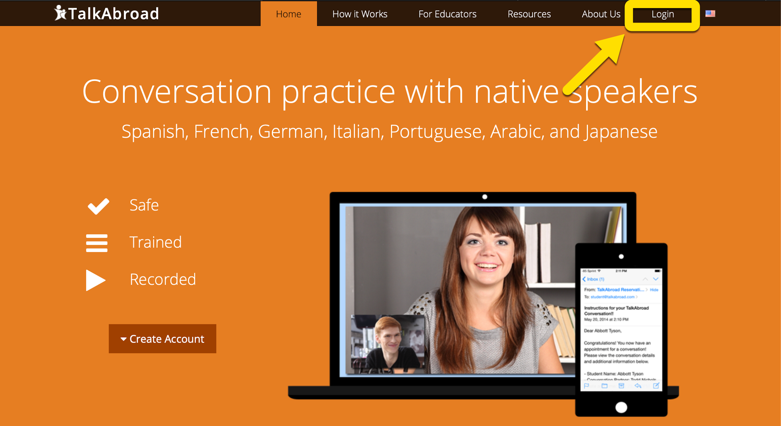

1. If you do not already have an account, click ***Create Account****.*

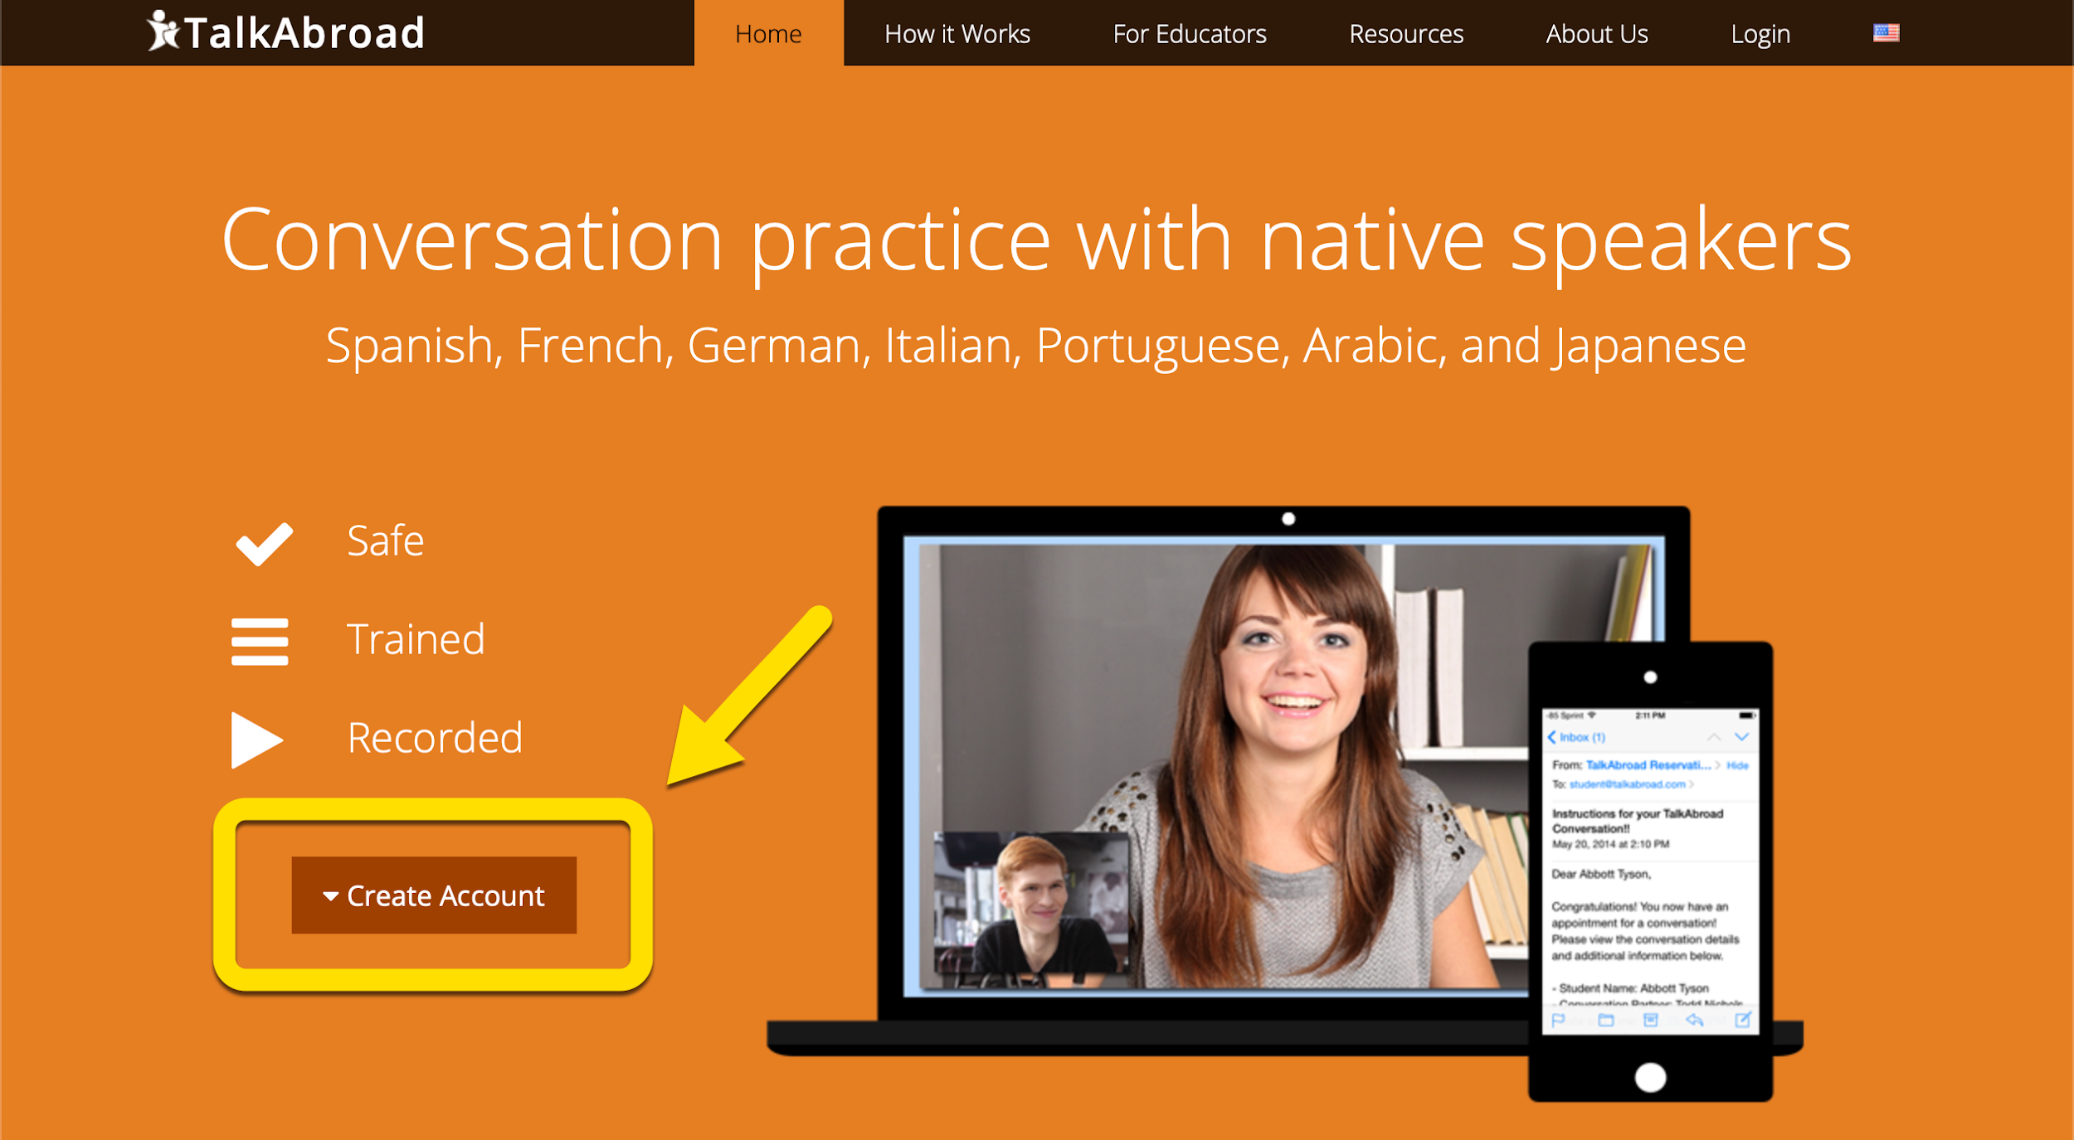

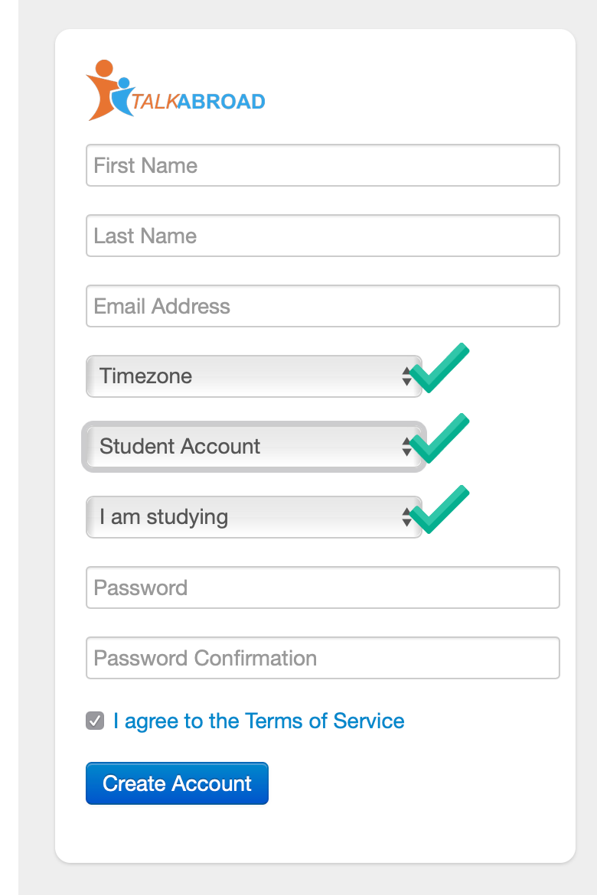

1. Fill out your required information and be sure to:

select the time zone where you live, the Student Account option, and the language you are currently studying.

Don’t forget to agree to the Terms of Service.

1. After clicking on *Create Account* you will see a confirmation page that asks you to verify your Email account to finalize the account creation.

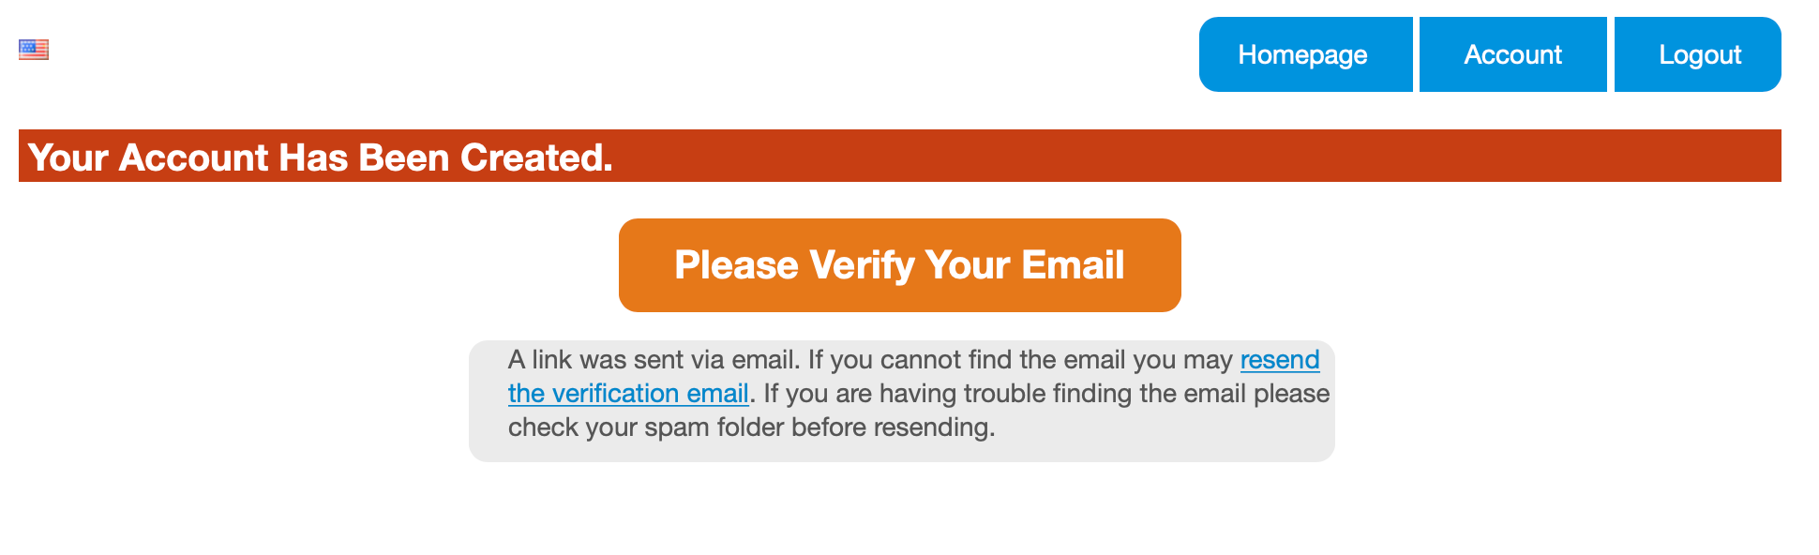

1. Sign in to the email account that you provided to verify the account and follow the link provided.

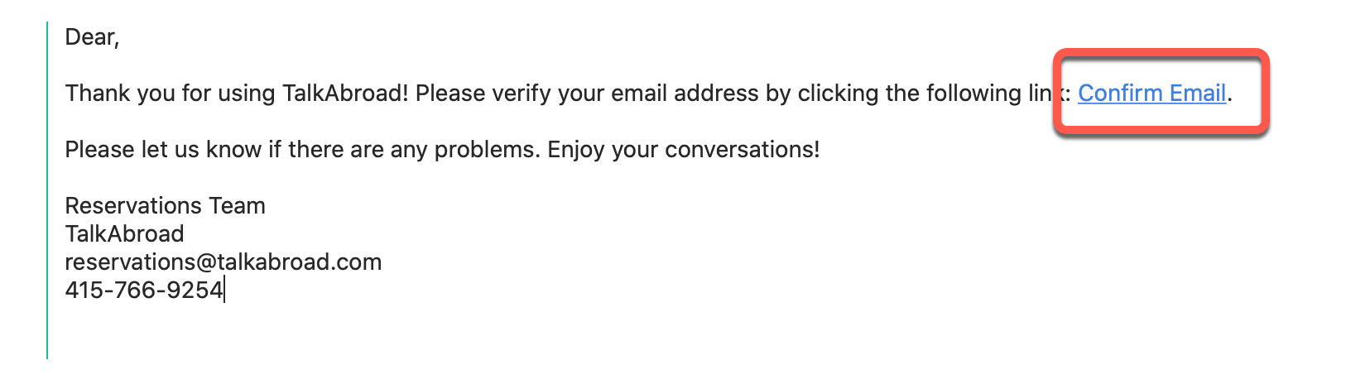Class Registration

1. After clicking on the *Confirm Email* link, you will be redirected to talkabroad.com and asked to enter a Section Code. When prompted, enter the section code provided by your instructor. Then click *Submit*.

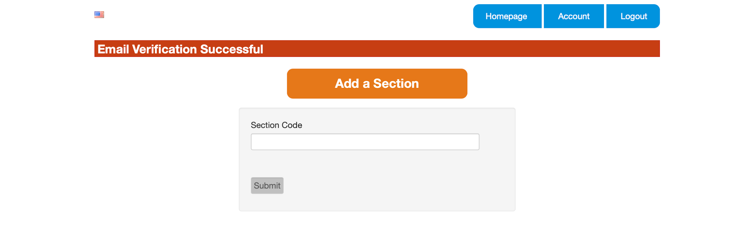

1. If you already have an account you can click on the *Account* tab from the student homepage section and then *Add New Section*. When prompted, enter the section code provided by your instructor. Then click *Submit*.

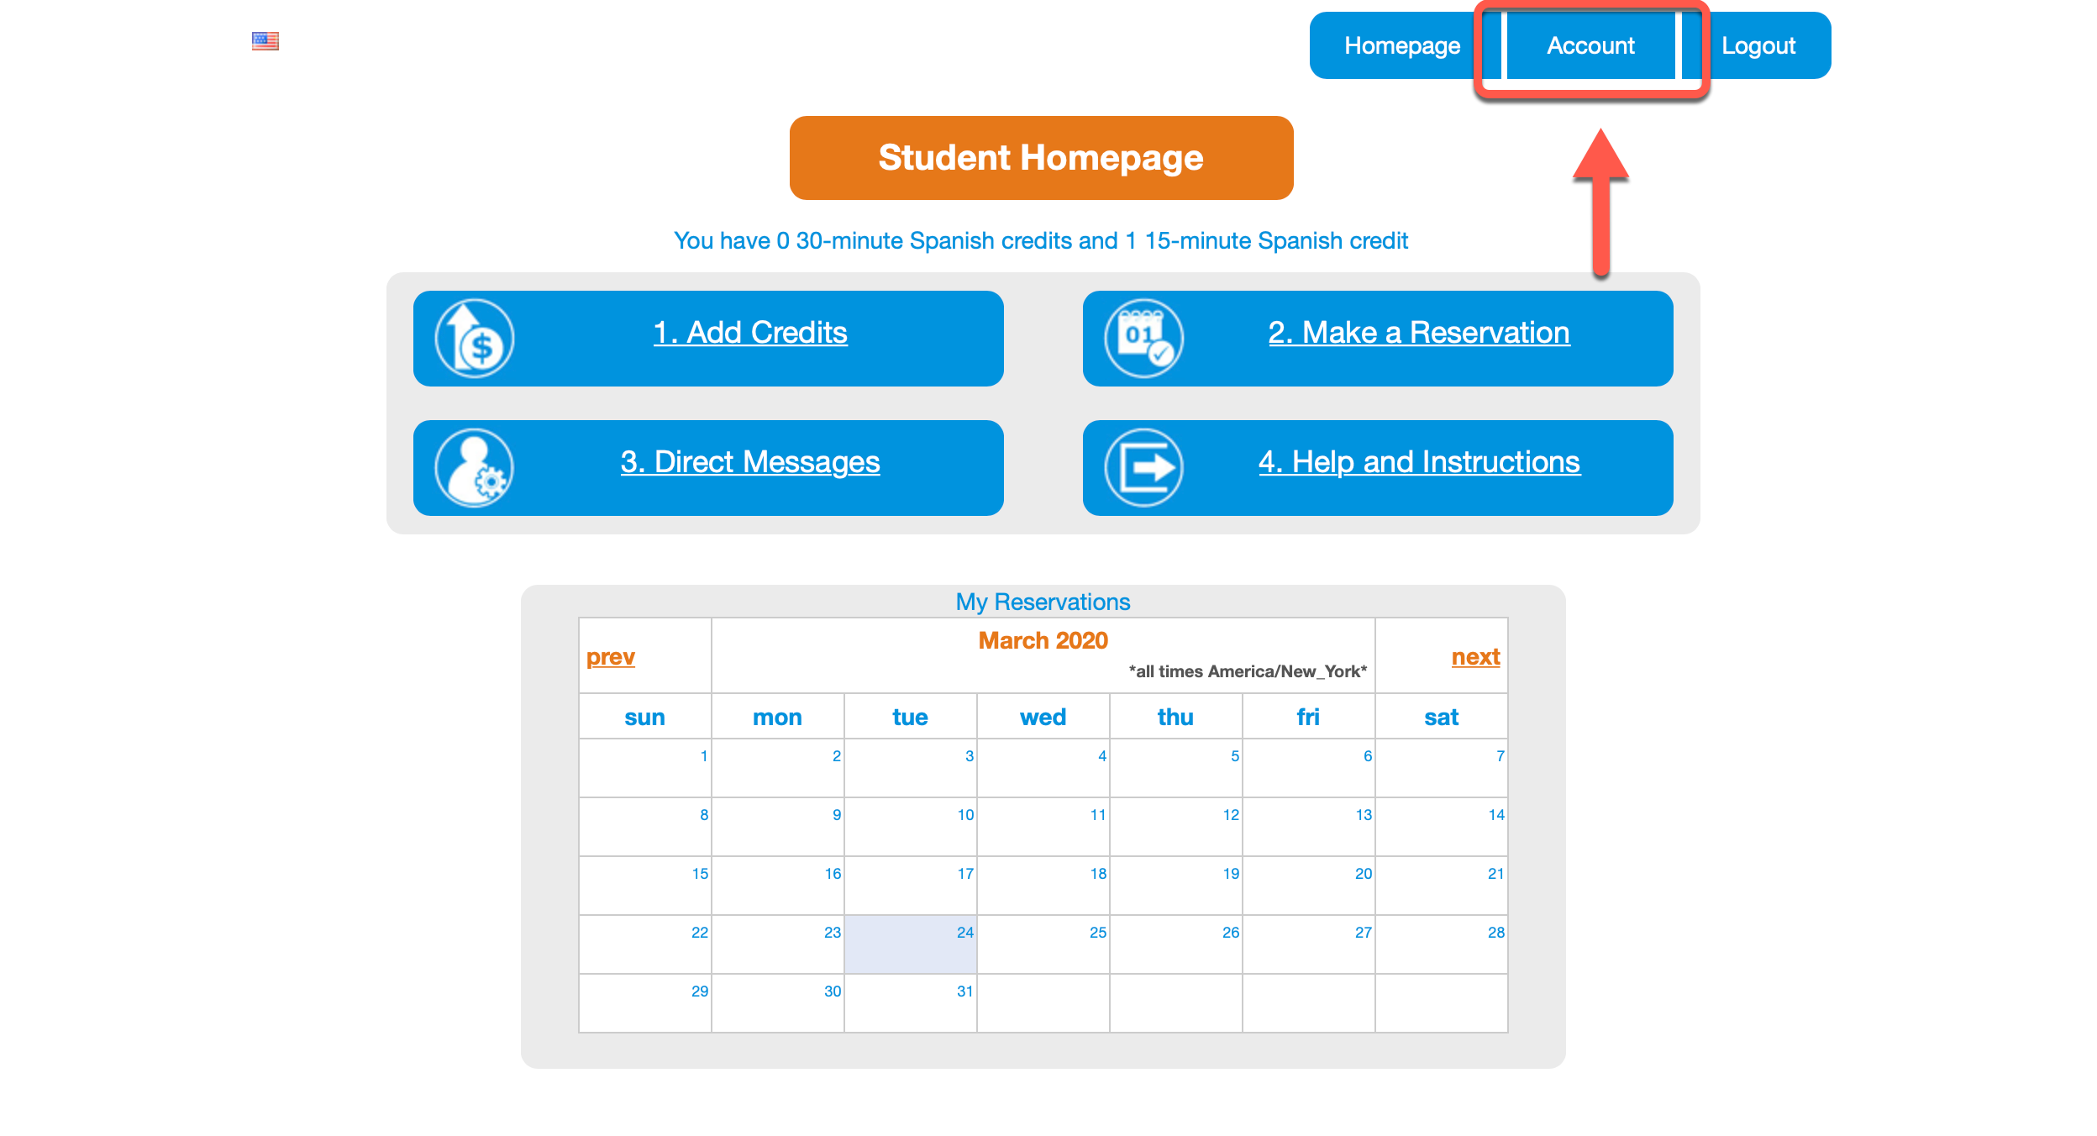

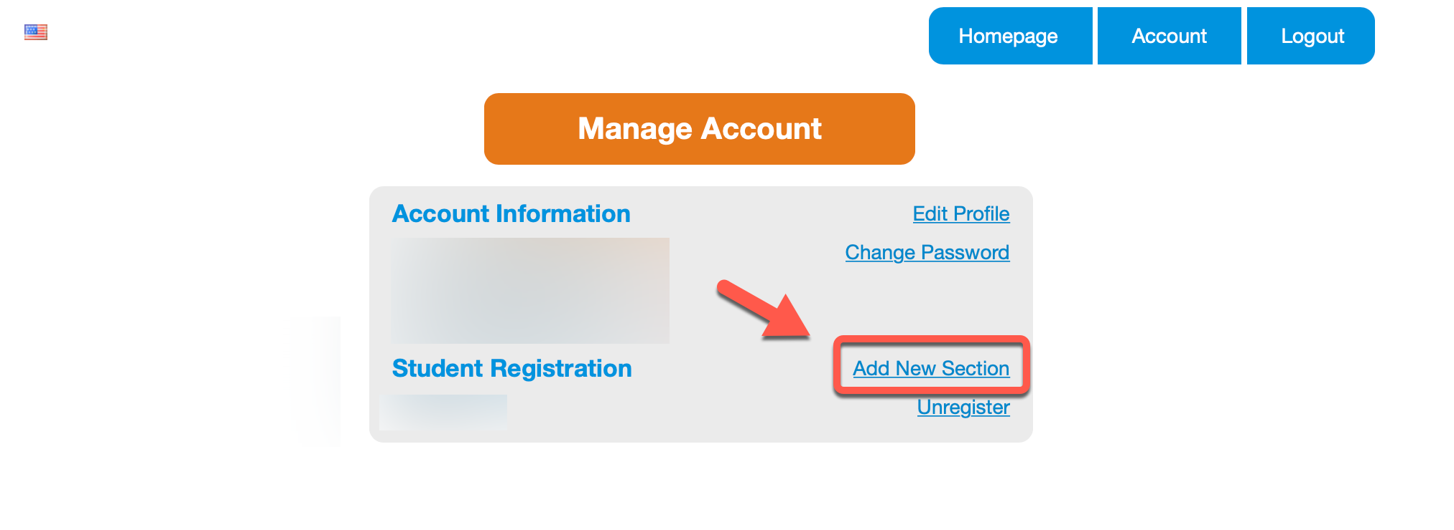

### Purchase Credits

1. From the Student Homepage click *Add Credits*.

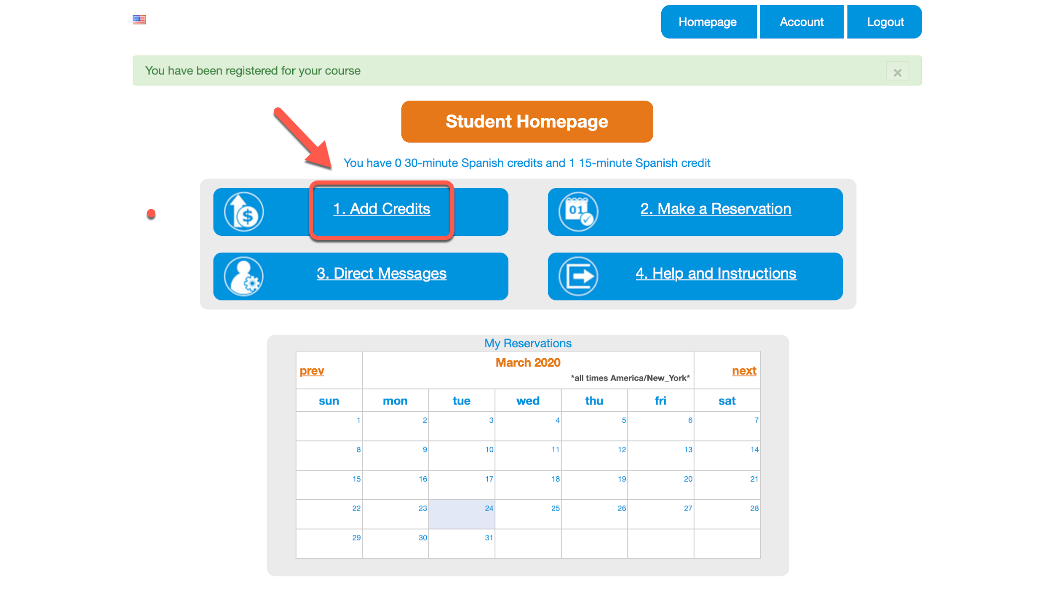

1. The Purchase Credits screen will show you how many credits you already have and allow you to purchase new credits. The appropriate language will be pre-selected for you. Select the number of credits for the *15-minute conversations* that you would like to purchase (the same number that your instructor has assigned to you). Enter the following in the *Redeem code* box: Then click *Redeem.* Once you see that the discount is applied, click *Purchase.*

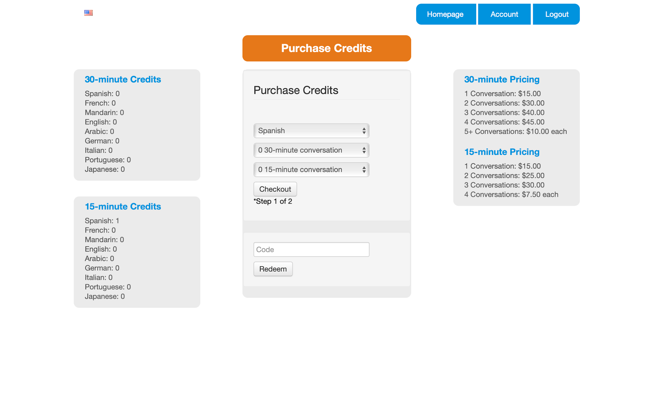

1. Now fill out your billing info and credit card number in the following boxes.

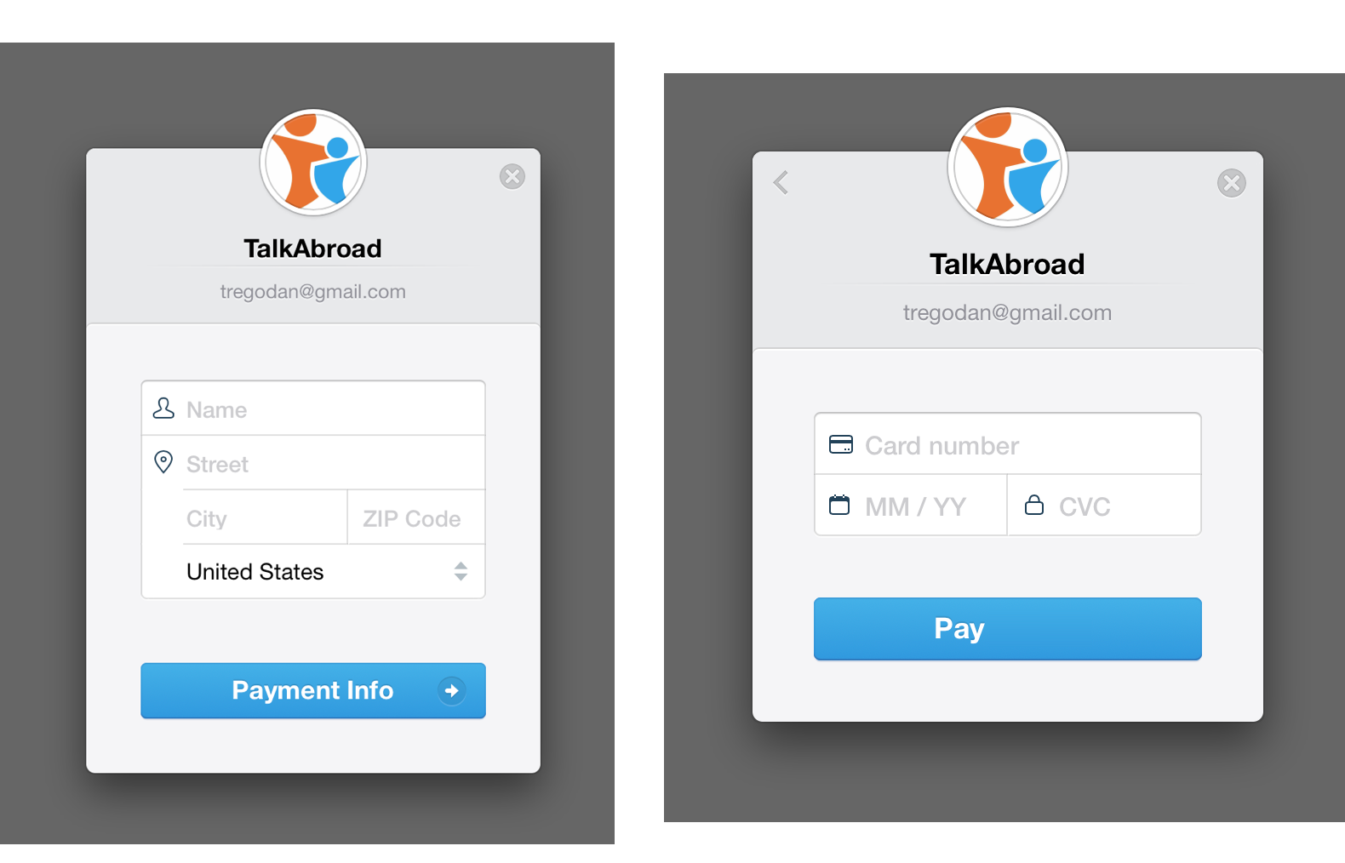

1. Once successful, you will see the number of conversations available on your Homepage.

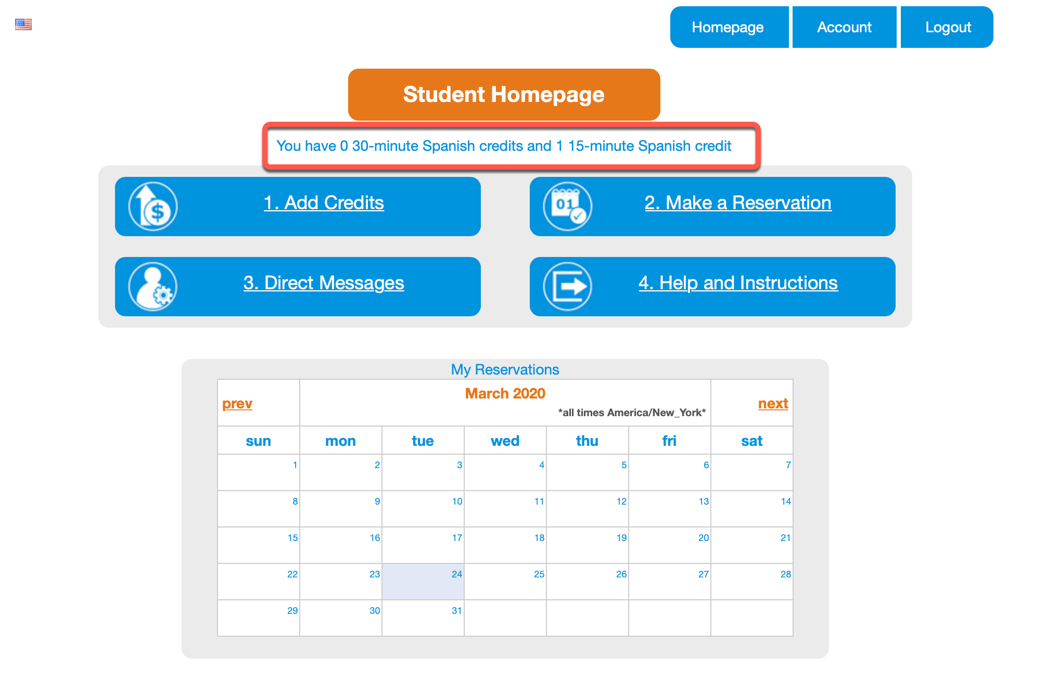

### 

### Complete a Test Call

1. Before you make your first reservation, you must complete a test call.
2. Click *Help and Instructions* on the Homepage.

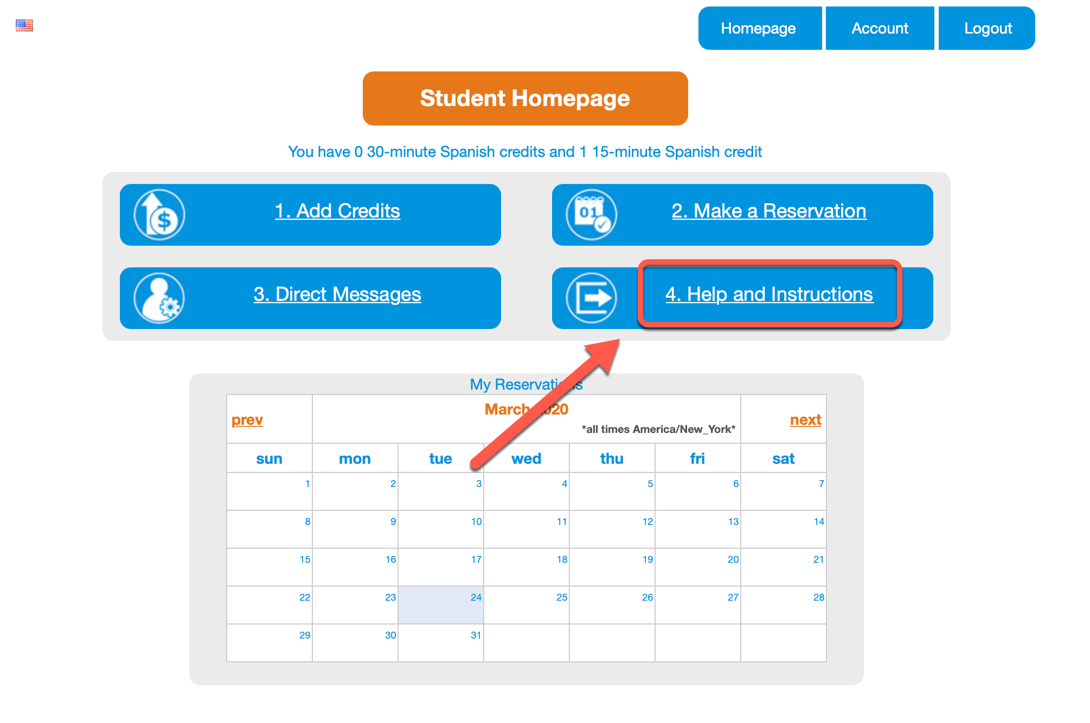

1. Now click *Test Call.*

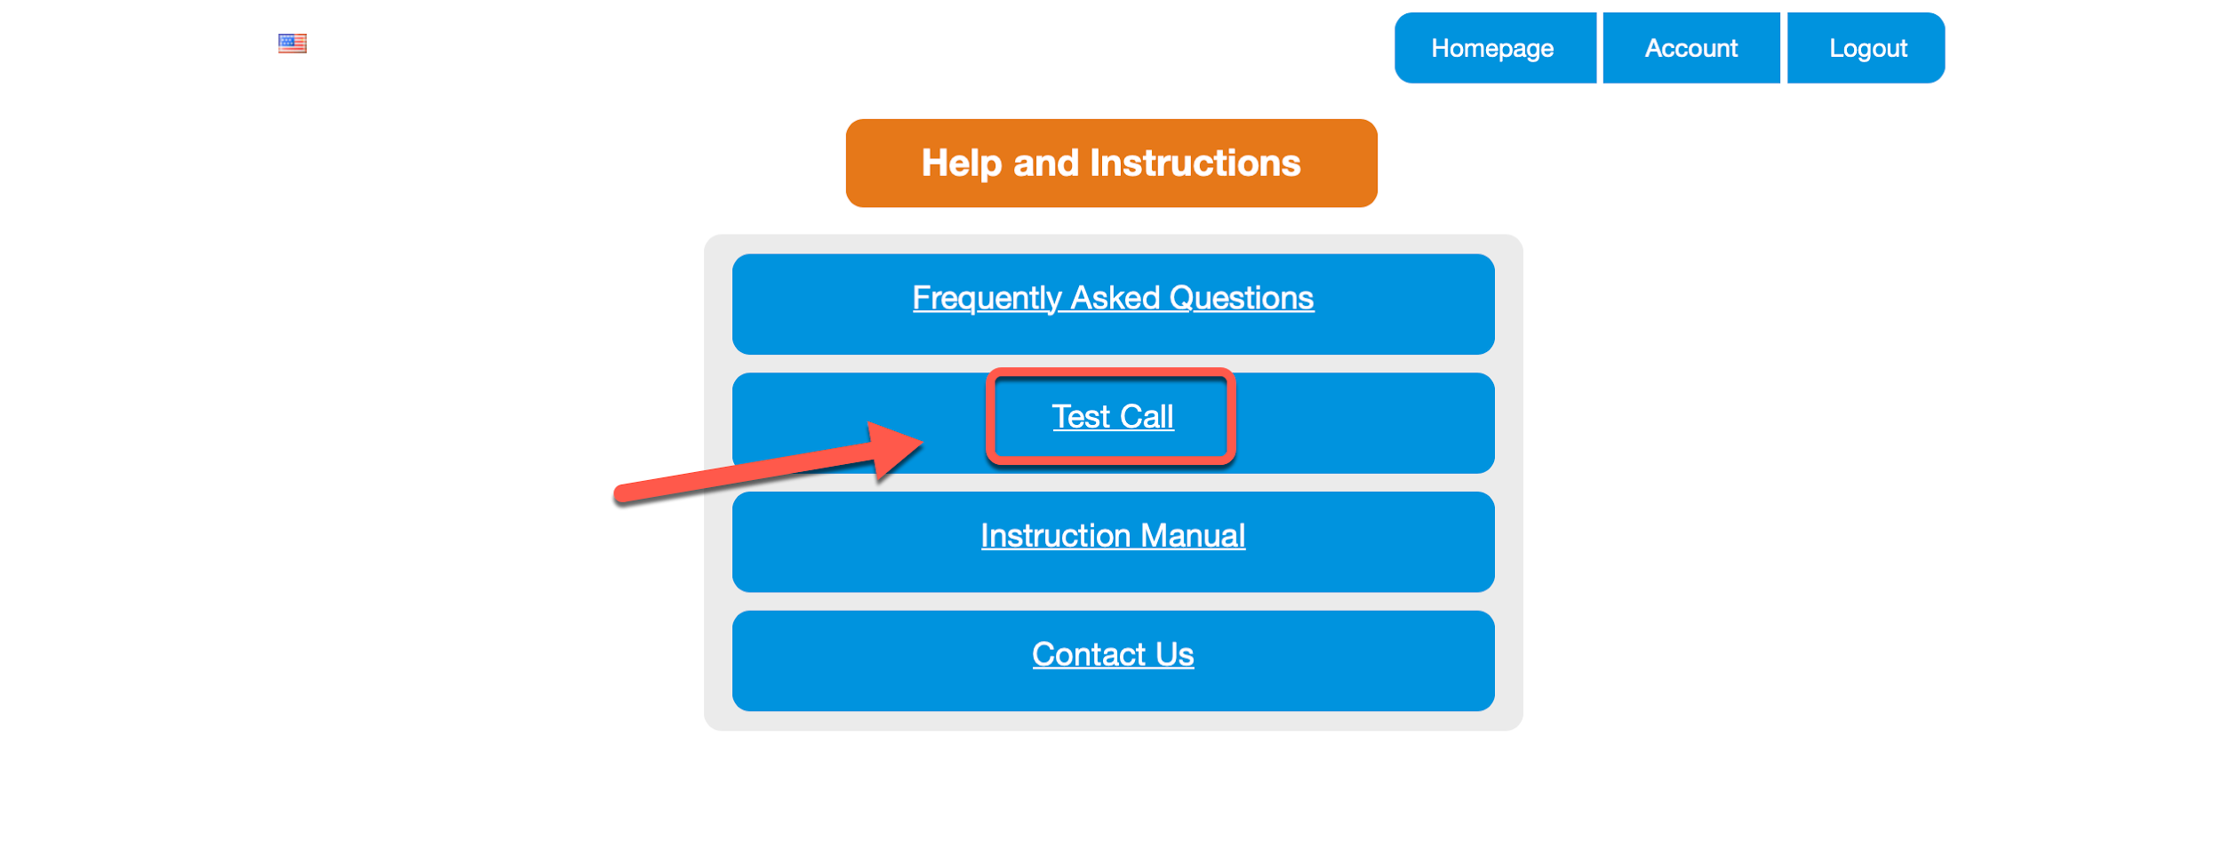

1. You will see a screen with the test call instructions. The easiest way to complete a test call is to ask a friend to help by joining on the call with their device. You can also use another device you own to complete the test call.

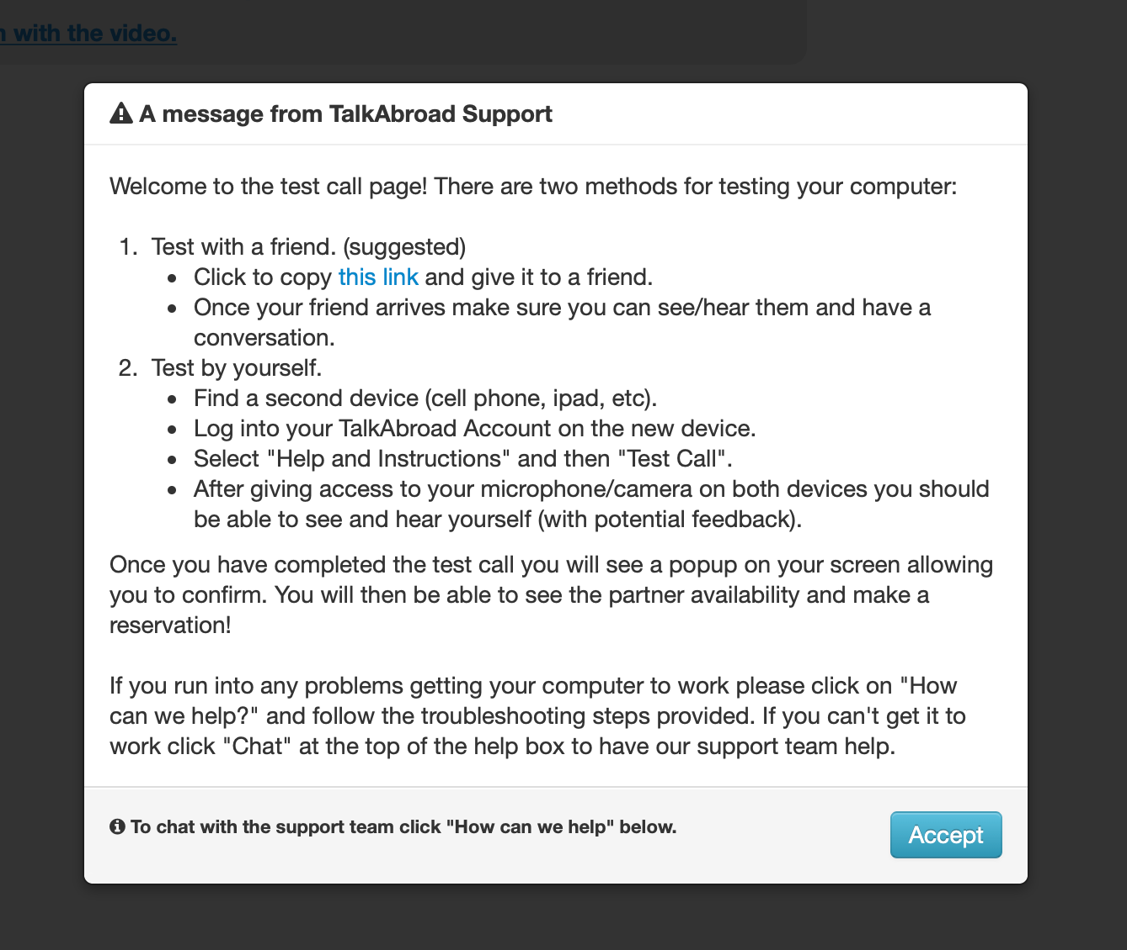

1. Click *Accept* and then follow the instructions to allow your browser access to the camera and microphone. This will look different across devices, platforms and browsers.

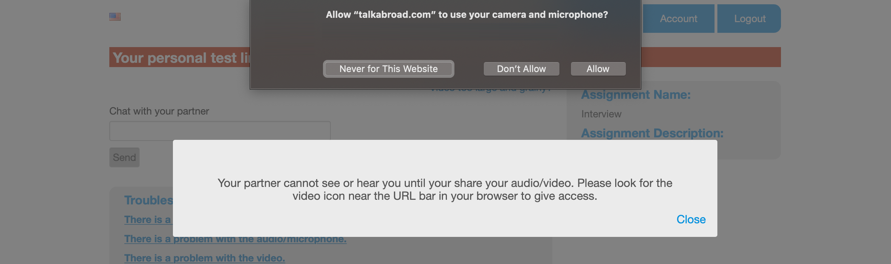

1. You will now be able to complete the test call. If anything is not working, you can follow the troubleshooting tips at the bottom of the call window.

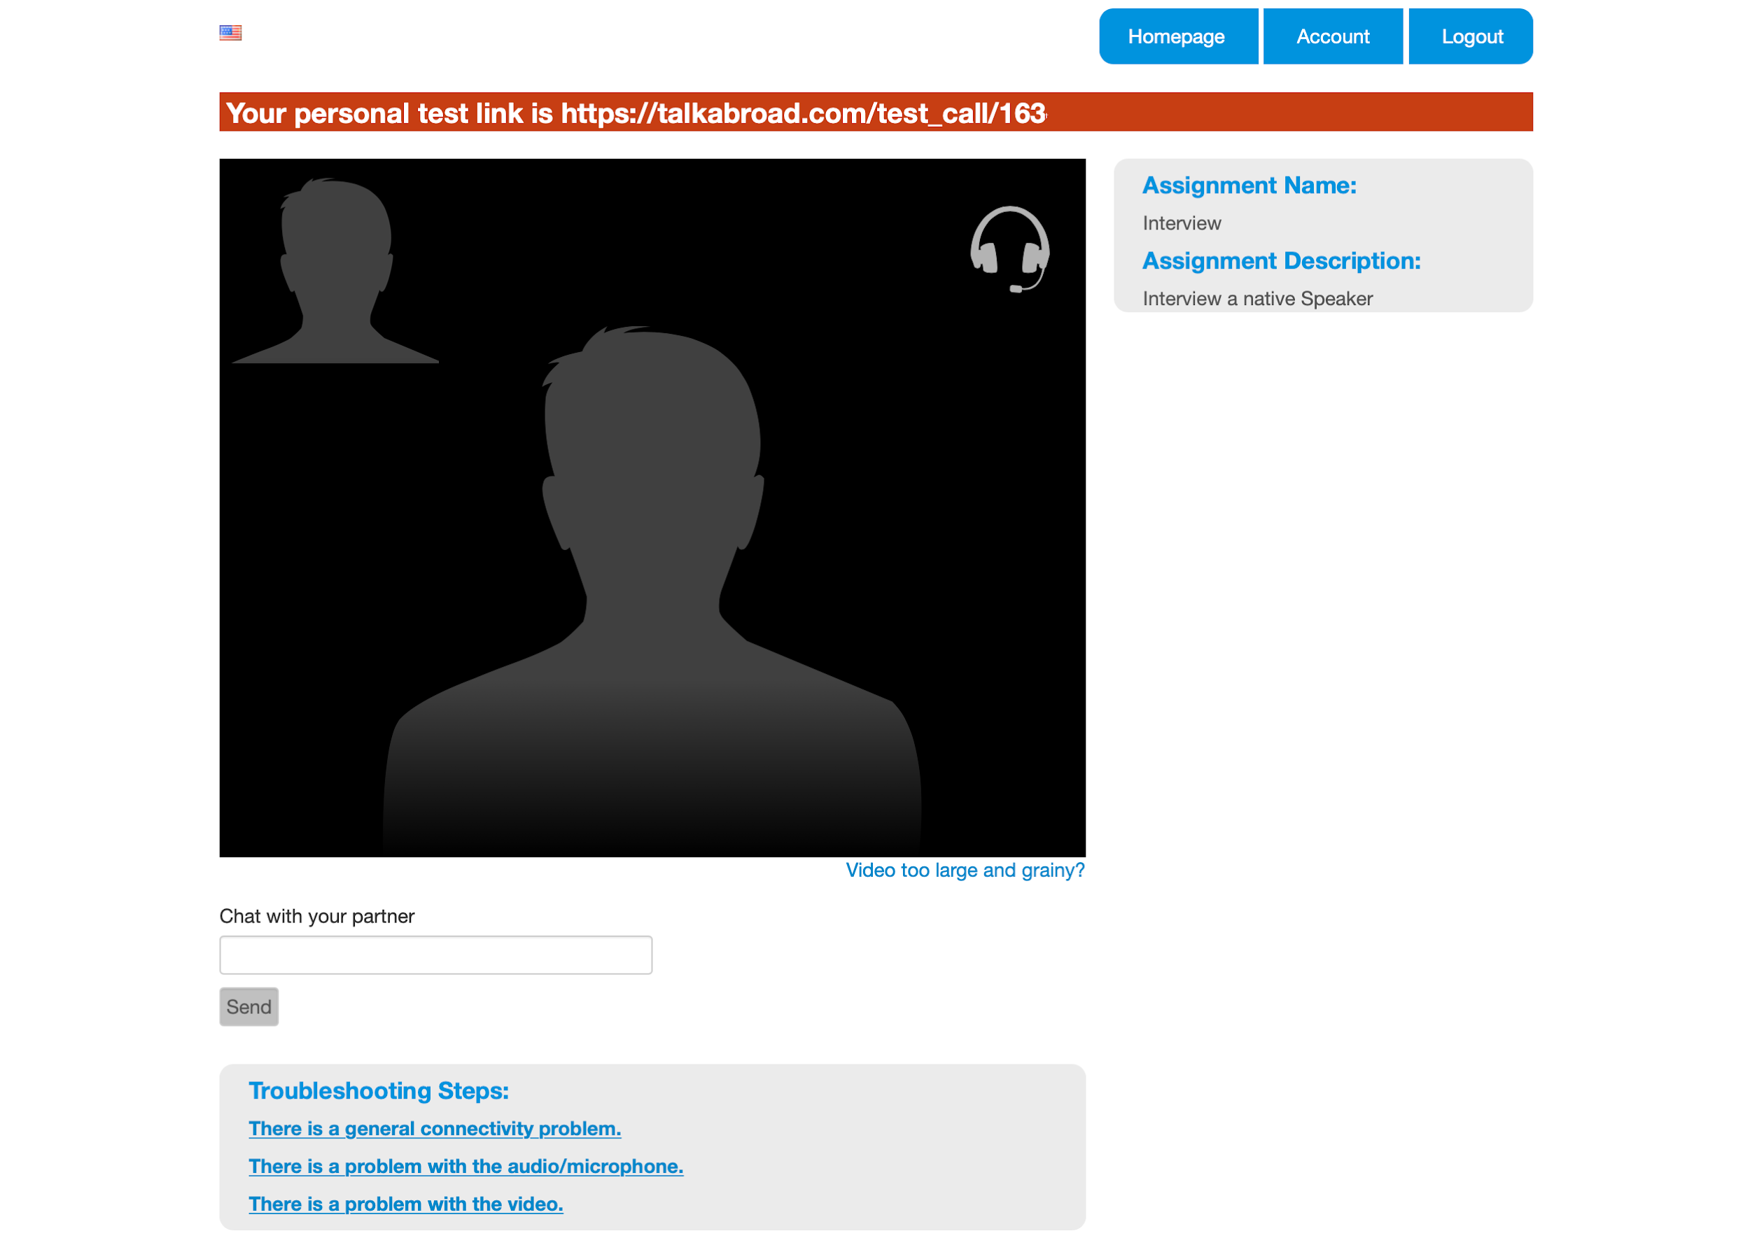

### 

### Make a Reservation

1. Click *Make a Reservation* on the Student Homepage to begin.

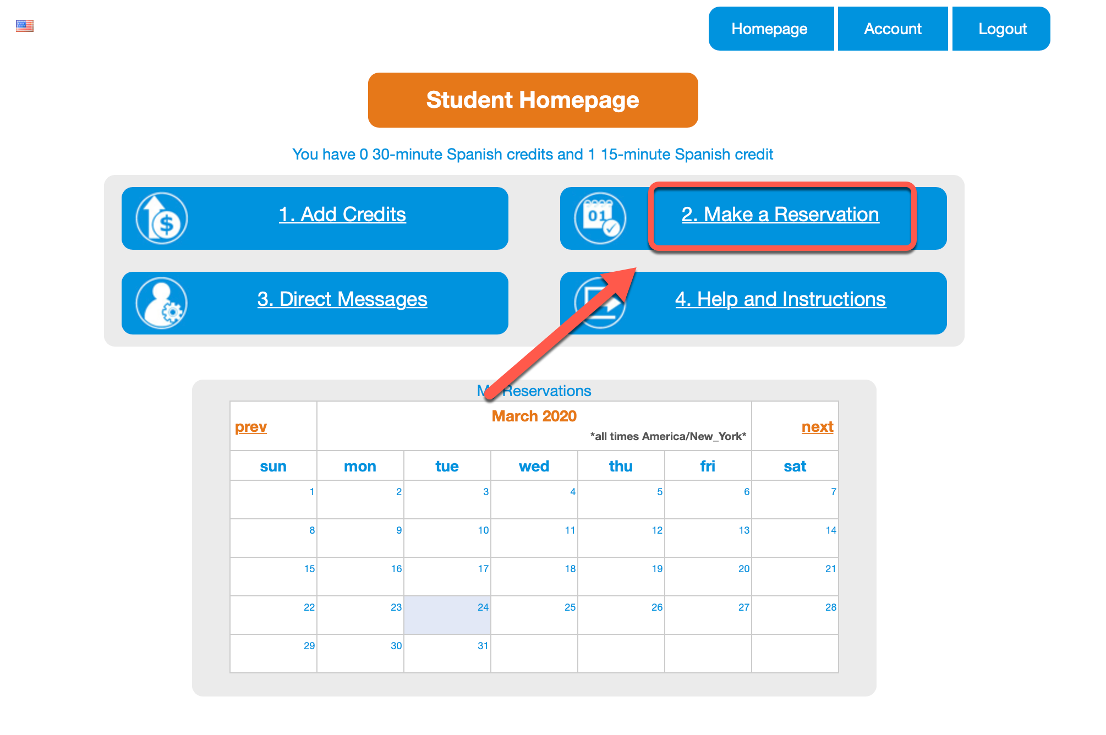

1. Now you will be able to see the available partners. You can scroll down the list or choose to search by country or specific date and time. If you have had a conversation in the past, you can also select the box to only search for past partners.

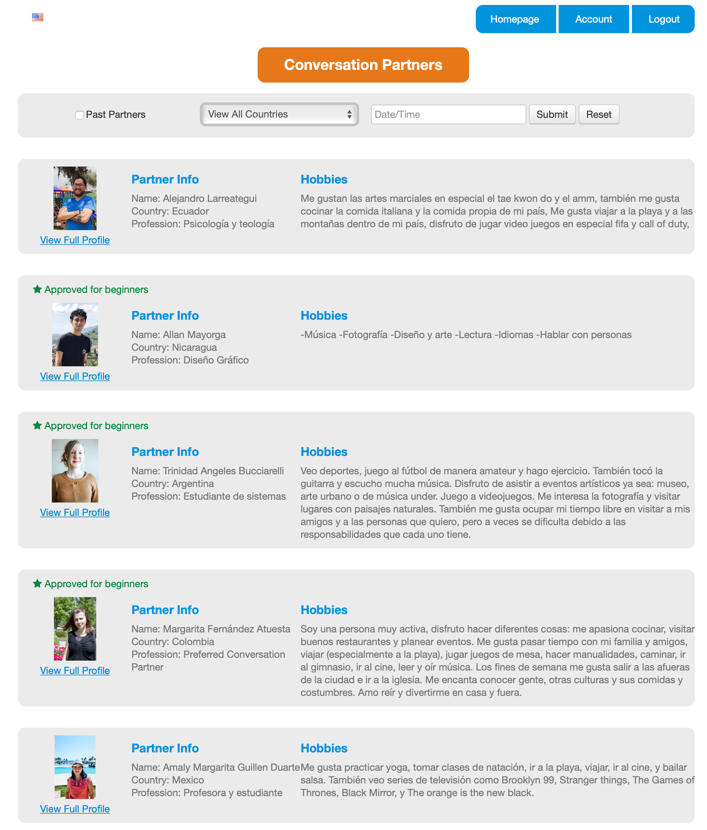

1. Click *View Full Profile* underneath the partner’s picture to learn more about the partner and to schedule a conversation. You will notice that some partners also have a star above their picture with the text *Approved for beginners.* These partners are trained especially to help students that are just getting started on the language journey.

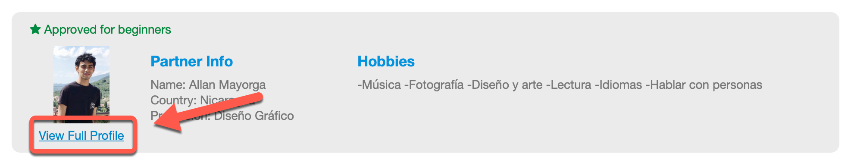

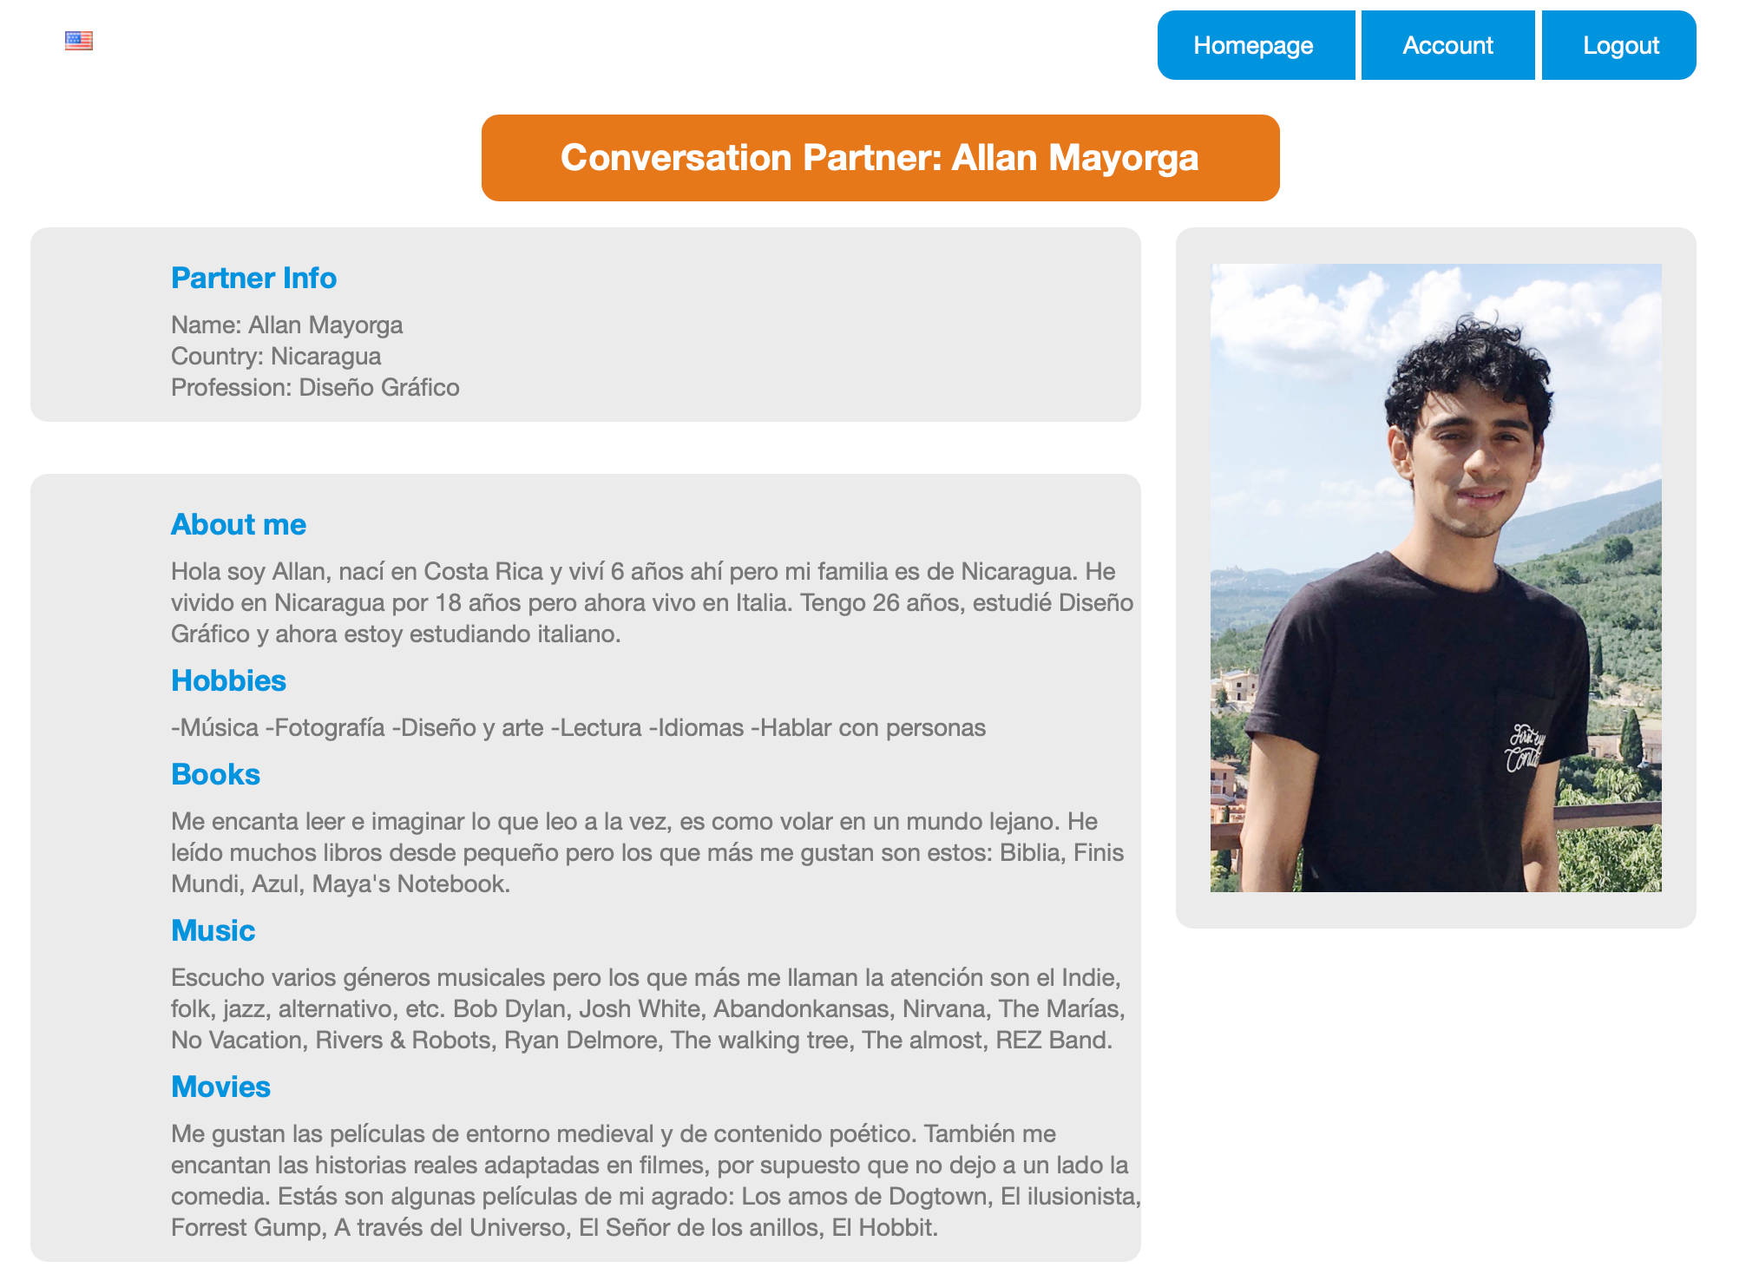

1. After reading through the profile, decide if you want to schedule a conversation with this partner. To keep looking at other partners, click *Back* on your browser. To schedule the conversation, scroll down to the calendar. Here you will find a list of available time slots. Click on one to schedule the conversation for that time. Remember, you can only schedule a conversation 36 hours in advance.

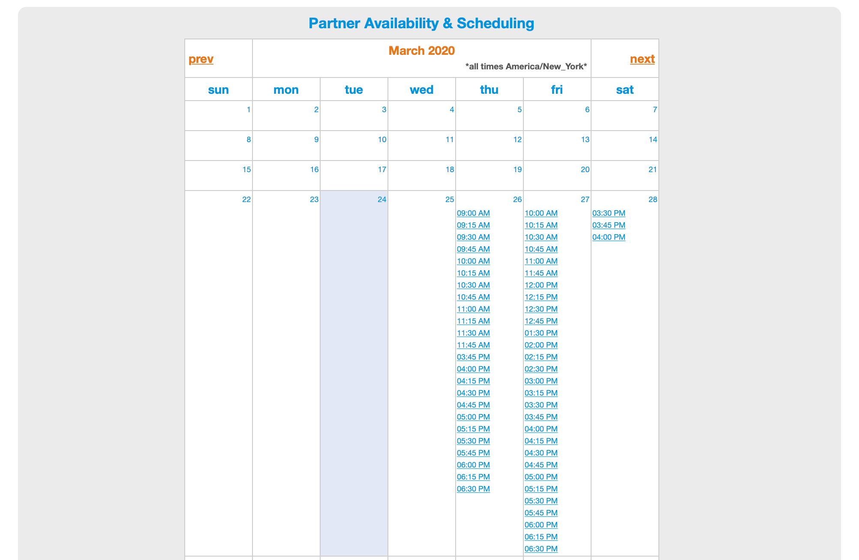

1. Once you click on the time to schedule the conversation you will see a Student Reservation screen asking you to confirm your reservation and enter your phone number. It is a good idea to enter your phone number in case of technical difficulties.

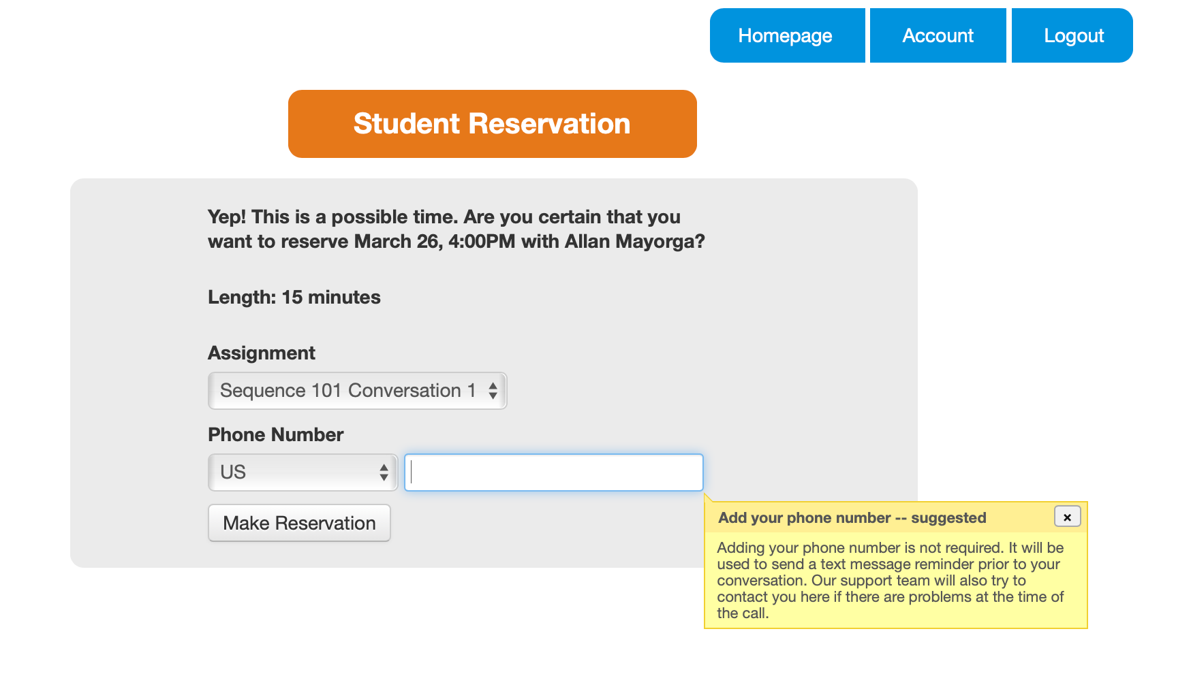

1. After you make the reservation you will be asked if you want to introduce yourself to the partner before the conversation starts. This will be in the form of a text comment. This step is completely optional but highly encouraged.

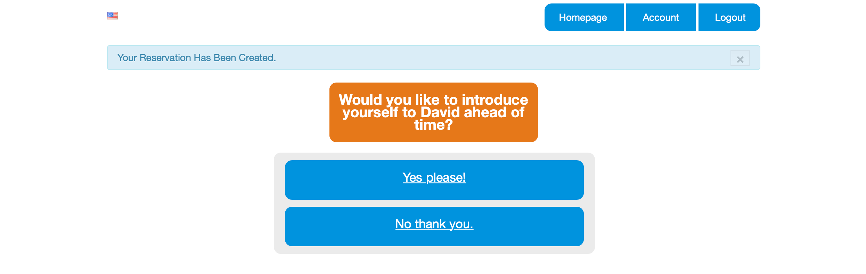

1. Head back to the Homepage to see your scheduled reservation in the calendar. You will also receive and email with the conversation information.

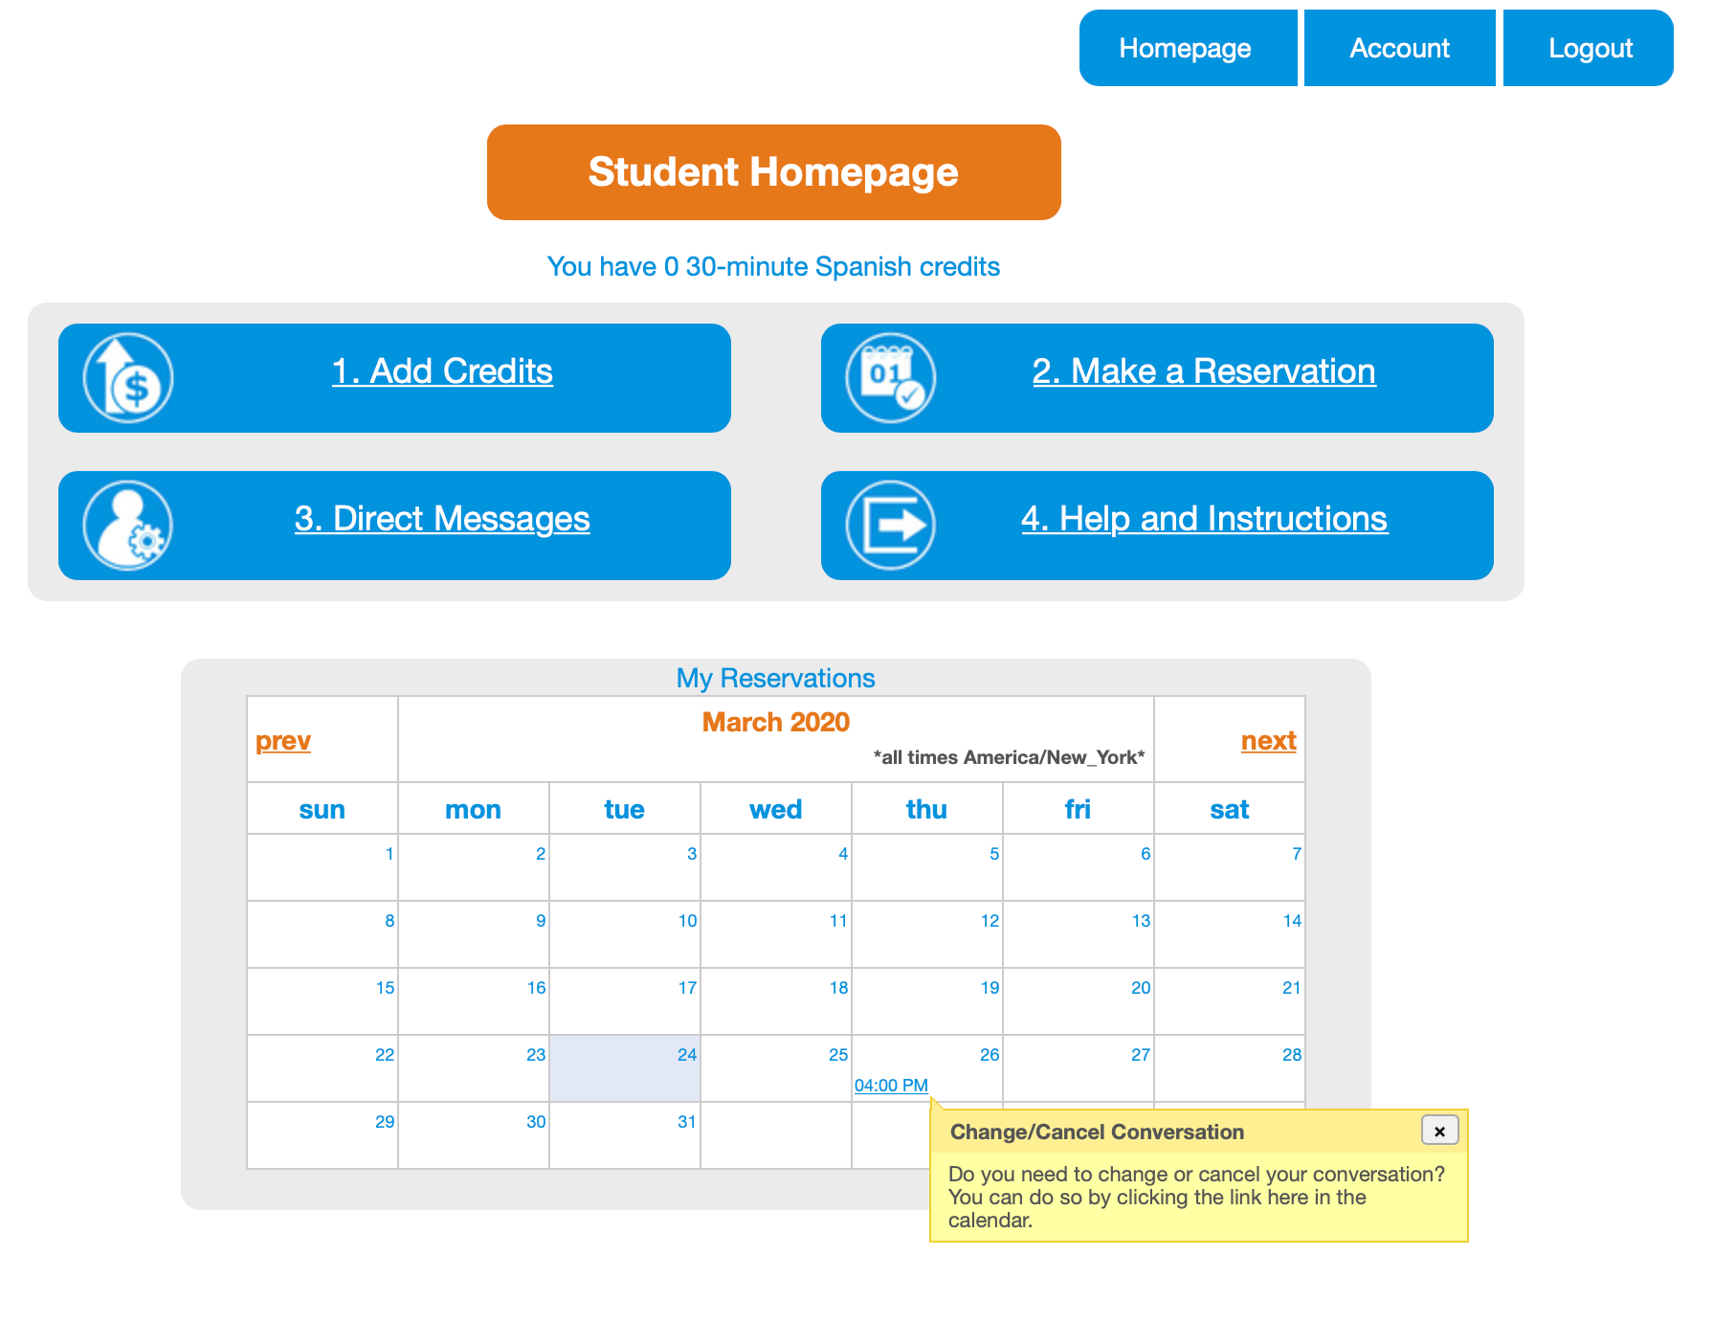

### Complete Your Conversation

1. Now you can view your conversation in your calendar on the Student Homepage. Click on the the conversation to view information or change the reservation. When it is time for your conversation to begin, you will be directed to the conversation when you login to talkabroad.com

### 

### 

### Download your conversation

1. After your conversation has ended you will be prompted to rate the conversation and given the opportunity to download the audio file of your conversation. You will also receive an email with a link to the feedback form. The feedback form will also load the next time you login to talkabroad.com.

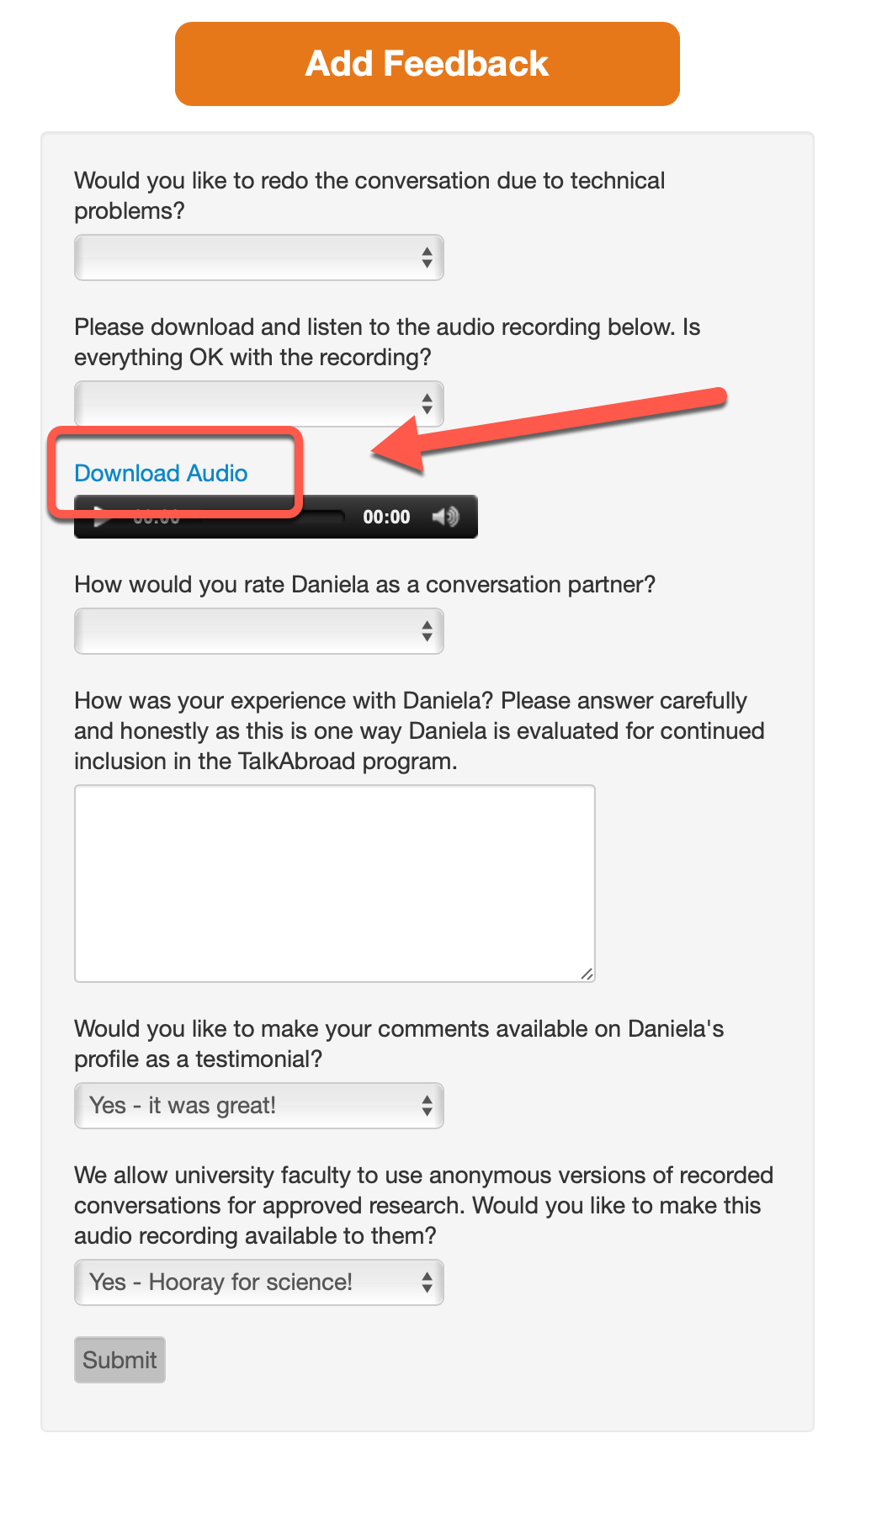

1. If there were any issues due to technical problems during the conversation or with the audio file, you can report them here (on the website) and someone from TalkAbroad will be in touch.
2. You can also download the audio from any previous conversation by clicking on the link to that conversation in the calendar.

### 

### 

### Contact

If you have any questions, please [contact our support team](http://support.talkabroad.com).