- Find an example of a monoclonal antibody used in medicine today (as a drug).
An example of a monoclonal antibody used currently by medical practitioners is Pembrolizumab (Keytruda).

- Summarize the condition that this drug treats: is it cancer? Autoimmune? Inherited? Tell us the basics (and cite your sources in APA format). Your description should be a paragraph of about 250 words.
Pembrolizumab is a monoclonal antibody treatment that is used to help target and kill various types of cancers. Pembrolizumab is a type of cancer immunotherapy treatment drug with the brand name Keytruda (National Cancer Institute, n.d.). Specifically, this drug mainly targets non-small cell lung cancer (NSCLC), melanoma skin cancer, bladder cancer, and Hodgkin lymphoma but has been used in other cancer treatments such as oesophageal, head and neck, ovarian, breast, mesothelioma, kidney, prostate, kidney, and cervical cancers (Cancer Research UK, 2019). Pembrolizumab is administered through the blood via multiple methods as a drip. The administration of Pembrolizumab can be through a central line, PICC line, portacath, or through a thin short tube that goes in the arm—a cannula (Cancer Research UK, 2019). Treatment with Pembrolizumab ceases when it is either no longer effective, an unacceptable toxicity is reached, or if symptoms become too unbearable/severe (Center for Drug Evaluation and Research, 2017). This treatment program typically takes no longer than two years, however this treatment is unique to the individual. This treatment may take longer than two years, or less, and some may experience worse symptoms while taking it compared to others (Cancer Research UK, 2019). In most cases, Pembrolizumab is used in concert with chemotherapy (Cancer Research UK, 2019). This drug comes with a seemingly endless list of side effects and is to be prescribed only when other treatments have failed. The FDA has approved the use of this drug with unresectable or metastatic microsatellite instability-high (MSI-H) or mismatch repair deficient (dMMR) solid tumors who have progressed on prior treatments and who have no satisfactory alternative treatment options (Center for Drug Evaluation and Research, 2017). In the case of using this drug specifically for a certain type of cancer, breast cancer, Pembrolizumab is administered when the cancer itself is triple negative (National Cancer Institute, 2022). Another example, in cervical cancer cases, this drug is used for when the cancer is recurrent, cannot be removed via surgery, or metastatic (National Cancer Institute, 2022). Pembrolizumab is not an end all be all, but it is a drug that targets multiple types of cancers while offering a safety net for when primary treatments fail.

- Identify what class of antibody it is (IgA, IgD, IgE, IgG, IgM) and briefly sketch its structure.
The class type of the antibody of Pembrolizumab is IgG (Kwok, Yau, Chiu, Tse, & Kwong, 2016).
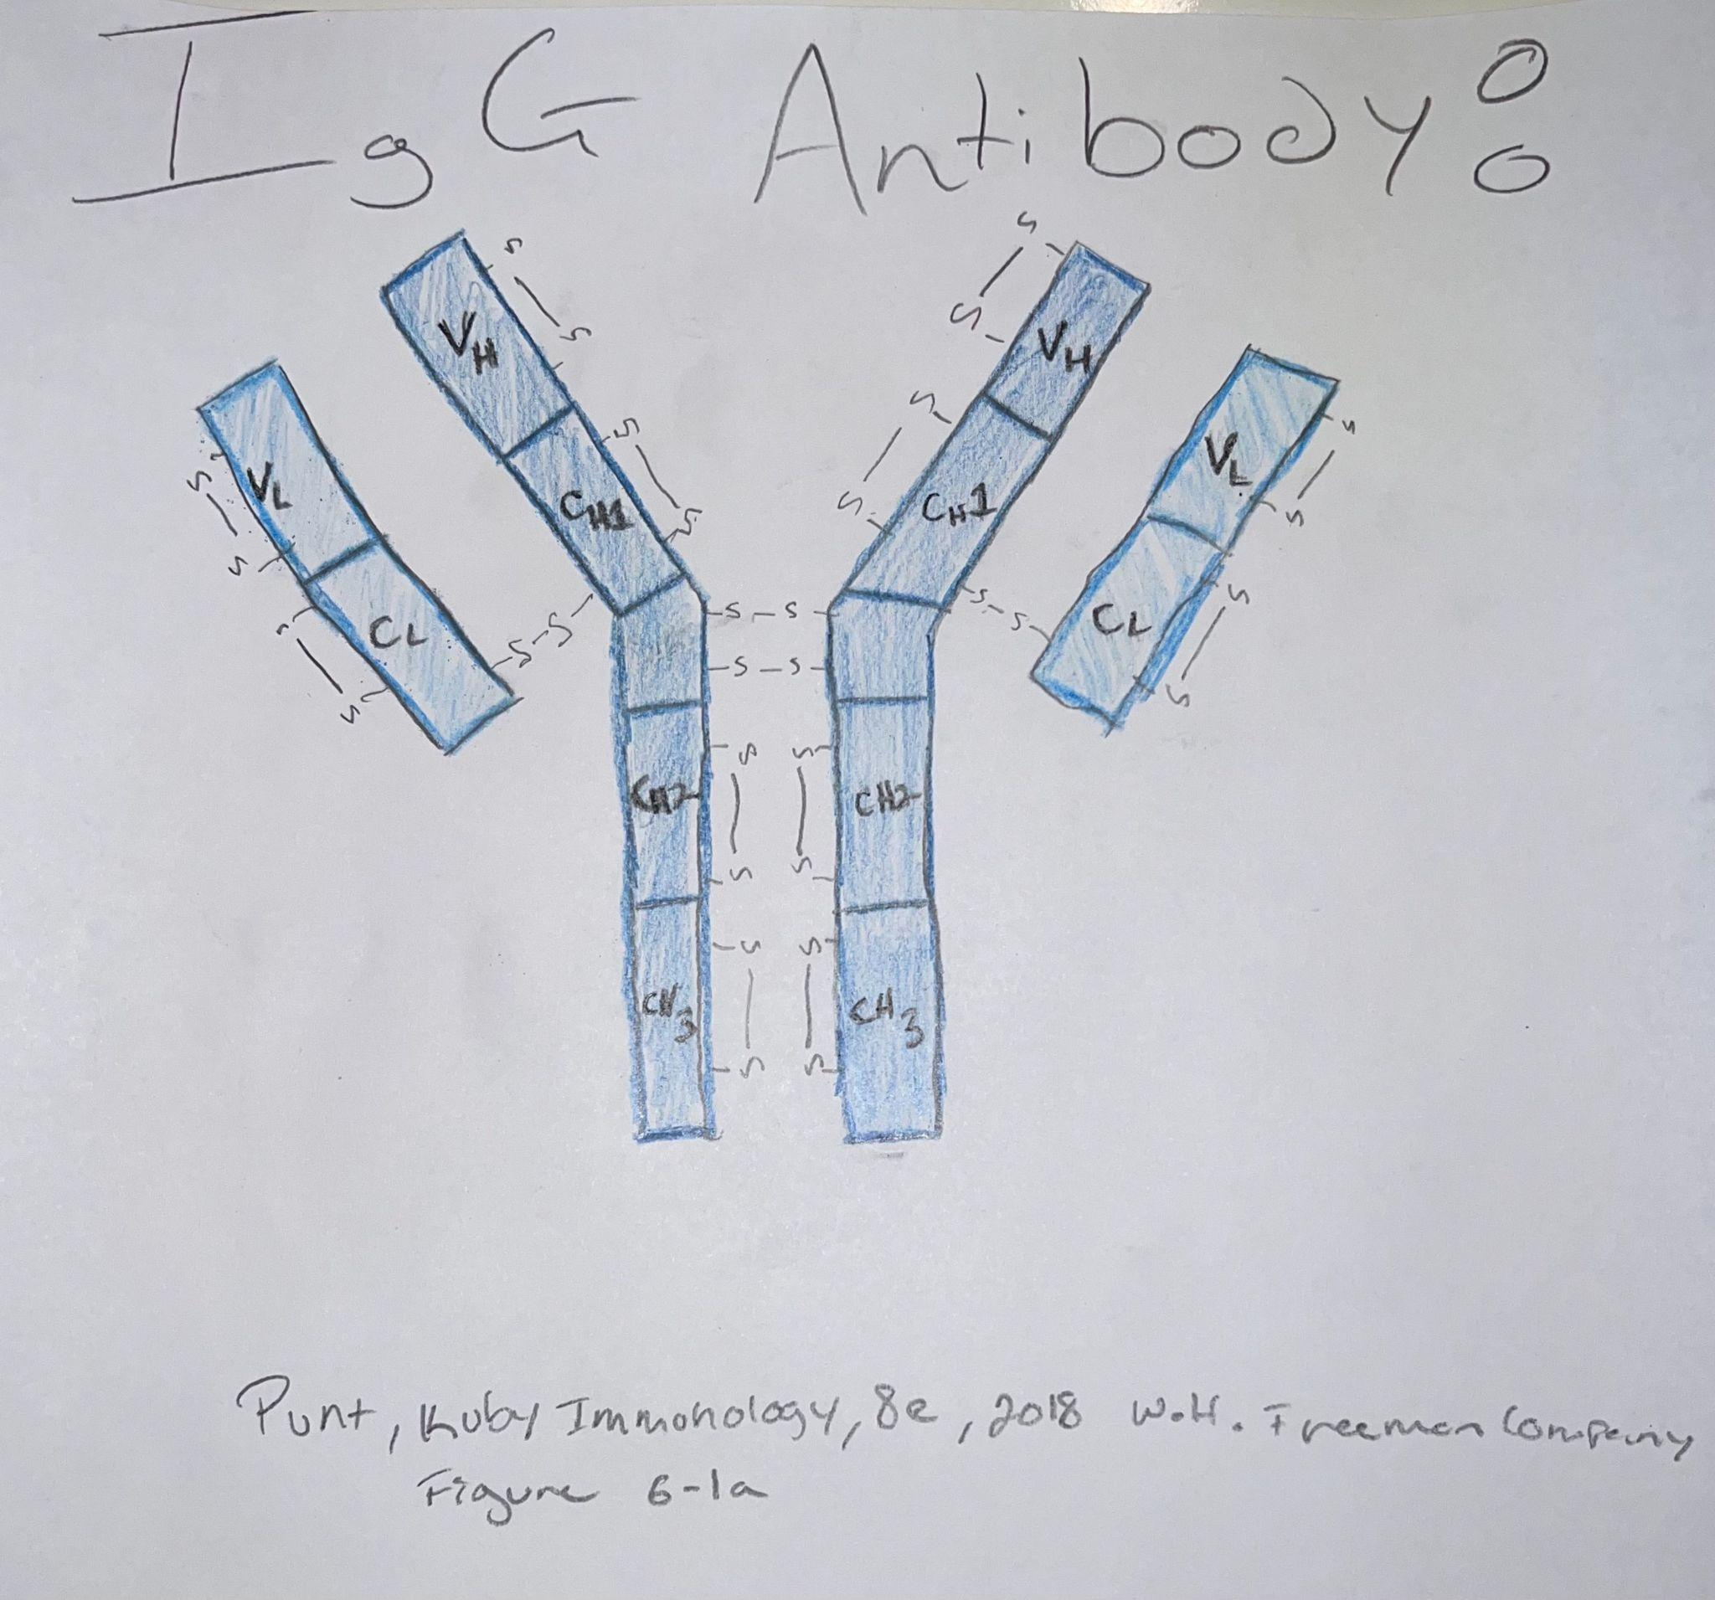
- In a second paragraph, explain what this antibody is binding to (or thought to bind to) and how that should improve disease symptoms. This should be a second paragraph of about 250 words.
Pembrolizumab targets and blocks a protein called PD-1—programmed cell death-1 (National Cancer Institute, n.d.). PD-1 is a cell receptor found on T-cells involved in a potential immune checkpoint and antineoplastic activities. The PD-1 receptor is one of the checkpoints that regulates the immune response (Kwok, Yau, Chiu, Tse, & Kwong, 2016). The ligands that are blocked due to the administration of Pembrolizumab include programmed cell death ligand-1 (PD-L1), which is overexpressed on certain cancer cells, as well as the programmed cell death ligand-2 (PD-L2), which is primarily expressed on antigen presenting cells (National Cancer Institute, n.d.). When PD-1 binds to either PDL-1 or PDL-2, a signal transduction pathway is activated that results in negative signals to T-cells (Kwok, Yau, Chiu, Tse, & Kwong, 2016). The expression of PD-1 on T-cells and PDL-1 on neoplastic cells enables tumor cells to evade anti-tumor immunity. Thus, Pembrolizumab is administered to block the PD-1 receptor to enable t-cells to detect the various types of cancer that evade the immune system via ligands of the PD-1 receptor (Kwok, Yau, Chiu, Tse, & Kwong, 2016). When PD-1 is blocked, via Pembrolizumab binding to the receptor and inhibiting the ligands of PD-1 from binding to the receptor, the activation of T-cells is set. Blocking Pd-1 allows T cells to detect neoplastic cells that have evaded the immune system via PDL-1 or PDL-2 which subsequently allows for the death of cancerous cells (National Cancer Institute, n.d.). This strategy has shown to be an effective treatment program for not just one type of cancer, but rather multiple subtypes of cancer found in almost every corner of the human body. It has shown to be an effective treatment at allowing the body to detect cancers in roughly 20-50% of all cancers accounted for, when previous treatments have failed (Kwok, Yau, Chiu, Tse, & Kwong, 2016).
References
Cancer Research UK. (2019, October 8). Pembrolizumab (Keytruda). Pembrolizumab
(Keytruda)
| Cancer information | Cancer Research UK. https://www.cancerresearchuk.org/about-cancer/cancer-in-general/treatment/cancer-drugs/drugs/pembrolizumab
Center for Drug Evaluation and Research. (2017, May 30). FDA grants accelerated approval to
pembrolizumab for first tissue/site agnostic indication. U.S. Food and Drug Administration. https://www.fda.gov/drugs/resources-information-approved-drugs/fda-grants-accelerated-approval-pembrolizumab-first-tissuesite-agnostic-indication
Davies, A. M., & Sutton, B. J. (2015). Human IgG4: a structural perspective. Immunological
reviews, 268(1), 139–159. https://doi.org/10.1111/imr.12349
Kwok, G., Yau, T. C., Chiu, J. W., Tse, E., & Kwong, Y. L. (2016). Pembrolizumab
(Keytruda). Human vaccines & immunotherapeutics, 12(11), 2777–2789. https://doi.org/10.1080/21645515.2016.1199310
National Cancer Institute. (2022, August 9). Pembrolizumab. Cancer.
https://www.cancer.gov/about-cancer/treatment/drugs/pembrolizumab
National Cancer Institute. (n.d.). NCI Drug Dictionary. Cancer.
https://www.cancer.gov/publications/dictionaries/cancer-drug/def/pembrolizumab

