Instructions for the Preparation of a Manuscript for
the 74th Annual EDGD Mid-Year Conference

A. B. Author
Department of Industrial Technology

Arizona State University

B. C. Author

Department of Mechanical Engineering
Purdue University

Abstract
An abstract is a condensation of the entire digest, stating its purpose, methodology, major results and conclusions. Readers look here to see if they wish to read the entire digest. The abstract should be approximately 100 words in length. The text in the abstract should be italicized. This digest should be formatted using the American Psychological Association (APA) style, the style used by the Engineering Design Graphics Journal.

Introduction
A uniform appearance for all of the digests is important to create a professional product. Such a product will reflect well upon the conference and the authors. The entire manuscript must be camera ready. There will likely be no further editing of the digest, so please be careful in its preparation. Errors in language and formatting will appear in the Proceedings, reflecting poorly upon the authors. Please have your manuscript read and edited by someone who is completely fluent in English.
The manuscript is to be prepared on U.S. size A digest, which is also known as “letter” size. This digest is 8.5 inches wide and 11 inches long. The margins are to be 1.25 inch on top, 1 inch on the bottom, and 1.5 inch left and right. Do not number the pages or use a header or footer, as this will be done after assembly of the entire Proceedings.
The digest should be between 1200-1500 words. All submissions are peer-reviewed. Authors will have a choice to present in one of two formats: Digest Presentations or I² (Innovations & Ideas) Presentations.

Text Formatting
The title and authors section appears in a single column format at the top of the first page. Lines in this section should be single-spaced. The text for the title and authors is to be centered within the column. The title of the digest is to be in bold, 16 point Times New Roman font. Only the first letter of each major word in the title is to be capitalized. Skip one line between the title and the authors. The names of the authors follow in an italicized, 10-point Times New Roman font. Unless otherwise desired, please use the initials of the given name followed by the complete surname. On the next line, give the author’s affiliation. For multiple authors, names of the authors from the same affiliation are to be placed on a single line. Authors from different affiliations are to be identified separately, as shown at the beginning of this manuscript. Skip one line between each author of a different affiliation. After identification of all the authors, skip three lines.

The Main Text
The main text is to be placed into one column. The font is to be 10 point Times New Roman, using 1.5 lines spacing between lines. The first line of each new paragraph is to be indented by 0.25”. Do not insert a blank line between paragraphs. All text alignment should be left and right justified.
Heading titles are to be a bold, 10-point Times New Roman font. The letter of each major word is to be capitalized, and the title is to be left justified within the column. Do not number the heading titles. Each heading title is to be preceded by a blank line. Sub-headings are to be placed at the beginning of a paragraph. Sub-headings are to be a bold italic, 10 point Times New Roman font with the first letter of each major word capitalized.

Figures, Tables, Graphs, and Equations
Figures are to be numbered sequentially. They should appear in the body of the digest. They may span all or part of the column. Drawings and lettering should clearly legible. Photographs need to be electronic and placed within the document. Because the Proceedings will be published electronically, the use of color in figures is permitted, and encouraged. Captions lines are to be single-spaced, centered and the font is to be bold, 10 point Times New Roman. A blank line should be inserted both before and after the figure.

Equations are to be placed within the text and numbered sequentially. The identification numbers are to be placed in parentheses and right justified. A good equation editor in a word processor should be used to produce equations. If possible, equations should be confined to the width of a single column. A blank line should be inserted before and after the equation.

(1)

Tables and graphs should be placed within the digest if possible. They are to be numbered sequentially. Captions lines are to be single-spaced, centered, and the font is to be bold, 10 point Times New Roman. Because the Proceedings will be published electronically, the use of color in tables and graphs is permitted, and encouraged.

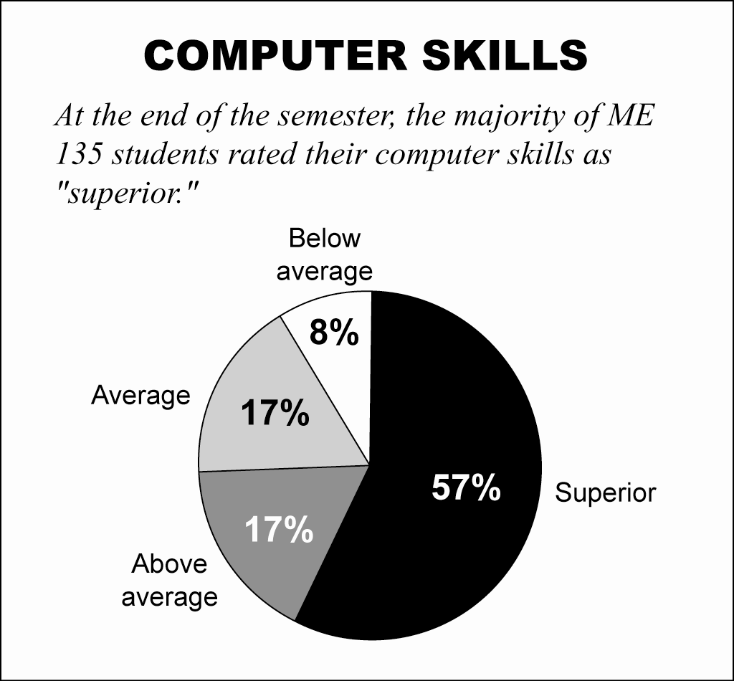

Figure 2. This is example of a graph.

A blank line should be inserted both before and after the graph or table. Edit carefully all the numerals, spelling, and grammar. Check for the accurate representation of the story and that the details in the table or graph match the details in story.

Conclusions
The conclusions should be a summary of the major findings of the work, and recommendations for future work. Conclusions should not be a repeat of the abstract, nor should the abstract be a repeat of the conclusions.
The completed electronic manuscript must be received on or before October 19, 2015.

Citations
Citations should be noted by author and date within the context of the digest. Footnotes should not be used. The following paragraph shows examples of cited literature.
Edward Tufte (1983) published a milestone book The Visual Display of Quantitative Information, which showcased the weaknesses of the graphs of the 1970s and 1980s. A successful line graph allows the reader to understand the flow of the figures if it clearly shows the relationship of the point immediately before it and the one immediately following it (Miller, 1999).

References
Cited literature is to be placed in a References section at the end of the manuscript. Authors should be listed alphabetically, by the last name of the first author. The following are some examples.

Miller, S. G. (1999). Teaching eye-catching informational graphics to technical graphic students at Purdue University, Proceedings of the Society for Technical Communication, USA, 322-331.

Tufte, E. R. (1983). The Visual Display of Quantitative Information. Cheshire, CT: Graphics Press.

