**Welcome! I’m...**

**Emanuel King**

ODU Undergraduate Cyber Security Major

Thank you for checking out my ePortfolio page. I am a freshman at Old Dominion University majoring in Cybersecurity. This is an overview of my accomplishments and aspirations coming to ODU. My passion in life is computers and I base my entire life around them. My hope is that when I'm out of college I can run my own cybersecurity business. After covid started it became hard to pursue my hobbies because computer chip shortages all around the world. I started to repair some old laptops from my dad's workplace to get the thrill of building a PC. My hobbies are collecting and playing trading card games and rpgs. I also enjoy playing video games and coaching eSports.

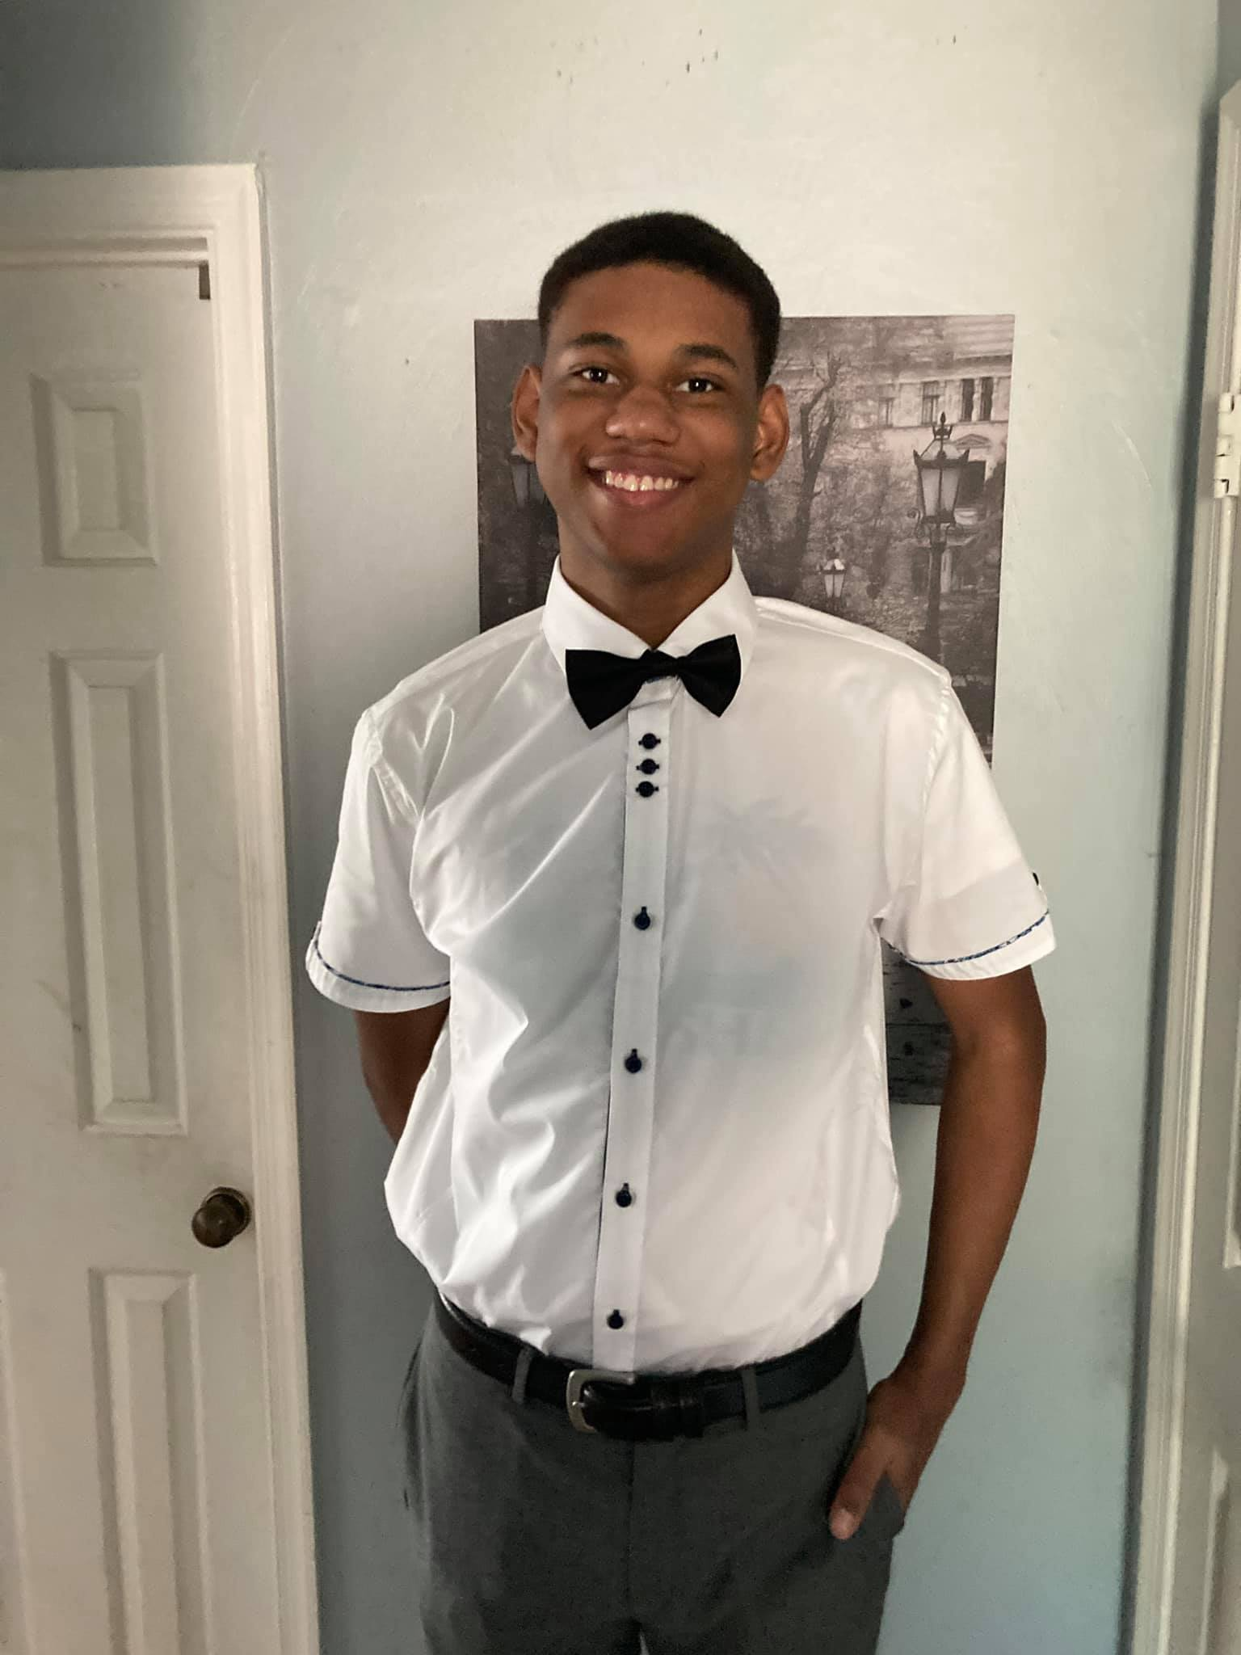

| Emanuel King | 4313 Midhurst Lane  Chesapeake, VA 23321  **(443) 355-1620**  **maxking527@gmail.com** |
| --- | --- |
| WORK EXPERIENCE Western branch high school, 1968 Bruin Pl, Chesapeake, VA 23321 —Volunteer September 2018 - November 2019   * 100+ hours at the school's concession stand for the band. * Seasonal * Stock and organized concession supplies * Provided customer service for concession stands during football season.  Big Lots, Store 4300 Portsmouth Blvd., Chesapeake, VA 23321 (757) 998-8115- Store Associate June 2021- August 2021   * Provide customer service to customers in store. * Stock and organize products for sale. * Placement of store marketing * All duties requested by management  EDUCATIONWestern Branch High School, 1968 Bruin Pl, Chesapeake, VA 23321— *June 2021*September 2017 - June 2021 HS Diploma Chesapeake Career Center, 1617 Cedar Road—June 2021September 2019 - June 2021 Dual-enrollment in CCC for cyber security  REFERENCES  Ann Dunn: Western Branch HS Band Teacher  Phone Number: (757) 638-7900 Extension: 501270  Email: [Westerbranchbands@gmail.com](mailto:Westerbranchbands@gmail.com)  Address: 1968 Bruin Place, Chesapeake, VA 23321 | SKILLS Proficient in Microsoft suite  Experienced in Windows and Mac Operating systems.  Basic graphic design skills  Organization and stocking of products and supplies.  Customer Service AWARDS **National Society of High School Scholars Award**  Academic achievement and excellence award  **Marching Band Award**  Letterman award for membership in the western branch high school marching band.  **Industry Certification**  Industry certification for Graphic design.  **Industry certification** working towards an A+ certification. LANGUAGES English (fluent) |