Nicholas Fehrer

Professor Steel

March 21, 2023

Scientific Literacy 1

Squamous cell carcinoma, or SCC for short, is considered the second most common skin cancer, only behind basal. Luckily it is curable if detected early on enough, but to be able to recognize squamous could be difficult. It typically appears to have large open wounds covered by thick additional squamous cells and can occur virtually anywhere on the body but is centralized to those with access to light and is unique to everyone. Since it is so hard to tell what squamous may be, how does one figure out if they have it? Squamous typically comes about from direct contact to strong light sources, especially to ultraviolet rays. Untreated, squamous could be life threatening, but only in the worst cases, since typically it is located and cured far before anything so drastic occurs. And having 1.8 million cases a year squamous cell carcinoma is no joke.

Collagen is a protein that keeps all the organs in the human body the right shape and size so to be able to keep us up and alive. Inside humans there are three types of collagens conveniently named; Type 1 that is good for skin, hair and bones, Type 2, for joints, and Type 3 beneficial to the skin. Type 3 provides human skin with resilience and the ability to protect organs and humanity. But, with collagen 3 decreasing with age elderly begin to have a greater risk of skin problems, the most threatening being cancer. Having such a unique structure, 3 alpha 1 chains in a triple helix, allows for the collagen to operate by winding through preexisting cells to replace the deceased, protect the active, and make whole new layers of skin. Below is a sketch of the structure, and with any differentiation from what is shown could threaten the ability for the protein to function and even the possibility of it to live.

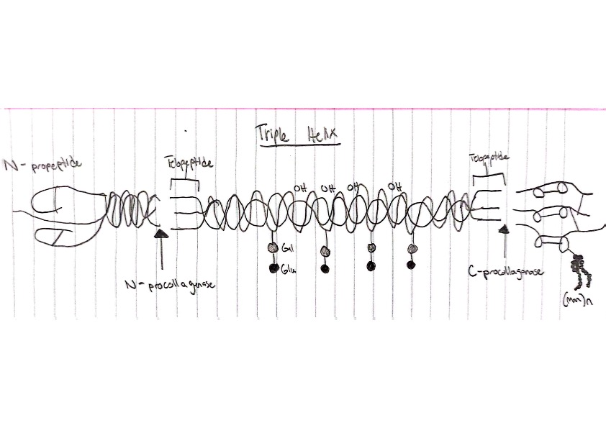

Does collagen 3 have any connections to squamous cell carcinoma though? Due to the decrease of collagen over time due to aging, and the likelihood of cancer developing, yes there is a correlation. A study published in PubMed explains how Type 3 collagen induces tumor dormancy, so in the absence of collagen 3 tumor cells can awaken and grow rapidly, creating a real problem for many of the elderly. Is there a way to reverse engineer collagen to stay around indefinitely? Thankfully, yes! There are collagen supplements one can take to drastically improve the length at which they continue working like they did in the past. Most people don’t realize how threatening this can be, and often brush off and sudden spots or bumps they find on their body leaving the cancer unchecked until it’s too late. But why are they not acing their supplements, and the answer would simply be the lack of awareness. Even though skin cancer is one of the biggest forms, many people seem not to notice, which should hopefully change in the coming years.

Word Count: 491

Resources

“Squamous Cell Carcinoma.” *The Skin Cancer Foundation*, 6 Mar. 2023,

https://www.skincancer.org/skin-cancer-information/squamous-cell-carcinoma/#:~:text=Squamous%20cell%20carcinoma%20(SCC)%20of,squamous%20cell%20carcinoma%20(cSCC).

Radcliffe, Shawn. “Do You Know Your Collagen Types? Here, We Explain Type I, II & III.” *Mindbodygreen*, Mindbodygreen, 23 Apr. 2020, https://www.mindbodygreen.com/articles/collagen-types-important-differences-between-i-ii-and-iii.

Di Martino, Julie S, et al. “A Tumor-Derived Type III Collagen-Rich ECM Niche Regulates Tumor Cell Dormancy.” *Nature Cancer*, U.S. National Library of Medicine, 13 Dec. 2021, https://www.ncbi.nlm.nih.gov/pmc/articles/PMC8818089/#:~:text=Type%20III%20collagen%20induces%20tumor,the%20context%20of%20dormancy%20regulation.

MD Anderson Cancer Center, and Clayton Boldt. “Collagen Plays Protective Role during Pancreatic Cancer Development.” *MD Anderson Cancer Center*, MD Anderson Cancer Center, 4 Mar. 2021, https://www.mdanderson.org/newsroom/collagen-plays-protective-role-during-pancreatic-cancer-development.h00-159459267.html#:~:text=The%20study%20finds%20that%20collagen,allowed%20to%20grow%20more%20rapidly.