Nicholas Fehrer

Professor Steel

April 23, 2023

Scientific Literacy 2

Squamous cell carcinoma, or SCC for short, is considered the second most common skin cancer, only behind basal. Luckily it is curable if detected early on enough, but to be able to recognize squamous could be difficult. It typically appears to have large open wounds covered by thick additional squamous cells and can occur virtually anywhere on the body but is centralized to those with access to light and is unique to everyone. Since it is so hard to tell what squamous may be, how does one figure out if they have it? Squamous typically comes about from direct contact to strong light sources, especially to ultraviolet rays. Untreated, squamous could be life threatening, but only in the worst cases, since typically it is located and cured far before anything so drastic occurs. And having 1.8 million cases a year squamous cell carcinoma is no joke.

Collagen is a protein that keeps all the organs in the human body the right shape and size so to be able to keep us up and alive. Inside humans there are three types of collagens conveniently named; Type 1 that is good for skin, hair and bones, Type 2, for joints, and Type 3 beneficial to the skin. Type 3 provides human skin with resilience and the ability to protect organs and humanity. But, with collagen 3 decreasing with age elderly begin to have a greater risk of skin problems, the most threatening being cancer. Having such a unique structure, 3 alpha 1 chains in a triple helix, allows for the collagen to operate by winding through preexisting cells to replace the deceased, protect the active, and make whole new layers of skin. Below is a sketch of the structure, and with any differentiation from what is shown could threaten the ability for the protein to function and even the possibility of it to live.

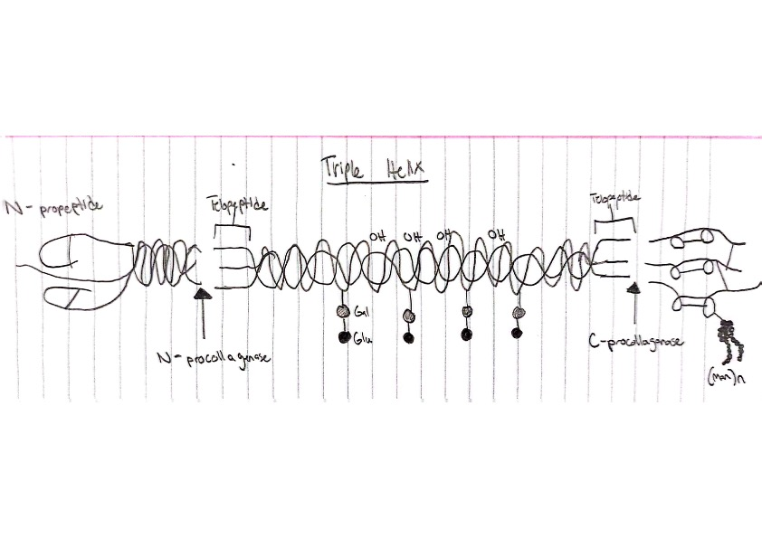

Does collagen 3 have any connections to squamous cell carcinoma though? Due to the decrease of collagen over time due to aging, and the likelihood of cancer developing, yes there is a correlation. A study published in PubMed explains how Type 3 collagen induces tumor dormancy, so in the absence of collagen 3 tumor cells can awaken and grow rapidly, creating a real problem for many of the elderly. Is there a way to reverse engineer collagen to stay around indefinitely? Thankfully, yes! There are collagen supplements one can take to drastically improve the length at which they continue working like they did in the past. Most people don’t realize how threatening this can be, and often brush off and sudden spots or bumps they find on their body leaving the cancer unchecked until it’s too late. But why are they not acing their supplements, and the answer would simply be the lack of awareness. Even though skin cancer is one of the biggest forms, many people seem not to notice, which should hopefully change in the coming years.

A collaboration of scientists dove deeply into this question in an article that they titled, “A tumor-derived Type 3 collagen-rich ECM niche regulates tumor cell dormancy.” A proteomic is the study of the innerworkings of proteins and studies associated with them. And this study proteomics are utilized to display that Type 3 collagen is needed to even keep tumors dormant. So essentially, with any mishap or error in the Type 3, tumors and cancerous cells are given wiggle room to grow and spread, obviously a big issue. Cancerous cells stay dormant until inhibited and undergoes proliferation. Cell proliferation is simply how fast a cell can undergo the cell cycle and divide. The speed at which this process continues results directly with how large or how many more cancerous cells are created, resulting in what is known as the tumor. When dormant the ECM can barely be noticed, but as proliferation happens and continues over time one can start to notice the onset of the cancer. The data recorded in the study showed that the ECM does in fact metastasize, and essentially break away from where the cell began multiplying to spread throughout the rest of the body.

The cell cycle creates life and allows life to continue to grow and evolve by completing a strict and highly regulated cycle of DNA replication and division. Passing the checkpoints through the cell cycle regulates the cells, but with all systems of life mutation is a continual possibility. When mutations in the cell hide the fact that any given cell has already undergone mitosis, the cell will proceed to the beginning of the cycle and pass through again, leading to a long cycle of continual replication. Single cells can stop this process quickly, but as the metastatic cells compile over time, it is overwhelming and vastly increases in speed and repetition, again causing an amass of cancerous cells, a tumor. In the data provided by the study, we can see the effect of collagen Type 3 on single cells, as there are no mice with lung DTCs (Differentiated Thyroid Cancer). But, when looking at collagen Type 3 effect of metastasizing cells, or ‘Clusters of greater than 20 cells as it is referenced in the study, one can see that three for every seven is observed in the ‘SiCOL3A1’ pool, and three for every four are found in the ‘Sh DDR1’ pool. This data, on a very much so surface level, is just putting numbers on the theories about the effects of metastasizing cells, and how when the cell cycle is repeated with speed, bad things happen, cancer.

Collagen Type 3 is a regulator, working to maintain the stasis of the body. When a specific cell, in this case T-Hep3, are growing increasingly larger over time, something must stop it before its too late. When this occurred and was studied in the experiment, collagen Type 3 was infused alongside the T-Hep3 cells. After close examination it was determined that, although the cells did end up growing, they were significantly smaller than those without the Type 3. With the now smaller size of these cancerous cells thanks to the help of collagen Type 3, scientists have physical and logical data deduced from experimental practices that Type 3 was able to decrease the number of cells continually going through the cell cycle. With a win this large, one speculates how can this information be used to further enhance its newfound ability? Using genetic modification, increased experimentation, and testing, cancerous cells and tumors could be a thing of the past. Something many thoughts wouldn’t be possible in their lifetimes could be possible in yours, an amazing feeling.

Word Count: 1101

Resources

“Squamous Cell Carcinoma.” *The Skin Cancer Foundation*, 6 Mar. 2023,

https://www.skincancer.org/skin-cancer-information/squamous-cell-carcinoma/#:~:text=Squamous%20cell%20carcinoma%20(SCC)%20of,squamous%20cell%20carcinoma%20(cSCC).

Radcliffe, Shawn. “Do You Know Your Collagen Types? Here, We Explain Type I, II & III.” *Mindbodygreen*, Mindbodygreen, 23 Apr. 2020, https://www.mindbodygreen.com/articles/collagen-types-important-differences-between-i-ii-and-iii.

Di Martino, Julie S, et al. “A Tumor-Derived Type III Collagen-Rich ECM Niche Regulates Tumor Cell Dormancy.” *Nature Cancer*, U.S. National Library of Medicine, 13 Dec. 2021, https://www.ncbi.nlm.nih.gov/pmc/articles/PMC8818089/#:~:text=Type%20III%20collagen%20induces%20tumor,the%20context%20of%20dormancy%20regulation.

MD Anderson Cancer Center, and Clayton Boldt. “Collagen Plays Protective Role during Pancreatic Cancer Development.” *MD Anderson Cancer Center*, MD Anderson Cancer Center, 4 Mar. 2021, https://www.mdanderson.org/newsroom/collagen-plays-protective-role-during-pancreatic-cancer-development.h00-159459267.html#:~:text=The%20study%20finds%20that%20collagen,allowed%20to%20grow%20more%20rapidly.

Di Martino JS, Nobre AR, Mondal C, Taha I, Farias EF, Fertig EJ, Naba A, Aguirre-Ghiso JA, Bravo-Cordero JJ. A tumor-derived type III collagen-rich ECM niche regulates tumor cell dormancy. Nat Cancer. 2022 Jan;3(1):90-107. doi: 10.1038/s43018-021-00291-9. Epub 2021 Dec 13. PMID: 35121989; PMCID: PMC8818089.

Author links open overlay panel, Chao Wang a, et al. “Type III Collagen Is a Key Regulator of the Collagen Fibrillar Structure and Biomechanics of Articular Cartilage and Meniscus.” *Matrix Biology*, Elsevier, 23 Oct. 2019, https://www.sciencedirect.com/science/article/abs/pii/S0945053X19303737#:~:text=Collagen%20III%20regulates%20fibril%20structure,and%20collagen%20I%2Ddominated%20meniscus.&text=Collagen%20III%20affects%20the%20aggrecan,aggrecan%20and%20collagen%20network%20integration.