**This is a written report that documents and outlines the plan for a COMPUTER forensics lab.**

**Summary**

A mid-sized police department's overview of the strategy for setting up and operating a digital forensics lab includes five essential elements: the physical layout of the lab, an inventory of the equipment, a plan for lab accreditation, a plan for lab maintenance, and a plan for personnel. Physical security measures should be used in the lab's design to ensure efficient and effective handling, storage, and analysis of digital evidence. At the very least, PCs and laptops, forensic hardware and software tools, network switches, monitors, printers, and evidence storage systems should be included in the equipment inventory. The plan for lab accreditation should include applying for certification from organizations that certify businesses. Regular upgrades, audits, backups, and testing of forensic equipment and procedures should all be part of the lab maintenance strategy. Finally, a lab manager and technician should also be included in the staffing strategy, along with detailed job descriptions outlining their tasks. This five-point approach can help a mid-sized police agency strengthen its digital forensic capabilities and capacity, assisting in more crime-solving and building community trust.

**Lab Plan:**

The lab's three-year plan is provided below, along with a physical layout diagram, a list of necessary equipment, a plan for lab accreditation, a schedule for lab maintenance, and staffing needs.

**Physical Layout Diagram:**

The actual configuration of the lab, which includes evidence storage for up to 20 cases, two analytical computers, and physical security features including key-code access, video monitoring, and alarms, is shown in the Visio design that is attached.



**Inventory of Equipment Needed:**

The following equipment will be needed for the lab:

* Desktops and laptops (minimum of 3 each)
* Forensic hardware tools (minimum of 2 write blockers, 3 acquisition devices, and 3 portable media devices)
* Forensic software tools (minimum of 3 licenses each for EnCase, FTK, and X-Ways)
* Network switches (minimum of 2)
* Monitors (minimum of 4)
* Printers (minimum of 2)
* Evidence storage systems (minimum of 2)

Hardware:

1. The main tools needed for performing digital forensics investigations are computers and laptops. To manage the volume of data that needs to be handled, they should have top-notch features including quick processors and ample storage.

2. Write-blocker: A write-blocker is a piece of hardware that stops any data on the storage device under investigation from being updated or modified. Write-blockers can be integrated into computers or used as independent devices.

3. Imaging tools: Without changing any of the data, imaging tools are used to make an exact replica of a storage device. This is an important phase in the investigation process for digital forensics.

4. The material gathered throughout the research is stored on external hard disks and USB drives.

5. Networking tools: To evaluate network traffic, networking tools including routers, switches, and hubs are employed.

6. Mobile device forensic tools: You may get data from mobile devices using programs like Cellebrite and XRY.

Software:

1. EnCase: The majority of forensic investigators utilize EnCase, a potent digital forensic program. A storage device can be completely forensically imaged and examined, and have deleted files and encrypted data recovered.

2. FTK-Imager: FTK-Imager is a free program used to produce evidence images without altering the underlying data.

3. AccessData: One of the top digital forensic programs, AccessData examines data both online and offline. It is capable of analyzing a wide range of data analytics, including network traffic, email data, mobile device data, etc.

4. Autopsy: Data stored on hard drives, USB drives, and other storage devices are examined using Autopsy, an open-source digital forensic program. It can recover deleted files and has sophisticated data recovery features.

5. Forensic Toolkit: Used extensively by forensic investigators, Forensic Toolkit is another strong digital forensic tool. It offers sophisticated capabilities for evaluating data from other sources, like emails and internet history.

**Lab Accreditation Plan:**

We will apply for accreditation from industry certification organizations like the International Association of Computer Investigative Specialists (IACIS) and the American Society of Crime Laboratory Directors to make sure the lab complies with industry standards and is recognized as a place where accurate and trustworthy digital forensics services are provided (ASCLD). We'll make sure our lab complies with all necessary norms and specifications. For accreditation, I'll also employ the ANB and ISO 17025:2005 standards. The accreditation procedure will begin with the actions listed below:

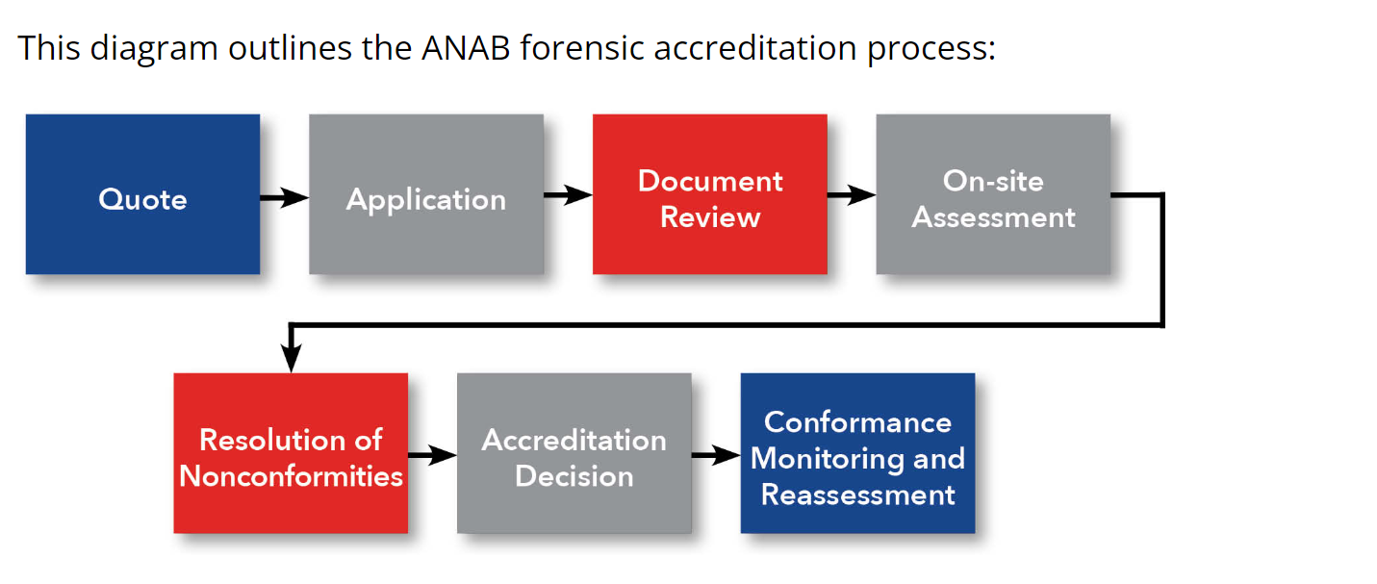

The laboratory is required to understand and follow all applicable ISO/IEC 17025:2005 requirements. The example ISO checklist for an accreditation application is provided below. The following are the accreditation requirements:

- Does the laboratory have a quality handbook outlining its quality system and demonstrating how it complies with standards?

- Have procedures been defined and recorded for every task important to running the laboratory and carrying out the quality system?

- To make sure that all measuring and testing equipment is in good condition and performing properly, does the laboratory maintain records of equipment calibration, verification, and maintenance?

- Are the testing and calibration procedures used in the laboratory based on procedures that are valid, dependable, and suitable for the particular measurements and tests to be carried out?

- Does the lab have policies in place to safeguard the security and integrity of client information?

- Are employees capable and competent to carry out their assigned jobs, and are there training programs in place to make sure that employees are familiar with the protocols they must adhere to?

- Does the laboratory have a mechanism in place to systematically check that the quality system is efficient, effective, and compliant with the standard?

- Are any nonconformities found during audits, inspections, or other assessments being addressed with prompt and efficient corrective actions?

- Does the laboratory have documented policies in place for how disputes, appeals, and complaints from customers are handled?

- Does the laboratory's quality management system take into account external concerns including the environment, health and safety, and security?

There are a number of standards that must be satisfied in order to receive certification as a digital forensic lab under International Standard ISO/IEC 17025:2005. They consist of:

1. Management and structure: The company will have a defined organizational structure with clear roles, processes, and guidelines.

2. Personnel: Employees in the lab must possess the necessary education, training, and experience to carry out the necessary responsibilities. They will be well conversant with the concepts, methods, and techniques of digital forensics.

3. Equipment: The lab will be equipped to the necessary standard to carry out digital forensic studies. This comprises the instruments required to acquire, store, and analyze digital data, as well as related gear and software.

4. Validated and documented test protocols and calibration processes shall be used in the lab for all utilized equipment. These techniques and procedures must adhere to accepted norms and best practices in the area of digital forensics.

5. Quality assurance: To guarantee the integrity and quality of the data produced during the study, the lab will have policies and procedures in place. This entails assuring the proper handling, documentation, and storage of the evidence in addition to putting in place the necessary safeguards to stop contamination or manipulation.

6. Reporting: In order to ensure accurate and prompt reporting of results, the lab will have protocols in place that include accurate recording of the methods, findings, and recommendations.

7. Records management: The lab will have a system in place for keeping track of evidence, case files, test results, and other pertinent paperwork in a secure and effective manner.

8. Audit and review: The lab must have policies in place for both external accreditation body audits and routine internal audits to guarantee conformity with ISO/IEC 17025:2005.

The lab's ability to undertake digital forensic studies to the required standard will be shown by meeting these requirements, which will also guarantee its accreditation under ISO/IEC 17025:2005.

**Lab Maintenance Plan:**

To make sure that digital forensic equipment and devices are operating properly and efficiently, a maintenance plan for digital forensics is essential. The actions we will take to build a digital forensics maintenance plan are listed below.

* Updating hardware and software frequently
* Periodic evaluations of security procedures and regulations
* Regular backups of the lab's data
* Frequent accuracy and dependability checks of forensic procedures and tools

1. Frequent Updates: Verify that the most recent software and firmware versions are installed on all digital forensic equipment and devices.

2. Cleaning: The maintenance strategy should include a routine cleaning of digital forensic equipment, including hard drive duplicators, forensic workstations, and evidence storage devices.

3. Calibration: To guarantee the consistency of their function, calibrate forensic hardware devices such as write blocks, duplicators, and analyzing tools on a regular basis.

4. Training: Make sure the staff employees who work with digital forensics receive frequent training to keep them current on new technologies and guarantee they are knowledgeable about the most recent forensic procedures.

5. Documentation: Keep a record of every maintenance task done on the hardware and software used for digital forensics.

6. Backup & archival: Ensure that all evidentiary data is archived securely and is backed up in accordance with the organization's policy so that it may be accessed again in the future.

7. Monitor performance: To make sure that the hardware and digital forensic tools are accurate, constant performance monitoring is required.

We may build an efficient digital forensics maintenance plan to help monitor performance and extend the life of the equipment by following these easy steps.

**Scope**

An electronic device's or digital data's investigation and analysis to find evidence of a potential crime or policy violation is included in the scope of a digital forensics lab. This may entail retrieving deleted files and examining web browsing history, email correspondence, and data from mobile devices. Forensic analysts can extract, preserve, and evaluate data using sophisticated software and hardware tools for use in court cases. A digital forensics lab's services might also involve supporting law enforcement with investigations and giving expert testimony in court.

**Staffing:**

Both a manager and a technician are needed for the lab. The following are the job descriptions for each role:

Lab Manager: The Lab Manager will be in charge of managing relationships with external stakeholders as well as supervising the lab technician and liaising with law enforcement agencies in order to oversee the lab's activities. The following duties will fall under the purview of the lab manager:

* Oversee the lab's daily operations, including staffing, scheduling, and the assignment of cases.
* Oversee the lab technician, giving advice, direction, and instruction as necessary.
* Cooperate with law enforcement to ensure that forensic examinations are completed quickly and accurately.
* Maintain communication with all external stakeholders, including as suppliers, consultants, and trade associations.
* Make that the lab complies with industry standards and accreditation specifications.

Lab Technician:

The lab technician will be in charge of conducting forensic analyses of digital media, writing reports, and testifying in court about the results. The following duties will be assigned to the lab technician:

* Examine digital media, such as computers, mobile devices, and other digital storage devices, forensically
* Reports that accurately and clearly convey results and conclusions should be prepared and documented.
* Where necessary, testify in court regarding findings and judgments Work with the lab manager to ensure that cases are prioritized appropriately and finished quickly and accurately
* Via training and professional development opportunities, maintain proficiency in the most recent forensic tools and procedures.

**Here are some roles and responsibilities:**

1. Digital Forensic Examiner: A digital forensic examiner's main responsibility is to review digital evidence gathered during investigations. This includes restoring erased data, examining computer systems and networks, and figuring out the reason for security breaches in the digital world.

2. Technician for Digital Evidence: A technician for digital evidence is in charge of gathering, conserving, and processing digital evidence. They work to document and retain the evidence in a way that preserves its integrity throughout the legal process, and they are frequently the first point of contact in the lab for incoming evidence.

3. Researcher: A researcher in a digital forensics lab is in charge of keeping abreast of new tools, methods, and technology in the industry. Also, they might carry out experiments and provide results that extend the realm of what is practicable in digital research.

4. Technical Analyst: A technical analyst helps other lab employees and digital forensic investigators with technical issues. This can involve setting up systems, maintaining the lab's digital infrastructure, and debugging hardware and software problems.

**Conclusion:**

By implementing the aforementioned strategy, we can establish and maintain a productive digital forensics lab for your medium-sized police force. Your department will be able to solve more crimes thanks to the lab, which will also boost public confidence in your agency.