Are we scaring ourselves to death?
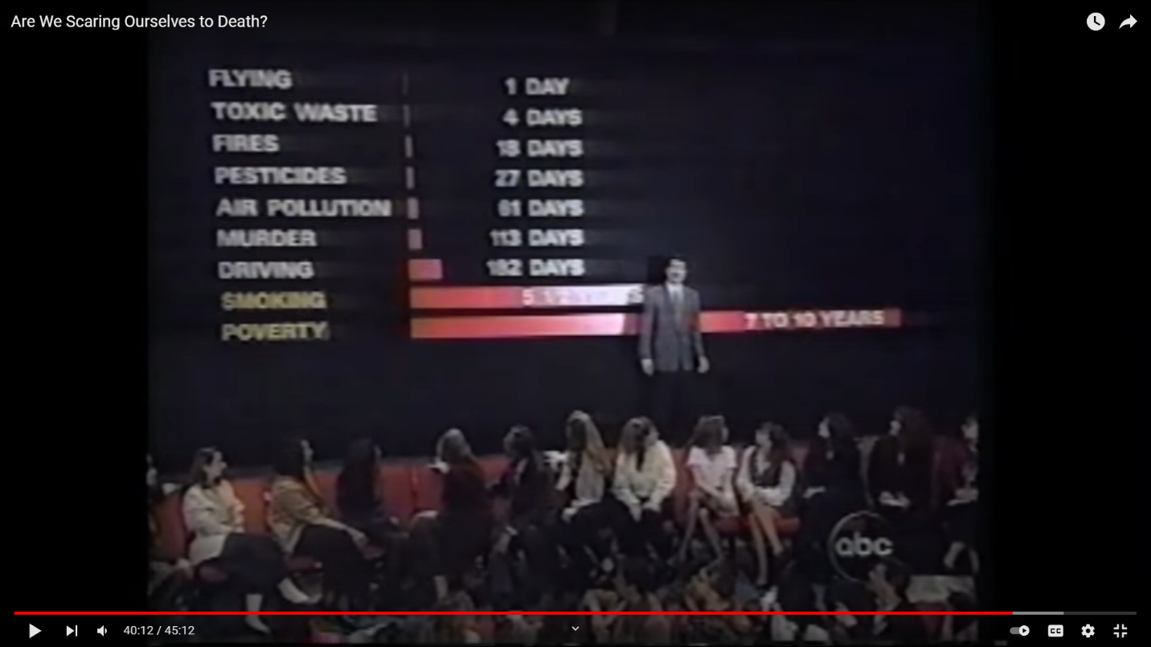

Something that really struck me from this video is really the main point of the video itself. It is especially expressed by this image here, where our host compares the significance of numerous public health concerns on overall lifespan. The purpose of his presentation was to reveal how we severely overreact to risks that are not actually that much of a danger to us. This is made worse when said risks are new or are hard to understand, such as the threat of dangerous chemicals or a sudden string of crimes.
For me, this concept especially struck me when he reveals in his chart that poverty is far more of a public health risk to everyone than any of the previous fears he had discussed, which had included airplane crashes, chemicals in pesticides, and house fires. Poverty and its effects, including less access to quality food and healthcare, kills far more people every year than any of these previous dangers. He suggests that instead of paying so much attention to novel risks that do not actually threaten us all that much, we must pay much more attention to the known and ignored risks we face every day.

