Gabriel Jacobson
2/5/26
IDS 300W
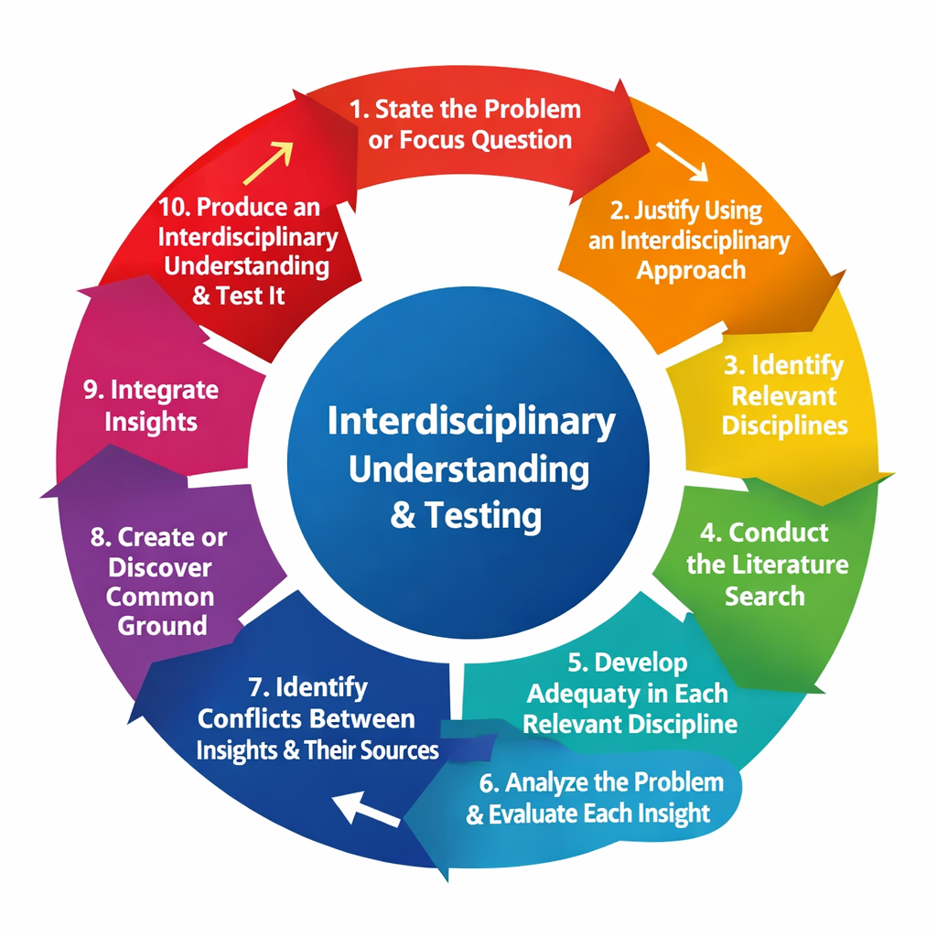
For my visual representation of the Interdisciplinary Research Process (IRP), I chose to use a circular chart. I selected this design because the IRP is not a strictly linear process. Although it includes ten steps, Repko and Szostak explain that interdisciplinary research often requires moving back and forth between steps as an understanding develops (Repko & Szostak, 2020). A circular model clearly shows this ongoing and reflective nature of interdisciplinary work.
The idea for this visual came from reviewing interdisciplinary research diagrams and flowcharts online, particularly those connected to Repko and Szostak’s framework. As I refined the design, I realized that arranging the steps in a loop better represented how later stages, such as integration and testing, will let researchers to revisit earlier steps like redefining the problem or reconsidering disciplinary insights. This helped me better understand how the IRP functions and moves in practice and more than just in theory.
To create the visual representation, I used an online AI tool that allowed me to create the shape and design of an image. This tool made it easy to clearly display each of the ten steps while keeping the design simple and easy. I avoided unnecessary visuals so that the focus stayed on the research process itself and also to avoid any other problems.
Each part of the visual corresponds directly to one of the IRP’s ten steps. The diagram begins with stating the problem and justifying the interdisciplinary approach, then moves through identifying relevant disciplines, conducting literature searches, and developing disciplinary adequacy. The middle steps focus on analyzing insights, identifying conflicts, and establishing common ground. The final steps emphasize integrating insights and producing an interdisciplinary understanding, with arrows looping back to earlier steps to show reflection and revision (Repko & Szostak, 2020).
Overall, this visual representation helped make the IRP clearer by turning an abstract list of steps into a flowing and connected process. It demonstrates how interdisciplinary research integrates multiple perspectives to produce deeper and more comprehensive understanding.

Refererences:
Repko, A. F., & Szostak, R. (2020). Interdisciplinary research: Process and theory (4th ed.). SAGE Publications.
Szostak, R. (n.d.). Diagrams of the interdisciplinary research process. University of Alberta.
https://sites.google.com/ualberta.ca/rick-szostak/research/about-interdisciplinarity/interdisciplinary-best-practices/interdisciplinary-research/diagrams-of-the-interdisciplinary-research-process

