Romanov Assignment
Part I
- Who were the Romanov’s (in Russian history)? According to history.com, the Romanov’s were a dynasty that ruled Russia for a little over 300 years. https://www.history.com/topics/european-history/romanov-family#:~:text=The%20Romanov%20family%20was%20the,Alexander%20I%20and%20Nicholas%20II.
- Briefly outline the Romanov lineage. According to russianlegitimist.org, the Romanov lineage begins with Nicholas I, who had many children. One of his sons, Alexander II, had children of his own, one of them being Alexander III. Alexander III also had children of his own, one of them being Nicholas II. Nicholas II marries his wife, Alix, and they have five children together: Olga, Tatiana, Maria, Anastasia, and Alexis. https://www.russianlegitimist.org/genealogy-of-the-imperial-house
- Nicholas II was the last Romanov to hold power in Russia. What was his title? Nicholas II was Czar of Russia from 1894 to his forced departure in 1917. https://www.history.com/topics/european-history/romanov-family#:~:text=The%20Romanov%20family%20was%20the,Alexander%20I%20and%20Nicholas%20II
- What happened to Nicholas II? Why (from a geopolitical view)? Who then took control? In 1917, Nicholas II was forced to step down as Czar after the Bolsheviks took overpower. Throughout his reign, Nicholas was unfavored by citizens of Russia, and World War I did not help his reputation. With an unsuccessful army and destroyed economy, many Russians began to side with the Bolshevik’s in wanting to overthrow the czar. After Nicholas II’s reign was overthrown, the Bolsheviks’ leader, Vladimir Lenin, was the next to rule over Russia. https://www.history.com/topics/european-history/romanov-family#:~:text=The%20Romanov%20family%20was%20the,Alexander%20I%20and%20Nicholas%20II
- Describe the family of Nicholas II. What happened to them? According to history.com, after the Bolsheviks took over Russia, the family of Nicholas II were initially sent to Siberia under house arrest, but then were relocated to a house in Yekaterinburg. On July 16, 1918, the entire family (including Nicholas II’s wife and young children) were executed by Bolshevik troops. https://www.history.com/topics/european-history/romanov-family#:~:text=The%20Romanov%20family%20was%20the,Alexander%20I%20and%20Nicholas%20II

Part II
- How was Nicholas II wife, Alix, related to Queen Victoria of England? According to townandcountrymag.com, Queen Victoria was Alix’s grandmother. https://www.townandcountrymag.com/society/tradition/a22133006/prince-harry-prince-philip-related-to-the-russian-romanovs/
- In a couple of sentences, describe the disease hemophilia. According to cdc.gov, hemophilia is a “bleeding disorder in which the blood doesn't clot properly.” This disease is usually inherited, due to a mutation in one of the affected person’s genes. Hemophilia is dangerous as it can cause bleeding easily, especially following an injury.
- What type of hemophilia (A or B) is (probably) represented in the pedigree chart? Type B.
- See below
- See below for Punnett square drawing. Because Hemophilia is a recessive trait on the X gene, and males have one X and one Y, there would be nothing to cancel out that trait if it were to appear within a male, therefore making them hemophiliac.
- Is it possible for a female to inherit hemophilia, and, if so, how? According to the cdc.gov, it is possible for women to have hemophilia, although it is much more common for hemophilia to appear in males. For Hemophilia to appear in females, her mom would need to be a carrier and her father be a hemophiliac. In this example, the recessive hemophilia trait would affect both X chromosomes, therefore making their female offspring hemophilic as well. https://www.cdc.gov/ncbddd/hemophilia/features/women-and-hemophilia.html#:~:text=Females%20can%20also%20have%20hemophilia%2C%20but%20it%20is%20much%20rarer,similar%20to%20males%20with%20hemophilia.
- None of Alexis’ sisters are shown to have hemophilia. Using only the tools available at the time they lived, how could it have been determined whether they were carriers like their mother? During the time Alexis’ family lived, there was no technology to determine who was a carrier to hemophilia and who was unaffected. At that time, Gregor Mendel, who is considered the father of genetics, had already proposed his law of segregation and his law of independent assortment. Punnett squares were used, and still are today, to predict possible traits.
- See below
- See below
- See below
- According to history.com, Alexis being a hemophiliac is a possible cause of the Russian Revolution. This mainly has to do with Alexis’ mother, Alix. Alix was unfavored by most people, not only because her husband was considered a poor leader, but also because of her dedication to Grigori Rasputin, a “self-proclaimed holy man.” Alix was convinced that Rasputin could cure Alexis from hemophilia. Because of Rasputin’s reputation, some of which was contributed to his support of the Romanov family, he was killed in 1916. Rasputin was only a part of the many problems Russians had with the Romanov family, which resulted in the Russian Revolution in 1917. https://www.history.com/topics/european-history/romanov-family#rasputin-and-the-romanovs
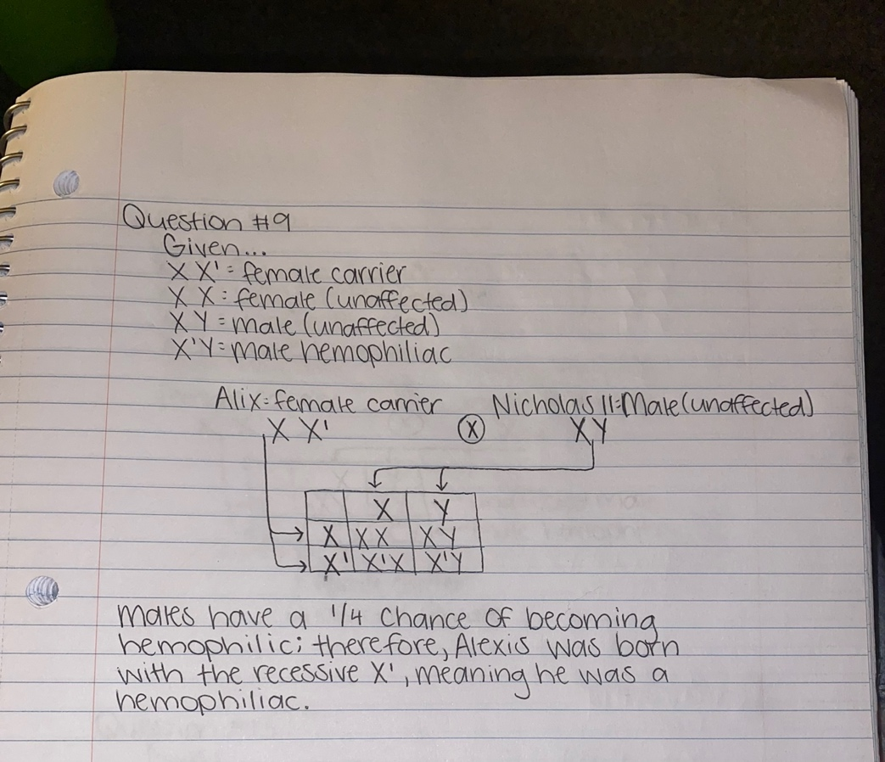

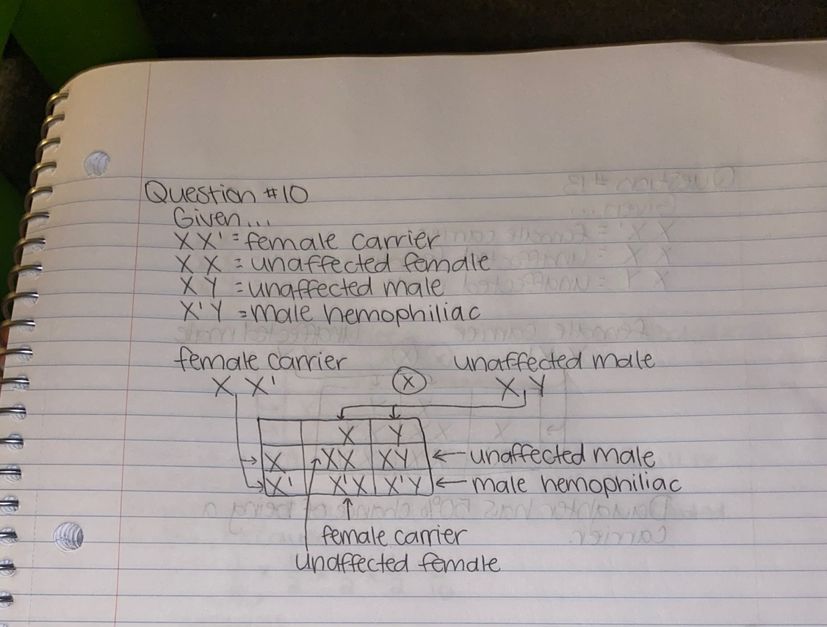

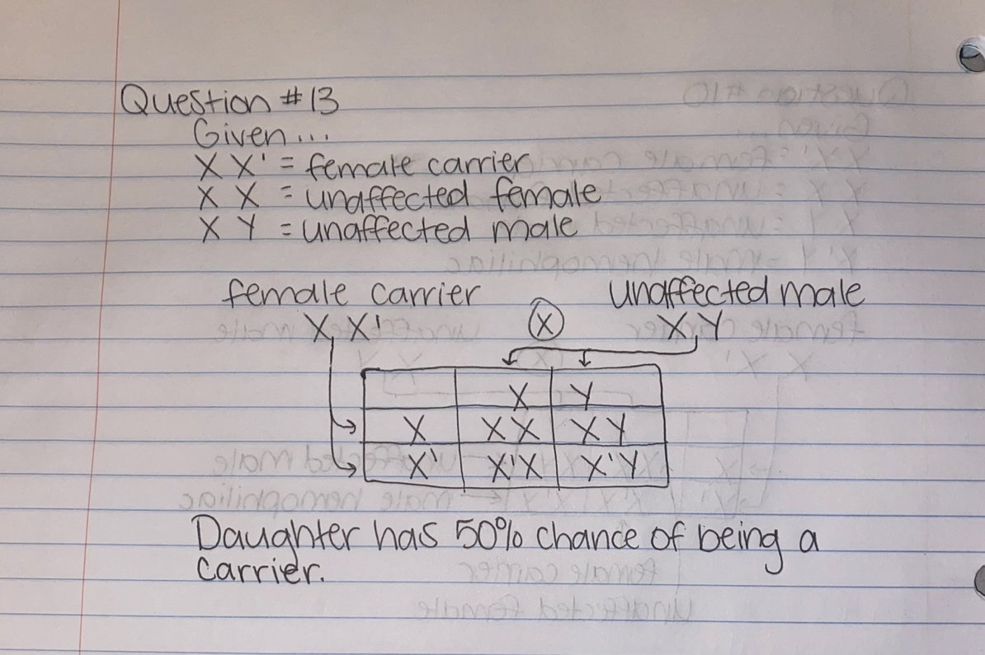

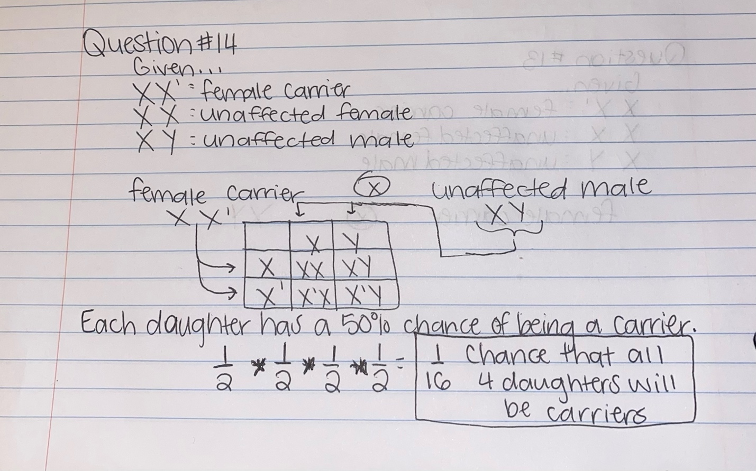
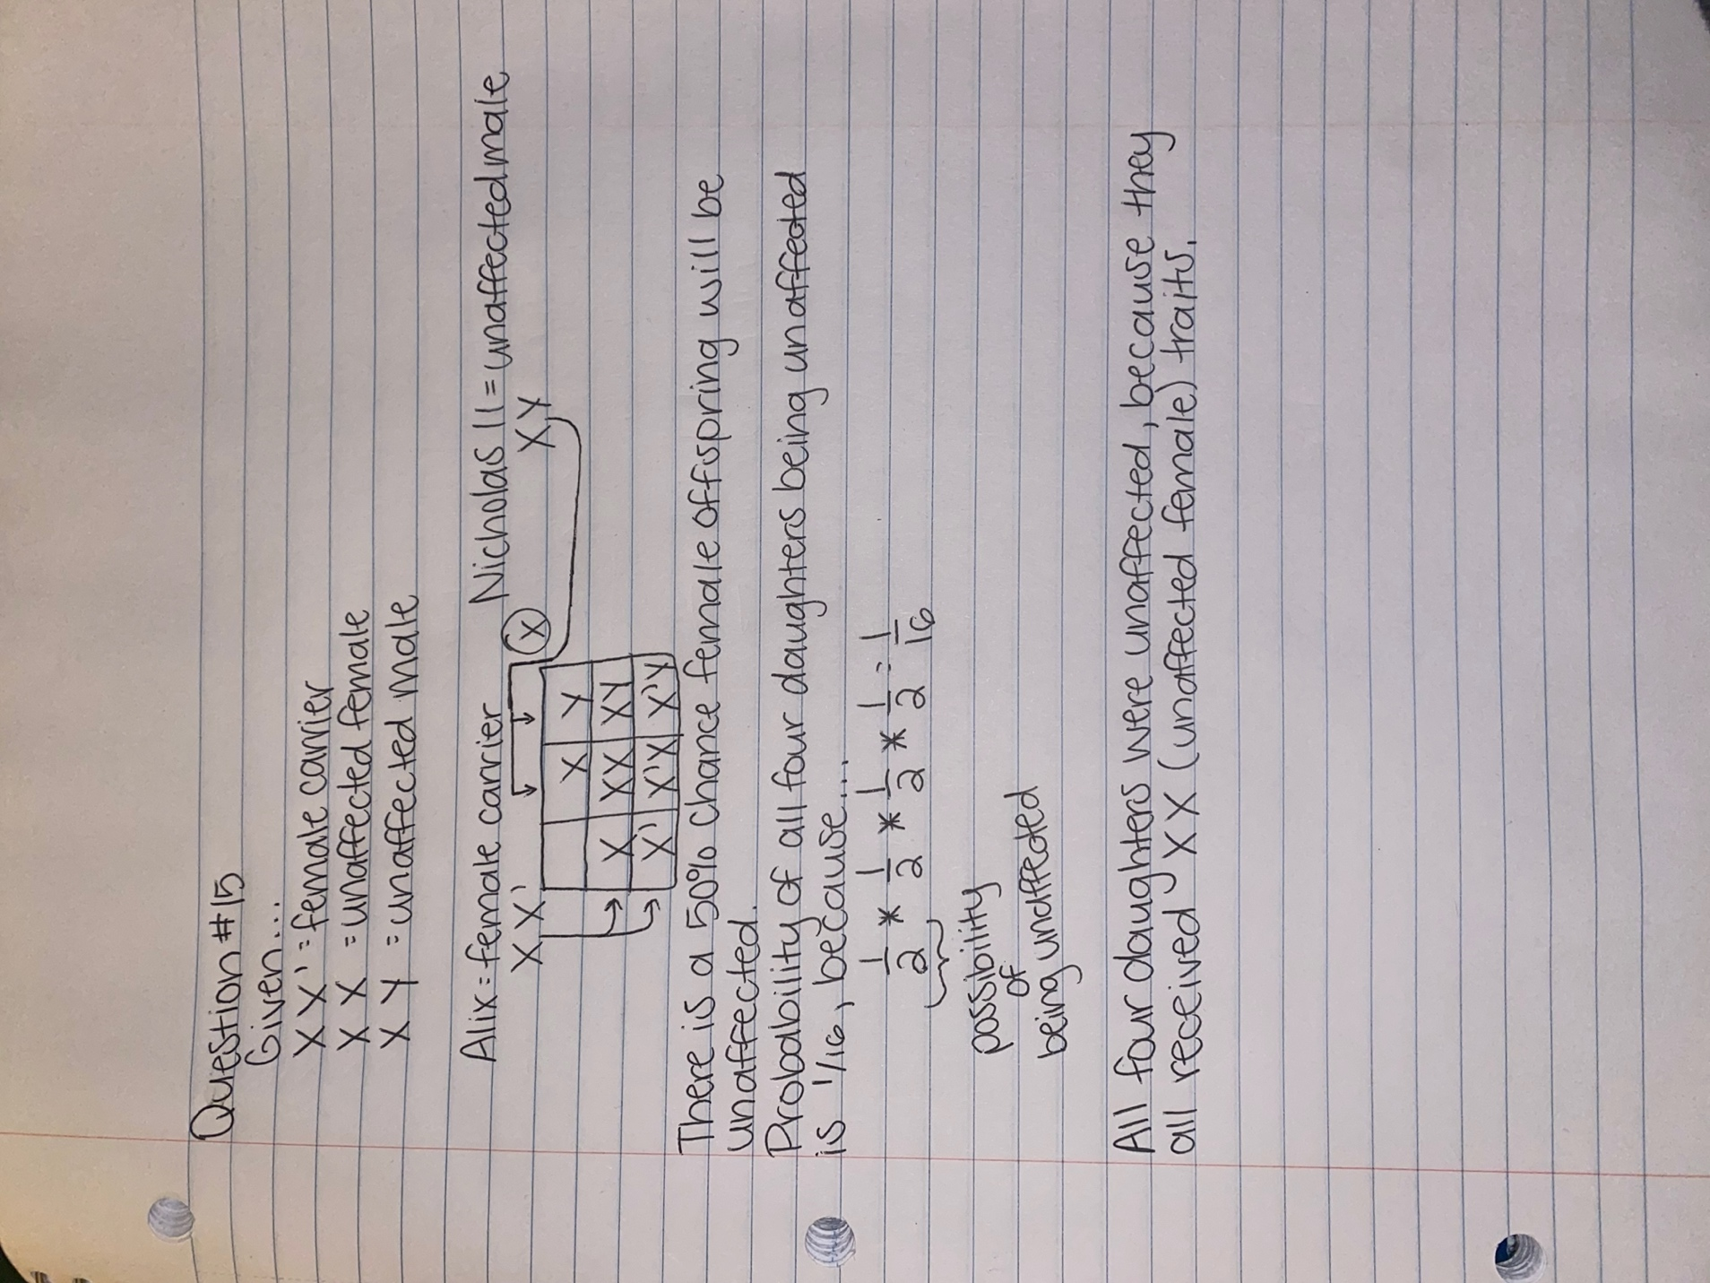

Cited Sources:

- History.com editors. (2017 September 21). Romanov Family. History.https://www.history.com/topics/european-history/romanov-family

- The Russian Legitimist. (2015). Genealogy and Succession Within the Imperial House. russianlegitimist.org.https://www.russianlegitimist.org/genealogy-of-the-imperial-house

- Hallemann, Caroline. (2022 November 13). How the British Royals Are Related to the Romanovs. Townandcountrymag.com. https://www.townandcountrymag.com/society/tradition/a22133006/prince-harry-prince-philip-related-to-the-russian-romanovs/

- Centers for Disease Control and Prevention. What is Hemophilia? CDC.gov. https://www.cdc.gov/ncbddd/hemophilia/facts.html

- Centers for Disease Control and Prevention. Women Can Have Hemophilia Too. CDC.gov. https://www.cdc.gov/ncbddd/hemophilia/features/women-and-hemophilia.html#:~:text=Females%20can%20also%20have%20hemophilia%2C%20but%20it%20is%20much%20rarer,similar%20to%20males%20with%20hemophilia

