I attended the 7pm lecture by Dr. Webby.

The presentation started with Dr. Webby introducing himself and talking a little bit about his field. He said he was particularly interested in diseases that spread from animals to humans. The lecture was ultimately about H5N1 bird flu that has become of higher concern, however the speaker first talked generally about influenza to give the audience some background on the topic. Influenza has 18 HA subtypes and 11 NA subtypes that all evolve through drift and shift. The way a virus works is that it first has to attach to a host cell, where it can undergo duplication. This can only happen in a host cell, because viruses are dependent on them. Then Dr. Webby made a basic distinction between zoonotic flu (bad but on a small scale), pandemic flu (really bad, spread globally) and epidemic flu (bad). Afterwards, he got more specific about the bird flu. The natural hosts for these were ducks and other water birds and then progressively spread to other species of animals as well. A picture was shown showing a market in Bangladesh with a striking 40% positivity rate of their chickens. This was shocking to me, but Dr. Webby proceeded to relief the horror slightly. He explained how most viruses cause zoonotic infections, but fortunately not a lot become pandemic. After raising the question on why that is, he named that we are rarely exposed to infected birds, that receptor preference plays a role and that the environment in a bird cell is different from human cells. These reasons are just examples on why there are so many bird flu types, but we only occasionally get infected.

The first outbreak of the H5N1 in a human was recorded in 1997 in Hong Kong. As a result, the city got rid of that specific species of bird, but back then the virus couldn’t yet be transmitted from human to human. The first introduction in the US was 2014, but then 2021 a few more cases started to appear. Experts believe that local birds died in high numbers because they were exposed to this new virus that they have never been exposed to before. This led to an unusual number of dead birds, which scavenger animals such as foxes and bears consume and therefore get infected as well. In 2024 cows were infected with this virus, but strangely the affected area was the cows utter. It depends on the species and type of cell to where the virus can affect a species, for cows it is the utter and for humans it is in the eyes. This virus causes conjunctivitis in human eyes. So far there have been about 67 cases of H5N1 in the US. Globally, this number is as high as 964 individuals. Sadly, 466 of these infections resulted in deaths. Dr. Webby and other experts conclude that there hasn’t been a lot of evolution of the virus in humans yet, so it remains an avian virus instead of a mammalian virus, but only one changed amino acid sequence might change this. In the end Dr. Webby offered his opinion on how worried we should be about this virus and its course. He said that right now the virus poses little risk. H5 viruses have had lots of 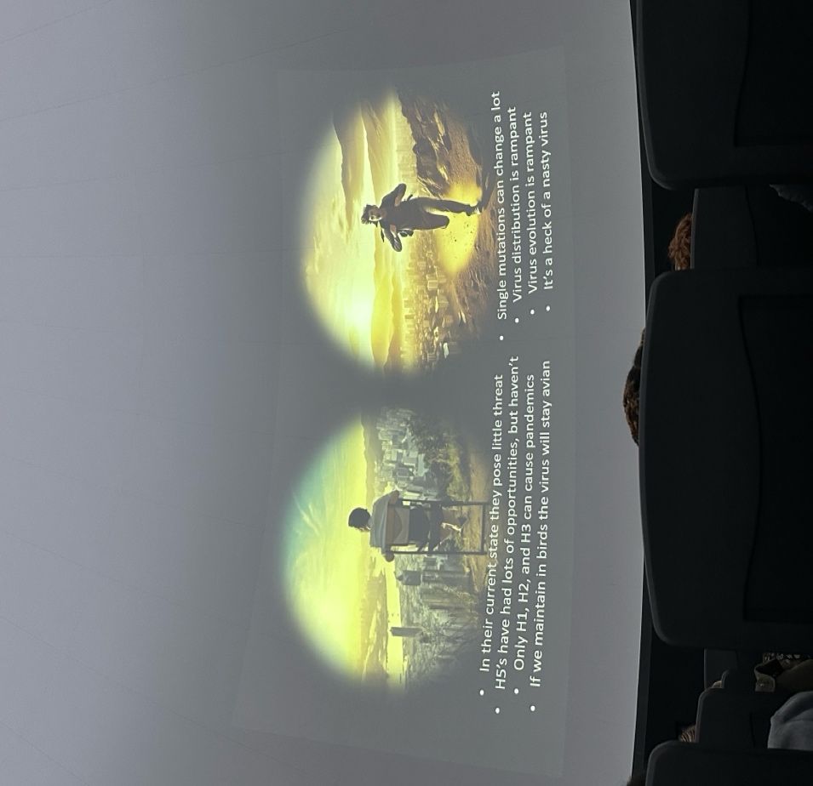opportunities to spread, but haven’t yet. In addition, the experts said that so far only H1, H2 and H3 viruses have become pandemic and that we might be able to maintain it as an avian virus. On the other hand, a single mutation can change a lot and the virus’ evolution is rampant. Most importantly, this is a really nasty virus, which would be painful for anyone having to go through it. At the end of his presentation, Dr. Webby answered any questions in the room. I thought this presentation was really interesting. For me the most fascinating as well as scariest was that parts of the virus have been found in milk.