Old Dominion University/BIOL294-Genetics/Rinehart-Kim/Romanov Project

**Internet Resources**

**You may use other Internet sources here, but please cite any sources that you use unless they are one of the following.**

[*http://journals.plos.org/plosone/article?id=10.1371/journal.pone.0004*](http://journals.plos.org/plosone/article?id=10.1371/journal.pone.0004)*838 (You should be able to access the entire article. You may need to copy and paste the site address.)*

[*http://www.ncbi.nlm.nih.gov/pubmed/20557352*](http://www.ncbi.nlm.nih.gov/pubmed/20557352) *(You won’t be able to access the entire article, but the abstract will give you important information.)*

<http://www.nature.com.proxy.lib.odu.edu/ng/journal/v9/n1/pdf/ng0195-9.pdf> (Please note that this is a PDF of an article.)

**History**

1. Nicholas II was the last Romanov to hold power in Russia. What was his title? His title was Tsar Nicholas II but his full name was Nikolai II Alexandrovich Romanov

2. How long had the Romanov family been in power in Russia? The Romanov family had been in power since 1613, making it just over 300 years old at the time of deposition (1917)

3. Nicholas II abdicated the throne. Who took power then? Although he named his brother, Grad Duke Michael, as his successor, he refused to accept the throne without first allowing the people to vote. After the vote the Provisional Government took over control of the Russian thrown

4. What happened to Nicholas II and his family after he abdicated the throne? Nicholas II, his wife, and all their children were imprisoned and eventually executed via firing squad.

5. One of the reasons that the family of Nicholas II was executed (vs. just imprisoned) was because there was a fear that the White Russian Army would save them. Who was the White Russian Army? The White Russian Army was the collective military unit under the “white movement” or antisocialist movement within Russian. They fought against the Red Army of the Bolsheviks.

**Hemophilia**

One of the pedigree charts found at the end of this assignment comes from the Module powerpoint lecture notes.

6. How was Alix, the wife of Nicholas II, related to Queen Victoria of England? (Look at the pedigree chart carefully.) Alix was the granddaughter of Queen Victoria of England, as Victoria’s second daughter was Alix’s mother.

7. On what chromosome is the gene that, when mutated, causes hemophilia and how does this contribute to its inheritance pattern? The chromosome that causes hemophilia when mutated is the X- Chromosome.

Both Queen Victoria and Alix are designated as being carriers for hemophilia.

8. What does it mean to be a carrier for a disease? If someone is a carrier for a disease, that means that they are capable of passing on genetic mutation associated with a disease but do not necessarily have to exhibit symptoms of the disease.

9. Why aren’t males considered carriers for hemophilia? Males can have a disease like hemophilia if they inherit an affected X chromosome that has a mutation in either the factor VIII or factor IX gene

10. In a couple of sentences, describe the physiology of the disease hemophilia. (Yes, I know it is severe bleeding because the blood cannot clot. But WHY can’t the blood clot? Be *very* specific.) Hemophilia is a blood disease caused by low levels of “clotting factors” within the blood. There are 13 types of clotting factors, which work together with platelets in the “coagulation cascade” to help blood clot. People with hemophilia have lower levels which makes it harder for the blood to coagulate and plug the wound.

11. What type of hemophilia (A or B) is (probably) represented in the pedigree chart? Hemophilia B

12. Describe the mutation (at the molecular level) that apparently caused hemophilia in Alix, (and probably all of the European families that had hemophilia). Be *very* specific. The mutation that occurred was a substitution of the splice acceptor site of exon 4 in the F gene. The substitution mutation is a nitrogenous base substitution that occurred and caused an amino acid sequence change.

13. How could the mutation you described in #12 result in a faulty gene product? Be *very* specific in your description. When mutation occurs, it causes a person to miss one of the clotting factors needed to prevent blood from bleeding non-stop. An alteration in the gene, like a certain mutation that changes the gene into another gene can cause that missing gene for example to cause hemophilia. In other words, if I need two slices of bread to make a sandwich and I only have one slice of bread I can only make a bun not a sandwich. This is what happened with hemophilia. To prevent it you need factor VIII or XI in order to have proper clotting.

14. The Romanov’s son, Alexis, had hemophilia. Describe how Alexis genetically hemophilia. (Use a Punnett square. You can either draw a table or line up the genotypes.) Alexis genetically acquired hemophilia through his mother Alix. She was a carrier of the X Linked recessive gene and passed it down to her son.

15. Using a Punnett square (again, draw a table or line up the genotypes), explain why only males in the pedigree chart have hemophilia. (Choose at least one of the males represented in the pedigree chart, and show his parents in the Punnett square.) Only males in the Punnett square tend to have hemophilia because it is an x linked recessive gene and if the mother has it there is a good chance that she will pass it to her son who only needs one x linked recessive gene to be a hemophiliac.

16. Is it possible for a female to inherit hemophilia, and, if so, how? Yes, it is possible for females to inherit hemophilia but mainly as a carrier. It is extremely rare for females to be a hemophiliac due to the way the gene is passed down; she would have to inherit 2 damaged x linked recessive genes to contract the disorder. So, father has to have the disease and mom will have to be a carrier. But even if a female gets one of those genes her other x chromosome acts as a backup preventing her from being a hemophiliac.

17. Some historians speculate that Alexis’ hemophilia condition could have led to the Russian Revolution. Explain.  ***You should look up the faith healer Rasputin and read about his relationship to the Romanov family.*** Rasputin inserted himself into the lives of alexi and Alenxandria’s life he claimed to be a healer of alexandria’s son and unexplained miracles happened which led her to believe him. Nobleman did not like his influence over her and her decisions based on his council and so they assassinated him and overthrew the romanov family. His influence and reputations helped discredit the tsarist government which helped cause the overthrow of the romanov dynasty which happened only a few weeks after his death

**Molecular Analysis of People in a Mass Grave**

18. Two “graves” were discovered near Yekaterinburg, Russia. Describe the number of bodies in each grave. Nine skeletons where found in the first mass grave which was the Tsar, the Tsarina and three of their daughters recovered from the grave. In the second grave a minimum of two bodies were found one male and one female who they thought were the other two children

19. When were these graves discovered? In the summer of 2007 the second grave was found. In the late 1970s in when the first grave was found

20. What type of testing was done to confirm sex and familial relationships among the remains found in the mass grave? Nuclear DNA testing of five STR markers and mtDNA testing of previous and present romanov testing was conducted to identify and link the bodies to be related.

21. Genetically, what does STR “stand” for? Be very specific in your answer. STR stands for short tandem repeats

22. HRH Prince Philip, the Duke of Edinburgh, provided mitochondrial DNA used to identify Alix and her three daughters. HRH Prince Philip, the Duke of Edinburgh, is married to Queen Elizabeth II of England. Wait, isn’t Queen Elizabeth II related to Queen Victoria? So why was ***Prince Philip’s*** mitochondrial DNA used? (To help you answer this question, look at the second pedigree chart.) Prince Philip as the only living relative of Tsarina mtDNA was used to compare and solidify mtDNA with Tsarina Alexandra. Confirming the mtDNA between the two also linked the mtDNA to the three daughters.

23. Who was missing from the mass grave (the one with the most skeletons)? Male and female bones were found in the second grave which turned out to be Tsarevich Alexei and one of his sisters

**Molecular Analysis of People in a Mass Grave, cont.**

24. The Duke of Fife and Princess Xenia provided mitochondrial DNA used to identify Nicholas. One of these is a female and another is a male. Does that matter? What general statement can you make about their genetic

relationship to Nicholas and Alexandra? Are these people still living? Duke of Fife has passed and Princess Xenia is still living. Using a male and female mtDNA matters if the parents are being identified but not to compare the mtDNA. Because it shows the mtDNA linkage of the family stemming from a genetic female or matriarch. The Duke of Fife and Princess Xenia mtDNA has been passed down with the mtDNA linking to Nicholas II and showing that they are maternal relatives.

25. What was discovered in the mitochondrial DNA of Nicholas that was not identified in either the Duke of Fife or Princess Xenia? The single point of heteroplasmy at the 16169 position differed with the C to T ratio. Tsar Nicholas ratio was C/T.

26. What is the term given to the existence of two (or more) genetically different mitochondria in the cell? Heteroplasmy

27. What three types of DNA were used to test the remains found in a second grave? Nuclear (str), mitochondrial and ancient DNA

28. Of the three types of DNA you listed in #28, which one would have been used specifically to identify Alexis? Mitochondrial

29. What was the source of the DNA used to identify Alexis? Teeth and bone fragments

30. Was Anastasia in the grave in which Alexis was found? It is not clear if Anastasia or Maria was found in the second grave but both did not survive the execution

**Who Wants to Be Anastasia?**

Apparently, about 200 people have wanted to be Anastasia and have claimed to be her! One of the most famous imposters was a woman named Anna Anderson (Manahan).

31. Give a brief history (2-3 sentences) of Anna Anderson-both her claims and what is thought to be true. Anna Anderson was a “polish peasant” who claimed she was the Duchess Anastasia the daughter of Tsar Nicholas II. She was originally from Poland but eventually moved and settled in the United states. She didn’t only lie about being Anastasia but she also lied about her real name which they later discovered is Franziska Schanzkowska.

32. Where in the US did Anna Anderson eventually settle and why? Anna Anderson eventually moved to the US and settled in Charlottesville, VA

33. What were the sources of Anna Andersons’s nuclear DNA? The sources of Anna Anderson’s nuclear DNA were her hair and intestine samples.

34. What were the sources of Nicholas’ and Alix’s nuclear DNA? The sources of Nicholas’ and Alix’s nuclear DNA were bone/skeletal samples

35. What type of analysis was done on DNA from Anna Anderson, Nicholas, and Alix? The types of analysis done on the Dna of the three of them was mtDNA and STR.

36. Anna Anderson’s mitochondrial DNA was compared to the mitochondrial DNA of what two “other” people? Anna Anderson’s mitochondrial DNA was compared to two people, the great nephew of Tsarina and Carl Maucher

37. A hypervariable region of the mitochondrial DNA was analyzed. Define a hypervariable region. Hypervariable regions according to “Brenner’s Encyclopedia of Genetics” are “portions in the genome or proteome of a species with much higher levels of variation than other similar areas,” it is said to be found in many kind of organisms that range from viruses to higher eukaryotes

38. What were the conclusions from the mitochondrial DNA comparisons? The conclusions from the mitochondrial DNA comparisons were that she wasn’t Anastasia and that her real identity was Franziska Schanzkowska.

39. The article which describes the analysis of Anna Anderson’s DNA was published in 1995.

When were all of Nicholas’ and Alix’s children finally accounted for?

The children of Nicholas and Alixs were accounted for in 2007 but it remains a question on whose remains belong to which sibling (Maria and Anastasia)

40. What did you learn from doing this assignment? I learned a lot about both Russian and European history and ancestry that I wasn’t aware of before. I was unaware that we could go back and use DNA to make such profound discoveries after that many years. It is certainly interesting and has opened my eyes to all the ways that genetics can be used.

Are you still interested in the life of the last Tsar of Russia and his relationship to British royalty? The headline for the following article showed up on my Internet browser earlier this year. While I can’t vouch for it as it did not appear in a peer-reviewed journal, it might be interesting reading for you.

<https://www.townandcountrymag.com/society/tradition/a31028924/windsors-romanovs-relationship-last-gathering-true-story/>

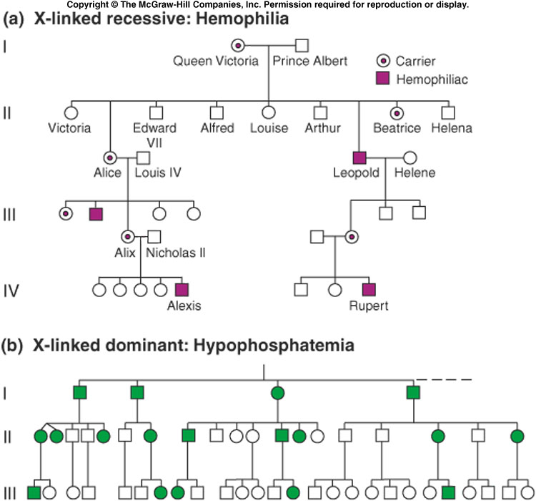

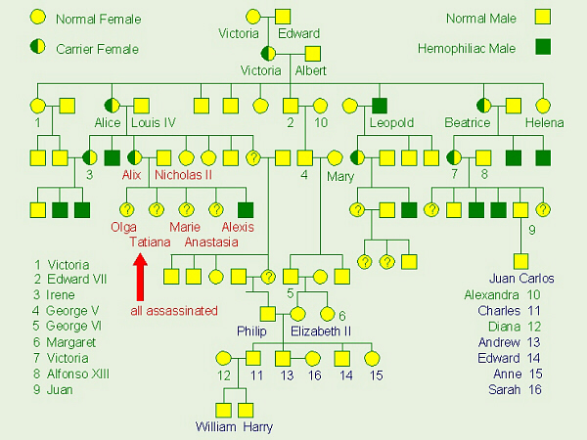 Source for the pedigree chart above: Janet Stein Carter, Biology Instructor at Clermont College, University of Cincinnati