Task 9/ Personal Reflection

Christopher Newport University PA.S.S. Program

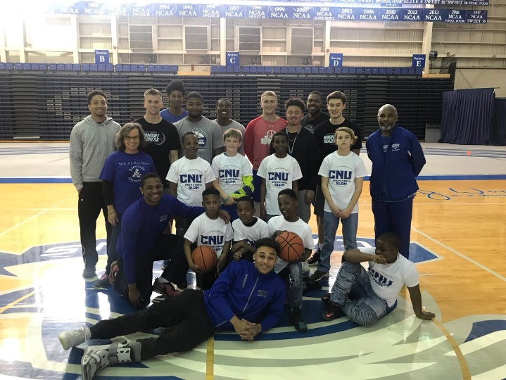When enrolling in the class, I thought we would study non-profit organizations that specialize in human services. I was looking to learning about how 501c-3 organizations are formed and the guidelines in which they work. I was surprised to learn that we would conduct an evaluation of an agency of our choice. At first glance, the process to complete the evaluation and developing an e-portfolio seem insurmountable. I got off to a slow start because I didn’t fully understand the assignments, but the class being in broken in segments I got on track. Working on each part to complete the whole E-portfolio helped a lot. We started by learning the types of program evaluations, defining stakeholders, and selecting our agency. I choose Christopher Newport University’s PA.S.S. program. It involves volunteer student-athletes from CNU work with at-risk public-school students in the areas of time management, classroom behavior, and S.T E.M. (Science Technology, Engineering, Math) research. Module 3 was one of the more important assignments. In this module, I was able to identify the P.A.S.S. program’s mission statement, stakeholders and make plans for my evaluation. During this time, I began to understand the evaluation process, research methods, and stakeholders. Stakeholders are defined as the individuals, groups, or organizations, who may affect, be affected by, or perceive itself to be affected the outcome of the evaluation. My stakeholders were the student volunteers, the program director, students in the public schools, teachers, principals, community organizations, and sponsors. The area I was most successful was doing the actual evaluation. Because of the previous modules, I felt prepared to do an effective evaluation. My discussion board posts are the most improved part of this class. I began to interact more in my post and give more detailed responses. This course will help me as a human service professional because it was a writing intensive course and it required you to be organized. This class stresses writing well. In the workplace, record keeping is important. Good organizations must have good records and structure to receive grants, keep track of client files, and referrals from co-workers.

<https://digitalcommons.murraystate.edu/cgi/viewcontent.cgi?referer=https://www.google.com/&httpsredir=1&article=1032&context=etd>