Old Dominion University

Final Research Paper

Armond Hardy

City of Petersburg

CYSE 368 - Cybersecurity Internship

Professor Teresa Duvall

Summer 2024

7-10-24

**Table of Contents**

Introduction

Description of the Organization

Major Products and Services:

Major Customers or Demographics:

Notable Facts:

Initial Impressions of the Company:

Management Environment

IT Help Desk Support

Network Monitoring and Maintenance

Cybersecurity Initiatives

ODU Curriculum Preparation

Most Motivating Aspects

Real-World Impact

Hands-On Experience with Cutting-Edge Technologies

Mentorship and Professional Development

Most Challenging Aspects

Balancing Multiple Responsibilities

Adapting to New Technologies and Systems

Handling High-Stakes Cybersecurity Incidents

Recommendations for Future Interns

During the Internship

Conclusion

# Introduction

# Choosing to intern with the IT Department for the City of Petersburg was a strategic decision rooted in my career goals and academic interests. The opportunity to work directly within a municipal government setting offered a unique perspective on public sector IT operations and cybersecurity, which aligns with my aspirations to contribute to critical infrastructure and community services. The City of Petersburg presented a dynamic environment where I could apply my classroom knowledge to real-world situations, gain practical experience, and develop professionally.

**Reason for Selecting the Internship:** A number of things had a role in my decision to intern at the IT Department of the City of Petersburg. First, the thought of working in the public sector appealed to me as there is a clear correlation between IT services and the efficacy and efficiency of public service delivery and government operations. Secondly, I was fascinated by the department's reputation for cutting-edge cybersecurity procedures and strong IT support systems, which offered me the perfect environment to advance my technical abilities. Lastly, the chance to collaborate with seasoned IT specialists in a team-oriented setting offered priceless professional development and mentoring.

**Learning Outcomes/Objectives:**

1. **Practical IT Help Desk Experience:** I aimed to immerse myself in day-to-day IT support tasks, learning how to troubleshoot various technical issues, assist city employees, and ensure smooth technological operations. This hands-on experience was essential for developing my problem-solving skills and gaining confidence in my technical abilities.
2. **Enhanced Cybersecurity Skills:** With cybersecurity being a critical concern for municipal governments, I sought to deepen my understanding of cybersecurity protocols, threat detection, and response strategies. I hoped to gain practical experience in safeguarding sensitive information and learn how to implement effective security measures.
3. **Insight into Municipal IT Dynamics:** Understanding the unique challenges and operational strategies of an IT department within a city government was a key objective. I wanted to learn how IT services are managed in the public sector, including budget constraints, policy considerations, and the integration of new technologies to improve service delivery.

**General Introduction**: I will give a brief summary of my internship experience in this paper, including everything from the first orientation and training to the fulfillment of several tasks and assignments. It discusses my responsibilities within the department, the skills I've used and gained, and how my academic background has affected my work. It also considers the areas of the internship that were most inspiring, depressing, and difficult, providing insights into the realities of working in a municipal IT context. The article ends with suggestions for upcoming interns and a summary of how this experience has affected my academic and career path.

I hope to show how the internship with the IT Department of the City of Petersburg has shaped my knowledge, abilities, and professional goals in this thorough report. It emphasizes the significance of internships for professional development and the usefulness of real-world experience to supplement academic learning.

## Description of the Organization

The City of Petersburg’s IT Department was established in response to the growing need for technological integration within city operations. Over the years, the department has evolved, adopting new technologies and expanding its scope of services to meet the increasing demands of a modern urban environment. The department has been at the forefront of implementing innovative solutions to improve public services, enhance communication, and ensure data security.

#### **Major Products and Services:**

The IT Department offers a wide range of services crucial for the efficient functioning of the city's operations:

* **IT support and help desk services:** Fixing hardware and software problems, guaranteeing that all IT systems operate at peak efficiency, and offering technical assistance to city workers.
* **Network management and infrastructure maintenance:** Keeping an eye on the servers, routers, and switches that make up the city's network infrastructure in order to guarantee dependable and secure communication.
* **Cybersecurity Measures and Incident Response:** To safeguard private municipal data, security procedures must be put into place, threats must be watched for, and security incidents must be handled.
* **Software Development and Integration:** To improve efficiency and service delivery, software applications that are customized to meet the demands of different city departments are developed and integrated.
* **Data management and analytics:** Handling municipal data, guaranteeing its availability and integrity, and applying data analytics to help with decision-making.

#### **Major Customers or Demographics:**

#### Employees of the city are the department's main clients as they depend on its services to carry out their daily responsibilities effectively. These workers are dispersed over several departments, such as administration, public works, health services, and public safety. Additionally, by making sure that public services are provided effectively and safely, the IT Department indirectly benefits the people of Petersburg.

#### **Notable Facts:**

* **Major Accomplishments:** The department has carried out a number of important projects, including the citywide network upgrade that greatly enhanced performance and connection. Additionally, they implemented a strong cybersecurity architecture that has successfully reduced security breaches.
* **Strategic Goals:** By using cutting-edge technologies like cloud computing and sophisticated data analytics, the department hopes to significantly improve the technical infrastructure of the city. In order to protect against changing threats, they are also concentrated on enhancing cybersecurity measures and improving the effectiveness of IT support services.

#### **Initial Impressions of the Company:**

The department's dedication to innovation and quality struck me during my first orientation and training. In addition to having a high level of competence, the team was committed to professional growth and progress. My choice to undertake this internship was strengthened by the department's proactive approach to addressing IT difficulties and the collaborative atmosphere that they provided.

### Management Environment

A helpful and cooperative management style is what makes the IT Department for the City of Petersburg unique. During my internship, I had supervision from department staff members who gave me advice and criticism. I observed that the hierarchical management system, which has distinct lines of accountability and communication, works well to guarantee efficient operations and project completion. The department has implemented an open-door policy, which encourages workers and interns to ask for help and explanation whenever they need it. This strategy promoted transparency and accessibility, which made it simple to ask coworkers and managers for assistance or guidance. My learning experience was improved, and the helpful supervision approach also gave me more self-assurance in my skills.

Major Work Duties and Projects

During my internship with the IT Department for the City of Petersburg, I had the opportunity to engage in a variety of duties and projects that provided me with hands-on experience and a deeper understanding of municipal IT operations. This section details the key responsibilities and projects I undertook, highlighting their significance to the organization and my professional growth.

#### **IT Help Desk Support**

One of my primary responsibilities was providing IT help desk support to city employees. This role involved:

* **Troubleshooting Technical Issues:** Helping people with a variety of technical issues, such as hardware malfunctions, communication problems, and software malfunctions. I made effective use of remote desktop technologies to identify and fix issues.
* **Managing user accounts:** Taking care of things like creating new accounts, changing passwords, and granting access. It was essential to make sure people had the right amount of access in order to preserve both productivity and security.
* **Installation and Configuration of Software:** Installing and setting up different software programs that municipal workers need for their everyday work. This comprised department-specific specialist apps as well as general office software.
* **Hardware Support:** Includes helping to set up, maintain, and fix computer hardware, such as printers, desktops, laptops, and other accessories. Maintaining operational efficiency and reducing downtime required making sure the gear was operating as intended.

**Significance to the Business:** IT help desk support is vital for the smooth operation of the city's services. By resolving technical issues promptly, I helped ensure that city employees could perform their duties without interruption, contributing to the overall productivity and effectiveness of the municipal government.

#### **Network Monitoring and Maintenance**

Another significant aspect of my internship was participating in network monitoring and maintenance activities. These duties included:

* **Network Performance Monitoring:** Keeping tabs on the functionality and condition of the city's network infrastructure through the use of network monitoring technologies. This required locating possible problems including outages, network congestion, and security breaches.
* **Routine Maintenance:** Performing routine maintenance, which includes firmware updates, hardware component replacements, and network configuration optimizations. These tasks were essential to keeping the network dependable and safe.
* **Troubleshooting Network challenges:** Identifying and fixing network-related concerns, such poor network performance and connection difficulties. This requires the capacity to function under pressure in order to promptly restore services, as well as a strong grasp of networking fundamentals.

**Significance to the Business:** The city’s network infrastructure is the backbone of its IT operations, supporting communication, data transfer, and access to various applications. By ensuring the network's reliability and performance, I contributed to the seamless operation of all city departments and services.

#### **Cybersecurity Initiatives**

Cybersecurity was a major focus of my internship, and I had the opportunity to work on several initiatives aimed at enhancing the city's security posture. Key activities included:

* **Security Protocol Implementation:** Assisting in the implementation of new cybersecurity protocols and best practices. This involved configuring security settings on various systems, updating security software, and ensuring compliance with industry standards.
* **Threat Assessment and Mitigation:** Participating in threat assessment activities to identify potential vulnerabilities and risks. I used security tools to scan for vulnerabilities, analyze threat intelligence, and recommend mitigation strategies.
* **Incident Response:** Assisting in the response to security incidents, such as data breaches and malware infections. This involved identifying the cause of the incident, containing the threat, and implementing measures to prevent future occurrences.

**Significance to the Business:** The integrity and secrecy of the city's operations, as well as the protection of its sensitive data, depend heavily on cybersecurity. Through my contributions to the cybersecurity projects, the city's defenses against possible attacks were strengthened, and its digital assets were protected.

**Reference Work Samples**

To illustrate the work I completed during my internship, here are some examples of the projects and assignments I contributed to:

1. **Help Desk Ticket Resolution Report:** A detailed report showcasing the various technical issues I resolved, the steps taken to address them, and the outcomes.
2. **Cybersecurity Risk Assessment:** A comprehensive assessment of potential security risks, including identified vulnerabilities, recommended mitigation strategies, and implementation progress.

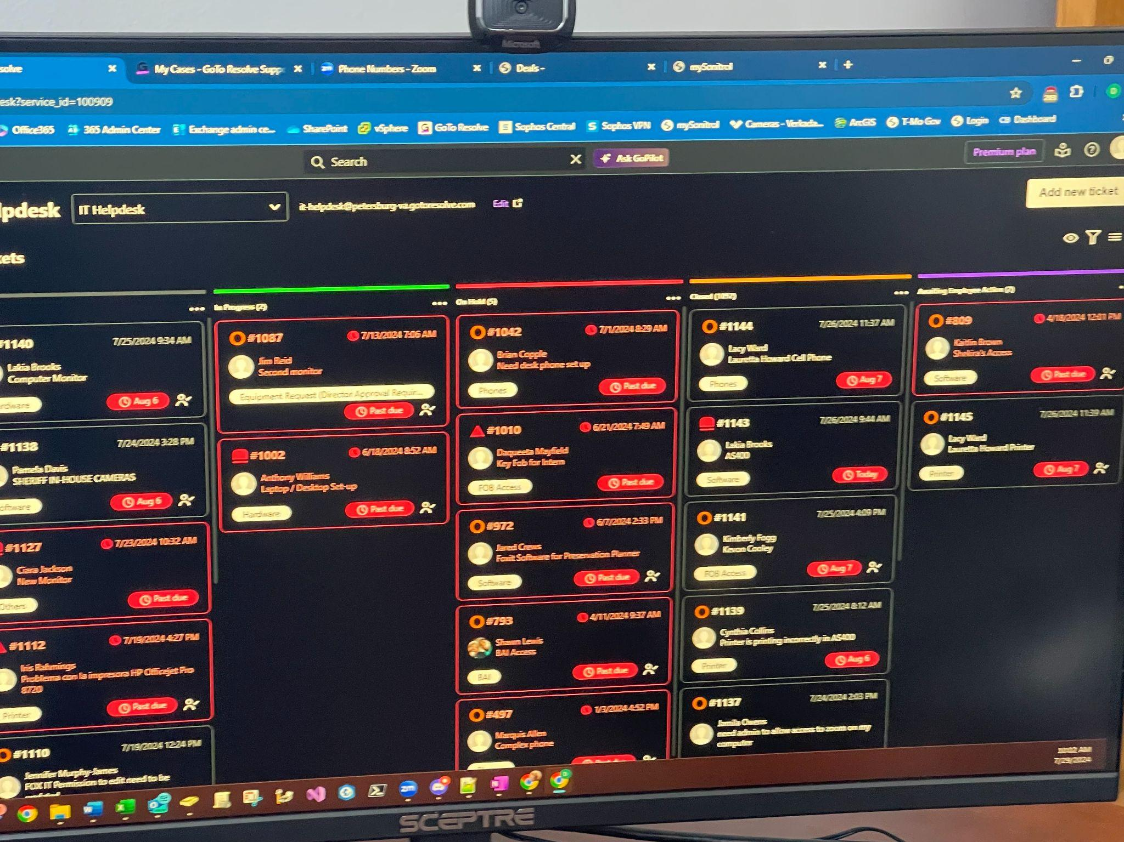

##### ODU Curriculum Preparation

My ODU education adequately equipped me for this internship. IT management, information systems, and network security courses gave me a solid theoretical basis that I could immediately apply to my profession. In example, in fields like network monitoring and cybersecurity, I was able to draw significant parallels between what I had learned in school and my real-world experience. Furthermore, the internship expanded my knowledge base and skill set by introducing me to new ideas and methods that I had not learned in my studies.

Fulfillment of Objectives

* **Practical IT Help Desk Experience:** Achieved through daily hands-on support tasks.
* **Enhanced Cybersecurity Skills:** Fulfilled by working on security protocols and threat assessments.
* **Insight into Municipal IT Dynamics:** Gained through observation and participation in departmental operations and projects.

###### Most Motivating Aspects

Throughout my internship at the IT Department for the City of Petersburg, several motivating aspects kept me engaged and enthusiastic about my work. These experiences not only reinforced my passion for IT and cybersecurity but also provided a deep sense of accomplishment and professional growth.

#### **Real-World Impact**

#### Seeing the results of my labor in the real world was one of the most inspiring parts of my internship. I had a strong sense of purpose knowing that the services and operations of the city that the people depended on were directly benefited by my contributions. I could clearly see the results of my efforts, whether I was building a new security protocol or fixing a major network issue. This clear link between my efforts and the benefits they produced really inspired me and reaffirmed the significance of my position in the department.

#### **Hands-On Experience with Cutting-Edge Technologies**

I had only previously studied cutting-edge tools and technologies in an academic context, but the internship gave me access to them. It was really fascinating to work directly with cutting-edge network monitoring systems, cybersecurity tools, and unique software applications. My technical abilities were improved by this exposure, but it also piqued my interest and made me want to study more. My motivation to keep abreast of developing trends and technology was sustained by the ever-evolving and innovative nature of the IT profession.

**Collaborative Work Environment**

The collaborative work environment within the IT Department was another significant motivator. The team-oriented culture encouraged open communication, knowledge sharing, and mutual support. Working alongside experienced professionals and other interns provided numerous opportunities for learning and growth. The camaraderie and sense of teamwork made even challenging tasks enjoyable, as we collectively worked towards common goals. The positive interactions and shared successes with my colleagues were a constant source of motivation.

#### **Mentorship and Professional Development**

During my internship, I was really fortunate to have mentors. My mentors and other senior team members were always happy to share their knowledge, give helpful criticism, and offer direction. In addition to guiding me through challenging assignments, this mentoring motivated me to pursue excellence. Frequent goal-setting meetings and performance evaluations helped me stay motivated and focused on making improvements. The department's emphasis on professional development emphasized the value of continuous learning and advancement in the IT industry.

Most Discouraging Aspects

The most frustrating part was running into administrative roadblocks that occasionally caused the project's execution to stall. But I also learned a lot about patience and persistence from this experience.

# Most Challenging Aspects

Interning at the IT Department for the City of Petersburg provided a wealth of learning experiences, but it also came with its share of challenges. Navigating these obstacles was crucial for my professional development and gave me insights into areas for growth. This section outlines the most challenging aspects of my internship and how I addressed them.

#### **Balancing Multiple Responsibilities**

One of the most significant challenges was balancing multiple responsibilities simultaneously. My role required me to juggle various tasks, such as providing IT help desk support, participating in network maintenance, working on cybersecurity initiatives, and contributing to software development projects.

* **Time Management:** Effectively managing my time was essential to ensure that I could complete all my duties without compromising on quality. I learned to prioritize tasks based on urgency and importance, using tools like task lists and project management software to stay organized.
* **Multitasking:** Handling different types of tasks required adaptability and the ability to switch contexts quickly. I developed strategies to minimize distractions and maintain focus, such as allocating specific time blocks for different activities and taking short breaks to recharge.

#### **Adapting to New Technologies and Systems**

The fast-paced nature of the IT field means that new technologies and systems are constantly being introduced. Adapting to these changes was a recurring challenge during my internship.

* **Learning Struggles:** Some technologies were completely new to me, requiring a steep learning curve. I dedicated time to self-study and sought out online resources, tutorials, and documentation to get up to speed quickly.
* **On-the-Job Training:** Hands-on experience was invaluable in learning new systems. I wasn’t afraid to ask for help or clarification from colleagues and mentors, who were always willing to provide guidance and support.

#### **Handling High-Stakes Cybersecurity Incidents**

Working on cybersecurity initiatives presented its own set of challenges, particularly when dealing with high-stakes security incidents such as potential data breaches or malware infections.

* **Pressure to Perform:** The pressure to respond quickly and effectively during a security incident was intense. I learned to stay calm under pressure, systematically analyze the situation, and follow established protocols to mitigate risks.
* **Complex Problem-Solving:** Cybersecurity issues often involve complex problem-solving and critical thinking. I enhance my analytical skills by breaking down problems into manageable parts, developing hypotheses, and testing solutions methodically.

# Recommendations for Future Interns

Future interns should come prepared with a solid understanding of basic IT and cybersecurity principles. Familiarity with common IT support tools and a proactive attitude will also be beneficial. Additionally, being open to continuous learning and adapting to new challenges will enhance their internship experience.

1. **Research the Organization:**

**Understand the City’s IT Infrastructure:** Research the City of Petersburg’s IT Department, its structure, key projects, and the technologies they use. This will give you a clearer idea of what to expect and how to prepare.

**Familiarize with Municipal IT Operations:** Learn about the unique challenges and requirements of IT in the public sector. Understanding the context in which the department operates will help you appreciate the significance of your work.

1. **Develop Soft Skills:**

**Communication Skills:** Effective communication is crucial for IT support roles. Practice explaining technical concepts in simple terms and actively listening to users’ concerns.

**Teamwork and Collaboration:** Be prepared to work in a team-oriented environment. Develop skills in collaboration, problem-solving, and adaptability.

**Professionalism:** Understand the importance of professionalism, including punctuality, dress code, and workplace etiquette.

#### **During the Internship**

1. **Be Proactive and Engaged:**

**Ask Questions:** Don’t hesitate to ask questions when you’re unsure about something. Seeking clarification shows your eagerness to learn and ensures you perform tasks correctly.

**Take Initiative:** Look for opportunities to contribute beyond your assigned tasks. Volunteer for projects, suggest improvements, and demonstrate a proactive attitude.

**Stay Curious:** Maintain a curious mindset and seek to understand the ‘why’ behind processes and decisions. This will deepen your understanding and help you see the bigger picture.

1. **Build Relationships:**

**Network with Colleagues:** Take the time to get to know your colleagues and learn from their experiences. Building relationships can provide valuable insights and create a supportive network.

**Engage with Your Mentor:** Utilize your mentor as a resource for guidance, feedback, and career advice. Regularly update them on your progress and seek their input on your development.

# Conclusion

When I think back on my internship with the City of Petersburg's IT Department, I can state with confidence that it was a life-changing time that greatly aided in my development on both a personal and professional level. The important lessons I learned from my internship are summarized below, along with how it affected my remaining time at Old Dominion University (ODU) and how it will affect my future professional path. The City of Petersburg's IT Department internship has been a crucial experience that has greatly impacted both my academic and career paths. I now have professional insights, useful abilities, and a clear path for my future career thanks to it. The challenges and accomplishments during this period have prepared me to navigate the complexities of the IT and cybersecurity fields with confidence and resilience. As I continue my education at ODU and embark on my professional path, I will carry the lessons learned and the experiences gained from this internship, using them as a foundation for future success and growth.

Letter from IT Manager:

It’s been a pleasure having Armond to intern with us in the IT department. Armond is very knowledgeable of hardware and software and looks to have a promising career in the future as an IT technician and cybersecurity analyst.

Thomas Booker

IT Manager (804-898-9620)

Pictures below (some that I could capture a lot of confidential information I wasn’t able to get)

