Hayden Neider
10/10/2025
Osgood
Hijacking the brain:
How Cocaine, Methamphetamine, Alcohol, and Cannabis Alter Neurochemistry and Influence Criminal Behavior

Introduction
Neurochemical hijacking refers to the process by which psychoactive substances override the brain’s natural signaling systems, redirecting neural activity toward drug-related rewards at the expense of adaptive behavior. This phenomenon is not merely a matter of altered perception or temporary intoxication; it represents a fundamental disruption of the brain’s capacity to regulate decision making, impulse control, and emotional stability. Such disruptions carry profound implications for criminal justice, where substance use is frequently intertwined with violence, impaired driving, acquisitive crime, and patterns of recidivism (Meyer, Cepeda, Taxman, & Altice, 2015).
This essay examines four widely used substances cocaine, methamphetamine, alcohol, and cannabis, each of which interacts with distinct neurotransmitter systems and neural circuits. Cocaine and methamphetamine primarily manipulate dopaminergic signaling, producing heightened arousal and impulsivity; alcohol alters inhibitory and excitatory balance through GABA and glutamate pathways, often resulting in disinhibition and aggression; cannabis modulates endocannabinoid and dopaminergic systems, impairing cognition and psychomotor control. By mapping these neurochemical mechanisms into behavioral outcomes, the essay demonstrates how predictable patterns of intoxication and chronic use translate into observable risks for law enforcement and the justice system.
The significance of this analysis lies in its interdisciplinary perspective. Neuroscience provides mechanistic explanations for drug-induced behaviors, while criminology and policing highlight the real-world consequences of those behaviors in investigative, crisis response, and rehabilitative contexts. Understanding how substances hijack brain chemistry allows officers, forensic specialists, and policymakers to anticipate behavioral cues, tailor de-escalation strategies, and design interventions that address the root neurobiological drivers of crime rather than relying solely on punitive measures.
The discussion proceeds in several stages. First, it outlines the neurochemical background of the brain’s modulatory systems, dopamine, GABA, glutamate, serotonin, and endocannabinoids that govern reward learning, executive control, and emotional regulation. It then analyzes the mechanisms and behavioral effects of cocaine, methamphetamine, alcohol, and cannabis, linking acute intoxication and chronic use to specific criminal justice challenges. A synthesis section compares behavioral outcomes across substances, followed by implications for law enforcement practice, rehabilitation, and policy. The essay concludes by emphasizing the need for future research and training that bridge neuroscience and criminal justice, offering more humane and effective responses to substance-related crime.
Neurochemical Background
The brain’s capacity to regulate thought, emotion, and behavior depends on a delicate balance among several modulatory systems. Dopamine, GABA, glutamate, serotonin, and the endocannabinoid system form the core neurochemical architecture that supports reward learning, executive control, arousal, and emotional stability. Each system contributes uniquely to adaptive functioning, and disruption of any one can produce cascading effects across cognition and behavior.
- Dopamine: Central to reward prediction and motivation, dopamine signals the salience of outcomes and drives goal directed behavior. Normal dopamine transmission allows individuals to weigh risks, anticipate rewards, and sustain effort toward long-term goals. When hijacked by drugs, dopamine signaling becomes exaggerated or blunted, leading to compulsive reward seeking and diminished sensitivity to natural reinforcers.
- GABA and Glutamate: These neurotransmitters maintain the inhibitory excitatory balance that underlies attention, impulse control, and cortical stability. GABA provides inhibitory “brakes” on neural activity, while glutamate drives excitatory signaling essential for learning and memory. Psychoactive substances that potentiate GABA or disrupt glutamate can impair judgment, slow cognition, or destabilize emotional regulation.
- Serotonin: Often described as a mood stabilizer, serotonin modulates aggression, anxiety, and emotional resilience. Balanced serotonin signaling supports prosocial behavior and impulse regulation. Drugs that deplete or dysregulate serotonin increase vulnerability to irritability, aggression, and mood instability, complicating law enforcement encounters.
- Endocannabinoid System: Endocannabinoids act as retrograde messengers, fine-tuning synaptic transmission and regulating stress responses. They play a critical role in synaptic plasticity, emotional regulation, and adaptation to environmental stressors. THC and other cannabinoids exploit this system, producing altered perception, impaired memory, and variable effects on anxiety and motivation.
Acute drug exposure perturbs these systems by altering neurotransmitter release, reuptake, and receptor activation. The result is transient changes in perception, cognition, and behavior often visible in intoxication. Repeated exposure, however, triggers neuroadaptations: receptor downregulation, altered transporter function, and synaptic remodeling. These changes manifest as tolerance, craving, withdrawal, and long-term deficits in executive function and emotional regulation.
For criminal justice, the distinction between acute intoxication and chronic neuroadaptation is crucial. Officers may encounter individuals whose immediate behavior reflects short-term drug effects such as aggression, paranoia, or impaired motor control or whose long-term deficits manifest persistent impulsiveness, poor decision making, and heightened risks of recidivism. Understanding these neurochemical foundations clarifies why different substances yield distinct behavioral profiles and why law enforcement must adapt strategies to both acute crises and chronic substance-related impairments.
Cocaine: Mechanisms and Behavioral Effects
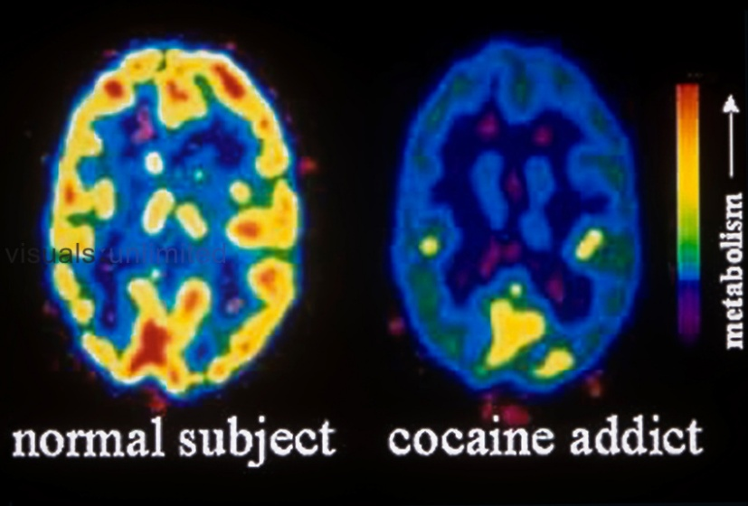
Cocaine’s primary action is to block the dopamine transporter (DAT), preventing dopamine reuptake and producing a rapid buildup of extracellular dopamine in the mesolimbic reward pathway and prefrontal cortex. This surge intensifies reward salience, making drug-related cues disproportionately motivating while weakening natural reinforces and executive control (Smith et al., 2021).
Red/Yellow areas = heightened dopamine release in the reward pathway (nucleus accumbens, prefrontal cortex).
Blue/Green areas = reduced baseline activity elsewhere, showing imbalance.

- Acute effects: Users often experience euphoria, heightened confidence, and reduced risk assessment. At the same time, irritability, agitation, and paranoia may emerge, with some individuals developing transient psychotic symptoms. These effects reflect overstimulation of cortical circuits and impaired prefrontal regulation.
- Chronic effects: Repeated exposure downregulates dopamine receptors and blunts baseline signaling, producing anhedonia and diminished motivation. Long-term use impairs executive function, undermining impulse control and decision making. These neuroadaptations reinforce compulsive drug seeking and increase the likelihood of economically motivated crimes to sustain use.
- Law enforcement context: Cocaine intoxication often presents as agitation, pressured speech, and unpredictable escalation, posing risks to officers and bystanders. Chronic users may appear emotionally flat yet impulsive, with repeated involvement in acquisitive offenses. Forensic challenges include distorted memory, paranoia, and unreliable testimony, requiring careful documentation of behavioral cues and timelines.
Cocaine demonstrates how a single mechanism dopamine transporter blockade can produce both short-term volatility and long-term compulsivity, creating distinct challenges for policing, forensic interpretation, and rehabilitation.
Methamphetamine: Mechanisms and Behavioral Effects
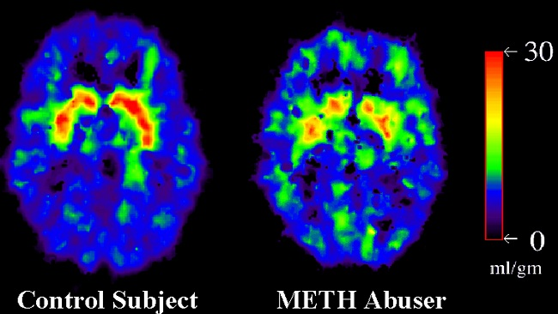
Methamphetamine manipulates dopamine signaling more aggressively than cocaine. Instead of simply blocking reuptake, meth reverses dopamine transporter flow, forces dopamine release from presynaptic terminals, and disrupts vesicular storage. The result is a larger and more prolonged surge of extracellular dopamine, often accompanied by neurotoxic damage to dopaminergic and serotonergic terminals with repeated high-dose exposure.
Bright red/orange regions = massive dopamine release and transporter reversal, especially in striatum and limbic circuits.
Cooler colors = areas of neurotoxic damage or reduced serotonin signaling.

- Acute effects: Meth produces intense stimulation, prolonged wakefulness, and heightened arousal. Users often display severe irritability, pressured speech, and hypervigilance. At higher doses, stimulant-induced psychosis can emerge, marked by hallucinations, paranoia, and violent behavior.
- Chronic effects: Long-term use damages neural circuits, leading to cognitive decline, executive dysfunction, and memory deficits. These impairments heighten impulsiveness and poor decision making, reinforcing compulsive drug-seeking and increasing vulnerability to recidivism. Neurotoxicity also contributes to lasting emotional instability and difficulty with social reintegration (Seiden & Ricaurte, 1997).
- Law enforcement context: Encounters with meth-intoxicated individuals are notable for high-intensity agitation and unpredictable escalation, posing risks to officers and bystanders. Chronic users may present with disorganized thought, impaired attention, and persistent paranoia. Forensic challenges include polysubstance involvement, medical complications such as hyperthermia, and neurocognitive deficits that complicate interviews and testimony.
Methamphetamine demonstrates how dopamine release and transporter reversal produce both acute behavioral volatility and long-term neurocognitive impairment. Compared to cocaine, meth’s effects are more prolonged and neurotoxic, creating especially complex challenges for policing, crisis response, and rehabilitation.
Alcohol: Mechanisms and Behavioral Effects
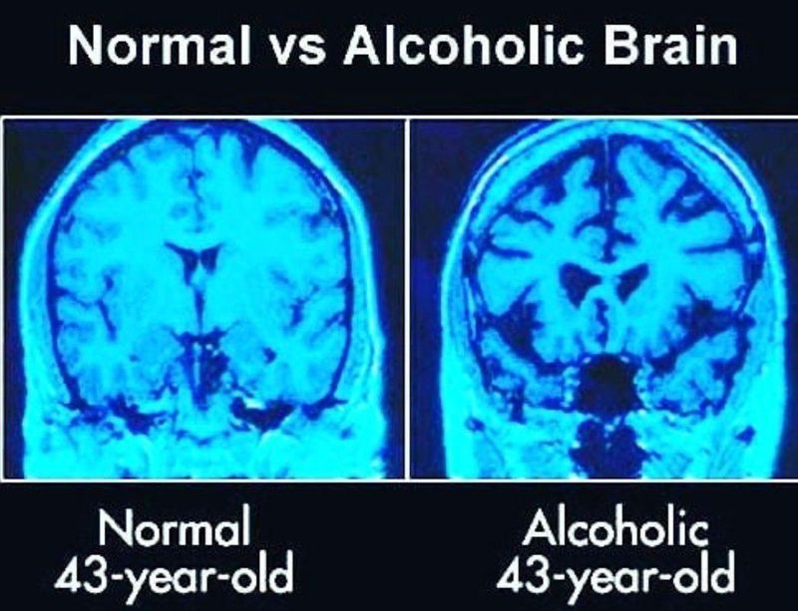
Alcohol exerts broad neurochemical effects by potentiating GABAergic inhibition and antagonizing NMDA-type glutamatergic excitation. This dual action dampens cortical activity while disrupting excitatory signaling, altering the balance between inhibition and arousal across frontal and limbic circuits. The result is impaired executive control, slowed information processing, and reduced behavioral inhibition (Magill et al., 2023).
The left side ("Normal 43-year-old") displays a brain with dense, uniform structure healthy cortical volume and intact neural tissue.
The right side ("Alcoholic 43-year-old") shows noticeable gaps and shrinkage, especially in the frontal cortex and surrounding regions signs of brain atrophy due to chronic alcohol use.

- Acute effects: Intoxication commonly produces disinhibition, poor risk assessment, and impaired working memory. In vulnerable individuals, alcohol lowers thresholds for aggression and impulsive behavior, contributing to interpersonal violence and reckless decision making.
- Chronic effects: Repeated heavy use triggers neuroadaptive changes, including altered receptor expression and deficits in frontal lobe functioning. These adaptations contribute to persistent impulsivity, executive dysfunction, and emotional instability. Long-term alcohol misuse is strongly associated with cognitive decline, dependence, and heightened risk of recidivism.
- Law enforcement context: Alcohol-related encounters are among the most frequent in policing. Officers often observe slurred speech, poor balance, slowed reactions, and heightened aggression. Intoxication complicates witness reliability and suspect interviews, as memory distortions and suggestibility undermine accurate testimony. Chronic misuse further increases involvement in violent offenses, impaired driving incidents, and repeated public order violations.
Alcohol demonstrates how modulation of inhibitory and excitatory systems produces both short-term disinhibition and long-term executive dysfunction. Its strong link to violence and impaired driving makes it one of the most consequential substances for criminal justice, requiring careful on-scene assessment and tailored investigative strategies.
Cannabis: Mechanisms and Behavioral Effects
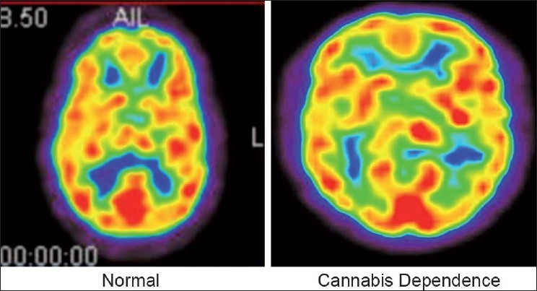
Cannabis exerts its primary psychoactive effects through delta-9-tetrahydrocannabinol (THC), which binds to CB1 receptors in the brain. These receptors regulate presynaptic neurotransmitter release across multiple circuits, indirectly influencing dopamine signaling in reward pathways. By altering synaptic transmission, THC disrupts normal regulation of perception, memory, and emotional balance.
Colors highlight CB1 receptor activity and altered perception.
Yellow/Red regions = hippocampus and prefrontal cortex showing disrupted memory and cognition.
Blue/Green regions = slowed signaling in motor and attention circuits.

- Acute effects: Cannabis use often produces altered time perception, slowed psychomotor function, and short-term memory impairment. Many users experience sedation or reduced motivation, while others particularly those with psychiatric vulnerability may develop anxiety, disorganization, or transient paranoia.
- Chronic effects: Heavy or prolonged use can impair attentional control, learning, and executive function. High-potency products, especially in adolescents, increase the risk of long-term psychiatric consequences such as persistent anxiety or psychotic-like symptoms (Meier et al., 2017). These deficits contribute to reduced academic or occupational performance and complicate rehabilitation efforts.
- Law enforcement context: Cannabis-related encounters typically involve impaired driving, public order offenses, or possession rather than severe violence. Observable cues include slowed reactions, poor short-term memory, and disorganized speech. However, individual variability and polysubstance use complicate assessment, requiring officers to distinguish cannabis intoxication from other drug effects or underlying mental health conditions.
Cannabis demonstrates how endocannabinoid system modulation produces primarily cognitive and perceptual impairments rather than overt aggression. While its acute risks are often less severe than stimulants or alcohol, chronic heavy use can contribute to lasting deficits and complicate both policing and rehabilitation strategies.
Behavioral and Criminal Outcomes Synthesis
Across psychoactive substances, the most important insight is not simply the specific symptoms of intoxication but the way repeated exposure reshapes behavior in ways that intersect with criminal justice. Regardless of whether the substance is a stimulant, depressant, or cannabinoid, chronic use tends to erode executive function, weaken impulse control, and destabilize emotional regulation. These deficits create a fertile ground for recidivism, as individuals struggle to weigh long-term consequences, resist cravings, and maintain prosocial behavior.
Another unifying theme is the amplification of situational risk. Substance use often magnifies existing vulnerabilities such as trauma, psychiatric illness, or socioeconomic stressors transforming them into acute crises that spill into public safety contexts. For example, individuals with untreated mental health conditions may experience intensified paranoia or aggression when intoxicated, while those facing economic hardship may be more likely to engage in acquisitive crime to sustain use (Meyer et al., 2015). Substance-related behavior therefore cannot be understood in isolation; it is embedded within broader social and psychological pressures that compound criminal outcomes.
Policing encounters also reveal a consistent challenge: the unpredictability of substance-influenced behavior. Officers must navigate situations where individuals oscillate between agitation, confusion, and emotional volatility, often within minutes. This unpredictability complicates risk assessment and requires flexible strategies that prioritize safety and de-escalation. Importantly, the observable cues of intoxication whether slurred speech, slowed reactions, or hypervigilance are valuable not only for immediate response but also for forensic interpretation, as they help reconstruct timelines and contextualize witness reliability.
Finally, substance-related crime underscores the cyclical nature of justice involvement. Intoxication may precipitate an initial offense, but the long-term neuroadaptations of chronic use sustain patterns of impulsivity and poor decision making that drive repeated arrests and incarceration. Without interventions that address the neurobiological roots of these behaviors, punitive measures alone risk perpetuating the cycle. Synthesizing behavioral outcomes across substances therefore highlights the need for justice systems to integrate neuroscientific insight into both frontline policing and long-term rehabilitation, ensuring responses that are not only reactive but preventative.

Implications for Law Enforcement Practice
The intersection of neurochemical disruption and criminal behavior requires law enforcement to adapt strategies that go beyond traditional punitive responses. Officers are often the first to encounter individuals under the influence of substances, and their ability to recognize behavioral cues linked to specific neurochemical states can determine whether an encounter escalates or is safely resolved. Training that emphasizes the observable signs of stimulant intoxication such as hypervigilance, pressured speech, and agitation or alcohol-related disinhibition and aggression equips officers to anticipate risks and prioritize de-escalation. Similarly, recognizing cannabis-related impairments in reaction time and memory helps frame impaired driving investigations and witness assessments more accurately.
Operational protocols must also account for the medical risks associated with intoxication. Stimulant-induced hyperthermia, alcohol withdrawal, and polysubstance complications require rapid medical evaluation alongside scene safety. Officers who understand these risks are better positioned to coordinate with emergency medical services, preserve evidence, and protect both suspects and bystanders. Documentation of behavioral timelines, collateral accounts, and physical signs consistent with intoxication strengthens the forensic record and supports accurate interpretation in court.
Investigative practices benefit from neurobiological awareness as well. Interviews with intoxicated or recently intoxicated individuals must be adjusted to account for impaired memory, suggestibility, and distorted perception. Delaying questioning until cognitive function stabilizes or adapting interview techniques to minimize confusion can improve reliability and reduce the risk of false or incomplete testimony. In addition, recognizing the long-term cognitive deficits associated with chronic substance use informs pretrial assessments and sentencing decisions, highlighting when diversion to treatment programs may be more effective than incarceration.
Finally, law enforcement agencies play a critical role in bridging public safety with rehabilitation. Diversion programs, treatment courts, and community-based recovery initiatives are most effective when officers and investigators understand the neurobiological drivers of substance related crime. By integrating neuroscientific insights into training curricula, crisis response protocols, and investigative strategies, law enforcement can reduce recidivism, improve officer safety, and promote more humane outcomes. This shift from purely punitive approaches to evidence-based practices reflects a broader recognition that substance related crime is not only a matter of choice but also of neurochemical impairment, requiring responses that are both scientifically informed and operationally practical.
Rehabilitation, Policy, and Prevention
Effective responses to substance-related crime must extend beyond immediate law enforcement encounters to long-term rehabilitation and prevention. Neurobiologically informed rehabilitation recognizes that chronic drug use alters brain circuits governing reward, impulse control, and emotional regulation. Treatment strategies therefore need to address both the physiological and psychological dimensions of substance use. Medication-assisted therapies can stabilize withdrawal and reduce craving, while cognitive remediation programs help restore executive function and decision-making capacity. Trauma-informed behavioral therapies are equally important, as many individuals with substance use disorders carry histories of adversity that amplify vulnerability to relapse. By targeting the neurochemical and psychosocial drivers of addiction, rehabilitation programs can reduce recidivism and support reintegration into society.
Policy initiatives play a critical role in shaping how the justice system responds to substance related offenses. Traditional punitive approaches often fail to address the underlying neurobiology of addiction, leading to cycles of incarceration and relapse. Diversion programs, treatment courts, and community-based recovery services offer more effective alternatives by aligning public safety goals with evidence-based treatment. Policies that prioritize rehabilitation over punishment not only reduce criminal justice involvement but also alleviate systemic burdens such as overcrowded prisons and strained court resources. Importantly, these shifts require sustained investment in cross sector collaboration, ensuring that law enforcement, public health, and mental health providers work together to deliver coordinated care.
Prevention strategies are equally vital, particularly for adolescents and young adults whose brains remain highly vulnerable to neurochemical disruption. Educational initiatives should emphasize the risks of high-potency cannabis products, stimulant misuse, and binge drinking, highlighting how these substances interfere with neurodevelopment and increase long-term psychiatric and behavioral risks. Community-based prevention programs that integrate schools, families, and peer networks can foster resilience and reduce initiation of substance use. By addressing risk factors early and promoting protective environments, prevention efforts reduce the likelihood of future criminal justice involvement and improve public health outcomes.
Taken together, rehabilitation, policy, and prevention form a continuum of responses that bridge neuroscience and criminal justice. Rehabilitation restores functioning for those already affected, policy ensures that justice practices reflect scientific evidence, and prevention reduces the incidence of substance-related harm before it begins. This integrated approach not only enhances public safety but also promotes more humane and effective treatment of individuals whose behaviors are shaped by neurochemical hijacking.
Conclusion and Future Directions
Drug-induced disruptions of dopamine, GABA, glutamate, serotonin, and endocannabinoid signaling produce distinct behavioral phenotypes that directly shape criminal behavior, policing encounters, and rehabilitation outcomes. Cocaine and methamphetamine amplify arousal and impulsivity, alcohol lowers inhibition and increases aggression, and cannabis impairs cognition and psychomotor control. Despite these differences, chronic use across substances converges on impaired executive function, emotional dysregulation, and elevated recidivism risk. Recognizing these neurochemical foundations allows law enforcement to anticipate behavioral cues, tailor de-escalation strategies, and integrate medical assessment into operational protocols. It also underscores the importance of diversion programs and treatment courts that address the biological drivers of substance-related crime rather than relying solely on punitive measures.
Looking forward, the integration of neuroscience into criminal justice practice offers several promising directions. Training curricula for first responders should incorporate neurobehavioral education, equipping officers to recognize substance-specific signs and respond with strategies that prioritize safety and medical care. Forensic research must continue to refine methods for linking intoxication timing with behavioral signatures, improving the accuracy of testimony and evidence interpretation. Policy initiatives should expand access to rehabilitation programs that combine medication assisted treatment, cognitive remediation, and trauma informed therapy, ensuring continuity of care across justice and health systems. Prevention efforts, particularly those targeting adolescents, should emphasize the neurodevelopmental risks of high-potency products and stimulant misuse, reducing long-term vulnerability to addiction and criminal involvement.
Ultimately, bridging neuroscience and criminal justice creates opportunities for more humane, effective, and scientifically grounded responses to substance-related crime. By aligning law enforcement practice, forensic science, and public health policy with evidence-based understanding of neurochemical hijacking, society can reduce recidivism, improve officer and community safety, and support individuals in achieving recovery. The future of criminal justice lies not only in enforcing the law but in recognizing the biological realities that shape human behavior, and in designing systems that respond with both rigor and compassion.

References
Baldaçara L, Ramos A, Castaldelli-Maia JM. Managing drug-induced psychosis. Int Rev Psychiatry. 2023 Aug-Sep;35(5-6):496-502. doi: 10.1080/09540261.2023.2261544. Epub 2024 Feb 1. PMID: 38299647.
Becker MP, Collins PF, Schultz A, Urošević S, Schmaling B, Luciana M. Longitudinal changes in cognition in young adult cannabis users. J Clin Exp Neuropsychol. 2018 Aug;40(6):529-543. doi: 10.1080/13803395.2017.1385729. Epub 2017 Oct 23. PMID: 29058519; PMCID: PMC6130912.
Carrà G, Nicolini G, Crocamo C, Lax A, Amidani F, Bartoli F, Castellano F, Chiorazzi A, Gamba G, Papagno C, Clerici M. Executive control in schizophrenia: a preliminary study on the moderating role of COMT Val158Met for comorbid alcohol and substance use disorders. Nord J Psychiatry. 2017 Jul;71(5):332-339. doi: 10.1080/08039488.2017.1286385. Epub 2017 Feb 14. PMID: 28635556.
Dhein S. Different Effects of Cannabis Abuse on Adolescent and Adult Brain.
Pharmacology. 2020;105(11-12):609-617. doi: 10.1159/000509377. Epub 2020 Jul 6. PMID:
32629444.
Fasciano J, Hatzidimitriou G, Yuan J, Katz JL, Ricaurte GA. N-methylation dissociates methamphetamine's neurotoxic and behavioral pharmacologic effects. Brain Res. 1997 Oct 10;771(1):115-20. doi: 10.1016/s0006-8993(97)00801-9. PMID: 9383014.
Jayanthi S, Daiwile AP, Cadet JL. Neurotoxicity of methamphetamine: Main effects and
mechanisms. Exp Neurol. 2021 Oct;344:113795. doi: 10.1016/j.expneurol.2021.113795.
Epub 2021 Jun 26. PMID: 34186102; PMCID: PMC8338805.
Kuhn BN, Campus P, Klumpner MS, Chang SE, Iglesias AG, Flagel SB. Inhibition of a cortico-thalamic circuit attenuates cue-induced reinstatement of drug-seeking behavior in "relapse prone" male rats. Psychopharmacology (Berl). 2022 Apr;239(4):1035-1051. doi: 10.1007/s00213-021-05894-9. Epub 2021 Jun 28. Erratum in: Psychopharmacology (Berl). 2022 Jul;239(7):2365. doi: 10.1007/s00213-021-05919-3. PMID: 34181035.
Ma L, Steinberg JL, Moeller FG, Johns SE, Narayana PA. Effect of cocaine dependence on
brain connections: clinical implications. Expert Rev Neurother. 2015;15(11):1307-19. doi:
10.1586/14737175.2015.1103183. Epub 2015 Oct 29. PMID: 26512421; PMCID:
PMC4651809.
Magill M, Kiluk BD, Ray LA. Efficacy of Cognitive Behavioral Therapy for Alcohol and Other Drug Use Disorders: Is a One-Size-Fits-All Approach Appropriate? Subst Abuse Rehabil. 2023 Feb 19;14:1-11. doi: 10.2147/SAR.S362864. PMID: 36844999; PMCID: PMC9948631.
Spear LP. Effects of adolescent alcohol consumption on the brain and behaviour. Nat Rev
Neurosci. 2018 Apr;19(4):197-214. doi: 10.1038/nrn.2018.10. Epub 2018 Feb 15. Erratum
in: Nat Rev Neurosci. 2018 Jul;19(7):439. doi: 10.1038/s41583-018-0007-2. PMID:
29467469.

