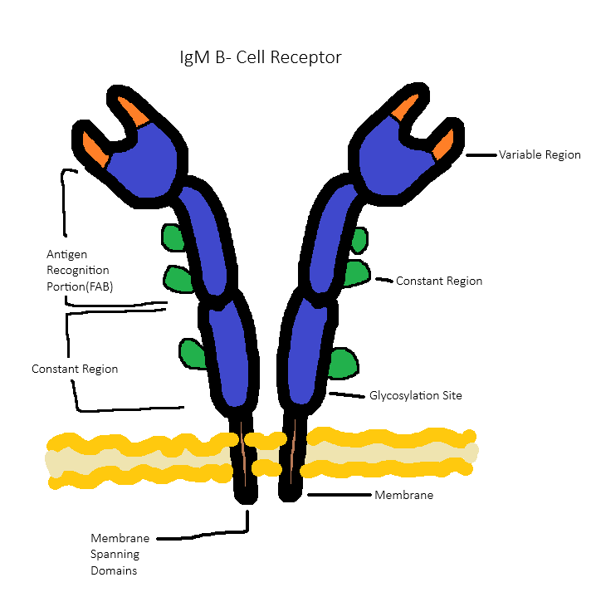
This drawing illustrates the membrane-bound human IgM B-cell receptor as resolved by recent cryo-EM analysis, highlighting its organization into two antigen-binding Fab arms containing the VH and VL variable domains and their associated constant domains (CH1/CL). The Fc portion is shown with the extended CH2–CH3–CH4 constant domains, each bearing multiple N-linked glycosylation sites characteristic of membrane IgM. Unlike soluble pentameric IgM, which assembles into a five-unit star-shaped complex with a J-chain and is secreted, the membrane IgM BCR exists as a single IgM monomer anchored in the plasma membrane through paired heavy-chain transmembrane helices. The diagram also includes the Igα/Igβ heterodimer positioned adjacent to the IgM transmembrane region, emphasizing their ITAM-containing cytoplasmic tails that mediate intracellular signaling upon antigen engagement. Overall, this drawing distinguishes the structural simplicity and membrane-anchored architecture of the IgM BCR from the multimeric, secreted form of pentameric IgM.

