Effects of Tidal Flooding on Dissolved Inorganic Nutrients in the Lafayette River, Norfolk, Virginia
Hunter Swann
Department of Oceanography, Old Dominion University
OEAS 307: Research in Oceanography
Dr. Margaret Mulholland
7 December 2025

Introduction
Tidal flooding is becoming increasingly common in coastal regions due to sea level rise and more frequent extreme weather events. These flood events can alter water chemistry by transporting nutrients from surrounding land surfaces, urban infrastructure, and sediments into estuarine systems. Urbanized coastal areas are especially prone to elevated nutrient inputs because anthropogenic land use increases nitrogen and phosphorus loading to surface waters (Delkash et al., 2018). Excess nutrient concentrations can accelerate eutrophication, promote harmful algal blooms, and degrade ecological health in coastal waterways. This issue is especially relevant in urbanized coastal areas like the Lafayette River in Norfolk, Virginia, where tidal flooding mixes with nutrient pollution from surrounding human activities. Understanding how nutrient concentrations change and respond to tidal flooding is critical for managing water quality and reducing ecological impacts on the local ecosystems.
This study investigates the hypothesis that concentrations of DIN and DIP increase in the Lafayette River following tidal flooding events. Specifically, it asks: How do tidal flooding events influence the nutrient concentrations of dissolved inorganic nitrogen and phosphorus in the Lafayette River? To address this question, nutrient samples were collected during cruise transects across twenty stations in the lower Chesapeake Bay region. Sampling dates were selected to capture both pre- and post-flooding conditions relative to the September 2025 tidal maximum, two before and two after flooding occurred. Concentrations of nitrate, nitrite, ammonium, and orthophosphate were measured using EPA-approved colorimetric methods.

Methods
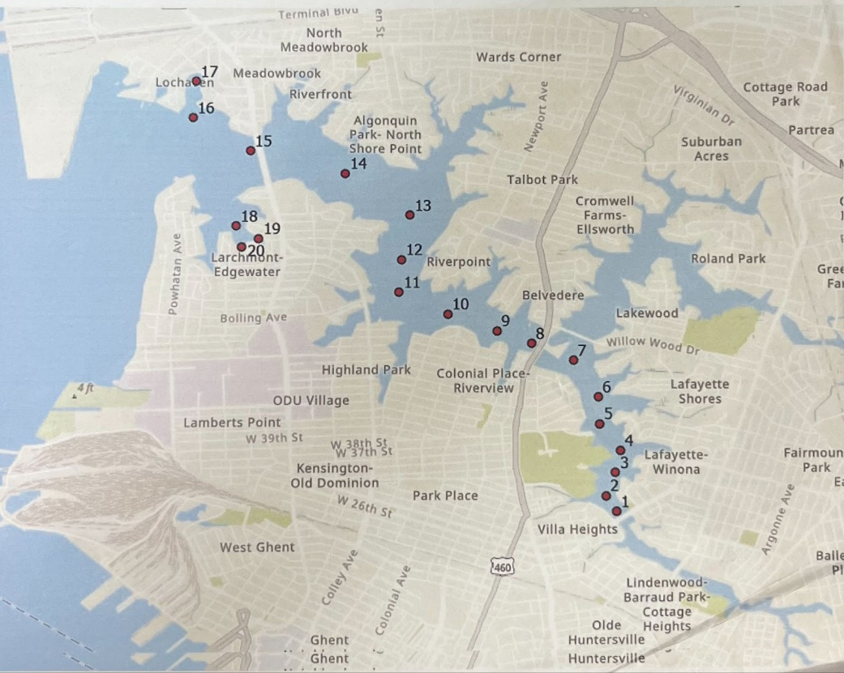
Samples for this study were collected as part of a cruise transect designed to monitor water quality changes across multiple stations in the lower Chesapeake Bay region. Sampling occurred on seven separate days: September 8, 10, 15, and 17, 2025, and October 6, 8, and 15, 2025. These dates represented the primary fall sampling period for the Boat Transect. The sampling period also captured tidal variation, with Sept 13 corresponding to the month’s highest tide. But I determined that peak flooding occurred Sept 10 Two of the sampling days occurred before this tidal maximum and two occurred afterward, providing coverage of both rising and falling tidal conditions.
Figure 1. Chesapeake Bay transect sampling stations (map created using ODU GPS station data)
Samples were collected as grab samples at each station with 250-mL Nalgene wide-mouth bottles. Water samples were collected into 15-mL centrifuge tubes, which were pre-cleaned with deionized water before use to prevent contamination. The samples were handled carefully to minimize disturbance and to ensure that they reflected in-situ water conditions as accurately as possible. Because the samples were part of the nutrient analysis project, no filtration was performed in the field. Nutrient (NUTS) samples were immediately frozen in 15-mL centrifuge tubes filled to 12 mL, while ammonium (NH₄) samples were frozen in identical tubes filled to 10 mL. Freezing served as both preservation and temporary storage until laboratory analysis. The samples remain under controlled storage at Old Dominion University (ODU) and are being processed by the ODU Analytical Water Quality Laboratory.
Nutrient samples were analyzed by the Old Dominion University Water Quality Laboratory using standard colorimetric methods following EPA-approved protocols. Specifically, nitrate + nitrite (NO₃⁻ + NO₂⁻) were determined using the cadmium reduction method (EPA 353.2; SEAL Analytical Method A-044-19 Rev.5), and orthophosphate (PO₄³⁻) was measured by the ascorbic acid method (EPA 365.1; SEAL Analytical Method A-005-19 Rev.3). Analyses were conducted using a SEAL AA3 AutoAnalyzer (SEAL Analytical, Germany), which automates sample injection, reagent mixing, and absorbance measurement to ensure precision and consistency. The method detection limits (MDLs) and reporting limits (RLs) were 0.0015 and 0.0025 mg/L for nitrate + nitrite, 0.0005 and 0.001 mg/L for nitrite, and 0.0014 and 0.002 mg/L for orthophosphate, respectively. Calibration standards and quality control checks were run with each batch of samples to verify analytical accuracy.
No major issues occurred during the cruise transects, though weather conditions occasionally limited visibility and wave action made sampling more difficult at a few sites. All samples were collected successfully, and the timing of the transects relative to the tidal cycle provides a strong basis for examining water quality variability under both pre- and post-flooding conditions.

Results
Tidal flooding occurred from September 10 to September 15, 2025, based on water levels exceeding the 3.5 ft minor flooding threshold at the NOAA Sewells Point tide gauge. During this period, water levels reached a maximum of 4.99 ft (1.52 m) relative to MLLW on September 15. The first cruise transects sampling day (September 8, 2025) occurred during a high-tide period, and subsequent transects on September 10, 15, and 17 captured conditions immediately before, during, and after the flooding peak. (TABLE)
Date | Time (GMT) | Max Water Level (ft)
9/8 | 14:12 | 4.28
9/10 | 15:42 | 4.99
9/12 | 17:18 | 4.07
9/15 | 20:18 | 4.48
9/17 | 22:36 | 3.95

Across the cruise transects, nutrient concentrations showed clear shifts between the pre-flood and post-flood conditions. Before flooding (September 8), ammonium (NH₄⁺) concentrations ranged from 1.42 µM at Tran_16_090825 to 7.96 µM at Tran_5_090825. Pre-flood NOx concentrations ranged from 1.321 µM at Tran_1_090825 to 4.705 µM at Tran_20_090825. Pre-flood DIN (NH₄⁺ + NOx) ranged from 5.642 mg/L at Tran_6_090825 to 16.740 mg/L at Tran_2_091725.
Parameter | Pre-Flood Minimum | Pre-Flood Maximum | Post-Flood Minimum | Post-Flood Maximum
NH₄⁺ (µM) | 1.42 (Tran_16_090825) | 7.96 (Tran_5_090825) | 2.77 (Tran_17_091525) | 6.96 (Tran_10_091525)
NOx (µM) | 1.32 (Tran_1_090825) | 4.705 (Tran_20_090825) | 2.64 (Tran_19_091525) | 10.74 (Tran_2_091725)
DIN (mg/L) | 5.642 (Tran_6_090825) | — (moderate values) | — | 16.74 (Tran_2_091725)
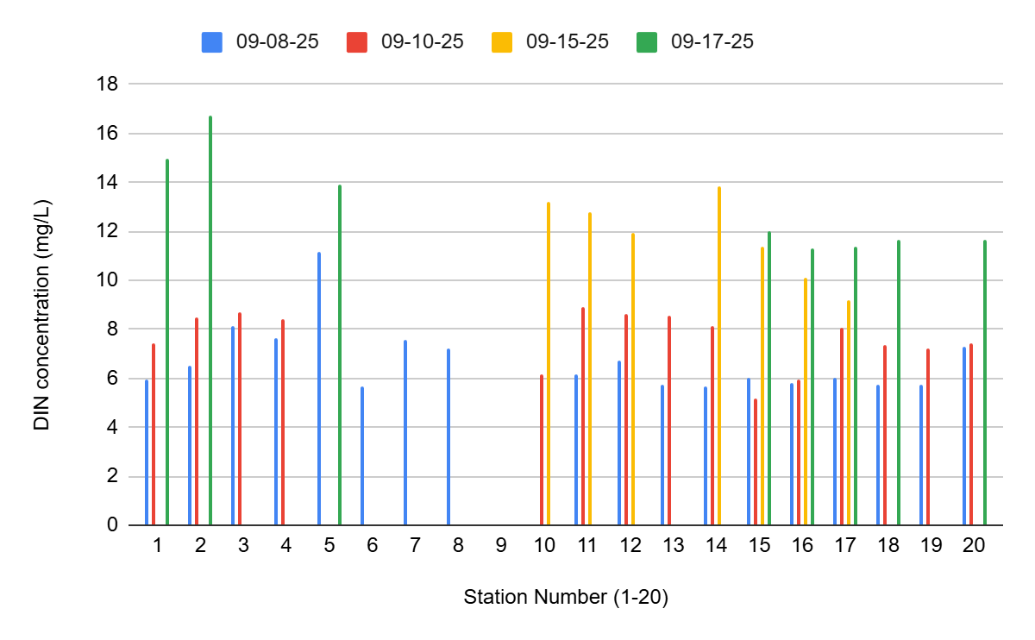
After the flood (September 15 and 17), nutrient concentrations increased at many stations. Post-flood NH₄⁺ ranged from 2.769 µM at Tran_17_091525 to 6.958 µM at Tran_10_091525. Post-flood NOx ranged from 2.643 µM at Tran_19_091525 to 10.736 µM at Tran_2_091725. These increases produced post-flood DIN concentrations as high as 16.740 mg/L at Tran_2_091725, the highest DIN value observed across all transects. This figure shows DIN concentrations across Stations 1–20, with different bars representing each sampling date. The clear upward shift in post-flood dates illustrates the flood-associated increase in inorganic nitrogen across the river system.
Discussion
Baseline nutrient concentrations in the Lafayette River prior to the king-tide event were consistent with typical late-summer conditions for urban Chesapeake Bay tributaries. Pre-flood NH₄⁺ (1.42–7.96 µM) and NOx (1.32–4.71 µM) fell within ranges reported in previous studies, indicating that the system was in a relatively normal nutrient state before the flooding occurred. These values serve as an important reference point for evaluating the magnitude of the subsequent changes. Following the king-tide flood, however, nutrient concentrations increased substantially. NOx rose to a maximum of 10.74 µM, far exceeding background levels, and DIN peaked at 16.74 mg/L the highest concentration recorded during the study period. These sharp increases strongly suggest that the flood acted as a significant nutrient delivery mechanism. Likely sources include urban runoff, overland flow across impervious surfaces, sediment resuspension, and the flushing of nutrient-rich soils and stormwater infrastructure. Similar flood-driven nutrient pulses have been documented in estuarine systems globally (Mallin 2002; Morse 2004; Paerl 2018), supporting the conclusion that tidal flooding can rapidly alter nutrient dynamics in coastal waterways. In the short term, elevated DIN concentrations have several ecological implications. Increased nutrient availability can stimulate algal production, alter microbial processing pathways, and enhance eutrophication risk. Rapid changes in NOx and NH₄⁺ availability may also disrupt the balance between nitrification and denitrification, temporarily shifting nitrogen cycling within the system.
The longer-term implications are equally concerning. With sea-level rise driving more frequent “nuisance” tidal flooding in coastal cities such as Norfolk, episodic nutrient pulses could become a chronic feature of the Lafayette River. Repeated flooding events may contribute to sustained water-quality degradation, including more frequent algal blooms, reduced dissolved oxygen, and altered habitat structure. Over time, such changes can reshape food-web dynamics and undermine ongoing restoration efforts. These findings highlight the need for adaptive management strategies that explicitly account for nutrient loading associated with tidal flooding not only rainfall-driven stormwater runoff. Restoration and mitigation approaches such as living shorelines, stormwater retrofits, and oyster-reef enhancements may need to be reassessed or expanded to address the growing influence of tidal-flood-driven nutrient transport. As coastal flooding becomes more common, integrating these processes into watershed management will be critical for maintaining ecological function and water quality in urban tributaries like the Lafayette River.

Citations
Delkash, M., Al-Faraj, F. A. M., & Scholz, M. (2018). Impacts of anthropogenic land use changes on nutrient concentrations in surface waterbodies: A review. CLEAN – Soil, Air, Water, 46(5). https://doi.org/10.1002/clen.201800051
U.S. Environmental Protection Agency. (1993). Methods for the determination of inorganic substances in environmental samples (EPA-600/4-79-020). Method 353.2, Rev. 2.0. https://nepis.epa.gov/
U.S. Environmental Protection Agency. (1993). Methods for the determination of inorganic substances in environmental samples (EPA-600/4-79-020). Method 365.1, Rev. 2.0. https://nepis.epa.gov/
SEAL Analytical. (2019). Method A-044-19 Rev. 5: Nitrate + Nitrite (NOx) analysis. SEAL Analytical Instruments.
SEAL Analytical. (2019). Method A-005-19 Rev. 3: Orthophosphate (PO₄³⁻) analysis. SEAL Analytical Instruments.
Ammonium (Lab Protocol)
ODU Oceanography Water Quality Lab. (2023). Ammonium (NH₄⁺) colorimetric analysis protocol (Unpublished laboratory method).
Kemp, W. M., Boynton, W. R., Adolf, J. E., Boesch, D. F., Boicourt, W. C., Brush, G., Cornwell, J. C., Fisher, T. R., Glibert, P. M., Hagy, J. D., Harding, L. W., Houde, E. D., Kimmel, D. G., Miller, W. D., Newell, R. I. E., Roman, M. R., Smith, E. M., & Stevenson, J. C. (2005). Eutrophication of Chesapeake Bay: Historical trends and ecological interactions. Marine Ecology Progress Series, 303, 1–29. https://www.researchgate.net/publication/228375141_Eutrophication_of_Chesapeake_Bay_Historical_Trends_and_Ecological_Interactions
Mallin, M. A., Williams, K. E., Esham, E. C., & Lowe, R. P. (2002). Effects of hurricanes on coastal ecosystems. Estuaries, 25(6), 113–127. https://www.researchgate.net/publication/225441088_Hurricane_impacts_on_coastal_ecosystems
Morse, R. E., Mulholland, M. R., & Hunley, W. S. (2004). Nutrient loading and algal blooms in estuarine systems. Estuarine, Coastal and Shelf Science, 61(3), 381–393. https://pmc.ncbi.nlm.nih.gov/articles/PMC5029501/
Paerl, H. W., Crosswell, J. R., Van Dam, B., Hall, N. S., Rossignol, K. L., & Osburn, C. L. (2018). Two decades of tropical cyclone impacts on North Carolina’s estuarine carbon, nutrient, and phytoplankton dynamics. Biogeochemistry, 141, 307–332. https://www.nsf.gov/news/two-decades-hurricanes-change-coastal-ecosystems
Testa, J. M., Kemp, W. M., & Boynton, W. R. (2012). Seasonal and spatial patterns of nutrient sources and transformations in the Chesapeake Bay. Estuaries and Coasts, 35, 1082–1097. https://www.chesapeakebay.net/files/documents/1-s2.0-S0043135420309428-main.pdf

