Katelynn Michelle Johnson
Old Dominion University Computer Science Department
CYSE 368
Spring 2020

Table of Contents

General Introduction of Internship | 2
Description of Internship Company and Workspace | 2
First Impressions of Internship | 3
Management Structure of Internship | 3
Detailed Description of Work Assignments and Duties | 3
Use of Skills and/or Prior Knowledge Through Internship | 7
How the ODU Curriculum Prepared Me for The Internship | 8
Internship and Objective Goals | 9
Exciting Aspects of My Internship | 9
Discouraging Aspects of My Internship | 9
Challenging Aspects of My Internship | 10
Recommendations for Future Interns at this Internship | 10
Thoughts on My Internship Experience | 10
Appendix | 11

General Introduction of Internship
For my internship requirement, I decided to intern with the Computer Science Department at Old Dominion University. The specific group I work for is the Computer Science Systems Group. We work directly under the Computer Science Department Director Mr. Ajay Gupta. I chose this to fulfill my internship requirement because the standards are high for those who want to intern here. During my interview for the internship position, I was asked many intermediate to advanced questions about computer network terms, host trouble shooting, and troubleshooting network connectivity issues. Because of this, I felt as though the work would be challenging and that I would learn a lot from this internship.
There are several outcomes I hope to achieve during this internship. My biggest goal is to become familiar with common issues that arise during a day to day basis. I find this goal to be very important because anywhere I will work after I graduate, there will be common issues that arise on a day to day basis. I want to learn the best way to approach common computer network issues and I want to learn ways to solve these common issues. Another goal I hope to achieve during this internship is to become more familiar with network devices such as routers, switches, firewalls, VPNs. Etc. I think this is another important goal because these are all necessary components when managing a network. I would like to learn how these devices are set up, how they are configured, and how to manage these devices. My third goal for my internship is to become more familiar with Linux hosts and servers and learn how to manage them. Currently, I have a basic understanding of Linux. I would like to learn more intermediate to advanced configuration of Linux hosts and Servers.
Description of Internship Company and Workspace
The ODU Computer Science Systems Group, or Systems for short, is the official title for where I fulfilled my internship requirement. The Systems Group has been around since the 1980’s and for the entirety of the groups existence, Mr. Ajay Gupta had been the supervisor. The main mission of the group is to assist the Old Dominion Computer Science Department faculty, staff, researchers, and students with whatever special computer network related needs they may require to complete their daily work. The ODU Computer Science Systems Group provides additional services to its CS users on top of what MIDAS provides for students. Faculty, staff, students, and researchers of ODU Computer Science require extra assistance, hardware, and software for the curriculum. This is what the Systems Group provides.
When I joined the Systems Group my orientation seemed fairly straightforward. I was greeted by everyone in the group, about 14 total people. I was shown around the workspaces. This includes the workspace that is set up in the ECS building and the workspace that is set up in the Dragus building on campus. The internship workers worked out of the Dragus building. In both of the buildings I was shown the datacenters that we manage and the spaces around the buildings that we are responsible for. After the initial “walk around” of the areas we work in and manage, I began the process of account creation for a CS user account and CS staff account. For the Computer Science Department, every user is required to have a CS specific account. This account is different from the MIDAS account that is used for the school’s network. I had a CS account set up and then I had a CS Staff account created. This account had special elevated permissions for me to be able to manage certain aspects of the network. I was told that once I reached certain check points, I would gradually be granted more permissions to manage the network.
First Impressions of Internship
My initial impression of the company was that it was one I look forward to working for. My coworkers seemed very intelligent and they also seemed friendly and eager to help get me up to speed with the rest of the group. I did not realize how many services we provided to our users and I also was surprised at the number of users we had. I found this larger than expected work experience to be slightly intimidating, but I looked forward to the challenge. I was also eager to learn as much as possible because it seemed that there was a great potential for me to learn a lot while I was at this internship.
Management Structure of Internship
At my internship we had a tiered structure for management purposes. The topmost level of management was Mr. Ajay Gupta. He was in charge of the entire Systems Group and he oversaw the productivity of the group. Mr. Ajay Gupta is who the Computer Science faculty members would correspond with if they required certain equipment to be purchased or if they had any requirements for the CS courses they taught. The next level under Mr. Gupta was the level of full-time administrators. As their title suggests, these admins were full time employees of the group. The “fulltimes” as they were called, were given tasks by Ajay directly and then they would determine at what level to delegate the task to or the fulltimes could keep the task for themselves to complete. A task that the fulltimes would complete would be a task that requires the most account privileges or a task that would require purchasing approval. A task such as this would be something like when faculty member or researcher needs equipment or certain software approval to conduct their work. The next level under the full-time admins were the part-time administrators. These admins were usually full-time students at Old Dominion University which didn’t allow for them the flexibility to work a full-time schedule. The part-time admins had most if not all of the same user privileges as the fulltimes, but they were not always available during the workday because of their classes. Though they had the same permissions, if a part-time admin had an idea of how to improve the network or a way to improve a way in which we conducted business, they would have to request permission to do so from a fulltime admin. The last level is the level where the interns worked and the rest of the part time employees and was called the consultants. The consultants got most of the tasking. Most of the tasking that was given to the consultants were tasks that did not require a high level of account permissions to complete. Such tasks would include host connectivity issues or user account issues.
Detailed Description of Work Assignments and Duties
During my internship I was given several types of work projects. The work I completed at my internship was usually in one of three categories. The first category was learning projects. Learning projects were something that was given to consultants to learn concepts that we were used within our network. During my time at the internship I was given two learning projects. The second type of work I completed at the internship was helping to address user “tickets”. The ticketing system was something that allowed our users to submit to us when they noticed and issue or if they required our assistance. Many tickets were handled by the consultants because most tickets submitted usually did not require elevated permissions. I answered and resolved many user tickets during my internship. The last type of work that I completed at my internship would be tasks that the fulltime administrators had for the group to complete. Sometimes these tasks were given to the fulltimes from Mr. Gupta directly and sometimes these tasks were tasks that the fulltime admins came up with themselves to better our network and workflow. I was given several task related work assignments during my internship.
First, I will discuss my learning project assignments. During the course of my internship I was given two learning projects. There were many categories of learning projects to choose from such as Linux, Windows, Virtual Machines, Networking, and Programming. Each category had around 5 learning projects, number 1 through 5, to choose from. Usually, the higher in number the harder the projects were. For most categories you did not have to follow the numbers consecutively, but the higher number projects usually require you to use concepts learned in the lower level learning projects. All of the learning project descriptions were on the Systems Group internal home page. This is where a consultant would go to begin a learning project when they were assigned one.
There was a general workflow for the learning projects, and it went as follows. If a consultant was not actively working on a task, a fulltime admin would ask the consultant what learning project they wanted to complete. They would choose a project and then it would be assigned to them in the project tracker by a fulltime admin. They had two weeks to complete the assigned project. After the project was complete, the consultant would have a project check with one of the fulltime admins. This project check would usually take an hour. The firxst 20 to 30 minutes consisted of a fulltime going over the project with the consultant present to make sure they completed the project fully and correctly. The next 35 minutes consisted of the fulltime conducting a quiz to make sure the consultant understands the concepts that were to be learned from the project. If the fulltime felt that the consultant completed the project correctly and understood all the concepts that the project dealt with, the consultant would pass the project check. If the fulltime felt that the consultant didn’t fully understand certain concepts or that the project was done incorrectly, the fulltime would give the consultant 48 hours to make appropriate fixes to the project or study on the concepts they missed. Afterwards there would be a re-check.
I chose to do leaning projects Linux 2 and Linux 3. I did not do these projects back to back, but I did do them consecutively. I did not complete these learning projects back to back because the time in between my completion of Linux 2 and beginning Linux 3 I had many user tickets and work tasks assigned to me that I had completed.
The purpose of the Linux 2 learning project was to learn about web servers, the concepts involved with them, and about redundancy when hosting a website. I was to create two Nginx servers and two Apache servers. The Apache servers would “sit behind” the Nginx servers. This was so that the outside internet could not connect directly to my Apache servers hosting the website. This is for security purposes. The Nginx servers were to act as a reverse proxy for my Apache servers. My Apache servers hosted two websites. One website interacted with a postgresql database and the other website interacted with a mysql database. The websites themselves were very simple websites. One website, the “winter” website, asked the user to input a sport played in the winter and then to rank that sport (1 -10, 1 being the least favorite) based on their preference. This is shown in Appendix 1.1. The winter website interacted with the postgresql database. This is shown in Appendix 1.2. My other site, the “summer” site, asked the user to input a US city and state combination. This is shown in Appendix 1.3. The summer site had the same concept of storing information in a database, but this site stored its information to a mysql database. This is shown in Appendix 1.4 & Appendix 1.4.2. I then used .htpasswd to protect my websites. htpasswd allows the site owner to set up a username/password combination so that only authorized users can visit the site. This is shown in Appendix 1.5 & 1.6.
The second learning project I completed was Linux 3. The purpose of Linux 3 was to create a Linux environment of one Linux server and several Linux hosts. Then I was to manage these hosts remotely from the server. I did this by using the management system known as Salt. I set my server as the Salt master. I then had to download Salt minion on my other Linux hosts. I had to configure the Salt master and minion relationship. This is shown in Appendix 2.1. I had to set my minions to recognize the Salt master’s key. I then would accept connecting minion keys on the master. This way a trust relationship was formed. I was then required to write configurations that would be set uniformly on my Salt minions. Examples of my Salt minion configuration files are shown in Appendixes 2.2, 2.3, 2.4, 2.5. The configuration settings written in Salt are called Salt states. I configured Salt states for the following requirements, set DNS to specific IP addresses, set up a floating IP between my hosts, create a login message on my hosts, and set up my hosts to send monitor information to a Nagios server. This project took me the entire two weeks to finish. I learned a lot from this project. I found this project to be very beneficial in my understanding of why it is important to have a central management point for hosts.
The learning projects are necessary for consultants to complete because each project is designed so that a consultant learns something about how the Systems group network works. For example, many of the sites the Systems Group has set up use a reverse proxy and are hosted by an Apache server. This was the learning purpose of Linux 2. The Systems Group also uses Salt states to manage our Linux servers and hosts. This was the learning concept in Linux 3. As a consultant completes each learning project, they learn another concept that is in use within the Computer Science Department network. The learning projects allow consultants to learn about and practice the application of these concepts in a controlled environment before applying these concepts directly to the CS network.
The next type of work I completed at my internship was answering and addressing user tickets. The Systems Group has a ticketing system site that users can go to and submit a ticket for anything they want to bring to our attention. This site is used by the Computer Science faculty, researchers, undergrad and graduate students. Most of the tickets that come in are addressed by the consultants. This is because many tickets that come in are tickets that do not require an elevated level of permissions to complete. Many tickets that come in include host connectivity issues, software installation requests, user account issues, hardware installations, and hardware requests. However, tickets that come in can be related to any issues that users may have with our network, equipment, or spaces the Systems Group is responsible for.
I answered and addressed about 30 total tickets over the duration of my internship. However, I will cover the category of tickets I learned the most from and that I found to be the most interesting. Over the duration of my internship I answered several tickets about user websites and their permissions. Within the Computer Science department, users are able to host their own personal website through their CS Linux directory, which is located on the CS Linux servers. Users can create and host their own website by creating a directory within their home directory and adding html files to that directory. The directory holding the html files and the html files themselves must have the correct permissions in order for the site to be viewable to the public. Many users run into issues setting up this directory architecture and also need help setting up the correct file and directory permissions.
Specifically, I will reference two website permission tickets I handled. In the first ticket I helped a student change the permissions on their html files to allow their website to display correctly. Screen shots to reference this ticket are in Appendix 3.1 & 3.1.2. The second ticket is also a website permissions ticket. In this ticket I helped another student to set the correct permissions on their html files in their html directory. Screen shots to reference this ticket are in Appendix 3.2 & 3.2.2.
The last type of work that I was given while working at the internship were assigned tasks. A few of my assigned tasks included updating our VPN to the newest version, installing new monitors for the faculty, installing new workstations in our labs, and visualizing network data. Updating the VPN was an easy task, but it had to be completed at a certain time. This was because while the VPN was updating, all the current connections to the VPN would be disconnected. Because of the VPN disconnection during the upgrade, I selected a date and time to start the VPN upgrade when there would be the least number of users connected to it. Before I conducted the upgrade, I sent out an email to the entire CS department notifying of the date and time that I would conduct the upgrade. This task was important to the Computer Science department because before the upgrade we were using 5.0.1 version of the VPN. The version I upgraded to was 5.0.5. This means we were using a VPN that was a few versions out of date. Operating with an out of date version is not recommended because as with any software, new versions come out that fix bugs or that patch vulnerabilities.
Another task that I was assigned was to install new monitors that were ordered for CS faculty members. This task was a relatively easy, but it was time consuming. There were several consultants that helped with this task but there were 50 new monitors that needed to be installed for faculty members. Another reason this task was time consuming was because in order to install the new monitors, the faculty member had to be in their office. So, the consultants needed to coordinate with the faculty member and discuss when they would physically be in their office so that their new monitors could be installed. A challenging aspect of this task was connecting the monitors to the workstation. The new monitors came with one HDMI cable and one Display cable. For all faculty members, two monitors were installed/replaced with their old monitors. Some of the workstations only had one Display port and one VGA port. For these workstations, a VGA to HDMI adapter was needed in order to set up two monitors at that workstation. This task was important to the Computer Science department because the new monitors were much bigger than the old monitors and they also had better resolution. When the new monitors were installed, the screen working area was much larger, making it easier and more organized for faculty members to complete their work.
The next task I was assigned was to install more workstations in one of our labs in the Dragus building. In the student lab, we already had 40 computers, but we had created space for another row of workstations. In this row I added six new workstations. In order to add six new workstations, I had to image six computers through our imaging process. During this process there is little interaction besides initiating the process, setting the local administrator password, and giving the computer a hostname. The challenging part of this task was making CAT5 cables and configuring the ports that these new machines would connect to. I had to create CAT5 cables for this task because I needed custom lengths of cabling for the workstations in this new row. Once the CAT5 cables were made, I then needed to configure the ports on the switch that the new workstations would connect to. To prepare the ports on the switch, I had to make sure they were enabled, port security was configured correctly, and give the port a description. Once these steps were complete, I was then able to connect the workstation to the wall port. This task is necessary to the Computer Science department because CS student use the lab frequently to complete their course assignments. This lab in particular was starting to become crowded at times, especially a week or two before midterms and a week or two before finals. This required that more workstations be installed so that our users could comfortably complete their work in our spaces.
The last task I was assigned was to visualize important data within our network such as current logged in users, CPU usage for virtual servers, network connectivity to our lab machines. I used a visual data program called Grafana to complete this task. I made several graphs that represent data within out network. First, I made a graph that represents how many users are logged in to our virtual network. This graph shows number of user connections for the virtual servers. This graph shows the current users and recent previous users to the virtual servers. Screen shots to reference this graph are in Appendix 4.1. Next, I created a visual chart that represents CPU and memory usages of each of our virtual servers. Screen shots to reference this graph are in Appendix 4.2. The last graph I created is a chart to show the network connectivity status of each of our lab machines. Screen shots to reference this graph are in Appendix 4.3. It is important to visualize data that represents important information about our network. This way, everyone in the Systems Group can easily see important network information without the hassle of searching through large amounts of data.
Use of Skills and/or Prior Knowledge Through Internship
During my internship, I realized that a lot of knowledge which I acquired through my degree coursework are best practices and concepts that I will need to apply to the specific environment I will be working in. In many of my courses, we were given an environment and then we were given a lab to complete within the given environment. All of the lab environments were different for each course and in each course, we practiced a different concept of cybersecurity. Without realizing it, I thought that the concepts I learned were specific to the type of environment that was set up in the course. Working at my internship I realized that this is not the case at all. I realized that my courses were trying to teach me overall concepts, not that these concepts only apply to this specific type of environment.
During my internship I used several skills and concepts that I had learned through my degree program. The skill that I used the most during my internship would be the skill of protecting the network and its devices. This concept was applied daily. When assigned the responsibility of a network, the sole responsibility is to conduct every action on the network in the most secure way as possible. The first example is the most basic concept of the network, the users and their usernames. There are a set of regulations that a user must meet before they can receive a CS account. One being that they are currently enrolled in a CS course that requires a CS account. After this information is verified, the user must create a password that meets set restrictions for the password to be accepted. Another example is if a user wants to use remote desktop to access their workstation from outside the network, they must connect to the CS VPN.
How the ODU Curriculum Prepared Me for The Internship
I believe my degree program curriculum did a good job at teaching me the cybersecurity concepts that I will need to apply in my profession. The program did a good job at reiterating important concepts and because of that, I feel like I had a solid understanding of important cybersecurity concepts going into my internship. Though I think it would be hard to find a way to apply this in the classroom, the program did not prepare me for troubleshooting common network issues. I feel like this is a major concept that I had to learn on the job at my internship. I think maybe incorporating a class with basic network and host trouble shooting issues that arise in common usage of networks would be helpful.
I feel as though a lot of the courses in my degree program covered in detail the types of cybersecurity attacks. Whereas in my internship, the majority of my tasks were ways to help secure the network or making sure to carry out actions throughout the network in a secure manner. There were some classes that I felt I made connections to in my internship, but in many of my classes I did not make a direct connection to. I think learning the types of cyber attacks is important because when you are trying to protect a network, you have a better understanding of what you are protecting against. However, I think the courses that I had the most connections to throughout my internship were the classes that I had to configure secure settings on hosts and then tested those settings.
There were experiences that I had in my internship that I related back to what I learned in school. In school my coursework covered several times why it is important to have strong passwords. This was reinforced in my internship with the user account requirements for computer science accounts. Another experience I had at my internship that was reinforced in my schoolwork was network protocols. During my internship I applied many protocols that I had learned about during my coursework. I think an experience that I did not relate back to my course work too much was the topic of IP addresses. I have an advanced amount of experience with IP addresses outside of my schoolwork and my internship, so this concept was not difficult for me to understand. However, I did notice other interns within my same degree program struggling with IP addresses. I really think this concept should be taught more thoroughly so that students have a better understanding of what an IP address is and how it applies to routing traffic.
A big concept that I learned strictly through my internship and not in my schoolwork was configuring routers, switches, and firewalls. I know I will not learn this through my curriculum because I graduate this semester and I have no more classes to complete before graduation. I think these are extremely valuable and important skills to have. These devices are essentially the backbone of the network and cybersecurity students will deal with these devices a lot. I am wondering why these concepts are not addressed in the curriculum. I am happy that my internship provided me with these skills, and I feel more confident going into my job search after acquiring these skills.
Internship and Objective Goals
Luckily, my internship fulfilled all of the objectives I introduced in my introduction paragraph. The three objectives of my internship were to become more familiar with common issues that arise within a network on a day to day basis, to become more familiar with network devices such as router switches, and firewalls, and the last objective was to become more familiar with Linux hosts. My first objective was fulfilled with the Systems Group ticketing system. On any given day the ticketing system would receive about 20 total tickets. As stated in previous paragraphs, most of the tickets were handled by consultants. This experience opened my eyes to many issues that arise on a regular basis within a network. My second goal was accomplished through tasks given to me in my internship. The task of updating the network VPN and the task of adding new workstations to one of the Systems labs helped me to accomplish this goal. My last objective was fulfilled through completing my learning projects, Linux 2 and Linux 3.
Exciting Aspects of My Internship
The most exciting aspect of my internship was the amount of knowledge I was able to gain from it. It seemed like every day there was something new I was learning or experiencing. I think this aspect kept me motivated and encouraged me to try my best every day. I also really enjoyed providing an important service to the network users. I felt great satisfaction knowing that the work I was completing on a daily basis was either one, enhancing the network from its previous state or two helping to improve the users experience of the network. Knowing that the work I completed will affect the network users directly, motivated me to hold my work in the highest of standards
Discouraging Aspects of My Internship
A discouraging aspect of my internship was that it was only one semester. I think I could have learned a lot more and gained many more skills if my internship spanned over two semesters. By doing an internship for two semesters I would have experienced many more network issues. I also would have had more time to gain more skills and potentially acquire more account privileges to complete more advanced network tasks.
Challenging Aspects of My Internship
The most challenging part of my internship was that there was so much to be learned. Working at a company is not really like anything in the classroom, even the classrooms that provide labs for the students to simulate “real life” activities. The entire workflow of a career environment is completely different than that of the classroom environment. So, adjusting how I completed my work was a challenge. Another challenge I faced, which is also related to the difference between the classroom and the workspace, was figuring out how to interact with the users of the network. When you are responsible for the network and its corresponding devices, services, and spaces, the entire goal of managing a network is to make sure it is running smoothly for its users. Everyday there was something that was needed by several of the users. On the rare day that there was not something that was needed by one of the users, we were actively working on way to improve and update our environment either with physical hardware upgrades or making the way we work more efficient. The work environment is definitely more demanding and more fast paced learning wise than the classroom. My biggest challenge was adjusting my work style to accommodate to this change.
Recommendations for Future Interns at this Internship
I highly recommend this internship for anyone who is thinking about working at the Systems Group to fulfill their internship requirement. This internship has taught me so much valuable information and has enhanced my technical skills. This internship has better prepared me for once I graduate and I feel more confident going into job interviews because of working with the Systems Group.
For anyone who is considering working at the Old Dominion University Computer Science Systems Group as their internship, first, I would advise to try and not allow yourself to become discouraged in the beginning. At first, it can seem like you are really far behind and that you have so much catching up to do, but do not let this discourage you, let this inspire you. The second tip I would give would be to not shy away from taking on tasks because maybe you aren’t fully confident in your skills. Everyone in this group is very helpful and willing to help you if you are unsure of how to approach a task. Take as many tasks and tickets as you can because this is how you apply what you learned in the classroom and this is also how you develop new skills.
Thoughts on My Internship Experience
I felt that my internship experience greatly improved my technical skills, my technical terminology, and my career confidence. I feel a lot more confident going into the workplace after completing my internship. Before my internship, I was unsure if my classroom skills had prepared me enough for the pace of the workplace. After working at an internship, I realized that classroom skills alone are not enough to fully prepare one for the daily routine of the workplace. The internship “bridged the gap” between the classroom and the workplace and I think an internship is a necessary component to prepare a student for the demands of a workplace.

Appendix

Appendix 1.1
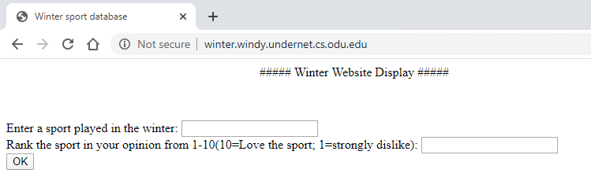

Appendix 1.2
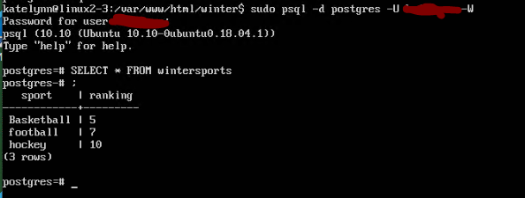

Appendix 1.3
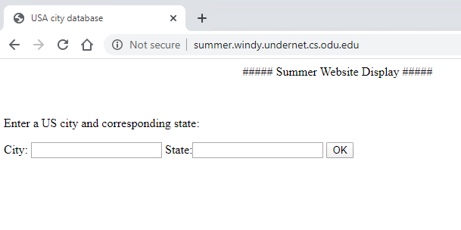

Appendix 1.4
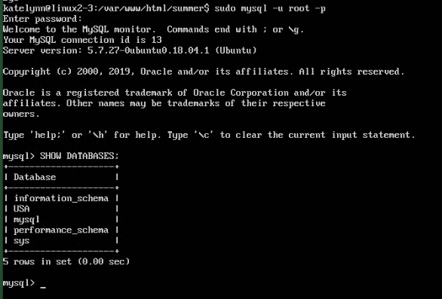

Appendix 1.4.2
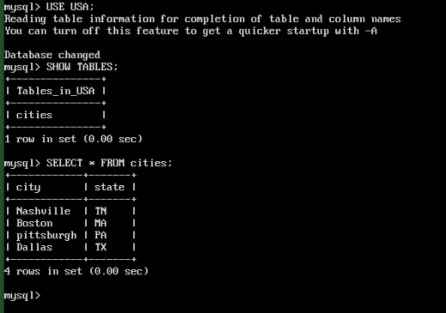

Appendix 1.5
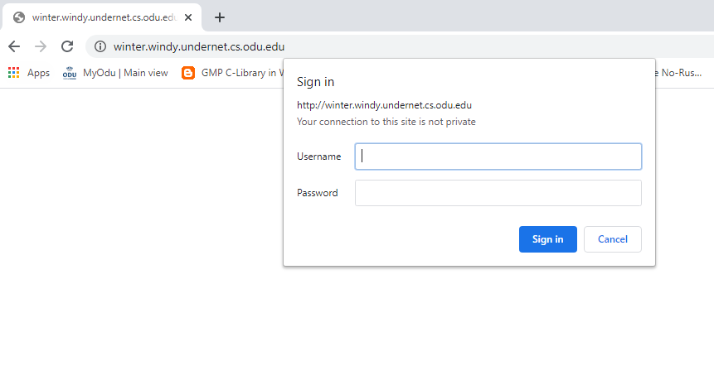
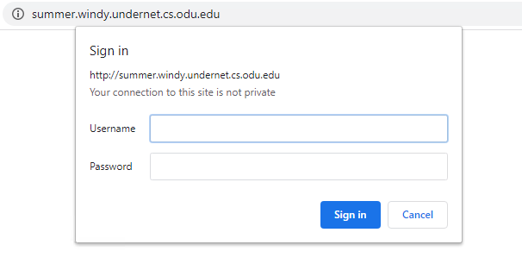
Appendix 1.6

Appendix 2.1
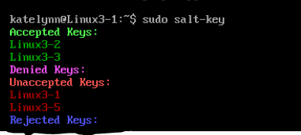

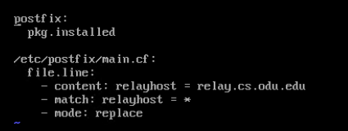
Appendix 2.2

Appendix 2.3
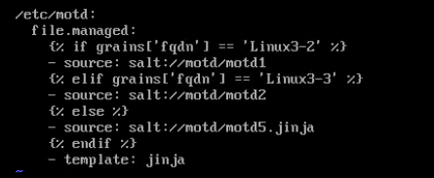

Appendix 2.4
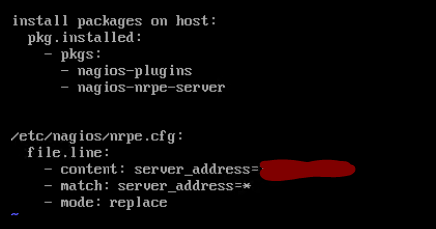

Appendix 2.5
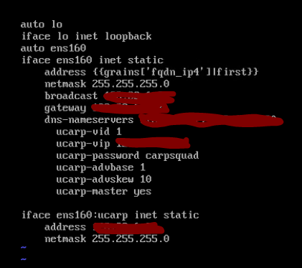

Appendix 3.1
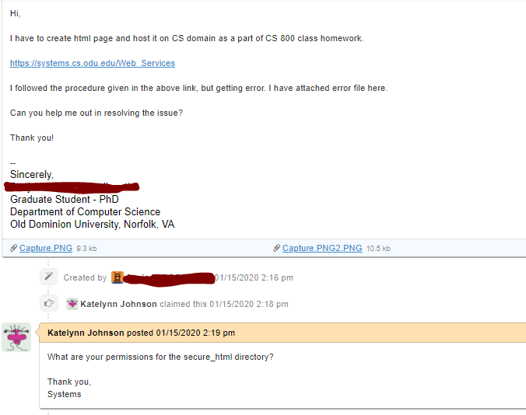

Appendix 3.1.2
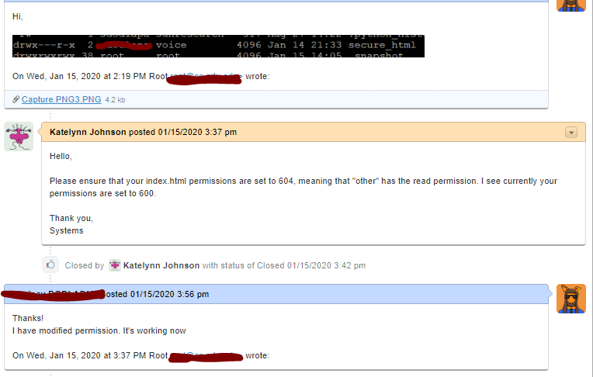

Appendix 3.2
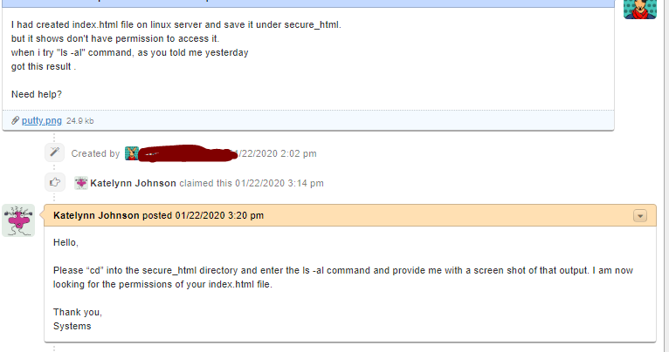
Appendix 3.2.2
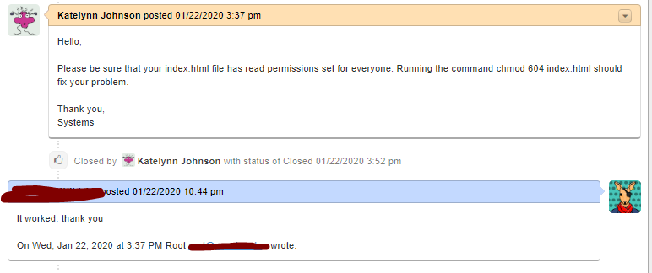

Appendix 4.1
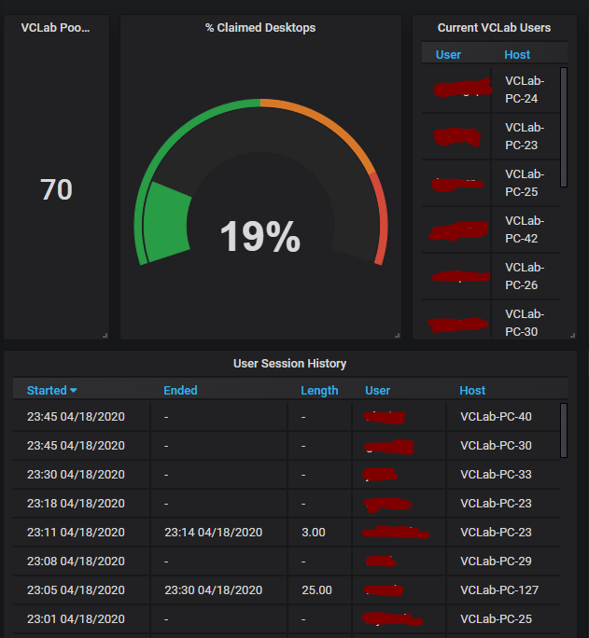

Appendix 4.2
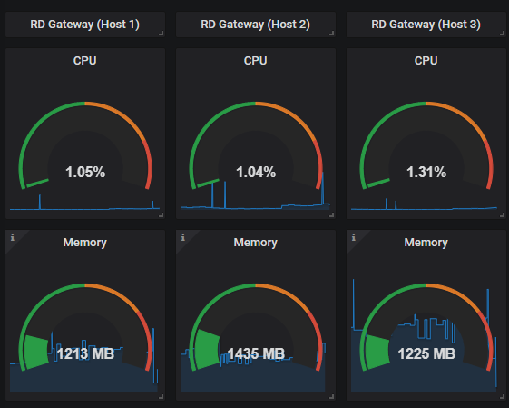

Appendix 4.3
