
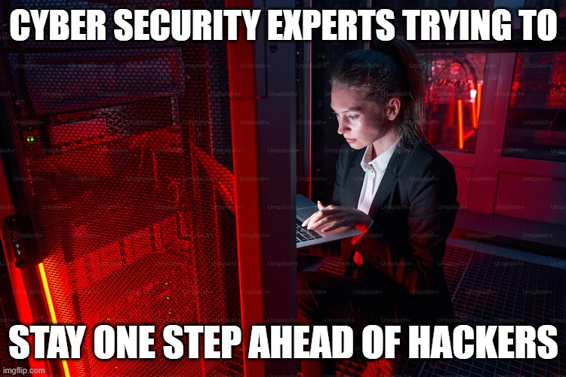
In the contemporary digital landscape, memes have emerged as a significant cultural phenomenon, serving not only as sources of humor but also as tools for communication and social commentary. When examining the relationship between memes and human-centered cybersecurity, it becomes evident that memes can encapsulate complex cybersecurity concepts in an accessible format. This democratization of information is crucial in fostering a culture of security awareness among users, who are often the weakest link in cybersecurity frameworks. Memes frequently highlight common cybersecurity pitfalls such as phishing attacks or poor password practices in a relatable manner. By utilizing humor and satire, these visual representations can effectively engage audiences who might otherwise overlook traditional educational materials on cybersecurity. For example, a meme depicting an exaggerated reaction to receiving a suspicious email can serve to reinforce the importance of vigilance in recognizing potential threats. This approach aligns with human-centered design principles that prioritize user engagement and comprehension.

