**Task 4: Mindmap**

Jade Bayless

Old Dominion University

HMSV 440: Program Development, Implementation, and Funding

Dr. Silverberg

July 10, 2022

Task 4: Mindmap

**Role**: Evaluator

**Audience**: Stakeholders

**Format**: Mindmap

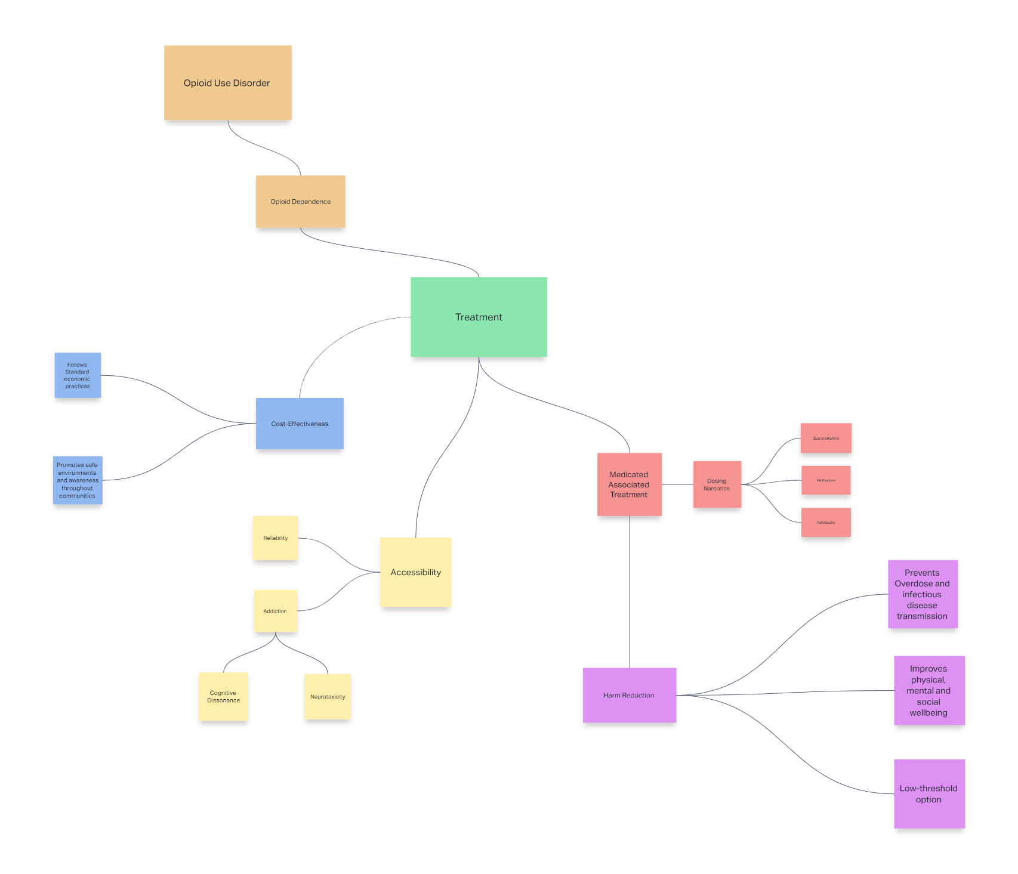**Task**: Develop a Mindmap that links themes found in your research articles.

# References

Cantor, J., Powell, D., Kofner, A., & Stein, B. (2021). Population-based estimates of geographic accessibility of medication for opioid use disorder by substance use disorder treatment facilities from 2014 to 2020. *Drug and Alcohol Dependence* , Vol 229.

Chang, D., Kilmas, J., Wood, E., & Fairbairn, N. (2018). Medication-assisted treatment for youth with opioid use disorder: Current dilemmas and remaining questions. *The American Journal of Drug and Alcohol Abuse*, 143-146.

Crist, R., Li, J., Doyle, G., Gilbert, A., Dechairo, B., & Berrettini, W. (2018). Pharmacogenetic analysis of opioid dependence treatment dose and dropout rate. *The American Journal of Drug and Alcohol Abuse* , 431-440.

Fairley, M., Humphreys, K., Joyce, V., Bounthavong, M., Trafton, J., Combs, A., . . . Owens, D. (2021). Cost-effectiveness of treatments for opioid use disorder. *JAMA Psychiatry*, 767-777.

Kennedy, K., Harper, C., Li, J., Suarez, N., & Johns, M. (2022). Protective environments, health, and substance use among transgender and gender expansive youth. *LGBT Health*.

<https://jadebayless564102.invisionapp.com/freehand/Untitled-mFckge55A?dsid_h=e9761076d35cb16294876999aa6c2d176e3bbbeecf2a9f0295971be0439129ac&uid_h=097bc22a58daac0c56515954ad045fa5dcc31b1433e61a8d177a1c5f8e24dffe>