James Applegate

2/28/24

Meme #1- In cybersecurity, we frequently find ourselves in a situation where we learn about something we shouldn’t have and have a “moment” upon learning about it.



Meme #2- This was a common mistake I had throughout all of my coding classes. While learning about how to type up code, I would frequently mess up a small, simple section, and it would run an error code until I figured out what I messed up.

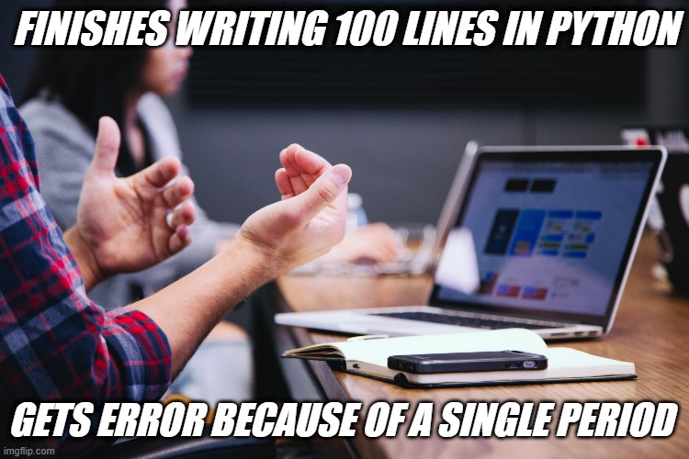

Meme #3- During one of my projects, and I know this happens all the time with people who have a job coding, my partner wrote around 40 lines of code and proceeded to close out before saving it a couple of days before the project was due.

