Newport News Shipbuilding

Jacob Breitbeil

CYSE 368

Summer 2024

Table of Contents

**12**

23

37

**49**

511

612

7………………………………………………………………………………………………………………………12

8………………………………………………………………………………………………………………………14

9………………………………………………………………………………………………………………………14

10……………………………………………………………………………………………………………………..15

11……………………………………………………………………………………………………………………..15

12………………………………………………………………………………………………………………………16

1

I decided to apply for the internship at the Newport News shipyard because it’s a 20-minute drive from my parents’ house. My grandfather and my father have worked there, and my brother was also applying. Being a third generation shipbuilder helps your chances of getting a position there because they like family retention. I also chose to apply to the shipyard because I wanted to get exposure in the cyber field in the DOD world. The shipyard is the perfect place to get exposed to cyber security and learn as much information as possible about this field, especially considering the size of the recently improved cyber team in the yard and the infrastructure invested into it. The team there is incredibly knowledgeable, and in my group alone between the higher ups there is over 100 years of experience. Any question I could possibly have, they have an answer for it between the three of them. I also chose to work there due to the close proximity to the ODU, the school I attend. Due to these factors, I came to the conclusion to apply for the Co-op position there.

I went into the internship wanting to learn more about the cyber field. What does cyber look like in practice and application? How do cyber teams implement these kind of practices? This was my first time being introduced and exposed to what cybersecurity really is, so these were often questions I asked myself. Before this internship I thought cybersecurity was an interesting field, but I've had no exposure to it. I had only had two semesters of cyber classes, so I really was just dipping my toe into the field with the knowledge that I had. The most important thing that I've learned from my classes was the CIA triad. However, as soon as I got to my group I was informed that the CIA triad is not always the golden standard. In reality, for an air gap system like a carrier, availability is the most important thing. To me, it sounded extremely backwards learning that 1000 people should have the same password to a system, but when you put it into the context of what the sailors are doing, it makes sense to have a memorable password that everyone has access to. This is due to the quick nature of combat situations, as you don't want the sailor to have to stop and think to try to remember their password. You want it available immediately so that the sailor can get into the system and do their job while under an immense amount of stress.

2

The Newport News Shipyard is one of the three branches of Huntington Ingles Industries, a Department of Defense contractor. The Newport News shipyard is the sole designer, builder, and refueler of nuclear powered aircraft carriers for the US Navy. They are also one of two companies that provide nuclear powered submarines for the Navy. Electric Boat and Newport News shipbuilding work in collaboration to produce the submarines.

Newport News shipbuilding has more than 135 years of experience building ships. They have worked on more than 800 ships in service for the US Navy and commercial customers. This long history of producing ships has created a culture of excellence at the company. This is embodied by the saying, “always good ships regardless of profit or loss.” In 1886, the shipyard was built to be a repair service for ships. In 1891, NNS built its first ship, a tugboat named Dorothy. To this day, Dorothy is still on display across the street from the yard. She is a reminder of the longevity of the company and its commitment to delivering quality goods. This culture is ingrained in the yard and the employees.

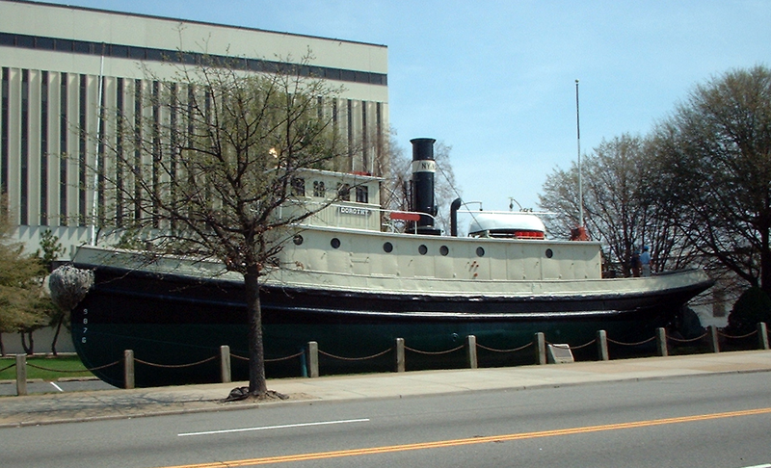

Dorthy the tugboat via [Wikipedia.com](https://en.wikipedia.org/wiki/File:Northrop_Grumman_Newport_News_032007_tugboat_dorothy.png)

During the 1890s, the shipyard started producing gunboats for The US Navy. This continued into the early 1900s as they transitioned to creating battleships in the dreadnought class. During this time they were also creating passenger ships. Fast forward to the interwar period, the shipyard was producing ocean liners, battleships, aircraft carriers, and cruisers. By 1940, liberty cargo and transport ships were added to the list. During the Second World War, production was cranked to an absolute high and the shipyard produced 11 aircraft carriers. To put that into context the modern shipyard produces one carrier around every seven years.

After the war was over, they continued to produce carriers, Cruisers, and one last ocean liner. In 1959, the shipyard produced its first submarine and one year later they produced their first nuclear powered submarine. In that same year of 1960 they produced the USS Enterprise, the first nuclear powered aircraft carrier in the world. Fun fact, the enterprise was the carrier that was used for filming of the first Top Gun movie. To the present day they have continued the production of nuclear powered carriers and submarines for the Navy.

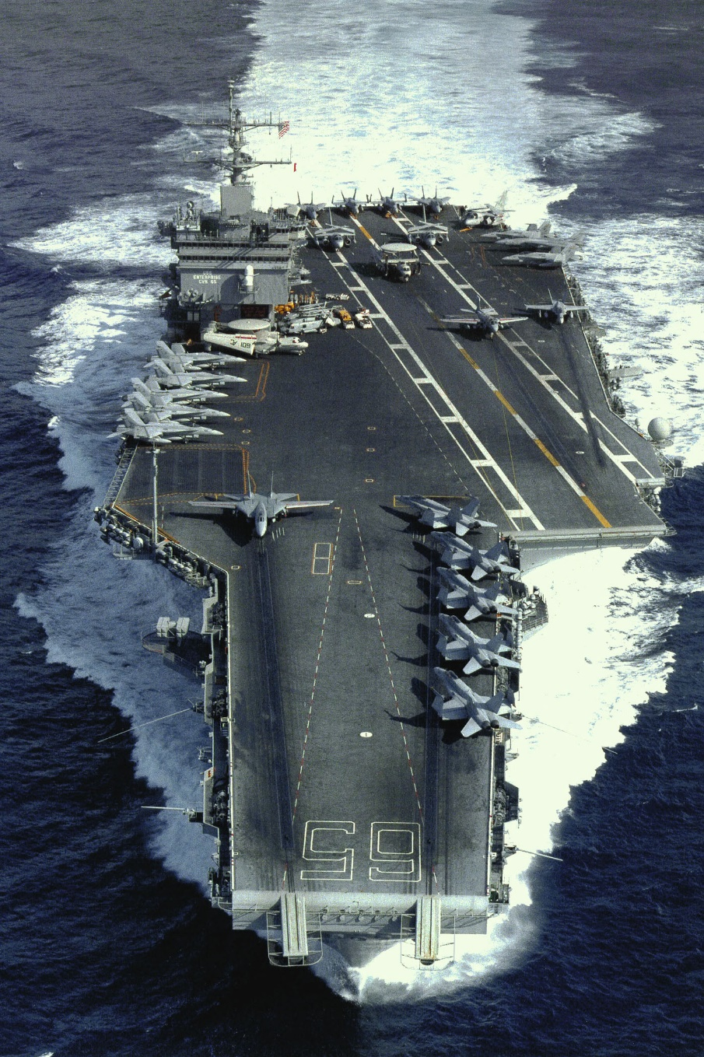

CVN 65 USS Enterprise via [northropgrumman.com](https://news.northropgrumman.com/file?fid=578e57baa138350d177d4bdc)

My orientation on the first day was held in a big conference room with about 30 other interns. Over the next six hours, we were given an introduction to the yard and its mission, who the important people are, yard safety, and a brief introduction to radiological safety. I was then introduced into my team that I would be working with throughout the course of the internship. The next day I had a big fat binder slapped down in front of me and was instructed to read it. It was a department introduction that discussed what the department does, some of the history of the department, and the lessons and reasons for what the department does including the design changes that they have implemented. The next week I was given PowerPoint trainings from one of my group members in the lab about the organization of my department and who was in charge of what within the management structure. My initial impression of the company is that it is a sink or swim environment, and you better be good at swimming because there only is a deep end. The group within your department is at least nice enough to throw you a float if needed, but it is crucial that you are self-sufficient enough to retrieve it.

3

Within the department, management is broken down with a director at the top, who reports to a vice president. Under the director there are manager threes who are in charge of groups called WIBS areas. You'll have to forgive me, they never told us what WIBS stood for. In those areas you have manager twos who report to the manager threes, under each manager two, you have a team of employees ranked from E1 to E5. The E stands for engineer, even if you're not an engineer your rank is still designated with an E in front. E1 through E4 report directly to their manager two. E5’s report directly to the manager 3 and are technically equivalent to the manager two rank wise, but they do not have any manager duties. Engineer 5s are considered subject matter experts and every group has a manager 2 and engineer 5.

I got lucky with my group consisting of such a small team. I was able to have conversations with each of my coworkers every day, and I interacted with my manager every single day. Not only was I able to talk about work topics with my manager, I was also able to ask him about his work experience as a contractor, his military experience, and his journey to the position that he is in now. I'm also able to talk to him about normal, mundane things and topics that we have similar interest in. It's like that with everyone in the office. That kind of environment is my favorite to work in because when everyone needs a break, we're all able to step back and just talk about normal things and have banter in the office. This is opposed to it being a heads down all the time enviroment. Hence, the office environment reminded me more of a trade environment instead of a corporate one.

I believe those kinds of environments are the most beneficial because you are able to disagree with someone and have debates on how certain things should be handled or implemented. Even if you're wrong or your idea is not chosen, everyone's able to move on and not hold grudges against one another. I believe even the lowest level employee should be able to have a debate with their boss on why they think they're wrong or taking something in the wrong direction and even if that lower level employee was wrong or their idea was not used, it is not held against them. Our group even has a name for this kind of event. It's called “cuss and discuss.” The white boards in the office are evident of these “cuss and discuss” sessions. We have had sessions so long that the people who are engaging in one stop at lunch time, go get lunch together, and then come back and resume the discussion.

4

My tasks and major work duties during the internship started with building RJ-45 cables. We were given instruction in the lab on how to terminate them. Every RJ-45 cable in the lab was created by someone on the team. This skill was then repeatedly put to use in the lab as we continuously cable managed our server rack. I once spent one entire Friday tasked with soley working on that.

I was taught how to create and delete a virtual machine through Hyper V. I was shown how to configure and manage my VMs. I created multiple throughout my time in the lab for the purpose of managing them and to perform security technical implementation guides on them. STIGS took up the majority of my time. I fully STIGged a windows machine and am currently in the process of STIGing a RHEL 9 image. I was able to perform STIGs by using the Eval STIG software. The Eval STIG software automatically determines which supported STIGs are applicable to the asset, it can document compliance directly into a checklist for each required STIG and injects user defined comments from answer files if applicable. The use of this tool saves so much time, as it highlights how the use of technology can streamline service security processes. The importance of STIGs is to maintain a security standard for devices that are used in service of the DOD. Since everything we use and create is related to the DOD, every system needs to be STIGed.

I also performed Nessus scans on VM images that were provided to us. Tenable Nessus is a vulnerability scanning tool used by cybersecurity professionals to assess and monitor the security posture of networks, systems, and applications. It helps to identify security vulnerabilities, misconfigurations, and the compliance issues across an organization's IT infrastructure. Part of my training gave me experience and understanding vulnerability assessment and mitigation strategies. After performing these scans, in collaboration with one of my teammates, we worked to address what was found in the scan and the future plan of action on how to handle it.

Another task that I participated in was creating cybersecurity newsletters for the department. In each letter we would dive into cyber hygiene tips, stats about cyber security and cyber attacks in the world. We also talked about current cyber threats that are happening or ones that happened in the past to bring awareness to how severe these attacks can be and how cyber security needs to be in the forefront in everyone's minds rather than an afterthought. This is an important duty as a part of the cyber team in an engineering department because we are the ones that are responsible for helping the rest of the department practice safe techniques and help protect the integrity of the company.

The last task that I was assigned was to create a network diagram for our lab. The current diagram was horribly out of date and desperately needed to be updated so that our lab would stay in compliance. With the time that we had to do the task we decided to make two of them. I created a logical diagram that can be used and put on the side of the server rack in order to stay in compliance with regulations. My coworker created a visual diagram to help us see and have a better understanding of how the network is mapped out. Both of them have already been put to use and we both enjoyed the process of creating the maps and seeing how our results were being used.

The last task was department wide trainings and we would have one at least every week. All of the interns would gather together in a conference room, and we would have a lecture presented to us about a number of topics such as, Navy operations, design changes to the new class of ship and why they were chosen, the Navy ranking structure, how the propulsion system works, and many more. These were provided to us to explore what the rest of the department completed and to get an understanding of how everything worked together. They didn't want us to be stuck in our own little bubble of only what we were doing. Their goal is to have every employee understand what each group does and how it contributes to the overall product of our department.

5

Going into the internship I had virtually zero skills in the cyber security field. I had some knowledge about some of the big things that have happened in the cyber world, like what Stuxnet was, which happens to be a favorite thing to be mentioned in the office. Everything I did there was a new experience and having to figure things out on your own is the best way to learn things. I had used Linux before in class but this is the most in depth I have ever used it. Being forced to figure out how to use eternal blue in Metasploit to back door into a Windows 7 machine taught me how to actually do it instead of just following a step by step guide. Being pointed in a direction and told “complete this task, good luck,” forces you to adapt and learn and use critical thinking to figure your problems out. Same thing can be said for using the Nessus scanner. It was a high paced environment that day that required me to be on my toes the entire time and performing the best that I could in order to keep up with the rest of the team as they were downloading the VMs. The same can be said for STIGing systems. I was told do it and then was left on my own to complete the task. Doing this has taught me how to complete these tasks, but has also made me comfortable repeating them in the future and adapting to new tasks as they come my way, something extremely important in this field.

6

Unfortunately aside from learning about the CIA triad and major cyber attacks that have happened, I did not feel prepared by my classes at all. I have learned more about cyber security in this internship than I have in my classes, but again I think that is a reflection of only being so far into the curriculum. Everything I've done has revealed new experiences to me. When I got there, I didn't know what a STIG was or that Nessus was even a tool. I didn’t know how to use the command line or that I could change settings in the registry editor. I look forward to seeing if I hear more about these things in my classes in the future, but until then the internship experience has been the most effective way for me to learn things.

7

My first goal, to learn more about the cyber field, has been met. I got to see what goes in to planning out a security package for a system, then testing that system in a lab environment that is then transferred over to another lab environment, before it can be put on the ship. This is the cycle of planning and then testing it and then going back to the drawing board if the testing doesn't go to plan. Also seeing each individual role that people on the cyber team play. It's not all playing around in the lab with VMs and seeing if you can hack into them. It's coming up with a plan and a risk acceptance package and then fighting with other departments when their stuff isn't in line with the package that was created. It's been eye opening to see how much of an afterthought cybersecurity is, and kind of how we're the bad guy after someone gets done with a system that they designed and then telling them that doesn't meet the compliance requirements.

The second goal of seeing what cyber looks like in practice and its application showed me that it's a lot more reading and writing. It is also staying on up-to-date threats, new exploits have been discovered, but also the cool stuff of getting to play around with the VMs and pen testing systems. Also getting to witness Murphy's law in full effect when images of VMs don't work or when components on the server breaks, like when the switch is broke or when drives in the NAS stopped working. It's also been eye opening to see how slow things move and how much red tape has to be cut through in order to complete the job, which is just the nature of the beast when dealing with defense contracting.

Lastly seeing how cyber teams implement everything. When everyone's all on the same page and firing on all cylinders and getting things done, it's a great show to watch. For example when I was running those Nessus scans as each VM was being uploaded to the server, there was a team of four people including me hammering away at it all day trying to meet the deadline that somehow always ends up being pushed back. This is again another intricacy of contracting work: stall and take as long as possible to do a project so that you can bill the government for more money. My team doesn't do that, but it is evident that other teams do participate in that. It is truly eye opening to see how much taxpayer dollars are truly wasted in the defense world.

8

The most motivating part of the job is figuring something out on your own and successfully completing a task and being told that you did a good job. I get such a rewarding feeling when I'm able to accomplish something new and then being told that I did a good job. Whether that was the network diagram, or having to go up in front of a whole bunch of higher ups and present what I had been doing this summer and what I had accomplished, being told by a team member afterwards that I killed it was super rewarding. This was reflected in my performance review where my boss said I outperformed expectations on every single category that I was judged off of. That part of struggling through something and then finally having that ah ha moment and figuring it out is especially rewarding.

9

The most discouraging parts are when I don't understand what is being discussed. I am still incredibly new to the field so it's to be expected that I don't know everything and don't understand everything, but it still feels defeating when that happens. There's so many things that are talked about that goes straight over my head. Another frustrating thing is all the acronyms that are used. There are three different sets of acronyms: Shipyard ones, cyber ones, and NAVSEA ones. The worst part is that all three use a lot of the same acronyms, but they all mean completely different things. When that happens, you have to stop the conversation and ask for clarification on what acronym is being used or what that particular one means. I guess that is a part of me being slightly impatient and feeling like I should know more than I do, but that has been the most discouraging part. On the bright side every time that that does happen it is a perfect learning opportunity to ask good questions and make sure that you write the answers down in your notebook, something to refer back to.

10

The most challenging aspect was the lack of knowledge that I had going in. Every intern got thrown into the deep end, but some of them had more knowledge and were able to tread water easier than me. I spent a lot of the time at the beginning being fire hosed with information and left soaking wet trying to absorb it all. This went about as well as you think it would. Some of it sticks, some of it doesn't and you have to rehash on it again later to get it. When you do get it, it's rewarding like I said earlier but it's challenging hammering away at stuff every single day and learning things instead of knowing the best course of action to complete the task at hand.

11

Advice for being in the E70 cyber group as an intern would be to learn how to do network maps beforehand and have a good foundational understanding of Linux and how to effectively navigate in it. Understanding networking and how to configure switches is also important. Networking has been one of the biggest hurdles for me to try and figure out. I figured out some of it but there is so much that I still don’t know. Being able to quickly think on your feet and learn as fast as possible is a necessary skill to be successful here. Also understanding the group policy and registry editor and how those settings impact your windows device can help you to use time more efficiently. If you know how to run a STIG scan and implement the results, you are way ahead of the curve as an intern.

12

The biggest takeaways that I've had from this internship is how much I actually enjoy the cyber field and enjoy learning about it. I didn't think I'd be as interested in it as I am when I was going in. I'm very appreciative of all the learning that I've been able to do on the job and the backup and support that I received from my team when I hit a roadblock and needed help. This has advanced my technical skills in the cyber field and has shown me that I want to continue working in it and learn more as I go along the way.

This internship experience has motivated me to get through the cyber degree as fast as possible so that I can get out into the workforce and get my certifications. This piqued an interest in these certifications that are offered. I had only planned on getting security plus, but now when im in my first years in the workforce I want to get the A plus certification and the network plus certification. After receiving these, I'd like to get as many as possible. The other great part about the shipyard is that they will pay for you to go to the classes and pay for your exams, one of the upsides of working in a department with a massive budget.

Upon completing this internship, I was inspired to apply for the Co-op so that I can continue working at the Shipyard throughout the school year. I've come to the realization that after I graduate, I want to work at the shipyard for a couple of years and further my education through the certifications. Once I've been there long enough and earned enough certifications then I'll be ready to move on two other companies. Doing this internship showed me that the shipyard is a valuable place to begin your career, and that by working there you're able to launch further into success. Whether that entails transferring to another division with HII or going and working for another company altogether, this internship has prepared me for new experiences within the world of cybersecurity. This experience has told me that I picked the right path, and it excites me for my future and what that holds.