John Michael Bedrosian

4/28/18

UIN#01022221

Final Project Portfolio STEM 221

NEW ENGLAND PATRIOTS MONEY BANK& LATEX MOLD

OLD DOMINION UNIVERSITY

**TABLE OF CONTENTS**

1. (Introduction)…………………………………3
2. (Background)…………………………………4-5
3. (Methodology)………………………………..5-7
4. (Alternative Solutions) ………………………..7-10
5. (Final Design Solutions) ………………………10-13
6. (Conclusion)…………………………………...13
7. (Appendices)…………………………………...14

**Introduction**

Project intent and Definition

The Intent I had to work on a product was that it was going be a money bank made from slip casting and a Latex mold, I would enjoy having a money bank on my desk so I can have something I can keep my spare change in. It also was intended to look like the logo of the New England Patriots, which is the football team I root for every Sunday. I originally had the idea to three different logos, but my professor brought up the idea of making different products with just one logo so I can stick to one design so it would lessen the large amount of work that would’ve needed to be done. I agreed with him, since focusing on one logo would benefit me and lessen the amount of materials I would need to purchase. I decided to take my original idea and criticism from my professor to create a New England Patriots money bank and latex mold. The timetable of coming up this idea for the money bank and latex mold was around 1 to 2 weeks. Once my professor approved my project he asked me to research how to perform latex molding, purchase my supplies early, and to create a design of my logo in inventor before checkpoint 2 was due.

**Background**

Project Research

I used to google to research ideas of how I would like my project to look.

The photo below was used to show the professor what logos I had in mind for my project.



The next photo below was my initial 3D model of my logo I did on Inventor

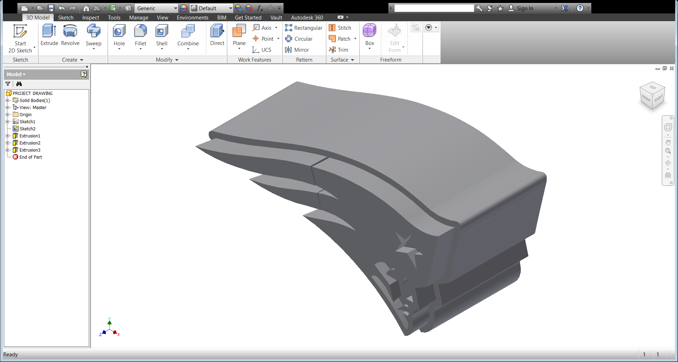

The design of my project was also determined based on what logo would be the most simplistic design and a design that would be easy to remove from molds. I also researched what kind of materials I would use for my project and where I could purchase them from. I go into depth of how I determined my materials in the materials section of my Final Project Portfolio.

**Methodology**

Project Making Procedures

Original Materials list (before revisions)

• Latex- TAP plastics ($33.95)

• Clay (ODU)

• Plaster Provided (ODU)

• ODU Plaster tools and Clay tools Provided (ODU)

• Drill

Total

$33.95

At the start of my decision-making process for my project, the list above shows what I needed for the slip cast and the latex mold. I chose to create a latex mold to make, since it was the only type of molding I was not able to create when doing the labs. I also chose a slip cast since my mold would have to become hollow if I would be able put any spare change into in my mold. The tools I used in my project were electric drill and clay carvers.

My original Process for making my wooden stool was the following list below.

1. Draw a 3D model of the product

2. Print it out using 3D printer

3. Use 3D mold to make Plaster mold

4. Once finished with Plaster mold, use the mold to make Slip cast for the money bank

5. While Slip cast of the money bank was drying, create Latex mold

Through the issues I’ve faced during the development of this project the list of materials and the original procedure were constantly changed.

The list below provides the revised list of my materials for my New England Patriots Money bank and Latex mold.

Updated List of Materials

• Blow torch (ODU)

• Blow Drier (Home)

• ODU Plaster tools and Clay tools provided (ODU)

• Latex- TAP plastics ($33.95)

• Drill (ODU)

**.** Clay andPlaster ODU/ Personal purchase (Lowes) - $25.00

Updated Total

$58.95

**Alternative Solutions**

The changes that were made during the project were due to the plaster mold breaking after trying to separate the two molds, another plaster mold had to be re-made. This process took an additional 2 weeks to complete. Another change was that I had to create a sealant for my mold since my slip mold couldn’t hold the amount of clay that it was taking in. the final change was that I had to purchase plaster, since the lab ran out of plaster.

The list below provides the updated process I took to complete my project

1. Draw a 3D model of the product.
2. Obtain materials from locations that had it.
3. Print out the 3D model with a 3D printer.
4. Mix plaster mold of 3D model by using skills learned from the Mold making lab.
5. Let Plaster mold dry (Breaks the first attempt).
6. Remake Plaster mold (works second attempt).
7. Remove 3D model from Plaster mold.
8. Pour slip cast into Plaster mold (leaks)
9. Use items to help seal the Plaster mold
10. Use a brush to paint liquid latex on the 3D model and create 8 layers of latex so it solidifies.
11. Use a Blow drier to help reduce the amount of time needed for the latex to dry.
12. Remove the slip cast from the Plaster mold once it has dried.

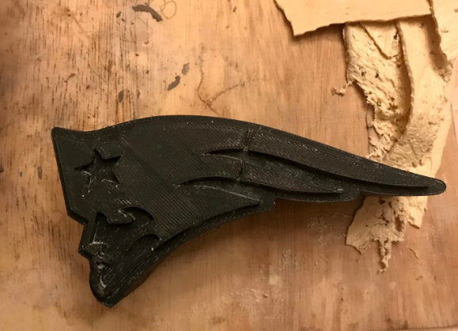

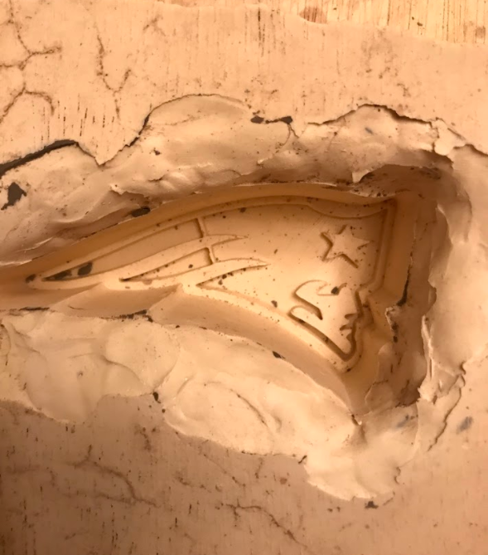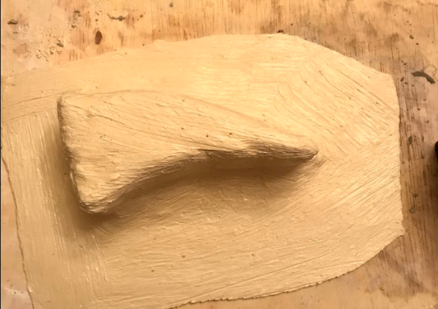

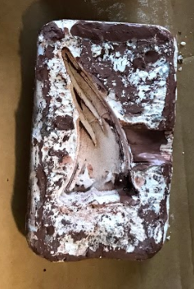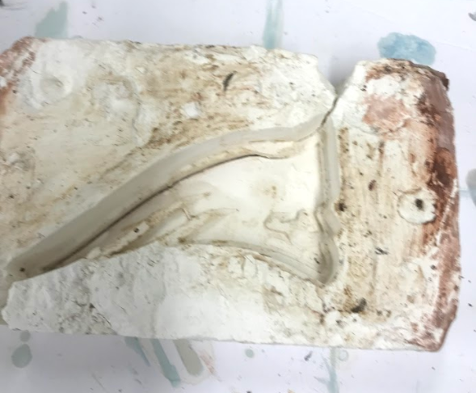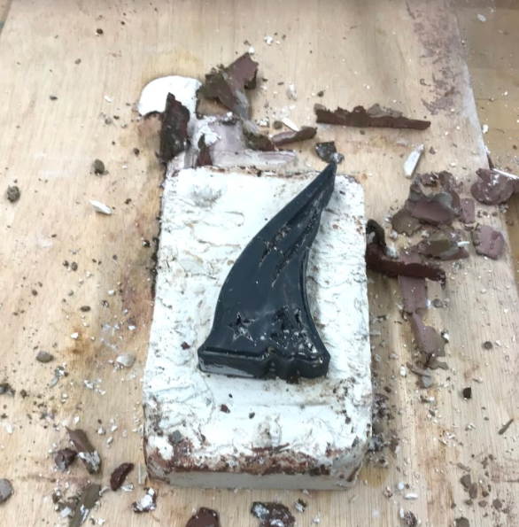

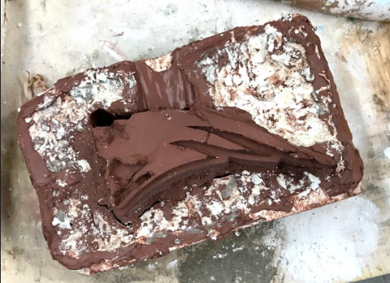

The pictures on the previous pages are my project molds and a few of my materials I used for the project.

**Final Design Solutions**

Project Problems faced and solved

Throughout this project I’ve faced many issues regarding the development of my Plaster mold and my slip cast. When creating the original Plaster mold, I was limited to wooden blocks that were barely one inch higher than my mold. I believe this was the reason my top half of the Plaster mold snapped in two when removing it from the bottom half. When I was going to repair the Plaster mold, someone touched it and it broke even more. This situation led to me making another top half to the Plaster mold. This situation made me lose up to almost two weeks where I could’ve used that time to let my slip cast dry. Another situation I’d faced during the process was the leaking issue my plaster molding had when pouring the slip cast. When pouring my slip into the Plaster mold wasn’t holding, this lead me to use items around my house to block the leaking spots. This issue made me have to wait even longer before it could possibly be dry. Time and weather was also a huge issue as well when completing my projects. Amount of time I needed my Plaster molding and my slip cast to dry was determined by the amount of good weather I could obtain, so I could let my projects dry. Time also had to make me rush the opening of my slip cast. Which lead to the top left of the slip to be separated from the rest of the slip.

The Outcome of the Project

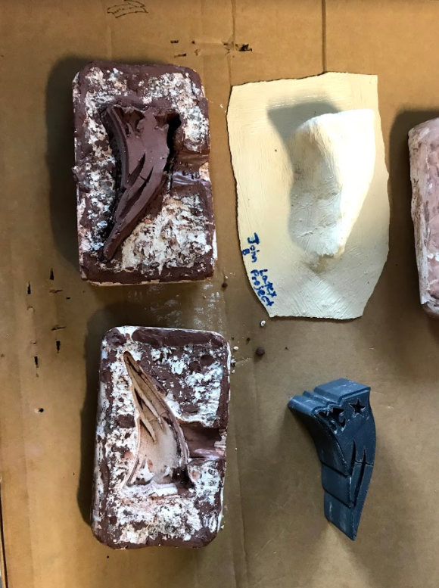I was able to finish my work on time to the best of my ability with the issues I’d faced during the semester. It was a long, hardworking, frustrating, and somewhat enjoyable experience. I’ve learned more techniques I can now use when I need them.

The pictures below are pictures of my finished project

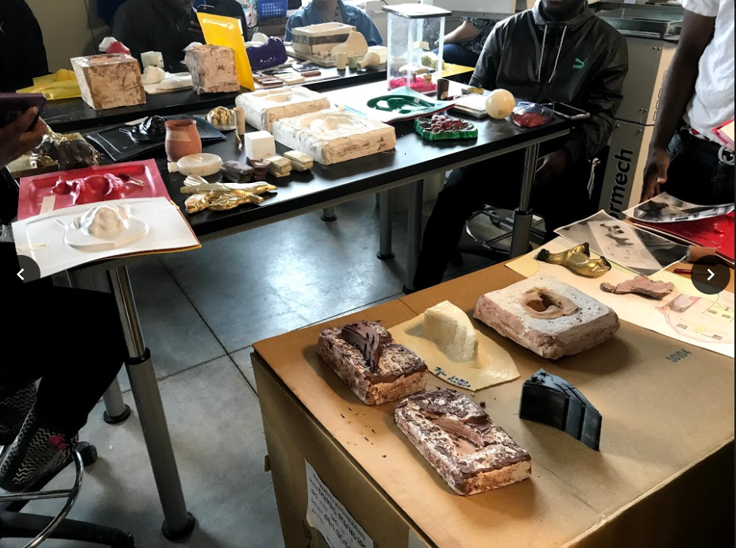

Cost and Time, it took to make my project

The list below provides the revised list of my materials for my New England Patriots money bank and Latex mold.

Bill of Materials

• 3D Model Material Provided (ODU)

• Latex ($33.95) (TAP Plastics)

• ODU Clay and Plaster Tools Provided (ODU)

• Plaster (Lowes) $25.00

• Clay Provided (ODU)

. Drill Provided (ODU)

. Blow Torch Provided (ODU)

. Blow Drier Provided (Home)

Total

Estimated around $58.95

I would estimate that the time it took to make this project the first time was 3 months.

If I would estimate if I were to do it again I would finish earlier If I had the materials I needed, so that I wouldn’t have made the mistakes that I’d made during those 3 months.

**Conclusion**

What did I learn

I learned through this project that materials can be scarce and with the more experience you have the better you can handle a situation in a better manner, as well as purchasing your materials as soon as possible. I was also able to learn how to create a latex mold and how long it takes to do so.

What would I do better

* I would purchase my materials sooner
* I would have gathered in lab materials sooner if I knew they would be scarce
* Allow more time for the Plaster molds to dry so that they won’t break in half.

**Appendices**

Citations

TB12 Logo. (n.d.). Retrieved February 04, 2018, from https://www.google.com/search?rlz=1C1NHXL_enUS758US758&biw=950&bih=901&tbm=isch&sa=1&ei=ITZ3WsfTOYWN0gKs25LAAg&q=TB12&oq=TB12&gs_l=psy-ab.3..0j0i67k1j0l8.590331.591666.0.592498.4.4.0.0.0.0.149.552.0j4.4.0....0...1c.1.64.psy-ab..0.4.551....0.2ykTO_Z_Zhk#imgrc=DirvfGCX_Jt8WM:

Patriots Logo. (n.d.). Retrieved February 04, 2018, from https://www.google.com/search?rlz=1C1NHXL_enUS758US758&biw=950&bih=950&tbm=isch&sa=1&ei=ajl3WrbHCuue0wLQi5jQAg&q=patriots&oq=patr&gs_l=psy-ab.3.0.0i67k1l3j0l7.839844.841064.0.843104.4.4.0.0.0.0.147.545.0j4.4.0....0...1c.1.64.psy-ab..0.4.544....0.AnPqhfbtBSY#imgrc=iHdKEM2qL8ohBM:

Red Sox Logo. (n.d.). Retrieved February 04, 2018, from https://www.google.com/search?rlz=1C1NHXL_enUS758US758&biw=950&bih=950&tbm=isch&sa=1&ei=tTx3Wrr-O6Hj0gLmvo-QCA&q=boston%2Bred%2Bsox&oq=boston&gs_l=psy-ab.3.0.0i67k1l10.195292.197361.0.199184.6.2.0.4.4.0.394.534.0j1j0j1.2.0....0...1c.1.64.psy-ab..0.6.560...0.0._763Ot7D44Q#imgrc=QMeEbxUlewyrgM: