John Michael Bedrosian

12/10/17

UIN#01022221

Final Project Portfolio

Project intent and Definition

The Intent I had to work on a stepping stool was that it was going be a household tool me and my family could use if we needed to reach for an item that was higher than you. I also intended for it to be a large step stool that someone like my grandmother who was short could use the step stool to reach for things that would be difficult for her to reach while on a smaller stepping stool. I originally had the idea to make it all wooden, but my professor brought up the idea of making a steel metal frame by welding pieces together and connecting them using screws. I agreed with him, since including a metal frame would increase the stability and strength of the stepping stool. I decided to take my original idea and criticism from my professor to make a wooden stepping stool with a metal inner frame. The timetable of coming up this idea for the stepping stool was around 1 to 2 weeks. Once my professor approved my project he asked me to make 2 so that I could receive full credit.

Project Research

I used to google to research ideas of how I would like my project to look.

The photo below was used to show the professor what I had in mind for my project.

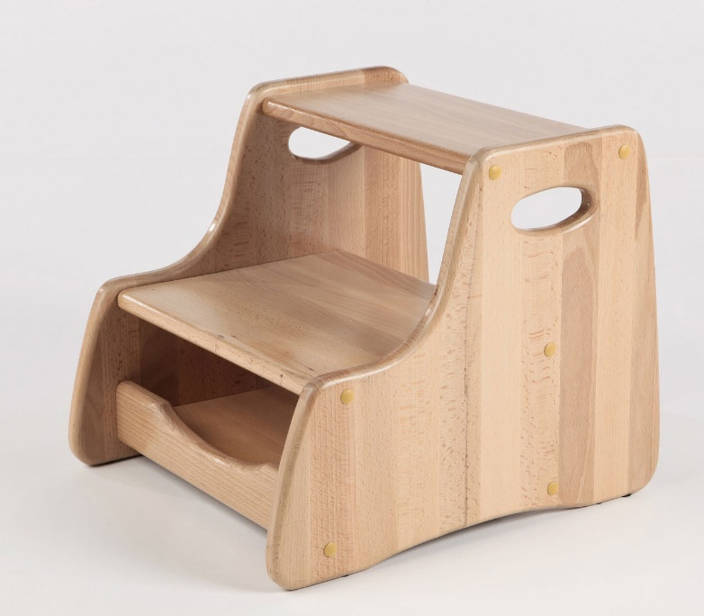

The next photo below was my initial sketch of my Wooden Step Stool I did on AutoCAD

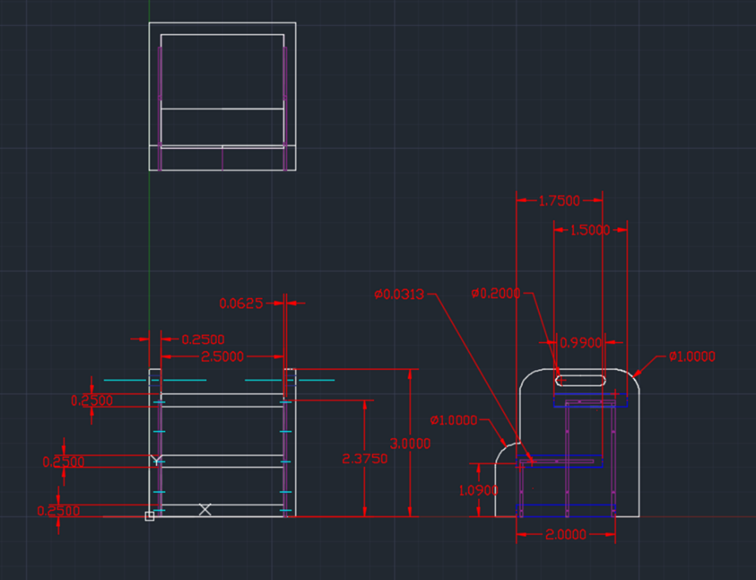

The design of my project was also determined based on what would be the most stable design and a design that would be like the metal frame. I also researched what kind of materials I would need for my project and where to get them. I go into depth of how I determined my materials in the materials section of my Final Project Portfolio.

Project Making Procedures

Original Materials list (before revisions)

• Maple wood ¾in X 5in X 48in $27.99 (Rockler Woodworking and Hardware)X2

• Metal wood inserters 8-32 X 10mm $4.59 X 20 ( woodworkers supply)

• Minwax wood finish $7.59 (Walmart)

• ODU Woodworking and metal working tools Provided (ODU)

• Stainless steel square tube ¾in X ¾in X 7ft $44.40 (Metals4uonline)X2

Total

$199.77

At the start of my decision-making process for my project, the list above shows what I originally came up with for the price and quantity of the materials I needed for the wooden stepping stool. I chose maple as the wood for my project because maple is used for projects like furniture and stools. I also chose to use steel for my metal frame because steel is known to be a strong and durable metal. The tools I used in my project were the metal cutter, the MIG welding machine, the drill press and the table saw.

My original Process for making my wooden stool was the following list below.

1. Draw a sketch with dimensions of the product

2. Cut out the wood in the shape you want it

3. Sand the wood to reduce splinters

4. And use wood finisher to give it protection and appearance

Through the issues I’ve faced during the development of this project the list of materials and the original procedure were changed.

The list below provides the revised list of my materials for my wooden stepping stool.

Updated List of Materials

• Maple wood X 8 and Wood Steps X 10 (obtained from family source)

• Minwax wood finish $7.59 (Walmart)

• ODU Woodworking and metal working tools Provided (ODU)

• Stainless steel square tube ¾in X ¾in X 2ft $8.21 (Home Depot) X14

• Screws provided (ODU)

**.** Sander (Personal)

Total

$122.53

The changes that were made were that instead of buying the wood, the wood was provided by a family member who builds wooden projects for a living. Another change was that I obtained my steel square tube from Home Depot instead of an online source. I also took out wood inserters since I didn’t need them after I did my revisions.

The list below provides the updated process I took to complete my project

1. Draw rough sketch of edited project.
2. Obtain materials from sources.
3. Draw the dimensions of the stool into the wood.
4. Cut the wood on the table saw using the dimensions I drew.
5. Sand wood to give smooth surface.
6. Draw points of where the metal frame would go on the wood.
7. Create metal frame using welding machine
8. Smooth the metal with the grinder once the frame is welded together
9. Drill holes into metal frame
10. Drill holes into wood
11. Assemble the project
12. Stain the project using wood finisher.

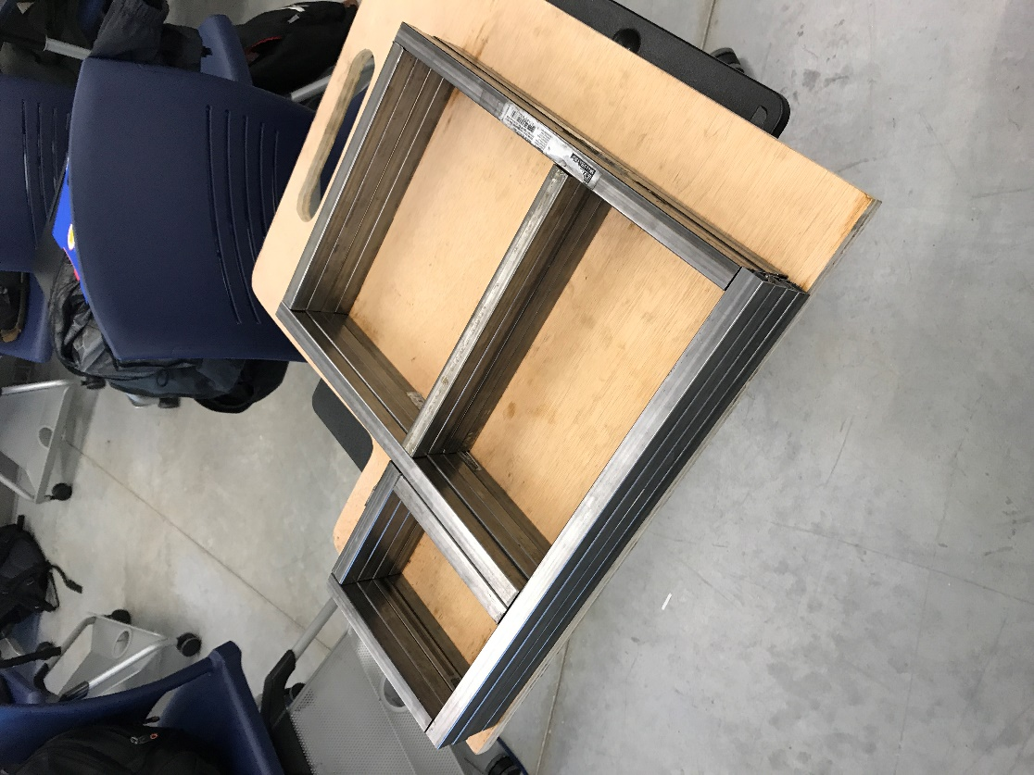

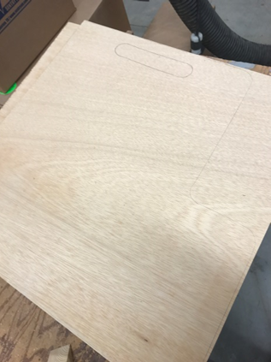

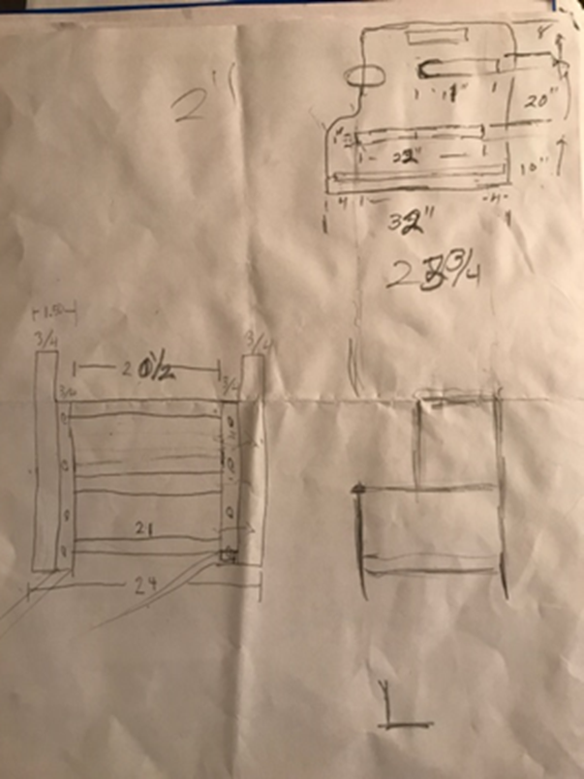

The pictures on the previous pages are my edited design and a few of my materials for the project.

Project Problems faced and solved

Throughout this project I’ve faced many issues regarding My design where Since providing my rough sketch on AutoCAD I have had to edit the dimensions I presented so that I can find a more affordable price and more appropriate size for my two Stepping Stools. Since presenting my original dimensions I have been able to find someone in my family who worked with me to provide me with a better understanding of what size I would want my project. He also gave me a few tips when editing the dimensions of my project. Another problem I faced during the welding process of my project was when my metal was crooked and not straight due to it being my first experience working on a welding machine. To fix the issue I used a rubber mallet and a vice to bend the metal almost back into position. They weren’t perfect and I would have to adjust my location of the holes, but my project was fixed.

The Outcome of the Project

I was able to finish my work on time with the issues I’d faced during the semester. It was a long, hardworking, frustrating, and somewhat enjoyable experience. I’ve learned techniques I can now use anywhere I need them.

The picture below is a picture of my finished project

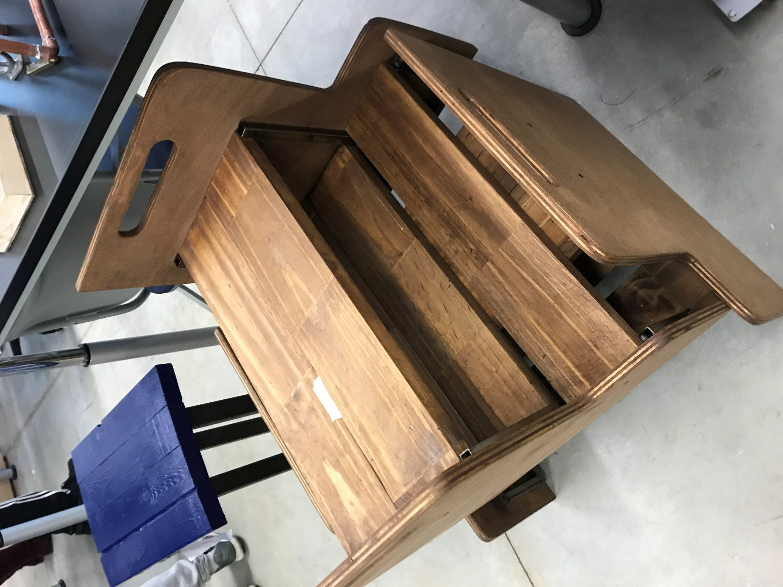

Cost and Time, it took to make my project

The list below provides the revised list of my materials for my wooden stepping stool.

Bill of Materials

• Maple wood X 8 and Wood Steps X 10 (obtained from family source) (Estimated $100)

• Minwax wood finish $7.59 (Walmart)

• ODU Woodworking and metal working tools Provided (ODU)

• Stainless steel square tube ¾in X ¾in X 2ft ($8.21) (Home Depot) X14

• Screws provided (ODU)($7.00)

. Sander (Personal) (20.00)

Total

Estimated around $242.00

I would estimate that the time it took to make this project the first time was 3 months.

If I would estimate if I were to do it again I would finish earlier with the experience I have now.

What did I learn

I learned through this project that the more experience you have the better quality your project will be and the less issues you will face along the way, as well as purchasing your materials as soon as possible. I was also able to learn how to weld steel together to make a metal frame and to drill holes through steel.

What would I do better

* I would purchase my materials sooner
* I would draw better schematics of my project
* And practice more before using welding techniques on my final project.

Citations

“Wooden Stepping Stool.” Google Search, Google, www.google.com/search?biw=1536&bih=710&tbm=isch&sa=1&ei=jPItWqugHZbGjwORrJqgBg&q=%2Bwooden%2Bstepping%2Bstool&oq=%2Bwooden%2Bstepping%2Bstool&gs_l=psy-ab.3..0j0i24k1.80505.82500.0.82847.8.8.0.0.0.0.197.1251.0j8.8.0....0...1c.1.64.psy-ab..0.8.1244...0i67k1j0i13k1j0i7i30k1.0.f0LX6oJfe8g#imgrc=nLnL-T1U5y6MOM: