Project Portfolio

John Michael Bedrosian

**My portion of the work**

When we initially started this assignment as a group, I was assigned to develop the process and sequence for each piece of material and to cut and sand the wooden dowel rods. I completed these objectives and then provided my assistance in the later sections of the project by assisting in the drilling of the holes into the wooden blocks and the assembly of the Tic-Tac-Toe Board. I also aided in developing the burned aesthetic look of the board.

**Process and Sequence for Each Piece of Material**

Below is a Process and Sequence Table I developed to show the process and sequences that went into each piece of the Tic-Tac-Toe board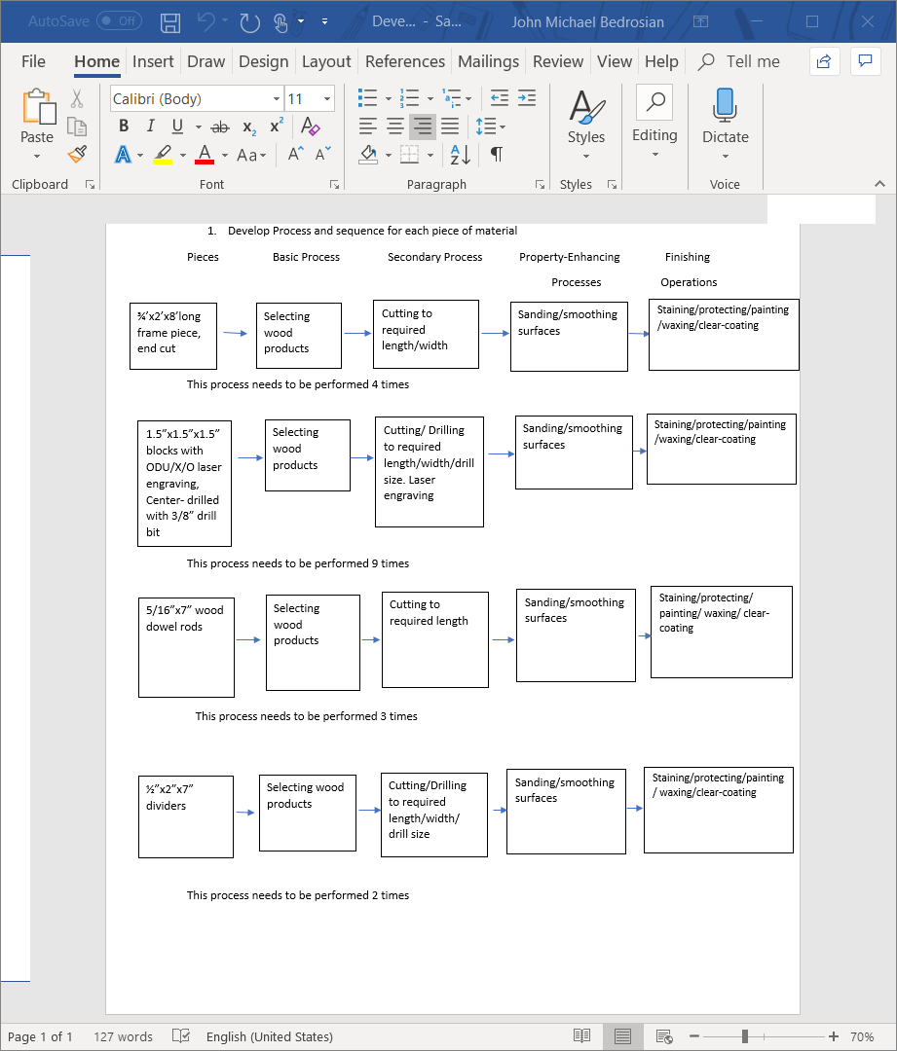

**Wooden Dowel Rods**

We as a group decided that wooden dowel rods were the desired material needed for the Tic-Tac-Toe board. I went to Home Depot and Purchased Thirteen 48-inch wooden dowel rods for 98 cents each. The total came to an estimated $13 and provided enough for 26 Tic-tac-Toe boards. One 48-inch dowel rod provided enough dowel rods for two Tic-Tac-Toe boards. I used a jig on the wooden band saw to cut each rod to the required length. This dowel jig consists of a block of wood, which has been cut at a 3/16th width, and 3/8th depth, and will be used to guide the dowel through the band saw blade at the exact measurement of 7in. It takes 5 mins at most to set up the jig on the band saw. It takes 5 sec to cut one rod and 15 sec to set up the next rod on the band saw. If we took the total times for all 75 rods it would take around 1,500 seconds or 25 minutes to complete. The sanding process took 3 mins for each rod and if we took the total time for all 75 rods it would be 225 minutes or 3 hours and 45 minutes.

If I were to improve this step, I would’ve made sure that 28 projects were the official number of projects before buying the materials, since the original number of projects was 25 and that I had enough for 26 projects.

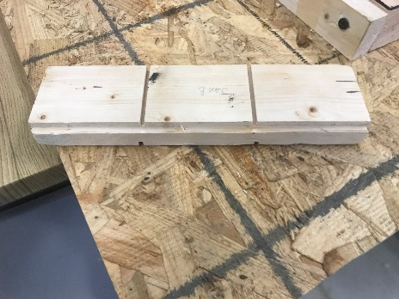

***Picture is of the jig that was used for cutting the dowel rods on the band saw.***

**Drilling Holes into Blocks**

Before the holes are drilled into the blocks a jig must be clamped onto the drill press. The jig is designed to secure the block as a hole is being drilled into it. It takes 5 mins at most to set up the jig on the drill press. The drill bit size is 3/8”. 270 blocks require holes so that 30 projects can be constructed. 9 blocks are needed for each individual project. It takes 25 secs each to drill one hole. If we took the times for all 270 blocks it would take 6,750 secs or 1 hour 53 minutes to complete.

If I were to improve the method of drilling holes to reduce time, I would make sure before drilling that a basket was there to place completed boxes and that drill was set up to drill through the entirety of the block.

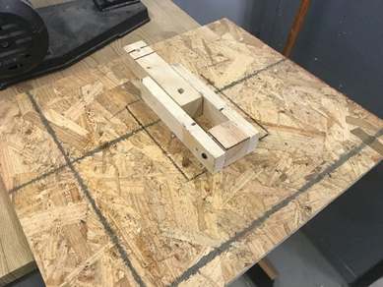

***Picture is of the Jig that was used for drilling holes into the blocks.***

**Assembly of Tic Tac Toe Board**

Before assembly, all tools that are required for assembly must be gathered and placed in the station. It took 15 mins to set up the assembly station. Assembly of the tic tac toe board takes around 7 mins to complete. For the 15 Boards that we completed on Saturday It took 1 hour 45 mins to complete assembly. Tool that were needed in the assembly process included a mallet, wood glue, clamps, paint, and paintbrushes.

**The assembly steps**

1. Set up assembly station

2. Gather pieces of the tic tac toe board

3. Use mallet to fit dowel rods into the holes that were drilled onto the board

4. Place first row of blocks into the dowel rods

5. Place first divider on top of the first row of blocks

6. Place second row of blocks into the dowel rods

7. Place second divider on top of the second row of blocks

8. Place third row of blocks into the dowel rods

9. Place topper onto the dowel rods by using mallet

10. Place wood glue on side board pieces and place them on the tic tac toe board

11. Use Clamps to keep glue connected to the board during drying process.

If I wanted to improve on one portion of the assembly is that we have all pieces ready so that the board can be assembled, since we lost a few mins due to waiting for the rest of the pieces to be done.

**The Burned design of the Board**

As a design aesthetic we gave the outer frame of the Tic-Tac-Toe board a burned designed. We used a blow torch to give the outer wood frame a crisp and burned look. In this process my objective was to assist in the transportation of moving Completed frame pieces to the assembly station.