**Evidence of Assignments:**

**Interpersonal Communication:**

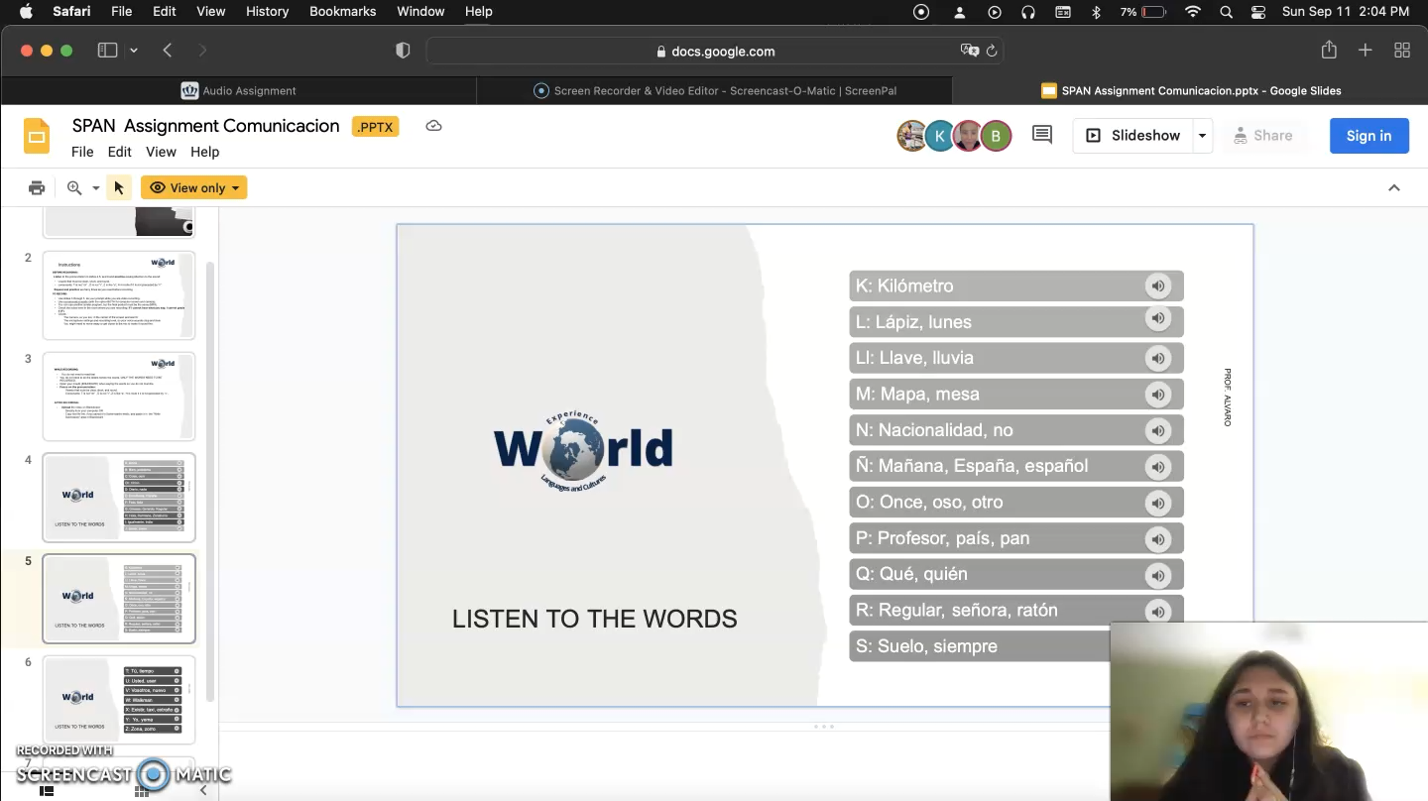**Presentational Speaking:**

Link to PowerPoint <https://docs.google.com/presentation/d/1unIPOffq5ugQPYwSjivrfsfk9zP1XY45/edit?usp=sharing&ouid=116311252158840300176&rtpof=true&sd=true>

Video of assignment linked in portfolio.

**Presentational Writing:**

**Interpretive Listening:**



**Interpretive Reading:**

<https://grados.ugr.es/historia/>

<https://inspain.news/history-of-the-university-of-granada/>