
Interpersonal communication:

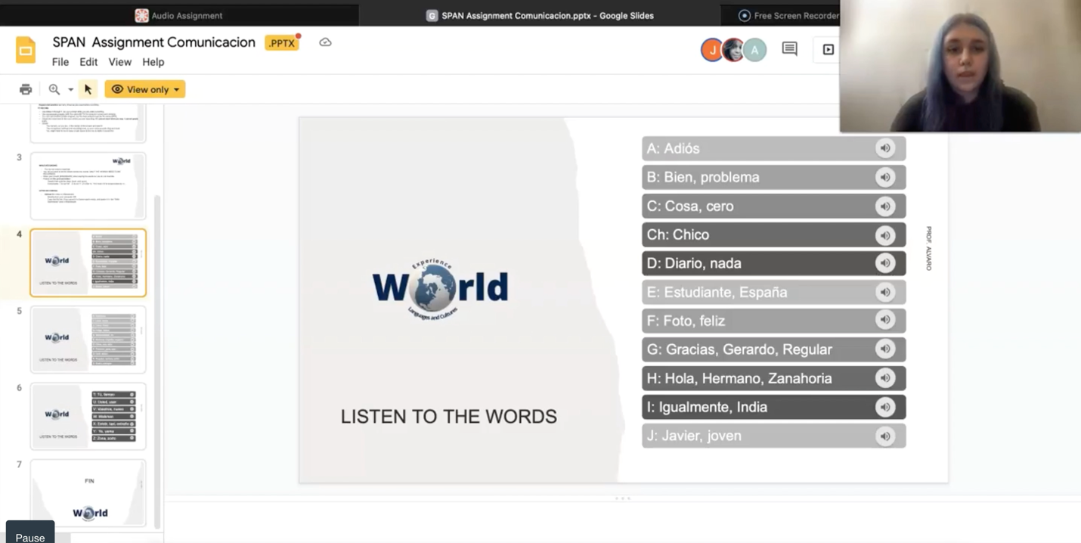
Presentational speaking:

Presentational writing:
https://oureverydaylife.com/importance-of-family-structure-in-hispanic-families-9890197.html
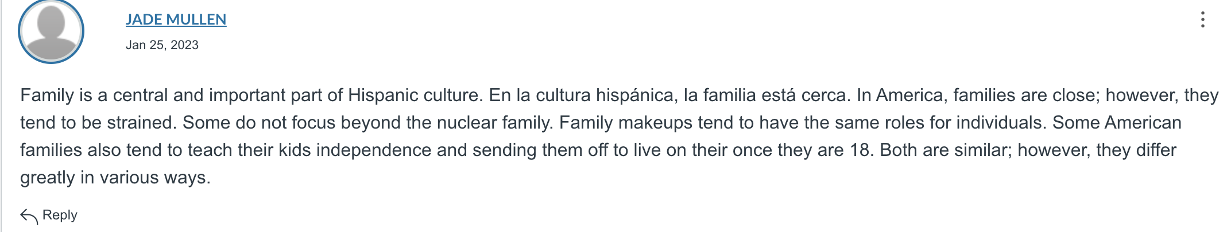

Interpretive listening:
https://www.youtube.com/watch?v=8HKfV9u6ehE
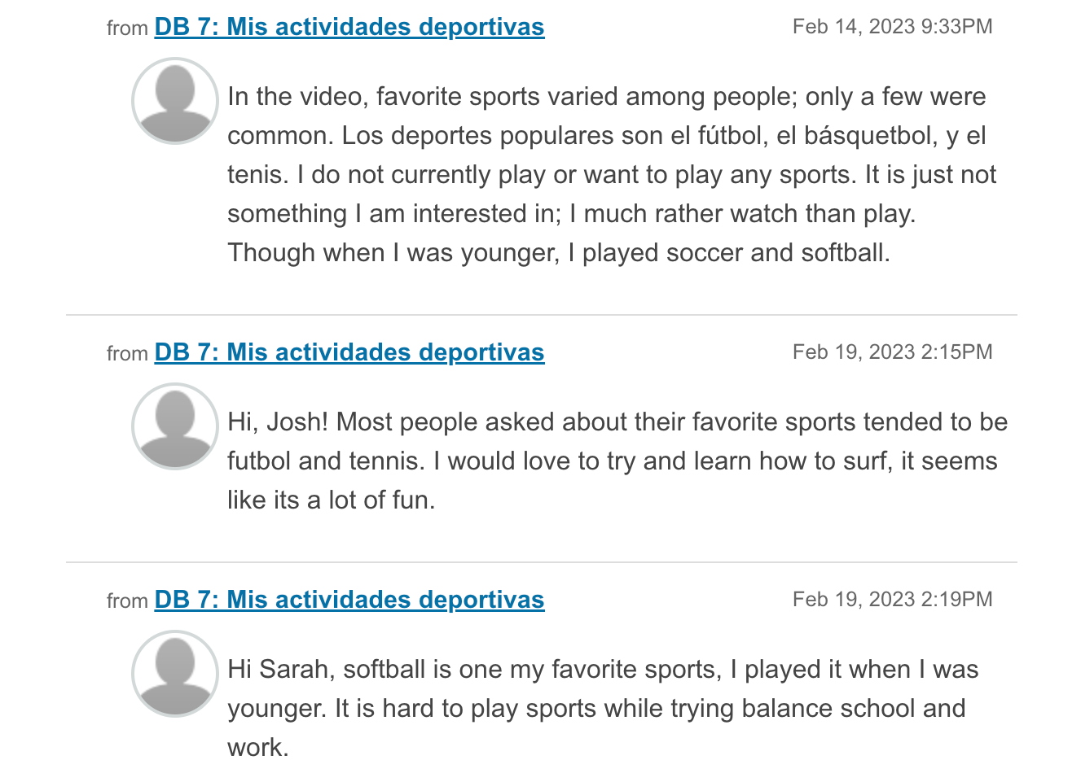

Interpretive reading:

https://falgbt.org/matrimonio-turistas/
