Name: Joshua Tamakloe
Class: SPAN 101F
Date: 4/21/2022
Final Portfolio

- Exploring culture
Exploring the Spanish culture was an attempt to learn how to speak the language. The words in the language are soothing and pleasing to the ear. I explored to learn the language in several ways. I did this by taking the Spanish class and the other was getting to speak with other Spanish cultured speakers to get to learn more outside class lectures. There was a connection between Spanish and French, especially in the conjugation part, which made it much easier to grasp. However, I believe English is the basis and the root of most languages especially Spanish, as it has a larger historic background and culture and, also being the most spoken language in the world.

- Engaging in Communities
I once engaged in a Spanish conversation with a Latino American in my 2nd project of the class. Below is a screenshot of my project.
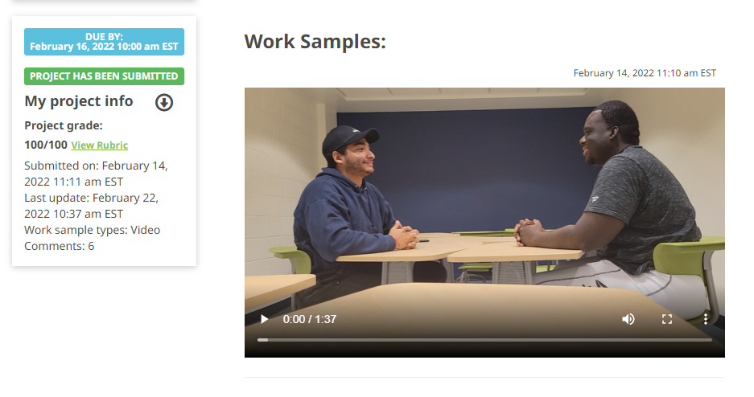

- Interpretive Listening
I achieved this by learning a lot of vocabulary, looking at body languages and facial expressions. The use of ‘mas despacio’ which means slow down can also help listen carefully the words let out. Interpretive listening was also achieved using Lingrohub learning in terms of speaking and listening practices.

- Interpretive Reading
Reading in Spanish was my greatest strength, trust me! When I started my Spanish class, the interpretation and vocabulary was my weakness and it was normal because I had no history of speaking Spanish, but when it came to the reading, it was like it was part of me. I could read Spanish like reading English and I was a beginner and that was even a surprise to me myself, as if I already knew how to speak Spanish from birth.

- Presentational Writing
This was achieved in my first project in the Spanish class. This project was simply about writing about myself. Below is a screenshot

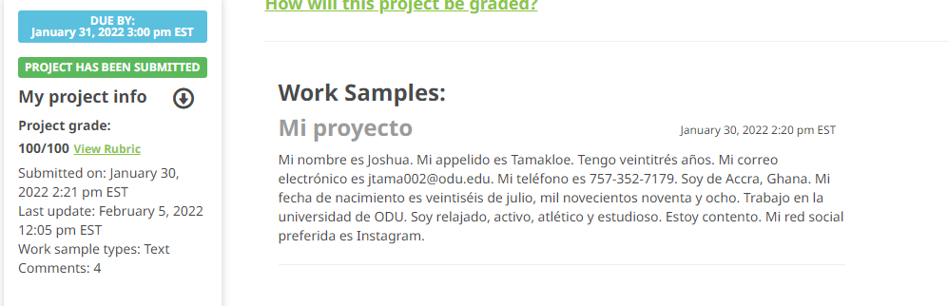

- Interpersonal Communication
Interpersonal communication level is at the novice level and I see that as a great achievement. This was achieved by active participation in class using group activities and speaking with the professor himself during those times.

- Presentational Speaking
This was achieved in my fourth project in the Spanish class. This project was simply about making a video and talking about the school. Below is a screenshot:
