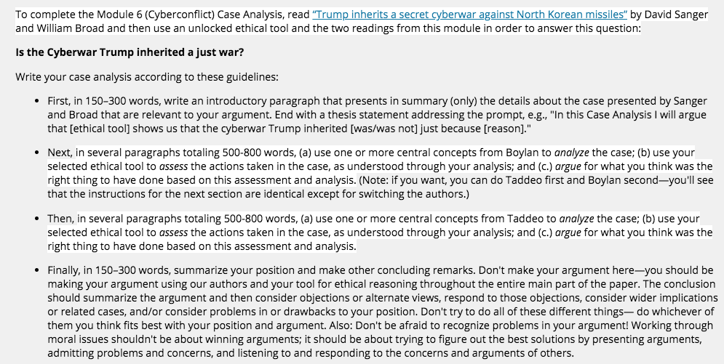

INTRO:
In order to analyze aspects of cyberwarfare we have to first examine what cyberwar is. Per lexico.com they state that cyberwar is “The use of computer technology to disrupt the activities of a state or organization, especially the deliberate attacking of information systems for strategic or military purposes”(Cyberwar, n.d.). The number of resources impacted, the amount of landscape impacted by an attack, and the amount of time that the victim is impacted constitutes the degree in which an attack can be labelled as an act of cyberwar (Boylan, 2015). There have, in recent times, been acts of cyberwar that could be argued to be “just” in that the acts limited or prevented impending impacts of loss of life and or resources in conflicts. In this analysis, we’ll examine the use of the Deontology Ethical Tool to argue that the cyberwar that Trump inherited is an unjust war.

ANALYSIS 1:
Michael Boylan, the Can there be a Just Cyber War? piece where he first recognizes that the embedded nature of technology in the frameworks of society could if attacked result in impacts and effects of regional and international cyber infrastructure(Boylan, 2015). This recognition requires a level of examination in exploring how to address the impacts of cyber infrastructure as an additional “dimension”(Boylan, 2015) to in how we think about war by adding an additional domain to war termed Cyberwar. Boylan first states the following which is rather important in the examination of Cyberwar issues: “We should be clear that acts of cyber sabotage occur internationally on a regular basis. The difference between sabotage and cyber warfare is a matter of degree”(Boylan, 2015). Acts that cause loss of life, loss of resources at the nationwide level, impacts to national security, and the amount of time that resource impacts occur are all examples of what constitutes as an act of war. And Cyberwar has to be included in this in that cyber operations that are used to attack another foreign entity to cause the same impacts.

Boylan goes on to examine aggressive acts and states “an aggressive act by one state against the territory or sovereignty of another state for the purposes of gaining land, resources, or strategic advantage according to internationally recognized rules and constraints governing such action both ad bellum and in bello. Well, this traditional understanding requires at least two components: 1. An aggressive act by one state against another against its territory or sovereignty, and 2. A telos of gaining land, resources, or strategic advantage. A traditional understanding of the first point envisions military personnel moving into a region to take control—involving almost universally the loss of life (preferably military only).14 In a cyber-attack there are no ground troops. The delivery mechanism is either via the Internet or by the agency of a fifth column person who has malware on a flash drive (the probable launch of Stuxnet)”(Boylan, 2015). With this information we can begin to formulate ideas regarding Cyberwar by examining the acts and motives via the lens of Deontological Ethics.

The focus of Deontology are the following tenets that actions of individuals focus on their contemplation and or determinations in how they deem actions to be right or wrong, anyone doing good things for bad reasons or to avoid bad out comes is immoral which is wrong and that actions should be out of the sake of respect for all individuals and that no exceptions can be made for oneself, and that two wrongs do not make a right. (Dwittkower, 2019). From these tenets we can argue that acts of war and Cyberwar are unjust. Completing an act of Cyberwar because if you don’t there will be negative impact and conducting an act of Cyberwar because the other entity will conduct wrongdoing to you is also immoral. Hence the reasoning that these views that conducting acts of Cyberwar like that in Stuxnet where the Israeli and U.S. governments bugged Iranian nuclear deployments and delayed them was still immoral and unjust even if these acts derailed future impending conflict between Israel and Iran. The Deontological examination and the example examination of Stuxnet determinations in acting help to build a strong case in debating that the use of Cyber tactics to abate North Korea’s usage of missiles are acts of Cyberwar that are immoral and ultimately unjust.

ANALYSIS 2:
In Taddeo’s Analysis of Cyberwarfare Ethics conference paper, she too asserts that Cyberwarfare needs to be examined first by comparing it to the “traditional paradigm of war”(Boylan, 2015). “Information revolution determines a shift, which brings the non-physical domain to the fore and makes it as important and valuable as the physical one. CW is one of the most compelling instances of such a shift, it shows that there is a new environment, where physical and non-physical entities coexist and are equally valuable, and in which states have to prove their authority and new modes of warfare are being developed specifically for be deployed in such a new environment (Taddeo, 2012)”(Traddeo, 2012 ). She goes on to describe the complexities of the non-physical aspects of Cyberwar in that it can “disrupt”(Traddeo, 2012), “deny service”(Traddeo, 2012), but then can cause “severe damage without exerting physical force”(Traddeo, 2012).

Traddeo also explains that in “Just War Theory(JWT)”(Traddeo, 2012), JWT applies “principles of ‘war as last resort’, of ‘more good than harm’, and of ‘non-combatants immunity’(Traddeo, 2012). Now when we examine the principle of “war as a last resort”(Traddeo, 2012) and how Cyberwar impacts the physical and nonphysical world that have been explained by Traddeo we can assert that Cyberwar is unjust because according to Sanger and Broad there were “other options”(Sander, 2017). They state “He could order the escalation of the Pentagon’s cyber and electronic warfare effort, but that carries no guarantees. He could open negotiations with the North to freeze its nuclear and missile programs, but that would leave a looming threat in place. He could prepare for direct missile strikes on the launch sites, which Mr. Obama also considered, but there is little chance of hitting every target. He could press the Chinese to cut off trade and support, but Beijing has always stopped short of steps that could lead to the regime’s collapse”(Sanders, 2017). Even with these so-called efforts there is the impending threat in retaliation that Sanger and Broad describe in that “In North Korea, the target is much more challenging. Missiles are fired from multiple launch sites around the country and moved about on mobile launchers in an elaborate shell game meant to deceive adversaries. To strike them, timing is critical. Advocates of the sophisticated effort to remotely manipulate data inside North Korea’s missile systems argue the United States has no real alternative because the effort to stop the North from learning the secrets of making nuclear weapons has already failed. The only hope now is stopping the country from developing an intercontinental missile and demonstrating that destructive threat to the world”(Sanders, 2017).Even so, in Deontology Ethics, these acts of Cyberwar in stopping North Korea and derailing North Koreas’s missile launches are immoral and unjust. Immoral because it fails to think of how the actions impact everyone involved. It is not described how the U.S. has reviewed how their cyber-attacks impact North Korea which is a key principle in Deontology Ethics. Yes, the acts of a missile crisis between the U.S. and North Korea could negatively impact the U.S. but in terms of Deontology ethics, one must always act morally and not hold themselves “above” moral values by making an exception for themselves”(Wittkower, 2019).

CONCLUSION:
In conclusion, in terms of Deontology Ethics the findings regarding the Cyberwarfare acts used against North Korea’s missiles are unjust. Even though if North Korea was able to continue building, testing, deploying missiles that could negatively impact the United States in Deontological terms any acts against them by use of Cyberwarfare are unjust in that it limits Missile resources that belong to North Korea and it impacts the time spent by the North Koreans attempting to deploy said missiles. The U.S. as a upholder of that which is just has a responsibility to not hold themselves “above”(Wittkower, 2019) the ethical values and morals that they stand on. In order to do that they have to stand firm and unfortunately allow North Korea to continue on with their plans without intervening in such a way like that of Cyberwarfare. The U.S. should instead make an effort to review all other avenues to pursue peace or some sort of agreement or arrangement instead of the proactive deterrence methods of Cyberwar they have resorted to. They have a responsibility to find another way to approach the North Korean conflict, for the American people, for North Korea, and for the World because everyone is watching.

References:
Cyberwar: Definition of Cyberwar by Lexico. (n.d.). Retrieved November 14, 2019, from https://www.lexico.com/en/definition/cyberwar.

https://www.blackboard.odu.edu/ultra/courses/_347180_1/cl/outline
https://www.nytimes.com/2017/03/04/world/asia/north-korea-missile-program-sabotage.html

